**Description**

In the past, GSM is the most commonly-used connectivity method used in commercial wide area wireless scenario, but one of its disadvantage is high power consumption.

LoRa is a perfect long-range protocol to create low-power, wide area network (LPWAN).

To manage communication between LoRa gateways and LoRa end-node devices, LoRaWAN is defined as one of the network layer protocols / routing protocols, it enables easy management of device interaction, configuration, data transmission etc. LoRaWAN empowers a device to have the capability to manage massive end-nodes.

So if your application is to manage a huge number of IoT devices like 1000+ within a large area in a private network and just need to transmit a small amount of data, a LoRaWAN network would be one of your best options.

You need 3 basic things to build you own LoRaWAN network: a LoRaWAN Gateway, at least one LoRa Node and a LoRa server where you can monitor all your devices.

To lower the barrier of building a LoRaWAN gateway, we provide this kit to give you a quick and easy start.

Please choose the corresponding ISM frequency plan for LoRaWAN gateway based on your location. The frequency plan we use in this kit is 902MHz – 928MHz which can be used in places like USA, Canada, South America, Japan, Australia, South Korea, for more info, please check each country’s regulation.

This kit includes 1 main module and some accessories:

1) RHF0M301- a LoRaWAN gateway module based on SX1301.

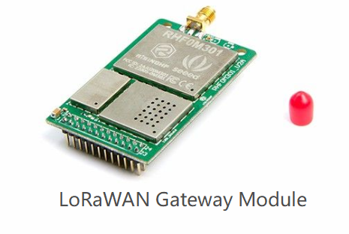 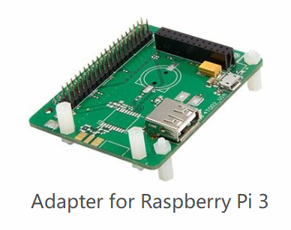

RHF0M301 is a joint effort by RisingHF and Seeed, it is a high performance LoRa/LoRaWAN module based on Semtech SX1301 which can support in total 10 programmable parallel channels, including 8 multi- SF channel (IF0~IF07), 1 standard LoRa channel (IF8) and 1 FSK channel (IF9)，the network capacity is so much bigger compares to a single channel gateway and enable you to manager more clients.

2) RHF4T002 – a RPi adapter to bridge Raspberry Pi 3 and RHF0M301

With its 24-pin DIP port, user can easily connect RHF0M301 to Raspberry Pi 3. RPi 3 is able to send the collected data through Ethernet and WiFi .

2) RHF4T002 – a RPi adapter to bridge Raspberry Pi 3B/3B+ and RHF0M301

With its 24-pin DIP port and 40-pin general Raspberry Pi Header, user can easily connect RHF0M301 to Raspberry Pi 3. RPi 3 is able to send the collected data through Ethernet and WiFi .

3）a 16G SD card - an OS image with Loriot server and local server is flashed in SD card to help you get started easily. If you prefer to use other servers like TTN, RisingHF also provides a guideline (放Getting started Guide链接) to help you switch to other services.

Besides 915MHz gateway, we also have 868 MHz gateway to fit in more countries (<https://www.seeedstudio.com/LoRa-LoRaWAN-Gateway-868MHz-Kit-with-Raspberry-Pi-3-p-2823.html>).

To build a private LoRaWAN network, the next thing you need is a LoRa node, please pair the gateway with Seeeduino LoRaWAN <https://www.seeedstudio.com/Seeeduino-LoRaWAN-p-2780.html>. If what you want to build is a tracker network, this one can help you. <https://www.seeedstudio.com/Seeeduino-LoRaWAN-W-GPS-p-2781.html>

If you need a commercial gateway, take a look at SenseCAP(<https://solution.seeed.cc/product/sensecap>)

**Note:**

Please update the firmware when the first time to use it. Please always plug 3.7V Lipo battery in case USB power supply is not sufficient.

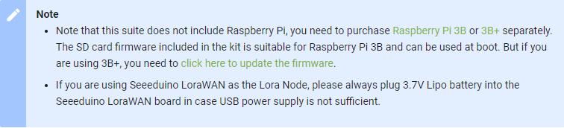

**Features**

* LoRa Concentrator Engine: Semtech SX1301
* Sensitivity up to -142.5 dBm @300bps
* Max output power up to 27dBm
* Range up to 15 km (Line of Sight), ~2km in dense urban areas
* Designed for 915MHz US/Australia LoRA ISM band
* Emulates 49 x LoRa demodulators, 10 programmable parallel demodulation paths, 8 uplink ch, 1 downlink ch
* Automatic adaptive to spreading factor from SF12 to SF7 in each of 8 channels
* Operating Temperature: -40 to 85 ℃
* 2x SX1257 as Tx/Rx front-ends
* RP-SMA connector for 915MHz antenna
* Fully support Class A, Class B, Class C
* FCC & CE compliance

**Note**:This kit does not contain Raspberry Pi 3 Board

**Part List**

* Gateway module RHF0M301 – 915 x 1
* RPi 3 Bridge RHF4T002 x 1
* 16GB Micro SD Card – Class 10 x 1
* USB to UART Adapter x 1
* 0dBi Rubber Duck Antenna x 1
* Micro USB Cable 20cm x1
* Micro USB Cable 100cm x 1
* RJ45 Ethernet Cable 200cm x 1
* 5V/2.1A American Standard power supply with Micro USB Connector x 1
* 5V/2.1A American Standard power supply with USB Type A Output x 1

**Documents**

Getting started Guide (看邮件附件)

RHF0M301 Product Brief (看邮件附件)

RHF0M301 Datesheet (看邮件附件)

Wiki（<http://wiki.seeedstudio.com/LoRa_LoRaWan_Gateway_Kit>）