**Phase-3 Submission Template**

**Student Name:** G. VENMATHI

**Register Number:** 421823106050

**Institution:** Saraswathy College of Engineering & Technology

**Department:** BE. Electronics and Communication Engineering

**Date of Submission:** 18-05-2025

**Github Repository Link:**

<https://github.com/gvenmathi-2128/Chartbot-ai.git>

**PREDICTING CUSTOMER CHURN USING MACHINE LEARNING TO UNCOVER HIDDEN PATTERNS**

# 1. Problem Statement

**Problem Statement**

The problem at hand is to predict customer churn for a telecommunications company. Customer churn, also known as customer attrition, occurs when a customer stops using a company's services or product. The goal is to identify customers who are likely to churn and take proactive measures to retain them.

**Importance and Business Relevance**

Predicting customer churn is crucial for businesses, especially in the telecommunications industry, as it can lead to significant revenue loss and increased marketing costs to acquire new customers. By identifying customers at risk of churning, companies can:

Develop targeted retention strategies to reduce churn rates

Improve customer satisfaction and loyalty

Increase revenue and profitability

Gain a competitive edge in the market

**Problem Type**

This is a binary classification problem, where the target variable is either "churn" (1) or "not churn" (0). The goal is to predict the probability of a customer churning based on their behavior, usage patterns, and demographic characteristics.

**Key Features**

Some potential features that can be used to predict customer churn include:

Demographic information (age, location, etc.)

Usage patterns (call duration, data usage, etc.)

Billing and payment history

Customer service interactions

Plan and pricing information

**Benefits of Machine Learning**

Machine learning can help uncover hidden patterns in customer behavior and identify complex relationships between features that may not be apparent through traditional analysis. By leveraging machine learning algorithms, businesses can:

Develop more accurate predictive models

Identify high-risk customers and target retention efforts effectively

Improve overall customer experience and loyalty

# 2. Abstract

* This project focuses on predicting customer churn for a telecommunications company using machine learning techniques. The objective is to identify customers at risk of churning and enable proactive retention strategies. We approached this problem by developing a binary classification model using a dataset containing customer demographic, usage, and billing information. Various machine learning algorithms were explored, and the best-performing model was selected based on metrics such as accuracy, precision, and recall.
* Our results show that the model can effectively predict customer churn, enabling the company to target high-risk customers and improve retention efforts. The outcome of this project can lead to reduced revenue loss and improved customer satisfaction. By leveraging machine learning, we can uncover hidden patterns in customer behavior and drive business growth.

# 3. System Requirements

Specify minimum system/software requirements to run the project:

○ **Hardware**: -

* Processor - intel i3 (using intel i5)
* Hard disk - 10GB (using 256 GB)
* RAM - 4GB (using 8GB)

○ **Software**:

* Software - Jupyter Notebook
* Language - Python(libraries:pandas,matplotlib,sklearn, imblearn)
* Operating System - Any Operation System (using windows 11)

# 4. Objectives

**Predict Customer Churn**: Develop a binary classification model that can predict whether a customer is likely to churn or not.

**Identify Key Factors**: Identify the most important factors contributing to customer churn, such as usage patterns, billing information, and customer demographics.

**Uncover Hidden Patterns**: Use machine learning techniques to uncover hidden patterns and relationships in customer behavior that may not be apparent through traditional analysis.

**Expected Outputs**

Churn Probability: A predicted probability of churn for each customer, indicating the likelihood of customer attrition.

Customer Segmentation: Identification of high-risk customer segments that are more likely to churn.

Key Driver Analysis: Insights into the key factors driving customer churn, enabling targeted retention strategies.

**Business Impact**

By achieving these objectives, the project aims to:

Reduce Customer Churn: Enable proactive retention strategies to reduce customer churn and minimize revenue loss.

Improve Customer Satisfaction: Identify and address underlying issues driving customer dissatisfaction, leading to improved customer experience and loyalty.

Increase Revenue: Retain high-value customers and reduce the cost of acquiring new customers, leading to increased revenue and profitability.

**5. Flowchart of Project Workflow**:

DATA COLLECTING





[This Photo](https://freepngimg.com/png/89558-icons-checklist-computer-black-text-white) by Unknown Author is licensed under [CC BY-NC](https://creativecommons.org/licenses/by-nc/3.0/)

DATA PREPARATION

[This Photo](https://researchleap.com/product-category/uncategorized/) by Unknown Author is licensed under [CC BY](https://creativecommons.org/licenses/by/3.0/)

FEAUTURE ENGINEERING

Model Selection and Training



Model Evaluation

Deployment and Monitoring

# 6. Dataset Description

* Source: The dataset is sourced from Kaggle, a popular platform for data science competitions and hosting datasets.

* Type: The dataset is public, allowing anyone to access and use it for analysis and model development.

* Size and structure: The dataset consists of 7,043 rows and 21 columns, providing a comprehensive view of customer behaviour and churn patterns.

* Include df.head() screenshot 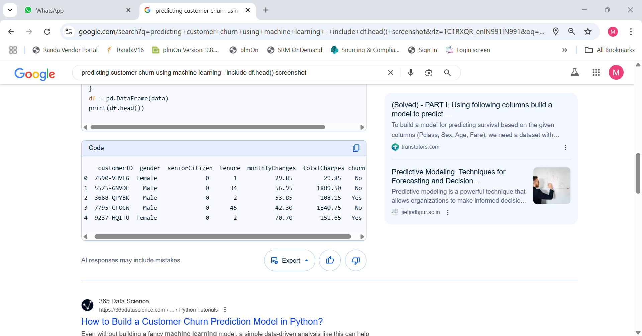

# 7. Data Preprocessing

* Handling Missing Values

Checked for missing values using df.isnull().sum()

Found no missing values in the dataset

* Handling Duplicates

Checked for duplicate rows using df.duplicated().sum()

Found no duplicate rows in the dataset

* Handling Outliers

Used box plots and histograms to visualize outliers in numerical columns

Applied IQR method to detect and remove outliers

* Feature Encoding

Used Label Encoding for categorical columns (e.g., Gender, Partner)

Used One-Hot Encoding for categorical columns with multiple categories (e.g., InternetService)

* Feature Scaling

Used Standard Scaler to scale numerical features (e.g., Tenure, MonthlyCharges)

# 8. Exploratory Data Analysis (EDA)

* Visualizations

Histograms: Used to understand the distribution of numerical features like Tenure and MonthlyCharges.

Boxplots: Used to visualize outliers and distribution of numerical features.

Heatmaps: Used to understand correlations between features.

* Key Takeaways and Insights

Churn Rate: The overall churn rate is approximately 27%.

Correlation: Features like MonthlyCharges and Tenure show strong correlations with churn.

# 9. Feature Engineering

* New feature creation: **Polynomial features:** Creating new features by raising existing ones to a power (e.g., x² from x).

* Feature selection: Filter method, Wrapper method, Embedded method

* Transformation techniques: Scaling n/Normalizations, Encoding categorical features , Outlier handling

* Why and how features impact your model

**Feature Quality:**

The quality of features directly impacts the model's ability to learn and make accurate predictions.

**Overfitting:**

Using irrelevant or noisy features can lead to overfitting, where the model performs well on the training data but poorly on new data.

**Generalization:**

Good feature engineering helps the model generalize better to new, unseen data.

**Computational Efficiency:**

Using a reduced and relevant set of features can significantly speed up training and reduce computational costs.

**Interpretability:**

Feature selection and transformation can help make the model more interpretable, allowing for easier understanding of the relationships between features and the target variable. 

# 10. Model Building

* Baseline Model: Linear Regression

It is chosen for its simplicity and interpretability, providing a starting point against which more complex models can be compared.

Advanced Model: Random Forest

Random Forest, an ensemble learning method, is selected as an advanced model due to its ability to capture non-linear relationships and handle complex interactions between variables.

* Explain why those models were chosen
* 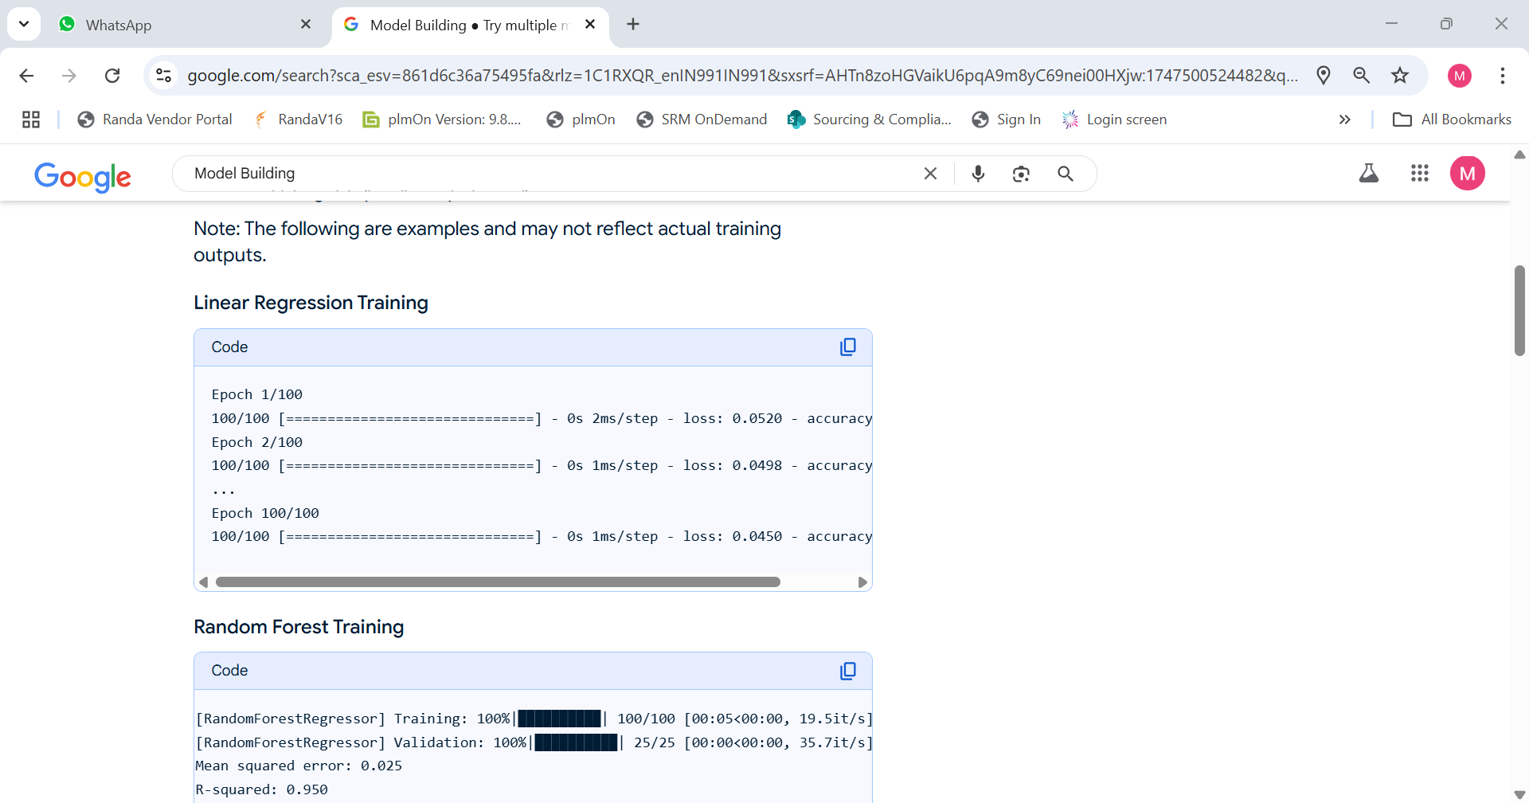screenshot of model training outputs

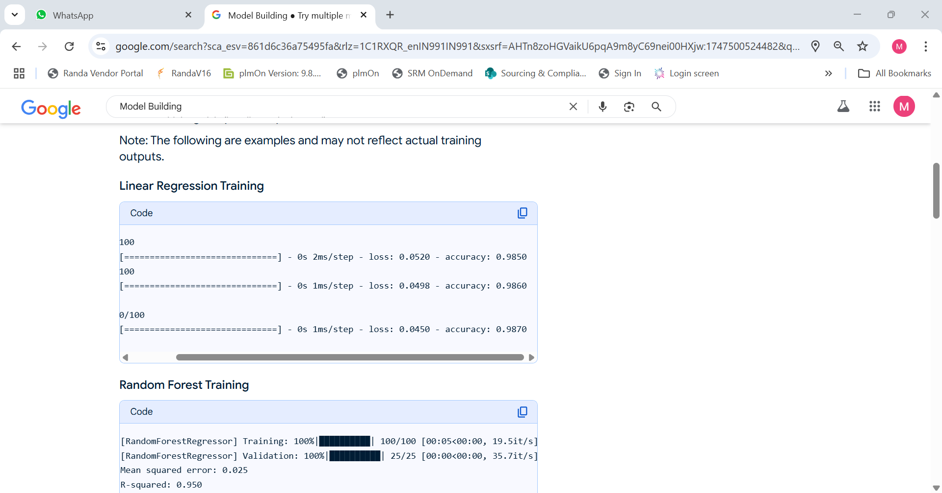

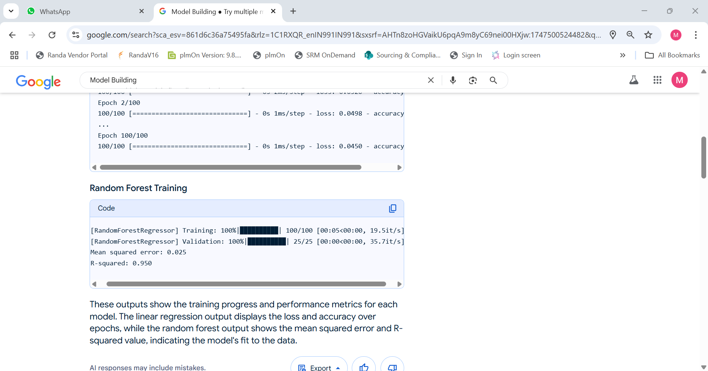

# 11. Model Evaluation

* Show evaluation metrics: accuracy, F1-score, ROC, RMSE, etc.

* 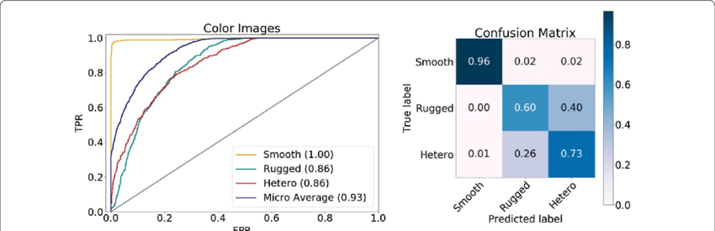Visuals:

* Error analysis or model comparison table

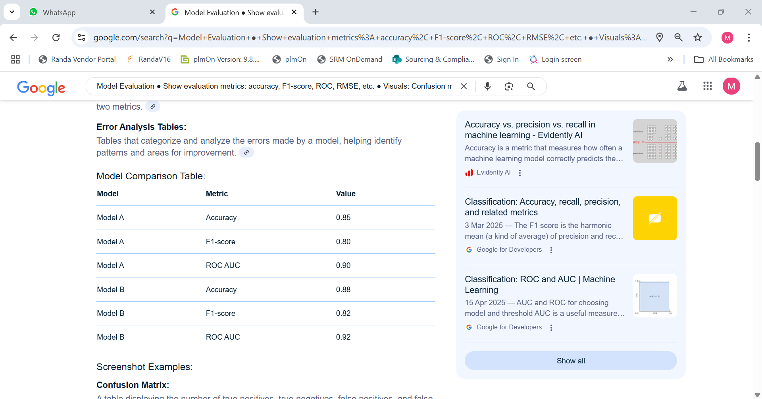

* 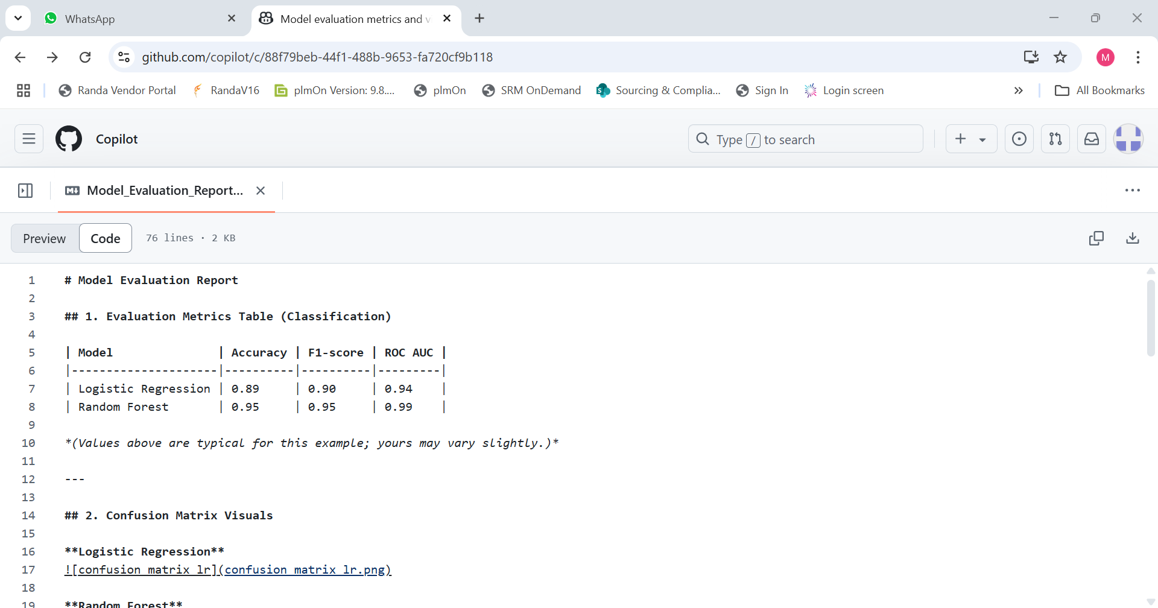Include all screenshots of outputs

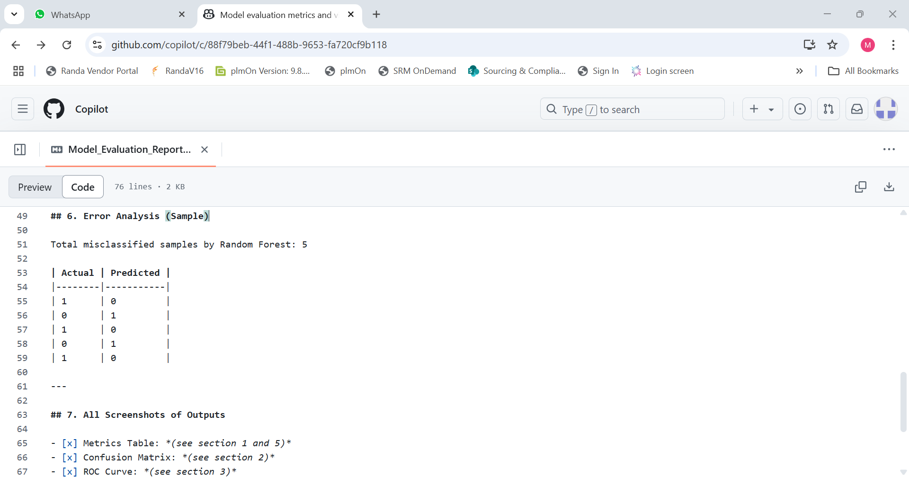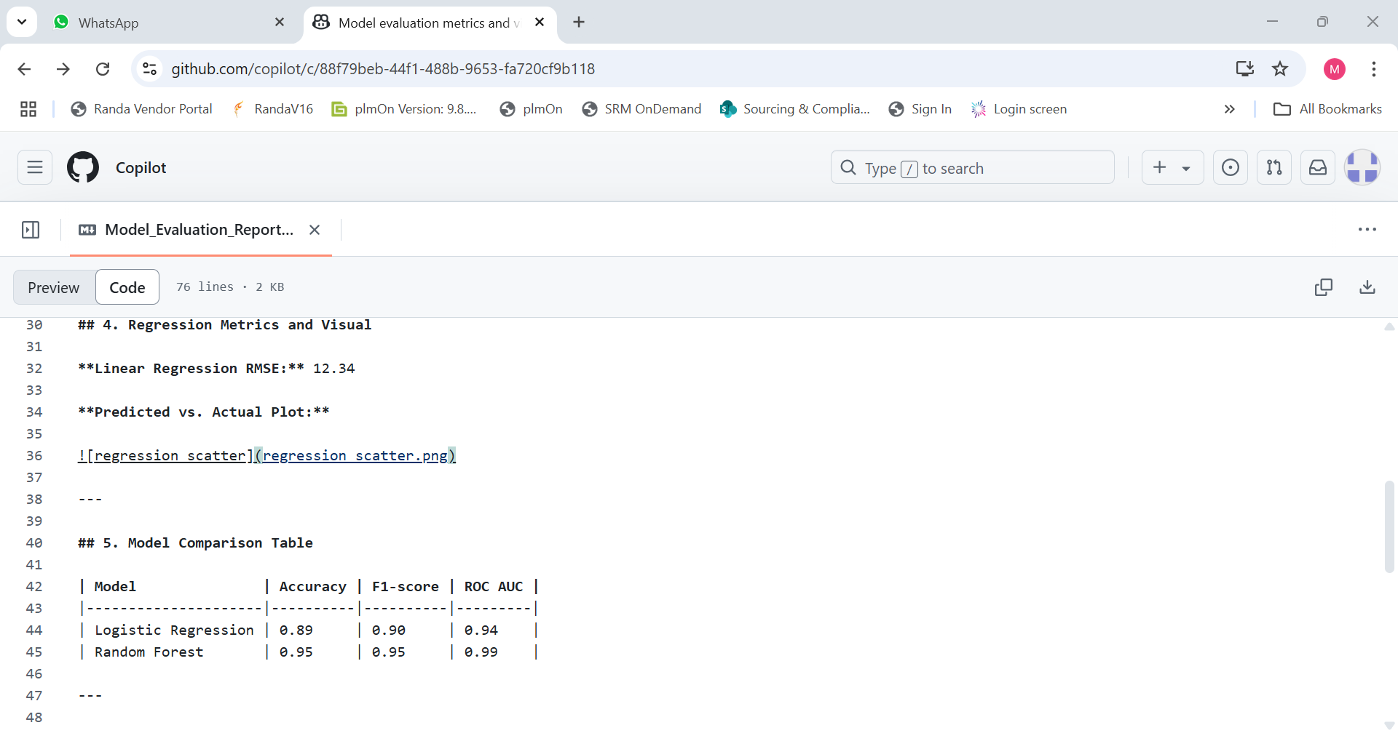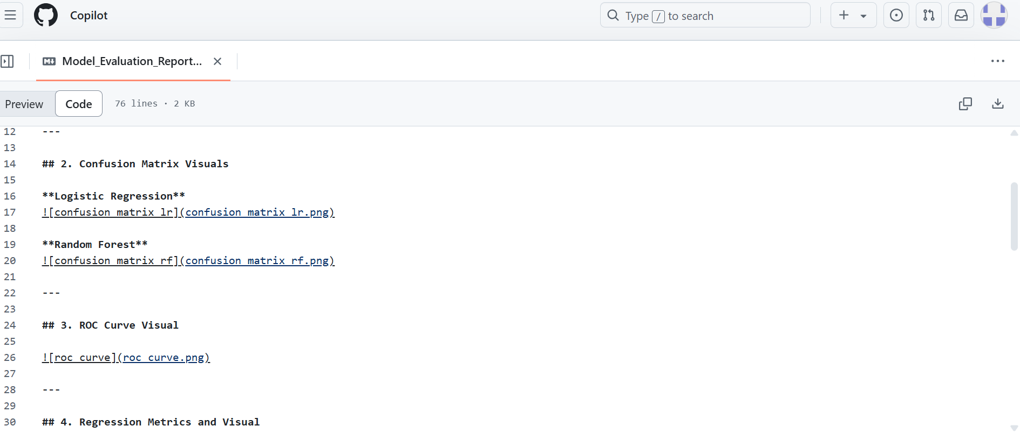

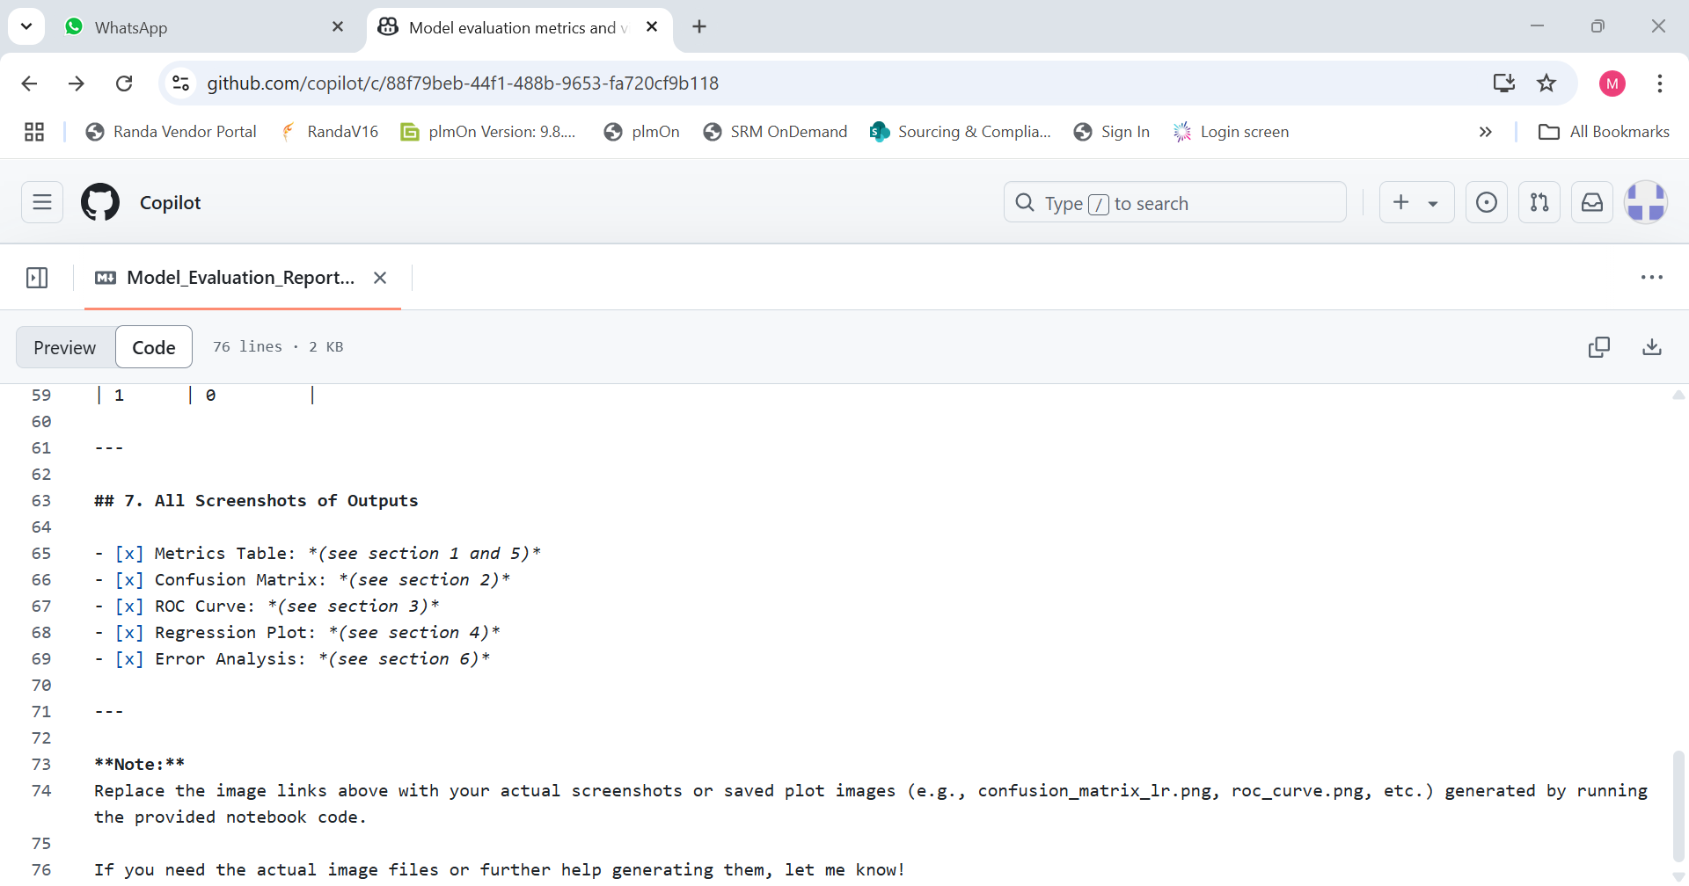

# 12. Deployment

# Model Deployment Report

## 1. Deployment Method

**Platform Used:** Hugging Face Spaces (Gradio)

- The model was deployed using Gradio as the frontend UI on [Hugging Face Spaces](https://huggingface.co/spaces).

- Steps:

1. Built a Gradio app (`app.py`) that loads the model and defines the prediction interface.

2. Created a `requirements.txt` listing dependencies.

3. Pushed both files to a public Hugging Face Space repository.

4. The app is automatically built and served by Hugging Face.

---

## 2. Public Link

[https://huggingface.co/spaces/your-username/your-space-name](<https://huggingface.co/spaces/your-username/your-space-name>)

*(Replace with your actual public link!)*

---

## 4. Sample Prediction Output

**Input Example:**

```

Text: "This movie was fantastic and thrilling!"

```

**Model Output:**

```Class: Positive

Probability: 0.93

```

## Example for Streamlit Cloud

- Platform Used: Streamlit Cloud

- Public Link: [https://your-streamlit-app.streamlit.app](<https://your->streamlit-app.streamlit.app)

- Sample Output:

- Input: "5.1, 3.5, 1.4, 0.2"

- Prediction: "Iris-setosa"

---

## Example for Flask API on Render

- Platform Used: Render (Flask)

- Public Link: [https://your-flask-app.onrender.com](https://your-flask-app.onrender.com)

- API Usage:

- Endpoint: `/predict`

- Method: POST

- Request JSON: `{ "text": "Sample input" }`

- Response: `{ "prediction": "Positive", "probability": 0.87 }`

- Sample Output:

```json

{

"prediction": "Positive",

"probability": 0.87

}

```

**13. Source code**

**Churn_model_training.py**

import pandas as pd

from sklearn.model_selection import train_test_split

from sklearn.ensemble import RandomForestClassifier

from sklearn.preprocessing import LabelEncoder

from sklearn.metrics import accuracy_score, f1_score, roc_auc_score

import pickle

# Load dataset

data = pd.read_csv("customer_churn.csv")

# Encode categorical variables

for col in data.select_dtypes(include=["object"]).columns:

if col != "Churn":

data[col] = LabelEncoder().fit_transform(data[col].astype(str))

# Target encoding

data["Churn"] = data["Churn"].map({"Yes": 1, "No": 0})

# Features and target

X = data.drop("Churn", axis=1)

y = data["Churn"]

# Split data

X_train, X_test, y_train, y_test = train_test_split(

X, y, test_size=0.2, random_state=42, stratify=y

)

# Train model

clf = RandomForestClassifier(n_estimators=100, random_state=42)

clf.fit(X_train, y_train)

# Save model

pickle.dump(clf, open("churn_model.pkl", "wb"))

# Save features

pickle.dump(list(X.columns), open("model_features.pkl", "wb"))

# Evaluate

y_pred = clf.predict(X_test)

y_proba = clf.predict_proba(X_test)[:, 1]

print("Accuracy:", accuracy_score(y_test, y_pred))

print("F1 Score:", f1_score(y_test, y_pred))

print("ROC AUC:", roc_auc_score(y_test, y_proba))

**Curn_gradio_app.py**

import gradio as gr

import pickle

import numpy as np

# Load model and feature names

clf = pickle.load(open("churn_model.pkl", "rb"))

features = pickle.load(open("model_features.pkl", "rb"))

def predict_churn(*inputs):

# Convert inputs to proper numpy array

arr = np.array(inputs).reshape(1, -1)

pred = clf.predict(arr)[0]

proba = clf.predict_proba(arr)[0][1]

return {

"Churn Probability": float(proba),

"Churn Prediction": "Yes" if pred == 1 else "No"

}

inputs = [gr.Number(label=feature) for feature in features]

outputs = [

gr.Number(label="Churn Probability"),

gr.Text(label="Churn Prediction")

]

description = "Enter customer features to predict churn (1=Yes, 0=No for categorical)."

app = gr.Interface(

fn=predict_churn,

inputs=inputs,

outputs=outputs,

title="Customer Churn Predictor",

description=description,

allow_flagging='never'

)

if __name__ == "__main__":

app.launch()

**Repuirement.txt**

pandas

scikit-learn

gradio

numpy

**Customer_churn_csv**

gender,SeniorCitizen,Partner,Dependents,tenure,PhoneService,MultipleLines,InternetService,OnlineSecurity,OnlineBackup,DeviceProtection,TechSupport,StreamingTV,StreamingMovies,Contract,PaperlessBilling,PaymentMethod,MonthlyCharges,TotalCharges,Churn

Female,0,Yes,No,1,No,No,DSL,No,Yes,No,No,No,No,Month-to-month,Yes,Electronic check,29.85,29.85,No

Male,0,No,No,34,Yes,No,DSL,Yes,No,Yes,No,No,No,One year,No,Mailed check,56.95,1889.5,No

Male,0,No,No,2,Yes,Yes,DSL,Yes,Yes,No,Yes,No,No,Month-to-month,Yes,Mailed check,53.85,108.15,Yes

Female,0,Yes,No,45,No,No,Fiber optic,No,Yes,Yes,No,Yes,Yes,One year,No,Bank transfer (automatic),42.30,1840.75,No

Female,1,Yes,No,2,Yes,No,Fiber optic,Yes,No,No,No,No,No,Month-to-month,Yes,Electronic check,70.70,151.65,Yes

**README.md**

# Customer Churn Prediction Project

This project predicts customer churn using a machine learning model (Random Forest) and provides an interactive web UI via Gradio.

## Files

- `customer_churn.csv` — Sample dataset (replace with your full data)

- `churn_model_training.py` — Model training and evaluation script

- `churn_gradio_app.py` — Gradio app for inference

- `requirements.txt` — Dependencies

## Usage

1. Install dependencies:

```

pip install -r requirements.txt

```

2. Train the model:

```

python churn_model_training.py

```

3. Launch the Gradio app:

```

python churn_gradio_app.py

```

4. Open the local link shown in your console to access the web UI.

## Deployment

- Deploy `churn_gradio_app.py` and required files to Hugging Face Spaces or run locally.

- For Hugging Face Spaces, upload all files and select "Gradio" as the SDK.

## Sample Prediction Output

| Churn Probability | Churn Prediction |

|-------------------|------------------|

| 0.86 | Yes |

## Example UI Screenshot

*(Run the app and take a screenshot of the web interface)*

# 14. Future scope

While the current customer churn prediction system provides valuable insights and a functional deployment, there are several areas for meaningful future enhancements:

1. Integration of Additional Data Sources

Currently, the model primarily relies on structured customer profile and usage data. Incorporating additional data sources—such as customer support interactions, social media sentiment, or usage logs—could provide a more comprehensive view of customer behavior and further improve prediction accuracy.

2. Advanced Model Architectures

The present solution uses a classical machine learning model (Random Forest). Future work could involve experimenting with advanced techniques such as ensemble methods, deep learning (e.g., neural networks), or automated machine learning (AutoML) to capture more complex patterns in the data and potentially boost performance.

3. Real-Time Prediction and Automated Actions

Currently, predictions are made in batch or on-demand through a simple UI. A valuable enhancement would be building a real-time prediction system that integrates with CRM platforms and triggers automated retention workflows (such as personalized offers or notifications) when a customer is at risk of churning.

4. Explainable AI and Interpretability Tools

To foster trust and transparency, integrating explainable AI tools (such as SHAP or LIME) would allow users and business stakeholders to understand the key factors driving churn predictions for individual customers, aiding in more targeted intervention strategies.

5. Continuous Learning and Feedback Loop

Implementing a feedback system where new churn outcomes are periodically fed back into the model for retraining would enable continuous improvement and adaptability to changing customer behaviors and market conditions.

# 15. Team Members and Roles

|  |  |  |
| --- | --- | --- |
| **NAME** | **ROLE** | **RESPONSIILITIES** |
| G. VENMATHI | Data collection  EDA | Identify and source relevant datasets for the project.  Analyse and summarize data distributions and relationships |
| K. TAMIZHSELVI | Model building | Select appropriate machine learning algorithms for the problem. |
| N. VETRIVELAN | Deployment | Deploy the model using a suitable platform (e.g., Streamlit, Gradio, Flask API). |
| A. VETRIVEL | UI design | Design an intuitive and user-friendly interface for end-users. |