WeiPipe: Weight Pipeline Parallelism for Communication-Effective Long-Context Large Model Training
Junfeng Lin
Ziming Liu
Yang You
Jun Wang
Weihao Zhang
Rong Zhao
Abstract
Training large language models (LLMs) has become increasingly expensive due to the rapid expansion in model size. Pipeline Parallelism is a widely used distributed training technique. However, as LLMs with larger context become prevalent and memory optimization techniques advance, traditional PP methods encounter greater communication challenges due to the increased size of activations and gradients of activations. To address this issue, we introduce weight-pipeline parallelism (WeiPipe) that transitions from an activation-passing pipeline to a weight-passing pipeline. WeiPipe reduces communication costs and achieves more balanced utilization by transmitting only weights and their gradients between workers in a pipelined manner. WeiPipe does not rely on collective communication primitives, thus ensuring scalability. We present four variations of WeiPipe parallelism, including WeiPipe-Interleave, which emphasizes communication efficiency, and WeiPipe-Zero-Bubble, discussing the potential for minimal bubble ratios. Our implementation of WeiPipe-Interleave, performed on up to 32 GPUs and tested in various model configurations, including large-context LLM training, demonstrates a significant improvement in throughput compared to state-of-the-art pipeline parallelism and Fully Sharded Data Parallelism with different underlying infrastructures, including NVLink connections within cluster with Ethernet among cluster, and PCIe within cluster and Ethernet among cluster. Additionally, WeiPipe shows greater strong scalability compared to Fully Sharded Data Parallelism.
<ccs2012> <concept> <concept_id>00000000.0000000.0000000</concept_id> <concept_desc>Do Not Use This Code, Generate the Correct Terms for Your Paper</concept_desc> <concept_significance>500</concept_significance> </concept> <concept> <concept_id>00000000.00000000.00000000</concept_id> <concept_desc>Do Not Use This Code, Generate the Correct Terms for Your Paper</concept_desc> <concept_significance>300</concept_significance> </concept> <concept> <concept_id>00000000.00000000.00000000</concept_id> <concept_desc>Do Not Use This Code, Generate the Correct Terms for Your Paper</concept_desc> <concept_significance>100</concept_significance> </concept> <concept> <concept_id>00000000.00000000.00000000</concept_id> <concept_desc>Do Not Use This Code, Generate the Correct Terms for Your Paper</concept_desc> <concept_significance>100</concept_significance> </concept> </ccs2012>

Introduction
Advancements in LLMs with Transformer architectures have revolutionized generative AI. Scaling law reveals a positive correlation between model performance and parameter capacity. However, as these models grow, their computational resource requirements for training increase significantly. Diverse distributed training techniques are designed to optimize efficiency training across a vast amount interconnected GPU workers, such as data parallelism (DP), tensor parallelism (TP), pipeline parallelism (PP), and Sequence Parallelism (SP). DP and SP duplicate the model across multiple workers. TP splits matrix operations within a layer among workers, whereas PP segments the layers into stages processed by different workers. Compared to other strategies, PP reduces per worker’s memory needs, requires less bandwidth, and only need peer-to-peer (P2P) communication.
As the demand for long-context large language models (LLMs) grows rapidly, training these models with extended token length leads to a significant increase in activation values between layers. Moreover, memory optimization techniques such as mix-precision training, recomputation (gradient checkpointing), and flash attention are becoming the standard options for LLM training. These techniques reduce the peak memory occupation and enable large micro-batch sizes for PP. Both of these increase the communication burden of PP due to the larger volumes of activation and gradient values. Specifically, the output activation size of a single transformer stage in PP is about $GSH$ (counted by number), where $G$ is micro-batch size, $S$ is the token length, and $H$ is the hidden dimension size in the Transformer. In contrast, the weight size for one layer in a model like Llama-2 is about $12H^{2}$, which includes $4H^{2}$ for the attention module and $8H^{2}$ for the feed-forward network (FFN). When the ratio of output activation to weight, $\frac{GS}{12H}$, exceeds 1, the weight-passing method can be more communication-efficient than the activation-passing method.
Inspired by this observation, we propose the weight-pipeline parallelism (WeiPipe) to address the challenges posed by long-context models and larger micro-batch sizes. In conventional activation-passing pipelines, one worker holds the activations of multiple micro-batches and the weights of one stage, passing activations ($A$s) and gradients of activations ($B$s) to the next worker. In contrast, a worker in WeiPipe maintains the activations for all layers of a single micro-batch, passing weights ($W$s) and gradients of weights ($D$s) of one stage to the subsequent worker. Unlike DP and TP, activation-passing pipelines and WeiPipe rely solely on P2P communication to achieve high scalability. Except for optimizing pipeline bubbles, which is the primary focus of conventional PP strategies, WeiPipe additionally emphasizes the arrangement of data to ensure the smooth flow of $W$s and $D$s between workers with minimal overhead. The contributions of this paper are as follows:
- We begin by introducing the basic WeiPipe strategy to demonstrate the fundamental concepts and mechanisms of the weight-passing pipeline.
- Next, we propose WeiPipe-Interleave that enhances the naive WeiPipe strategy by interleaving the forward and backward passes, which reduces the bubble ratio and halves the communication requirements compared to the naive approach.
- We investigate the potential of integrating WeiPipe with Zero-Bubble parallelism, demonstrating that a weight-passing pipeline can achieve near-zero bubble ratios.
- We implement WeiPipe-Interleave on PyTorch from scratch and perform WeiPipe-Interleave on mainstream LLama-style models (also GPT-like). Experiments show that WeiPipe can improve training efficiency by about 30%-80% compared to state-of-the-art PP and maintain weak and strong scalability under long-context scenarios.
To enable a more comprehensive analysis of state-of-the-art methods and WeiPipe, we have standardized the symbolic representation, which is presented in Table 1.
Meaning of the symbols that are used in this paper.
$N$ | The number of micro-batches in an iteration
$Iter$ | The number of iteration
$G$ | Micro-batch size
$P$ | The number of workers
$L$ | The number of layers in neural network
$A_{j}^{i}$ | Meaning of the symbols that are used in this paper.  Activation values of $j$th layer  in $i$th micro-batch
$B_{j}^{i}$ | Gradients of $A_{j}^{i}$
$W_{j}$ | Weights of $j$th layer
$D_{j}$ | Gradients of $W_{j}$
$M_{A/B/W/D}$ | Memory consumption of A, B, W or D
$T_{F/B/W}$ | Meaning of the symbols that are used in this paper.  Time cost for complete forward pass,  B pass or W pass.
$T_{BW}$ | $T_{B}+T_{W}$
$α$ | Meaning of the symbols that are used in this paper.  The percentage of left memory  consumption of activations after B pass.
$H$ | The size of hidden dim in Transformer
$S$ | The sequence length in Transformer

Background and Related Work
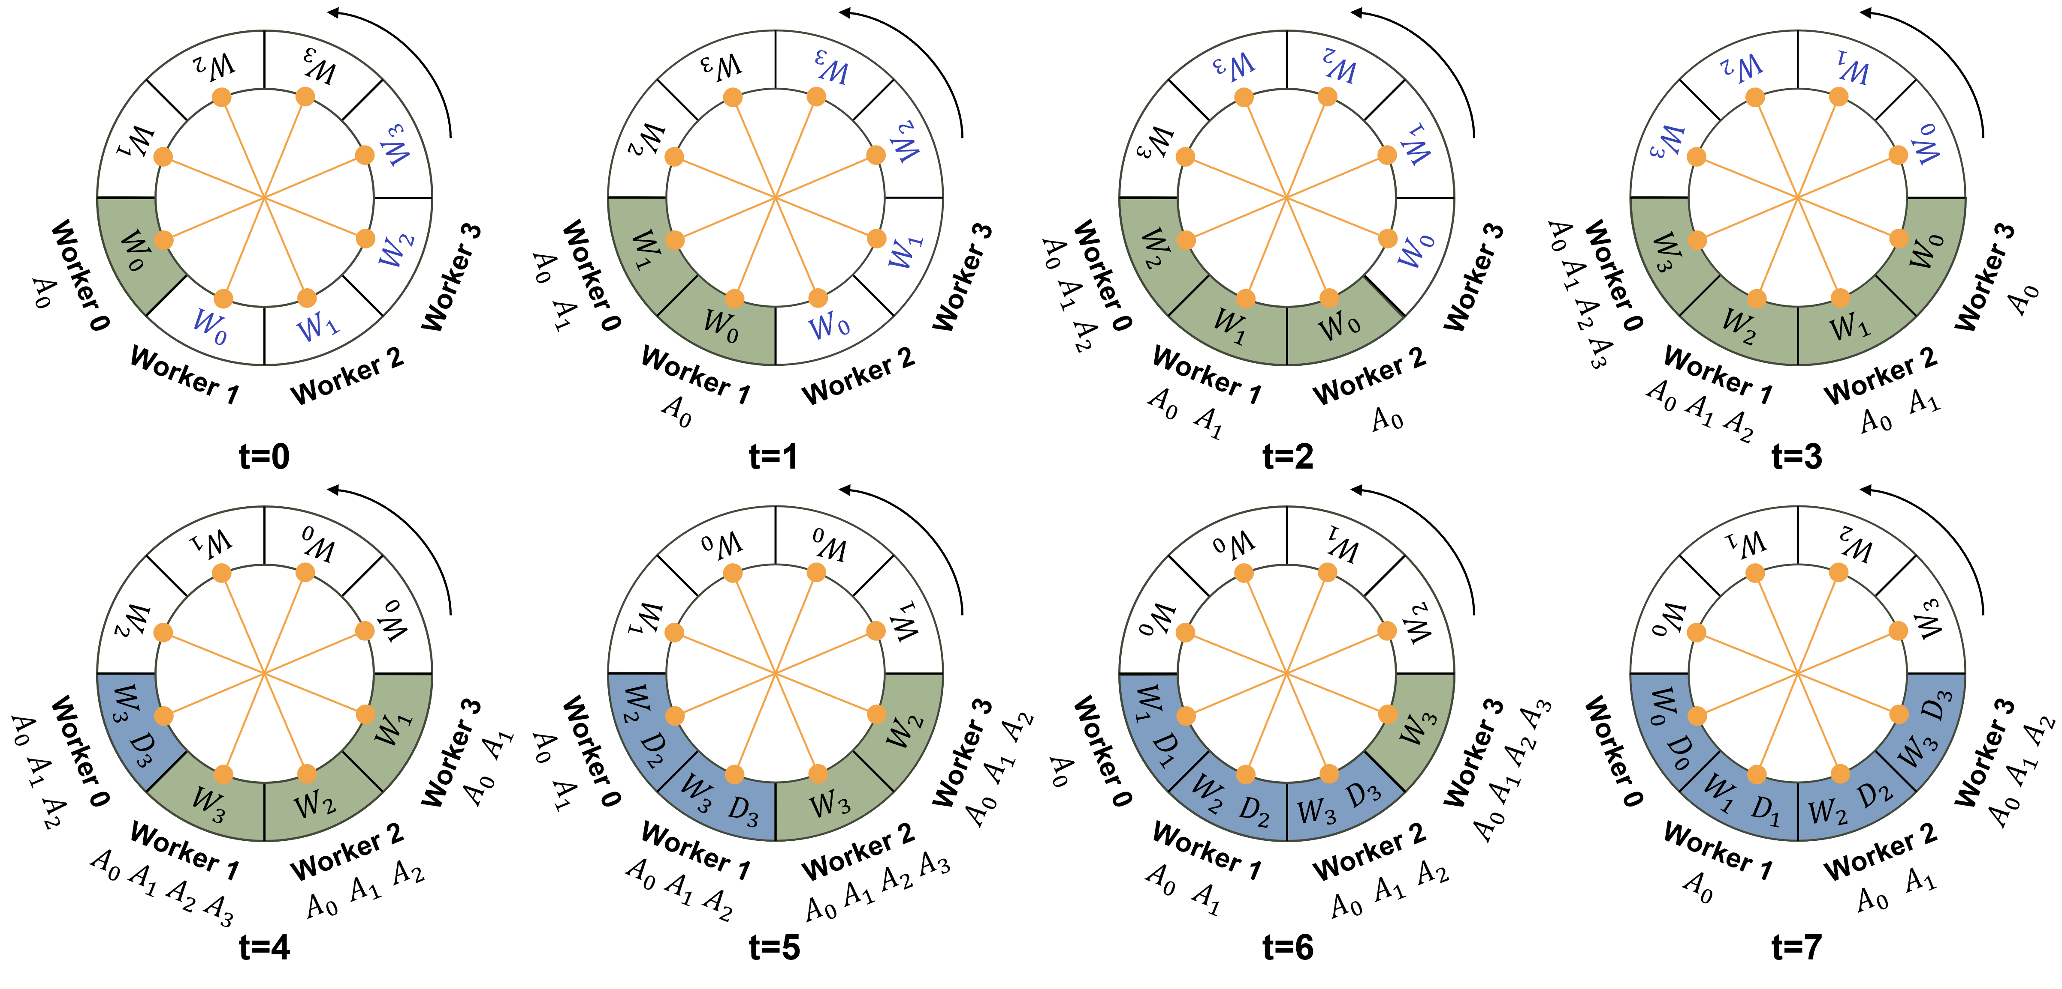

Large Models and Long Context Training
Recently, Transformer-based models have become foundational across multiple fields, such as Natural Language Processing (NLP) and Computer Vision (CV). As researchers strive for better performance, the scale of these models has increased significantly in two major dimensions. First, the size of the models has grown substantially. For example, the recently Llama-3.1 model boasts an impressive 405 billion parameters, necessitating at least 6480 GB of GPU memory to accommodate the model parameters. This disparity presents a significant challenge in distributing such large models across a vast number of GPUs, with up to 16,000 NVIDIA H100 required in the case of Llama-3.1 .
Second, the activation size during training has also increased due to longer sequence lengths. In NLP, long-context capabilities are crucial for tasks such as multi-round conversations, summarization, and processing large codebases. In CV, generating high-resolution, long-duration videos results in sequences that expand both temporally and spatially. Additionally, in scientific AI, models like AlphaFold must manage long sequences of amino acids. These long-context scenarios introduce new challenges in designing parallelism schemes that achieve efficient and balanced memory management.

Parallelism Technique for Training
To address the above challenges, various parallelization techniques have been developed. DP is the most straightforward approach, dividing the data among devices and using all-reduce operations at each iteration to synchronize gradients. Enhanced versions, such as FSDP and ZeRO-3 , further optimize by splitting model weights and optimizer states. TP divides tensors into chunks along specific dimensions, allowing each device to hold only a portion of the tensor without compromising the integrity of the computation graph. This technique requires frequent collective communication to synchronize the results. PP partitions the model at the layer level and splits the batch into micro-batches. Traditional PP assigns layers across multiple devices and uses P2P communication to pass activations between devices. Additionally, SP splits activations along the sequence dimension. Among these parallelization strategies, DP, particularly FSDP, is widely adopted due to its ease of use. Meanwhile, PP is favored for its reliance on P2P communication, making it a viable option for devices with less robust connections. To better understand WeiPipe, we will first explore these parallelization techniques in detail.

Pipeline Parallelism
In this paper, we primarily focus on synchronous pipelines, which maintain the convergence of the training. One of the most known PP techniques is Gpipe , which completes all forward propagation for all micro-batches before starting the backward propagation. Dapple , also known as 1F1B, enhances this approach by initiating backward propagation of a micro-batch immediately after its forward finishes, thereby reducing peak memory on certain devices. Chimera further optimizes by combining multiple pipelines in different directions to reduce the bubble ratio. Hanayo builds on this by utilizing a wave-shaped pipeline to decouple Chimera from model duplication, thereby improving efficiency. Zero-Bubble PP computes gradients for weights and activations separately, allowing for a more flexible pipeline arrangement. This method offers two schemes: one minimizes peak memory, and the other reduces the bubble ratio. Further discussion on these approaches can be found in Section 4. While current PP have largely focused on reducing the bubble ratio, they face significant challenges in long-context scenarios where overhead from activation and gradient communication can exceed the computational load of a single pipeline stage.

Fully Sharded Data Parallelism
FSDP has similar functions with Zero-3, sharding the data, model weights and optimizer states on different GPUs. In FSDP, weights and gradients are only gathered when necessary for computation and are promptly discarded after the computation is completed. This sharding and unsharding process is facilitated by all-gather and reduce-scatter operations. FSDP also incorporates asynchronous communication to enhance overlap. Despite its ease of use and memory efficiency, FSDP requires a substantial amount of collective communication during both forward and backward propagation, which could be challenging in scaled scenarios.
In a word, existing techniques are not well-equipped to reduce the communication overhead in long-context scenarios, particularly in clusters with less robust network connections.

WeiPipe Framework

WeiPipe-Naive
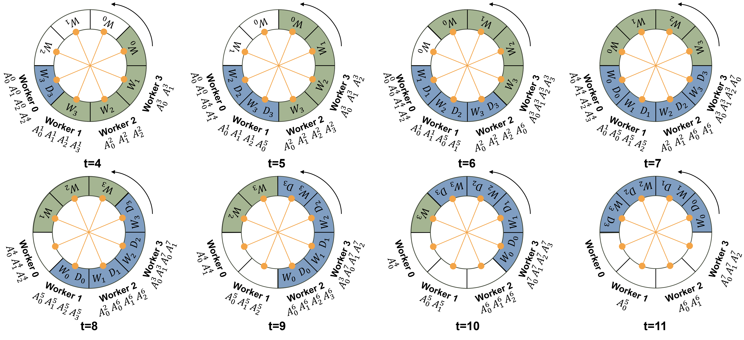
To introduce the basic idea of WeiPipe, we focus on the commonly used ring topology PP. The initial step is evenly distributing the layers of the model across all workers along the ring. Let’s assume the number of layers $L$ is equal to the number of workers $P$ and each worker holds one layer’s weight. The training procedure consists of three passes: the forward pass, the backward pass, and the update pass. During the forward pass, achieving a weight-passing pipeline is straightforward. Worker 0, holding the weights $W_{0}$ of the first layer, initiates the forward computation. Simultaneously, it passes $W_{0}$ to worker 1 and receives $W_{1}$ from worker $P−1$. Subsequently, worker 0 discards the $W_{0}$ but retains the activations of the first layer $A_{0}$ on its memory and begins forwarding the second layer using $W_{1}$. Meanwhile, worker 1 computes the first layer with a new micro-batch input. This process continues until worker 0 completes the all layers’ forward pass. Figure [fig:weipipe-naive] illustrates this procedure from $t=0$ to $t=3$ with $P=4$. In Figure [fig:weipipe-naive], we use a circular representation to illustrate data arrangement and transmission in WeiPipe, which is particularly helpful for understanding the following complex strategies. For $P=4$, the circle is divided into 8 positions, each filled with $W$s or $D$s. Each worker holds data at its current position and at the diagonal position (indicated by the orange line across the circle). Initially, worker 0 through worker 3 each hold $W_{0}$ to $W_{3}$ respectively (the black text in the circle). The circle rotates counterclockwise, with each turn denoted as $t+1$. After each rotation, workers update the data they hold, reflecting the transition of data between workers. From $t−0$ to $3$, each worker processes the forward pass for its corresponding layer (the green block in the circle), and accumulates activations from $A_{0}$ to $A_{3}$ in their own memory, as shown below each worker.
The backward pass becomes more complex because weights are required in reverse order. To maintain the weight-pipelining, we fill the opposite side of the circle with $W_{3}$ to $W_{0}$ (the blue text in Figure [fig:weipipe-naive] from $t=0$ to $3$). After Worker 0 completes the forward pass, the circle continues to rotate counterclockwise. Worker 0 then receives $W_{3}$ to $W_{0}$ one by one and executes the backward computation from layer 3 to layer 0 (blue blocks). In WeiPipe-Naive, workers with lower index finish earlier than those with higher index. So, a smaller-indexed worker starts to perform the backward pass, a larger-indexes worker might still be engaged in the forward pass. Thus, weights for both forward and backward need to be transferred simultaneously. To facilitate this, each worker holds weights for both forward and backward. Figure [fig:weipipe-naive] from $t=4$ to $8$ presents the backward pass of worker 0 and worker 0 can initiate another cycle for a new micro-batch after $t=8$.
During the update pass, each worker utilizes the weight gradients ($D$s) to update the weights. However, since weights cycle among workers and each worker just generates a piece of $D$s for their micro-batch, updating the weights of a layer requires gathering all corresponding $D$s. In DP, the all-reduce primitive is used to collect $D$s. WeiPipe aims to use only P2P communications, so $D$s also circulate through the ring after it is generated. Taking worker 0 in Figure [fig:weipipe-naive] as an example, at $t=4$, worker 0 performs the backward pass for layer 3 with $W_{3}$ and generates $D_{3}$. Then, $D_{3}$ travels together with $W_{3}$ around the circle. Each worker that processes layer 3 backward will average, sum, or normalize the newly generated $D_{3}$ with the existing $D_{3}$ and keep the communication volume unchanged. This circular process repeats until all micro-batches are processed, at which point each worker updates $W$s and $D$s it holds using the specified optimizer. Since each worker updates one layer of weights, it also stores the corresponding layer of optimization state, which does not need to be transmitted between workers.

WeiPipe-Interleave for Lower Bubble Ratio
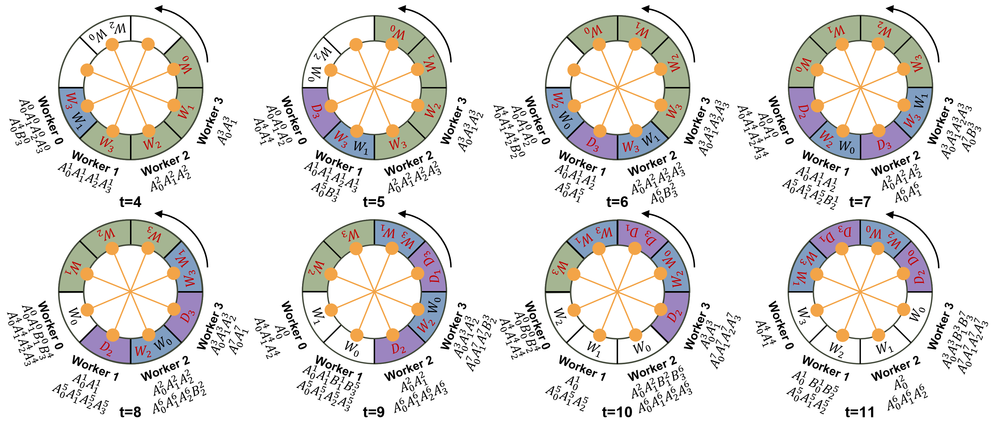
There are major flaws of WeiPipe-Naive. First, the memory utilization among workers fluctuates rather than being balanced. Second, there are two weight-flow circulating simultaneously, but only one is used for the current computation. The redundant transmission of weights inflates transmission costs. Most crucially, the computational time for the backward pass of a layer is approximately twice that of the forward pass. When one worker executes the backward pass, it significantly increases the pipeline bubble for other workers currently engaged in the forward pass. To address these issues, we interleave the forward and backward pass and get the WeiPipe-Interleave strategy.
The idea is to utilize the weights at the diagonal positions of the circle for another micro-batch forward or backward computation. The initial forward process is the same as WeiPipe-Naive. Figure [fig:weipipe-interleave] illustrates the interleaving forward and backward from $t=4$ to $11$. At $t=4$, worker 0 begins to perform the backward pass. In the meantime, it utilizes the $W_{0}$ to perform the forward pass of a new micro-batch’s input. Therefore, at this position, worker 0 will execute one backward and one forward before the circle makes another turn. During this time, other workers can only perform one forward operation and wait for worker 0’s computation to finish. In the subsequent turn, workers 0 to 3 also enter the forward-backward interleave stage when the computation workloads are balanced between workers.
There is no pipeline bubble during the forward-backward interleave stage no matter how different the workloads of backward and forward are. Each worker can also decide their own executing order for the forward and backward passes based on their data transmission situation. Moreover, idle memory during the forward and backward pass is utilized for storing activation values generated by new micro-batches, as shown in Figure [fig:weipipe-naive], which results in a balanced storage utilization across different workers and times. WeiPipe-Interleave further reduces communication overhead. For the LLama structure that has $12H^{2}$ parameters in one layer, during the forward-backward interleave stage, each worker receives two layers of weights and one layer of $D$ in each turn. The communication volume is $36H^{2}$, which doubles the compute/commute ratio compared to WeiPipe-Naive.

WeiPipe-Zero-Bubble
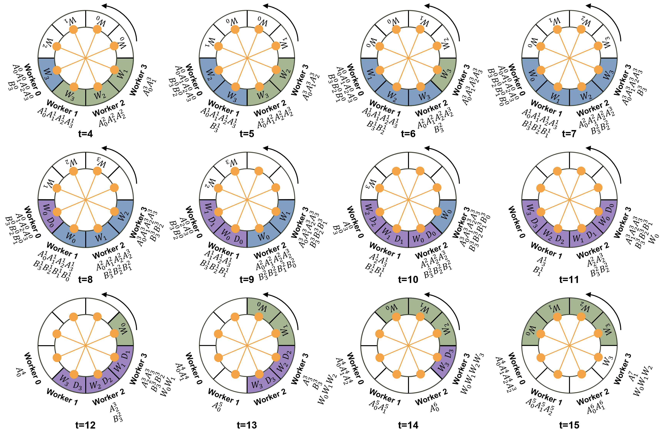
To further explore the potential of WeiPipe, we present a design that combines WeiPipe with the Zero-Bubble pipeline. Zero-Bubble strategies are state-of-the-art PP that split the backward computation into B pass and W pass to achieve almost zero-bubble. In Zero-Bubble, the B pass computes gradients for activations, and the W pass computes gradients for the weights. The B pass is performed in a backward manner while the W pass can be delayed to fill the blanks in the pipeline. Inspired by this, we introduce WeiPipe-Zero-Bubble 1 (WZB1), which slightly reduces the bubble ratio compared to WeiPipe-Interleave with relatively low storage and communication overhead, and WeiPipe-Zero-Bubble 2 (WZB2), which achieves a nearly zero bubble configuration.
Figure [fig:weipipe-zero-1] shows the procedure of WZB1 from $t=4$. Blue blocks represent B passes, while purple blocks denote W passes. At $t=4$, worker 0 conducts two tasks: forward of layer 0 on a new micro-batch (micro-batch 4) with $W_{0}$, generating $A_{0}^{4}$; the B pass of layer 3 with $W_{3}$ on the old micro-batch (micro-batch 0), producing the activation gradient $B_{3}^{0}$. Worker 0 still retains part of the $A_{3}^{0}$ after $t=4$ for the future W pass on $W_{3}$. Different from WeiPipe-Interleave, $W_{1}$ for the backward pass is placed together with the $W_{3}$ in the circle. The red text in Figure [fig:weipipe-zero-1] indicates the data used by the worker at current. At $t=5$, worker 0 performs the W pass, consuming $A_{3}^{0}$ and $B_{3}^{0}$ to generate $D_{3}$ on the circle, which will be sent to the worker 1. Simultaneously, worker 0 also conducts micro-batch 4’s forward with $W_{1}$. This process continues with alternating "one-forward-one-B" and "one-forward-one-W" until the forward pass of micro-batch 4 is completed. Then, at $t=8$, worker 0 performs two B passes–one for micro-batch 0 with $W_{1}$ and one for micro-batch 4 with $W_{3}$. From $t=8$ to $11$, worker 0 alternates between two B passes and two W passes until $t=12$ when all passes for micro-batch 0 are completed, and the forward pass for a new micro-batch (micro-batch 8) begins.
Figure [fig:weipipe-zero-1] illustrates the data arrangement on the ring. $W_{0}$ to $W_{3}$ for the forward pass are consistent with the previous strategy. Weights for the B pass and gradients generated by the W pass are both placed in pairs. Generally, for a network with $L$ layers, $W_{L−1}$ and $W_{\frac{L}{2}−1}$ are placed together, $W_{L−2}$ and $W_{\frac{L}{2}−2}$ are placed together, and so forth. The same pairing applies to $D$s. This arrangement ensures that each worker performs 2-chunk operations while transmitting 3 chunks of data to the next worker within one turn.
WZB2 offers a more simple procedure with the same $W$s and $D$s arrangement as WeiPipe-Interleave, as shown in Figure [fig:weipipe-zero-2]. In WZB2, the forward, B, & W passes for all layers are executed sequentially within a worker. Notably, the W pass progresses from layer 0 to layer 3, matching the forward’s order. During the B pass, old versions of weights can be discarded to reduce transmission, as indicated by the blanks from $t=8$ to $11$. The last worker, worker 3, aggregates all $D$s and updates the weights. In the case in Figure [fig:weipipe-zero-2], at $t=11$, worker 3 holds the aggregated $D_{0}$ updates $W_{0}$ with specified optimizer. Worker 3 then sends the updated $W_{0}$, which initiates a new forward pass at $t=12$. This seamless handover allows for frequent weight updates with fewer micro-batches and achieves almost zero bubble. WZB2 incurs higher communication and storage costs. It performs 1-chunk operation while transmitting 2 chunks of data to the next worker.

Theoretical Analysis
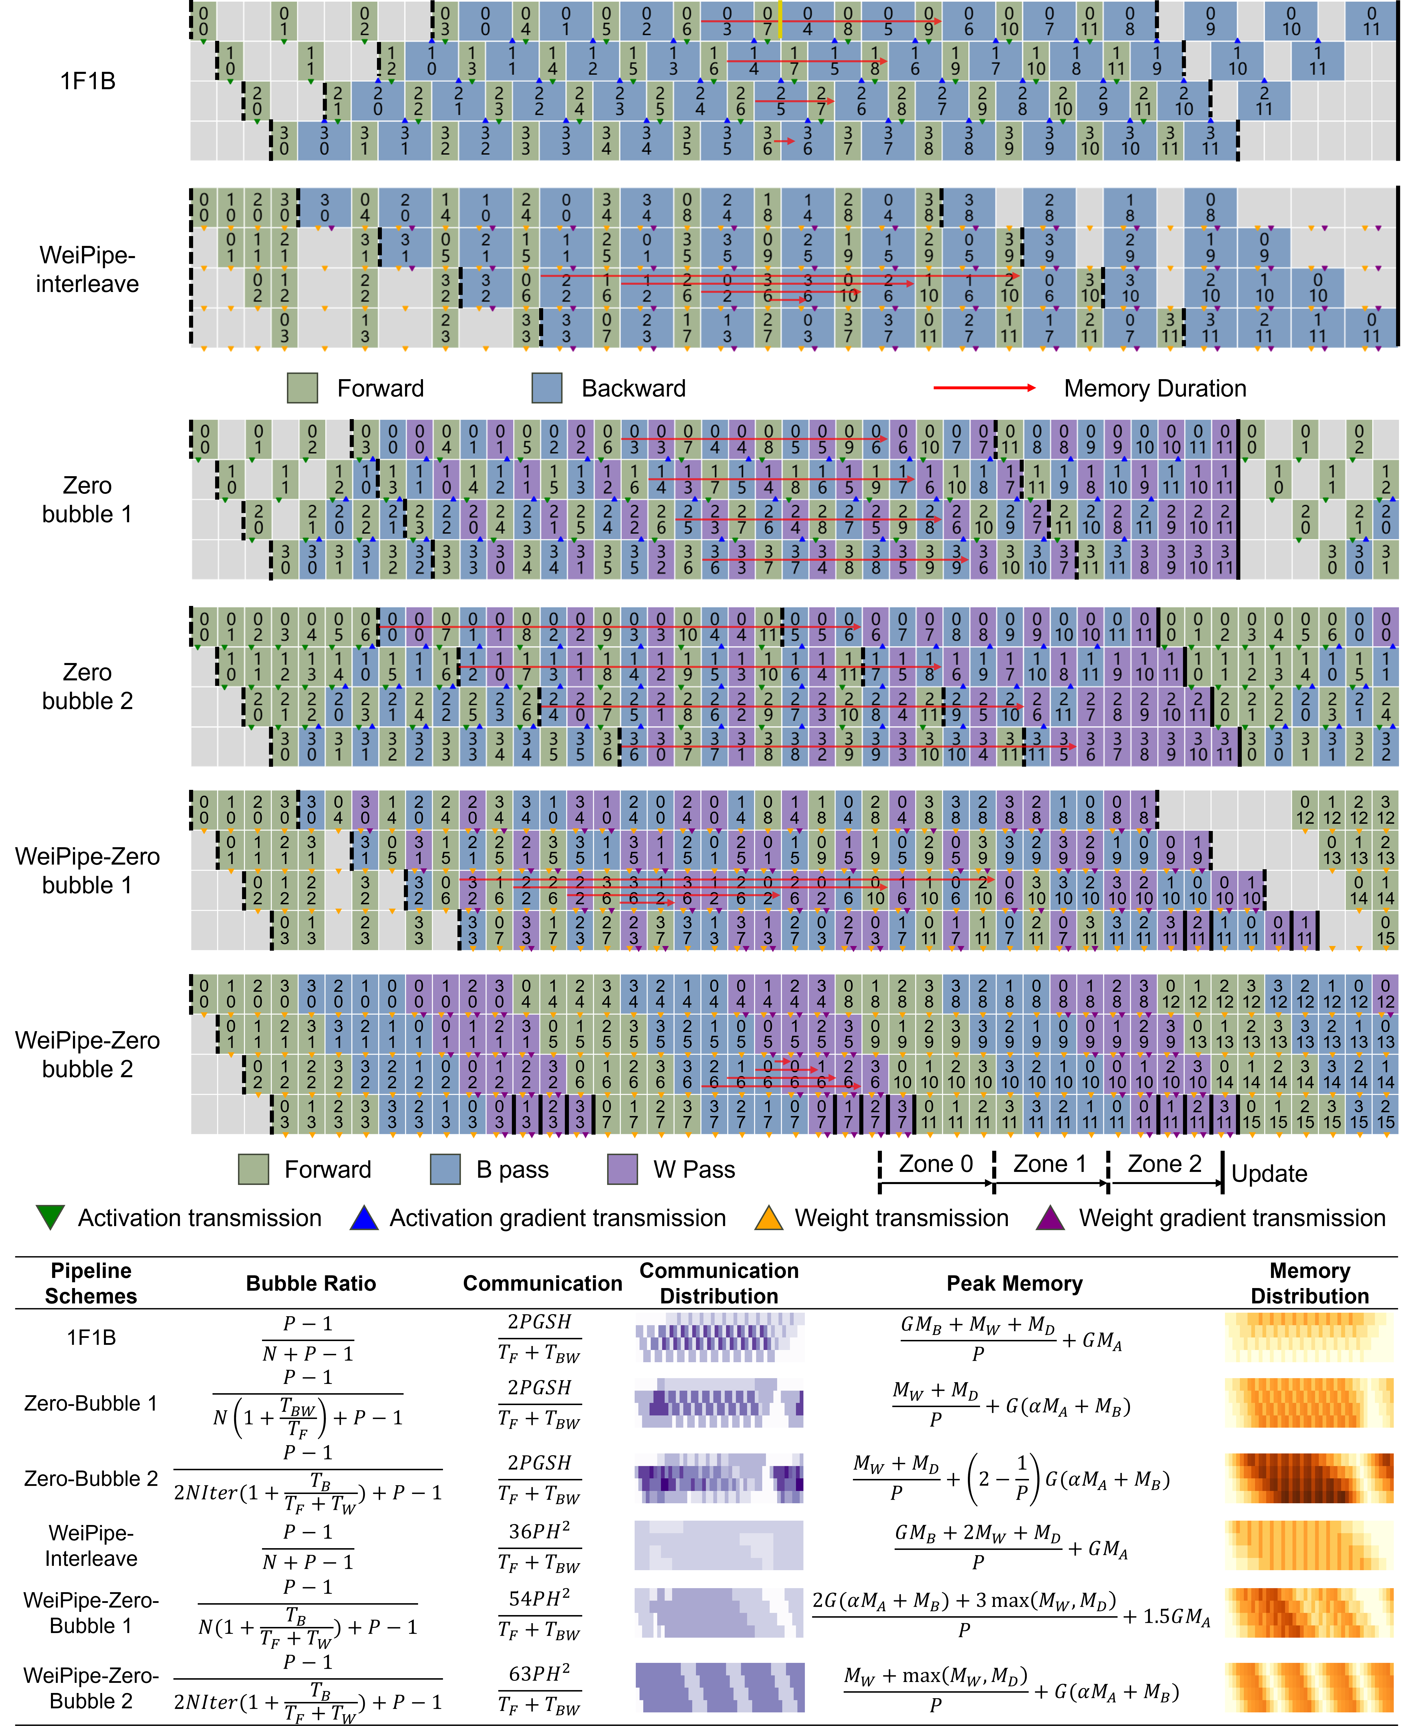
Figure [fig:weipipe-comparision] compares WeiPipe with other PP. WeiPipe-Interleave has the same bubble ratio as 1F1B. Both zero-bubble strategies reduce the bubble by multiplying a factor greater than 1 to $N$ in the bubble ratio equation. Zero-Bubble 2 and WZB2 have almost no bubbles along the iteration.
Communication efficiency is assessed by dividing the total number of received data by the computation time (Bandwidth usage). Different zones of a pipeline strategy have different communication densities. Figure [fig:weipipe-comparision] presents the equation of theoretical bandwidth usage of Zone 1, where passes are fully alternated (Zone 0 for WZB2). For activation-passing PP, the equation is derived from middle workers transmitting both $A$s and $B$s (So, there is a "2" in the equation). Communication for activation-passing strategies increases linearly with micro-batch size $G$ and sequence length $S$. In contrast, WeiPipe’s communication is dictated by the amount of weights, independent of $G$ and $S$. In this paper, LLama-style models are selected as standard models for analysis, where the number of weights per layer is $12H^{2}$. WeiPipe-Interleave requires transmitting two chunks of $W$ and one chunk of $D$, resulting in a communication volume of $36H^{2}$ at each turn with a time duration of $\frac{T_{F}+T_{W}}{P}$, where $T_{F}$ and $T_{F}$ is the time for a complete forward and backward respectively.
Memory consumption is significantly impacted by the specific implementations. Here, we provide a rough estimation of $M_{A}$, $M_{B}$, $M_{W}$, and $M_{D}$ based solely on the counts of these values, while ignoring factors such as communication buffers, embedding layers, and mixed-precision training. For 1F1B and WeiPipe-Interleave, the dominating part is the storage for activations, measured as $GM_{A}$. WeiPipe-Interleave has similar memory consumption with 1F1B but more balanced. In strategies that separate the B pass and W pass, one stage of the B pass ($\frac{1}{P}$ of a complete B pass) will consume part of the activations $M_{A}/P$ stored by the forward pass and generate gradients $M_{B}/P$. We assume that $αM_{A}/P$ activations storage is left after one stage of B pass. For Zero-Bubble, we assess the peak storage required by the last worker. Zero-Bubble 1 and WZB2 both need to store $G\left(αM_{A}+M_{B}\right)$ data. The Zero-Bubble 2 nearly doubles this requirement. However, WZB1 can achieve peak memory consumption of approximately $1.5GM_{A}$, which is less than other zero-bubbles strategies when $\frac{M_{B}}{M_{A}}>1.5−α$. It should be noted that calculating the peak memory for Zero-Bubble 1 could be tricky. With smaller $α$ and specific memory management strategies in GPU, worker 0 may have the largest memory consumption.

Implementation
Current distributed training frameworks offer various activation-passing pipeline strategies, but few accommodate high-level modifications to achieve weight pipelining. Thus, we have implemented WeiPipe-Interleave from scratch in PyTorch. The implementation is tailored for training LLMs, but our approach is not limited to Transformers. Due to the need for intricate and fined-grained control, we present WeiPipe-Zero-Bubble to demonstrate the potential of a weight-passing pipeline and to facilitate a deeper discussion, while leaving the implementation for future exploration. The following details are considered for implementation:
Mixed Precision. Unlike other pipeline research that primarily focuses on full precision implementation, our implementable incorporates widely adopted mixed precision training to further reduce storage and communication. Specifically, $A$, $W$, and $D$ are in fp16 precision, while $B$ is in bf16. The optimizer state is in fp32, distributed among workers.
Communication overlap. WeiPipe meticulously adjusts the arrangement of computation and weight-passing to balance the communication and computation workload. To ensure WeiPipe’s high-performance potential, communication hiding optimizations are implemented. During forward-backward interleaving, $W$s and $D$s are prefetched using asynchronous communication, which is realized by the function batch_isend_irecv provided by PyTorch NCCL backend.
Recomputation and Flash Attention. Recomputation (gradient checkpointing/rematerialization) is a strategy that saves storage by abandoning part of activation values during the forward pass. Instead, these values are recomputed during the backward pass, thus significantly reducing memory consumption with redundant computation. Similarly, Flash Attention is a widely used technique to optimize memory access and save memory in attention modules. By employing these techniques, we can increase micro-batch size and enhance the strengths of WeiPipe. We also implement these optimizations across other strategies for a fair comparison.
Model Config |  |  | Throughput(Tokens/second/GPU) |  |  |  |  | Memory(GB)
H | S | G | 1F1B | ZB1 | ZB2 | FSDP | Our | 1F1B | ZB1 | ZB2 | FSDP | Our
1024 | 4096 | 16 | 536.4 | 471.7 | 477.4 | 720.4 | 946.2 | 13.0 | 20.4 | 39.3 | 8.6 | 9.4
 | 8192 | 8 | 462.7 | 421.2 | 423.0 | 589.0 | 757.6 | 9.9 | 10.7 | 20.5 | 8.6 | 9.4
 | 16384 | 4 | 352.6 | 353.2 | 353.2 | 435.8 | 511.8 | 9.1 | 21.6 | 42.2 | 8.6 | 9.4
2048 | 4096 | 16 | 260.2 | 239.0 | OOM | 256.5 | 406.2 | 18.7 | 44.3 | OOM | 17.9 | 19.9
 | 8192 | 8 | 237.0 | 219.9 | OOM | 231.7 | 377.1 | 19.6 | 22.3 | OOM | 17.9 | 19.9
 | 16384 | 4 | 196.6 | 190.6 | OOM | 192.9 | 288.0 | 22.9 | 42.9 | OOM | 17.9 | 19.9
4096 | 4096 | 16 | 103.9 | OOM | OOM | 69.4 | 126.4 | 40.5 | OOM | OOM | 39 | 44.5
 | 8192 | 8 | 97.3 | OOM | OOM | 66.4 | 128.7 | 41.6 | OOM | OOM | 39 | 44.5
 | 16384 | 4 | 83.2 | OOM | OOM | 59.0 | 105.3 | 45.1 | OOM | OOM | 39 | 44.5

Evaluation
Throughput and peak memory of training the LLama-style model on 16 GPUs with PCIe and Ethernet connections. Due to the limitation of memory, for ZB strategies, G is set to 4 if S=4096 and G=1 if S=8192 or 16384.
Model Config |  |  | Throughput(Tokens/second/GPU)
H | S | G | 1F1B | ZB1 | ZB2 | FSDP | WeiPipe
1024 | 4k | 16 | 512.0 | 481.8 | 497.0 | 721.5 | 865.5
 | 16k | 4 | 337.1 | 286.4 | 289.4 | 422.7 | 471.9
2048 | 4k | 16 | 251.9 | 231.3 | OOM | 262.8 | 349.2
 | 16k | 4 | 181.7 | 164.9 | OOM | 196.9 | 259.4
4096 | 4k | 16 | 95.6 | OOM | OOM | 74.1 | 87.6
 | 16k | 4 | 77.0 | OOM | OOM | 60.4 | 94.1

Experimental Setup
We evaluate our implementation on models based on the open-source LLama-2 structure (also GPT-style models). In our experiments, we fix the head number as 32 and layer number $L$ as 32. We change the hidden dimension size $H$, token length $S$, micro-batch size $G$, and the number of micro-batches $N$ in an iteration to get models with various scales. We compared the WeiPipe-Interleave against widely-used 1F1B, state-of-the-art Zero-Bubble 1 & 2, and FSDP under different communication infrastructures in terms of throughput, memory consumption, and scalability. The 1F1B and Zero-Bubble strategies are implemented through Megatron-LM, while FSDP is achieved by the ZeRO-3 optimization in DeepSpeed. All strategies are applied with the same model configuration, micro-batch size, mixed-precision settings, recomputation, flash-attention, and hardware environment.
We choose Colossal Cloud with A800 GPUs as the experimental hardware environment. The A800 has 80GB HBM and 312 TFlops fp16/bf16 tensor cores. However, compared to the A100 GPUs, the A800 limits NVLink bandwidth from approximately 600GB/s to about 400GB/s. To evaluate the communication effectiveness of WeiPipe, we conducted experiments using two different communication infrastructures. The first setup involves 16 A800 GPUs across two clusters with NVLink connections. The second setup features 32 A800 GPUs across 4 clusters but with PCIe connections within each cluster. Clusters are connected by Ethernet with 10GB/s bandwidth. We utilized the NCCL as the underlying communication library. The NCCL chooses ring all-reduce in FSDP within a cluster by default and we avoid tree algorithms among clusters. Therefore, overall, we keep a ring topology for all of the parallel strategies in experiments.

Throughput and Memory Consumption
For NVLink environment, the performance and peak memory consumption of WeiPipe and other strategies are shown in Table [tab:perform_nvlink]. In this experiment, the hidden dimension size ranges from 4096 to 16384 combined with sequence length of 4096, 8192 and 16384 to get 9 different models, covering scenarios with long context. The model size is ranging from 384M to 6.1B with unifies the batch size as 64. Among all configurations, WeiPipe demonstrates higher performance compared to other strategies. Specifically, when $H=4096$ and $S=16384$, WeiPipe achieves 22.3% and 78.4% improvement of throughput compared to the 1F1B and FSDP respectively.
Throughput of training the LLama-style model on 8 GPUs with NVLink connections with layer number as 16. For ZB strategies, G is set to 4 if S=4096 and G=1 if S=8192 or 16384.
Model Config |  |  | Throughput(Tokens/second/GPU)
H | S | G | 1F1B | ZB1 | ZB2 | FSDP | WeiPipe
1k | 4k | 16 | 4003 | 5726 | 5808 | 4734 | 3908
 | 16k | 4 | 1981 | 2753 | 2758 | 2225 | 2117
2k | 4k | 16 | 1881 | 2806 | OOM | 2126 | 1770
 | 16k | 4 | 1169 | 1604 | OOM | 1268 | 1214
4k | 4k | 16 | 652 | OOM | OOM | 744 | 618
 | 16k | 4 | 465 | OOM | OOM | 475 | 450

Table [tab:perform_nvlink] also presents the peak memory usage of each strategy. 1F1B has the smallest memory usage among all pipeline strategies. Recomputation and Flash Attention notably reduce memory usage for 1F1B and the earlier workers in the Zero-Bubble strategy. However, the memory consumption of the Zero-Bubble method is significantly higher than that of the 1F1B method and is easily fell into out-of-memory (OOM) under long context scenarios, which is partially contradicts the conclusions reported in and our theoretical analysis—that ZB1’s memory consumption is not higher than 1F1B, and ZB2’s memory consumption is twice that of 1F1B. This discrepancy arises because the original method did not employ the FlashAttention or recomputation methods; activations in the forward pass were mainly generated by Attention computations. During the B Pass stage, this portion of memory was released while gradients of the remaining activations were generated. Compared to the size of the eliminated activations, this memory overhead is minimal, so the overall peak memory still occurs before the first backward pass of the first Rank begins. However, after enabling FlashAttention, the activations generated by the Attention process are greatly reduced. At this point, the forward activations are mainly produced by the computations of the FFN, and the size of the gradients produced during the B Pass is approximately equal to the size of the activations generated in one forward pass. Consequently, the peak memory appears before the first W Pass of the last Rank and is about twice the peak of the first Rank. Therefore, although ZeroBubble pipeline parallelism can theoretically significantly reduce the computation bubble rate, the high memory consumption necessitates the use of smaller batch sizes, which to some extent compromises computational efficiency.
Conventional activation-passing PP typically use small micro-batch sizes due to the potentially large size of $GM_{A}$. However, with the adoption of Flash Attention and recomputation, memory consumption can be significantly reduced, allowing for larger micro-batch sizes and highlighting the advantages of WeiPipe. The memory usage for WeiPipe is slightly higher than FSDP due to the additional buffer requirements for communication. In WeiPipe-Interleave, each worker allocates three buffers for receiving $W$s and $D$s and three buffers for sending. In contrast, FSDP’s Megatron implementation creates buffers on an operator-wise granularity, which may result in smaller and more fragmented buffers.
Table 5 presents the throughput in PCIe and Ethernet environment with 16 A800 GPUs from 2 clusters. Compared to NVLink, this environment further increases the communication pressure of large-context training. From the Table 5, we can see that WeiPipe-Interleave achieves 31.7% and 22.2% improvement of throughput compared to best performance of other strategies when $S=16384$ and $H=2048,4096$.
The two experiments above are both under communication-bottleneck conditions, where the low bandwidth of Ethernet make a significantly impact. The results shoes WeiPipe allows LLM training to be less dependent on high-bandwidth techniques. Similar to DP, WeiPipe is well-suited for optimizations that overlap communication and computation. In our experiments, we implement layer-wise latency hiding in WeiPipe. However, in activation-passing methods, the previous layer must complete its computations before passing activations during the forward pass, and similarly during the backward pass. Communication hiding is constrained by data dependencies, while WeiPipe can transmit weights concurrently with computations. As a result, even in scenarios without long contexts, WeiPipe can still outperform current PP methods. We also conducted an experiment using eight A800 GPUs connected solely via NVLink, where communication constraints are less significant. The results in Table 6 indicate that in this environment, conventional methods may have advantages.

Weak Scaling
Weak scaling assesses how well a strategy preserves efficiency as both the number of workers and the size of tasks grow. We examine WeiPipe’s ability of weak scaling by keeping the workload per worker constant while progressively increasing the number of workers from 8 to 32, and batch size from 128 to 512. The scalability experiments are performed on the 32 A800 GPUs from 4 clusters with PCIe connections within each cluster. We fixed the sequence length as 16384 and the layer number as 32. The results are shown in Figure 1 which reveals the overall throughput of WeiPipe scales proportionally with the increase of GPUs.
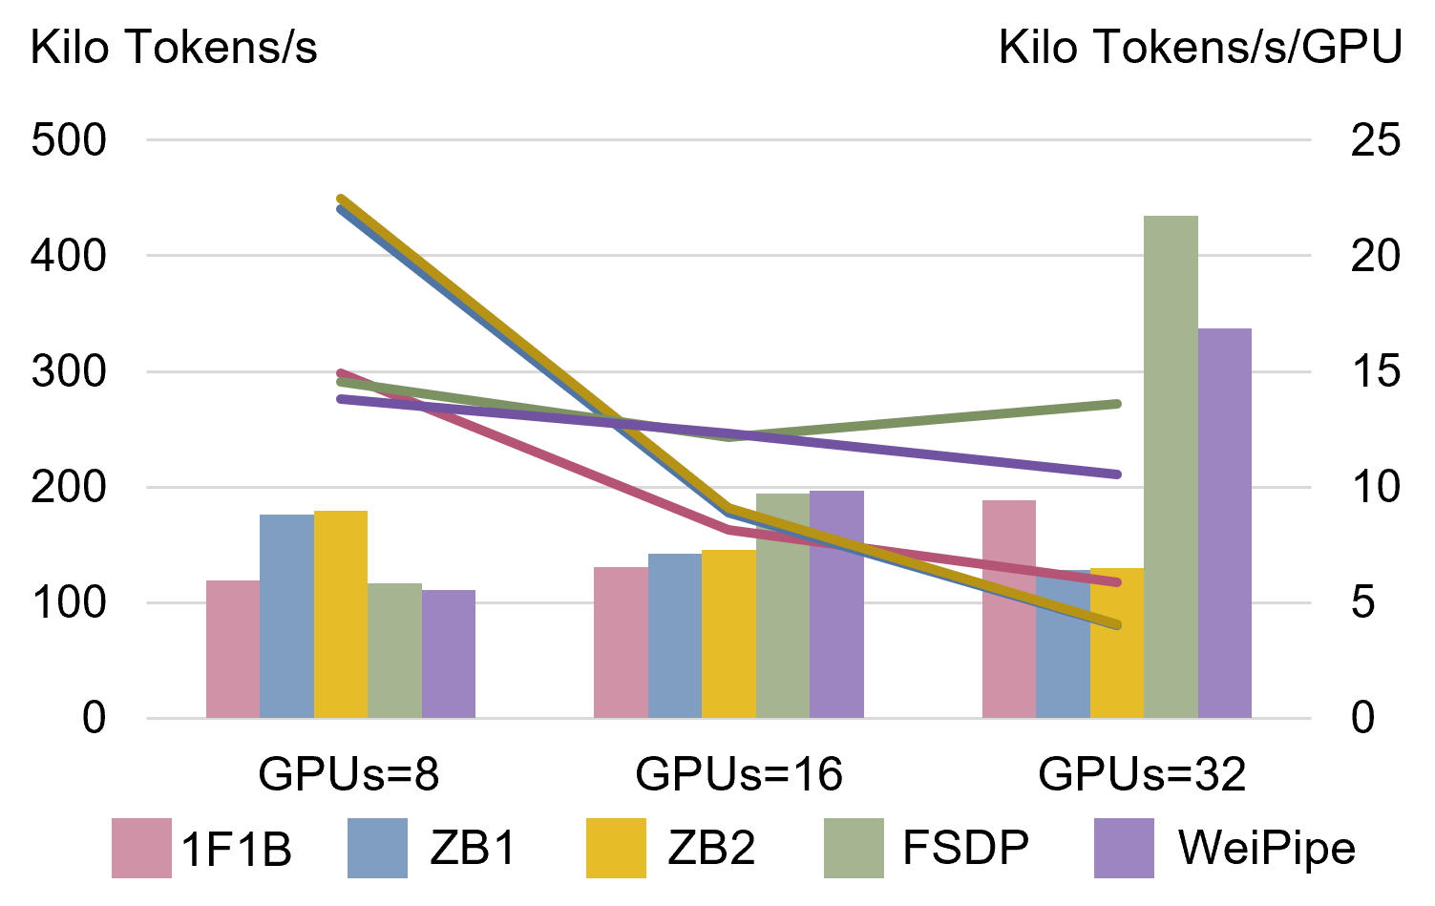
Weak scaling of different strategies. The number of GPUs scales from 8 to 32, and the batch size increases proportionally. The left coordinates correspond to the overall throughput as represented by the bar chart, while the coordinates on the right indicate tokens per second per GPU.
It can be seen a lower performance with PCIe connections of WeiPipe-Interleave, especially compared to FSDP. Though profiling, we found the primary inefficiency in WeiPipe-Interleave occurs during the tail of the last backward pass. Worker 0 has to wait for other workers to complete the pipeline while still transferring large blocks of data. In contrast, FSDP divides communication into many fine-grained blocks, and high-bandwidth NVLink does not effectively reduce the frequency of interruptions. This result also suggests that further optimization of NCCL in WeiPipe is necessary to achieve ideal performance.

Strong Scaling
Different from weak scaling, strong scaling measures scalability by keeping the task size constant while expanding the number of workers. In our experiments, the model configuration is the same as the experiments of weak scalability, also increasing the number of GPUs from 8 to 32 but fix the batch size to 128. The result can be found in Figure 2 and it shows that WeiPipe-Interleave exhibits superior scalability compared to other strategies. This result reveals the WeiPipe-Interleave has the potential to utilize more GPUs to achieve greater speed-up. The large token length and low-bandwidth communication infrastructure cause serious troubles for conventional PP approaches with increasing communication pressure.
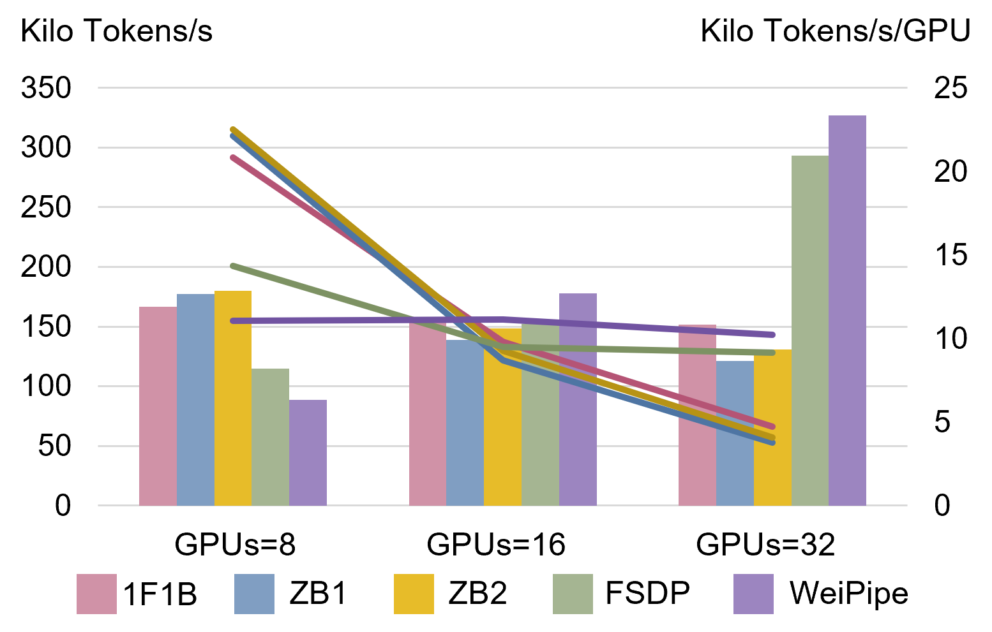
Strong scaling of different strategies. The number of GPUs scales from 8 to 32, but the batch size remains 128.

Conclusions
In this work, we introduce a novel strategy for pipeline parallelism aimed at reducing communication overhead in LLM training by shifting from activation-based to weight-based communication. We have developed and implemented the WeiPipe-Interleave to minimize the weight-passing overhead, reducing the bubble ratio and balancing memory usage. To further explore the potential of weight-passing pipelines, we discussed the WeiPipe-Zero-Bubble methods to achieve nearly no-vacancy pipelining. Our experiments demonstrate that WeiPipe-Interleave can outperforms current PP approaches and FSDP. WeiPipe extends the prospect of training large-context models with PP and reduces reliance on expensive high-bandwidth communication infrastructure.

