**COLLEGE OF TECHNOLOGY AND ENGINEERING**

**Information Technology Department**

|  |  |
| --- | --- |
| **Approval Sheet** | |
| **Title of Project:**   Student Discipline System | **Date Submitted:**  June 3, 2025 |
| **Name of Proponents** :     Janlie Pantinople – Backend Programmer  John Ghendel De Los Santos – Frontend Developer  Jayzon L. Caol-olan – Technical Writer  Cecelio Gelig Rozada – QA Engineer  Rodney Ray Villarta – Content Provider | |
| **Brief Description of the Project:**  The Student Discipline System is a comprehensive platform designed to manage and address student violations within the academic community. It provides a structured framework for documenting and addressing disciplinary issues, promoting accountability, and fostering a positive learning environment. The system enables administrators to record and track case profiles of students involved in disciplinary incidents, manage community service assignments as consequences, and generate reports for administrative and user use.  ***Purpose***  The main purpose of this project is to make Documentation and tracking of Disciplinary records a lot easier by having a user friendly system store all the records that can be easily accessed anytime.  ***Objectives***  The main objectives of the project are the following:  1. Documentation and Tracking: Develop a user-friendly interface for administrators to efficiently document and track case profiles of students involved in disciplinary incidents, including relevant details such as name, date, section, grade, violation, description, and reporter information.  2. Community Service Management: Implement a system for assigning, tracking, and managing community service hours as consequences for disciplinary infractions, ensuring that students fulfill their obligations in a timely and accountable manner.  3. Promotion of Accountability: Encourage personal responsibility and accountability among students by providing transparent documentation of violations and consequences, fostering a sense of ownership over their actions and behaviors.  4. Behavioral Intervention: Utilize disciplinary incidents as opportunities for behavioral intervention and character development, promoting positive behavior and preventing future misconduct through constructive consequences and guidance.  5. Safety and Respect: Maintain a safe and respectful learning environment within the academic community by addressing disciplinary issues promptly and fairly, thereby ensuring the well-being and security of all members.  6. Transparency and Reporting: Develop robust reporting features to provide administrators and users with access to comprehensive data and insights, enabling them to track disciplinary trends, measure outcomes, and make informed decisions for continuous improvement.  7. Community Engagement: Engage students in meaningful community service assignments as a proactive approach to addressing disciplinary infractions, fostering a sense of social responsibility and encouraging positive contributions to the broader community. | |
|  | |

**APPLICATION MANUAL**

1. **Decomposition Description**

During the subsystem decomposition of Student Disciplinary System, we divide the system into smaller subsystems with strong coherence. The different subsystems should have a loose coupling.

The decomposition shows the existence of the following subsystems:

* Case Profile subsystem
* Community Service tracker subsystem
* Admin Panel management subsystem
* Student Panel management subsystem
* Transaction Report subsystem
* Good Moral Issuance subsystem

1. ***Module Decomposition***

Student Disciplinary System has 6 different components each has different responsibilities inside the system.

**Case Profile subsystem**

This subsystem responsible for enlisting all the students past disciplinary records.

**Operations provided by this subsystem are:**

* caseProfile ()

**Community Service Tracker subsystem**

This subsystem responsible for enlisting all the Community Service sanctioned to a student.

**The operations provided by this subsystem are:**

* saveRecord ()

**Admin Panel management subsystem**

This subsystem is used by Admins only. They can add records on Community Services and Student Violation Report

**The operations provided by this subsystem are:**

* saveCaseProfile ()
* CaseList ()
* TransactionReport()

**Student Panel management subsystem**

This subsystem is used by Student only. They can only view records and request for good moral certificate.

**The operations provided by this subsystem are:**

* Login()
* View Profile()
* Request Goodmoral ()
* Community Service Tracker()

The **database subsystem** will be implemented by relational database management system used to store the persistent data.

The **storage subsystem** will encapsulate the database providing a common interface to other three high level subsystems. It is responsible for getting system-related data from different subsystems and issuing DBMS-specific calls for information storage and retrieval.

**Transaction Report subsystem**

This subsystem is responsible for displaying all of the past transactions made through the system.

**The operations provided by this subsystem are:**

* goToDashboard()

**Good Moral Issuance subsystem**

This subsystem is responsible for accepting requests for good moral from the students.

**The operations provided by this subsystem are:-**

* requestGoodMoral()
* caseProfile()

1. ***Data Decomposition***
2. ***Student Entity***

This is an entity representing the students. It holds all the required properties for the students such as studentID, firstname, lastname, etc. A detailed description will be given in section 6.

1. ***Case Profile Entity***

This is an entity representing the Case Profile of the students. It holds all the required attributes of a Case Profile including ID, student, hours rendered.

1. ***Community Service Entity***

This is an entity representing the hours rendered by students who has case profile. It will calculate the hours needed through inputting the hours rendered by the student.

1. ***Good Moral Entity***

This is an entity represents the request for good moral and whether the admin would approve or disapprove the request

1. **Dependency Description**

***1. Data Dependencies***

The dependencies between the data will be fully presented in E/R diagram that can be seen in **Figure 1**.

*Figure 1 Entity - Relationship Diagram*

1. **Interface Description**

In this section, each user interface is explained along with some screenshots.  Note: Describe the step – by – step process for each task here.

***6.1.1 Home***

Upon opening our system this screen will appear, this screen lets you to input and search a student’s ID on the upper left corner of the screen. General view of this screen can be seen in **Figure** **2**.

*Figure 2 Home*

***6.1.2 Student Violation Report***

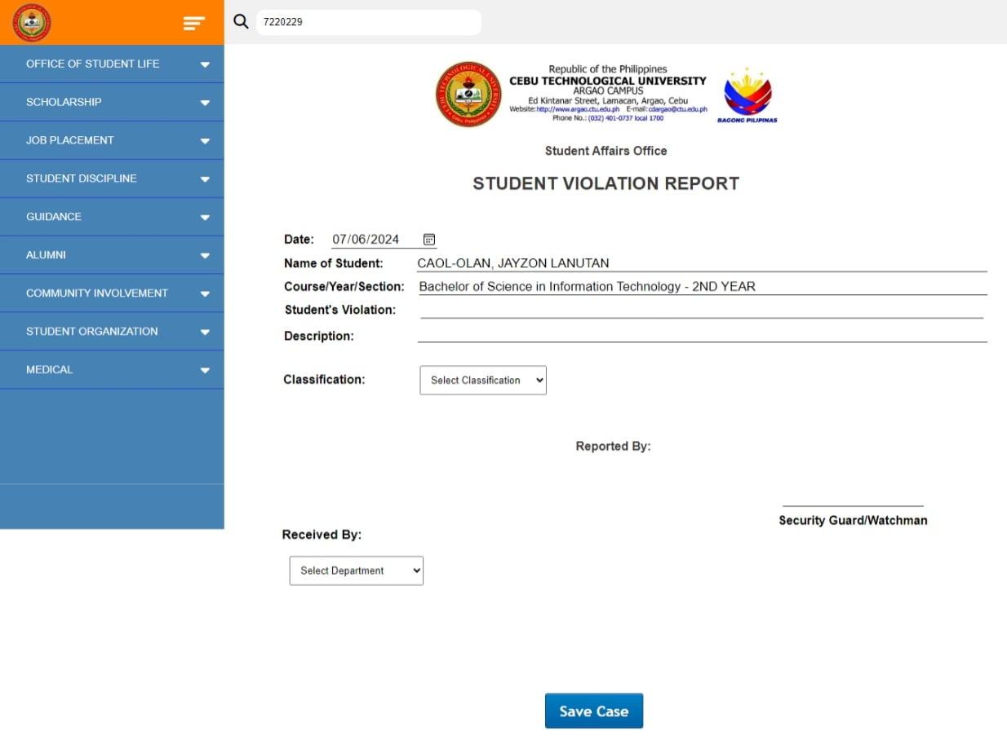After searching a Student’s ID this screen will appear, this screen will let you input his/her violation and save it. General view of this screen can be seen in **Figure** **3**

*Figure 3 Student Violation Report*

***6.1.3 Student Case List***

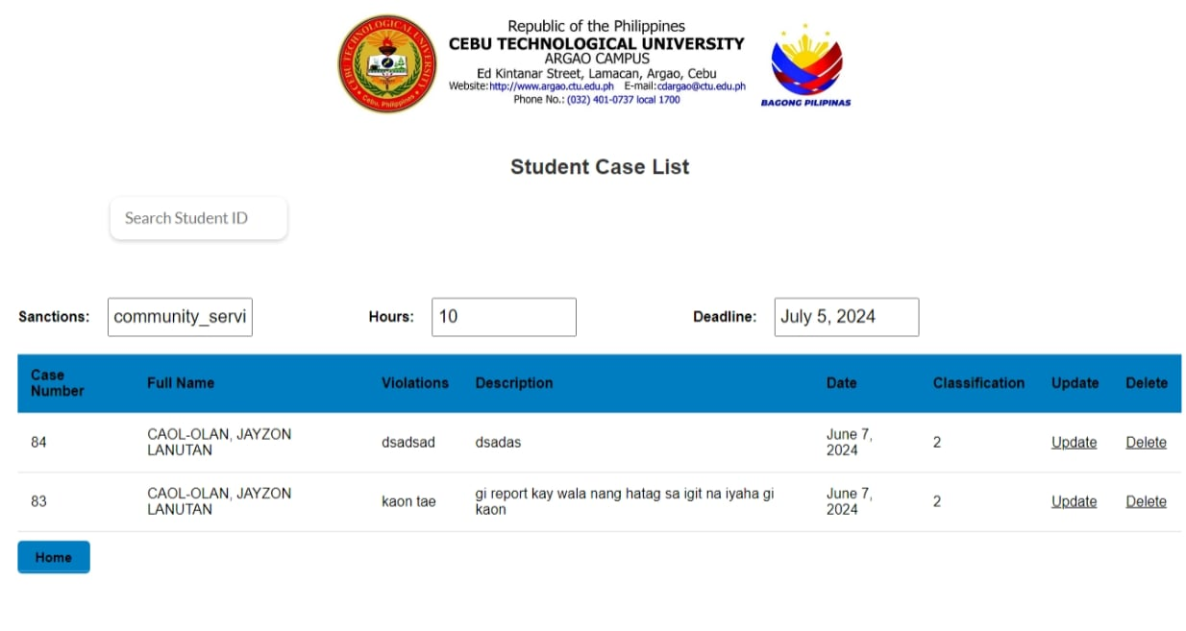This screen displays the List of Student Cases it also lets you delete or update your chosen Student Case; this screen can be accessed through the side bar. General view of this screen can be seen in **Figure** **4.**

*Figure 4 Student Case List*

***6.1.4 Update Student Violation Report***

By clicking “Update” in **Figure 4** this screen will appear which lets you update the chose Student Case easily. General view of this screen can be seen in **Figure** **5.**

*Figure 5 Update Student Violation Report*

***6.1.5 Admin - Community Service Tracker 2***

This screen can be accessed through the side bar under “Student Discipline” This screen show the past transaction records. General view of this screen can be seen in **Figure** **6.**

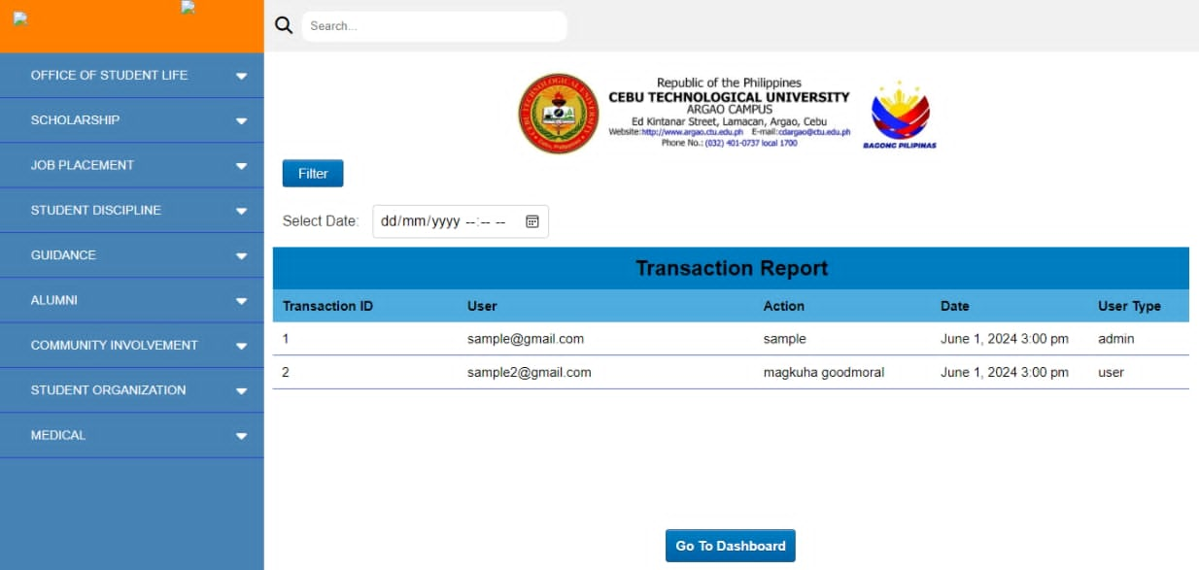

*Figure 6 Transaction Report*