REPUBLIC OF THE PHILIPPINES

### CEBU TECHNOLOGICAL UNIVERSITY

ARGAO CAMPUS

Ed Kintanar St. Lamacan, Argao, Cebu, Philippines Website: [http://www.argao.ctu.edu.ph](http://www.argao.ctu.edu.ph/) [Email:cdargao@ctu.edu.ph](mailto:cdargao@ctu.edu.ph)

Phone No.: (032) 485-8290/485- 5109 loc 1700 Fax No. (032)-4858-290

O F F I C E O F T H E S T U D E N T L I F E

*present this*

BEST CAPSTONE

RESEARCH

*to*

# CLEMENT ALCANTARA

in recognition of their remarkable research capstone project “Capstone Title Here”, which exhibited exceptional functionality and excellence in enhancing industrial operations for a company.

Given this June 13, 2024, during the Ring Hop Ceremony and tribute to Parents held at CTU-AC Kalampusan Gym.

**MELANIE R. ALBARRACIN**

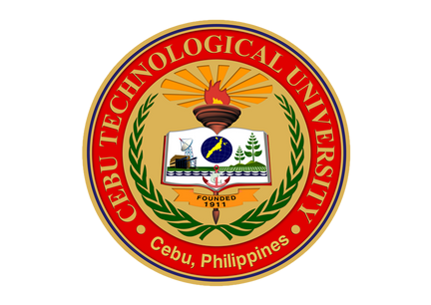

Dean, Student Life

**EINGILBERT C. BENOLIRAO**

Campus Director