FundLINUX: Free and Open-source OS

OS: Operating system -- > communication blw user & system.

TYPES OF OS:

1. WINDOWS

2. LINUX

3. MAC OS

LINUX COMPONENTS:

1. KERNEL: Manages hardware components (CPU, MEMORY, etc --)

The lowest level of OS.

2. DAEMON: Manage the Background Service (Lights, Sounds, schedule)

While starting the system.

3. SHELL: Manage the User Inputs (Command, Script, programs)

Takes input from the user and executes and gives the output.

LINUX OS FLAVOURS/DISTRIBUTIONS:

IPHONE: 14, 14+, 14 PRO, 14 PRO MAX,

VERSIONS: 14, 13, 12, 11

MAIN:a

RedHat

Ubuntu (75%)

Amazon Linux

MODES:

1. GUI: Its having the Dashboard

2. CLI: Command line interface (Works with commands only)

HISTORY:

1991 -- > Linus Torvalds -- > student from finland.

1991 -- > Want to create an OS that works like UNIX.

LINUX is Written in C Programming. (1972)

Firstly he wanted to name it as 'Freax' but later it became 'Linux'.

1992 -- > Linxu's initial version was released.

TOTAL PROGRAMMING LANGUAGES: 700 +

OPEN SOURCE:

It is free no need to pay money.

It is available publically.

We can change the code.

we can give a copy of the code to other people.

ADVANTAGES:

It's free and open-source.

Multi-user based.

Fewer Bugs.

Better Performance.

It can be used for all programming languages.

It will hang very rarely.

===========================================================================

DAY-02: SERVER & COMMANDS

MOBAXTERM LINK: https://download.mobatek.net/2312023031823706/MobaXterm_Portable_v23.1.zip

NOTE: Go to the path where you have keypair

CONNECT: SELECT THE SERVER -- > CONNECT -- > SSH CLINET -- > COPY TO TERMINAL

PASTE: 1. RIGHT CLICK 2. SHIFT + INSERT

COMMANDS:

ec2-user: default user root: admin

* : refers all in linux

**sudo -I / sudo su / sudo su** - : switch to root user form ec2-user

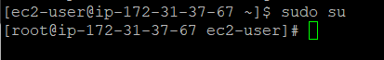

**clear/ctrl + l** : to clear the screen

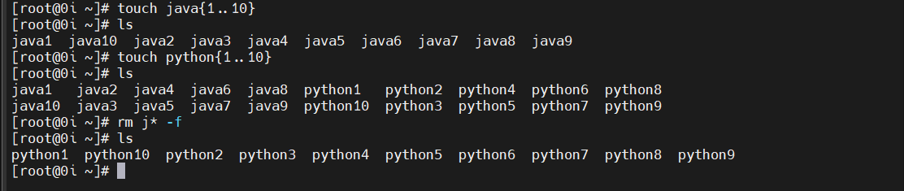

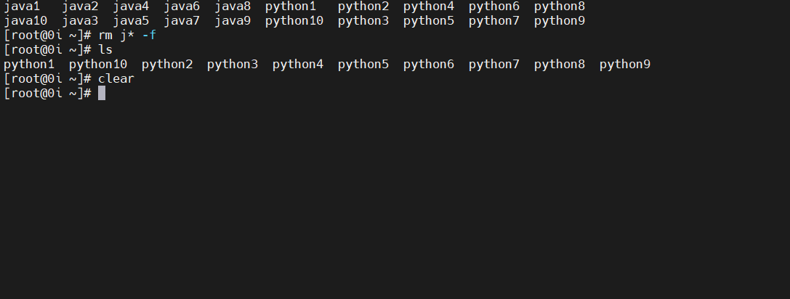

**touch file1** : to create a file

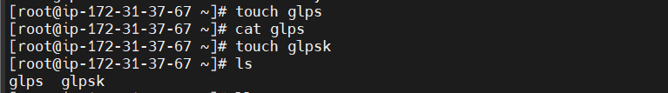

**touch sachin{1..50}** : to create series of files

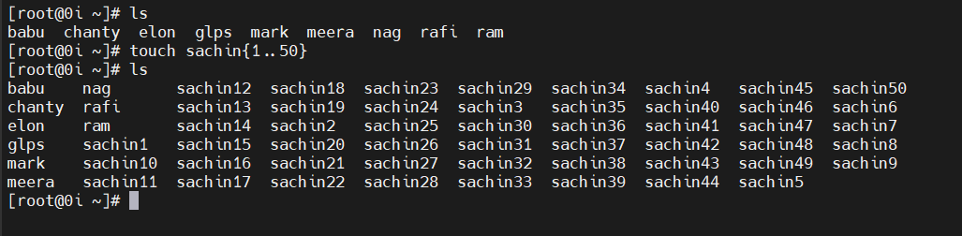

**ll**/**ls** : to list the files

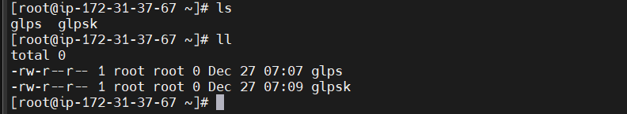

**pwd** : to show the present working directory

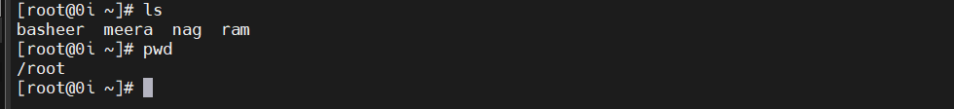

**cat file** : to show the content in a file

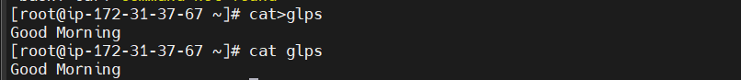

**more file1 :** to show the content in a file



**cat>file1** : to insert the content

**enter, ctrl d** : to save the content

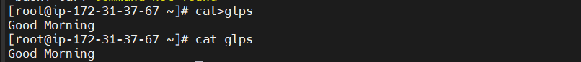

**cat>>file1** : to insert the content more than one time.

**enter, ctrl d** : to save the content

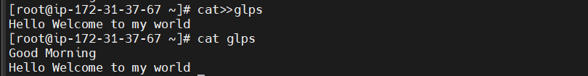

**cp file1 file2** : to copy the content from file1 to file2

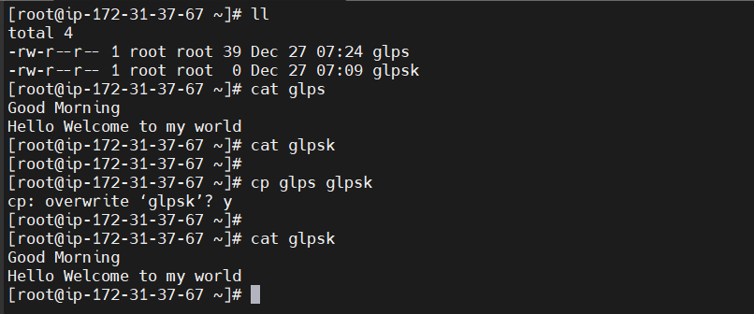

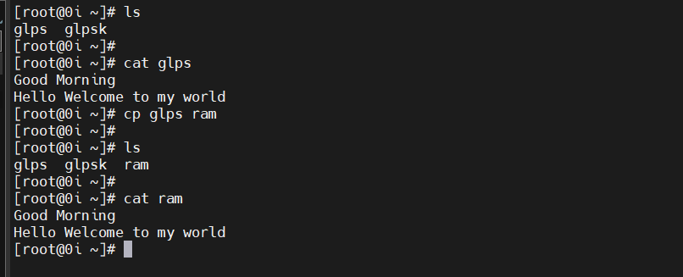

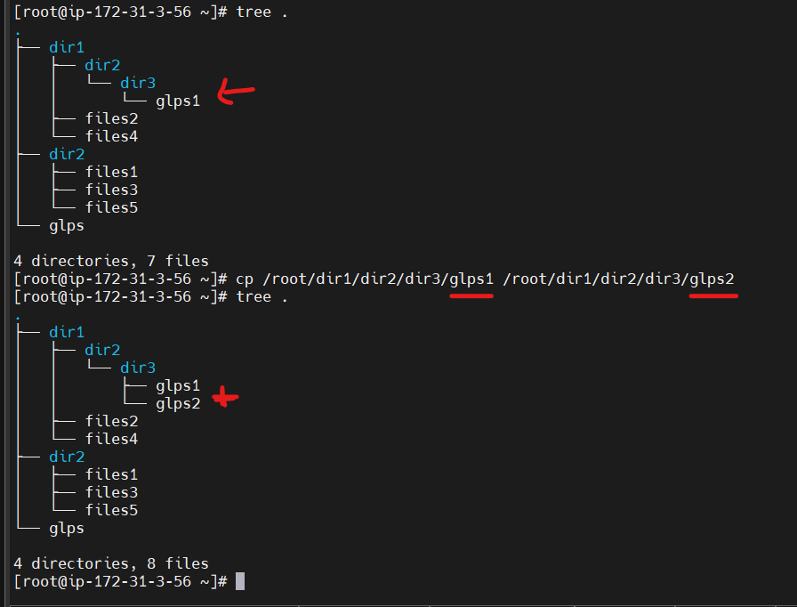

**mv file1 file5** : to rename file1 to file5

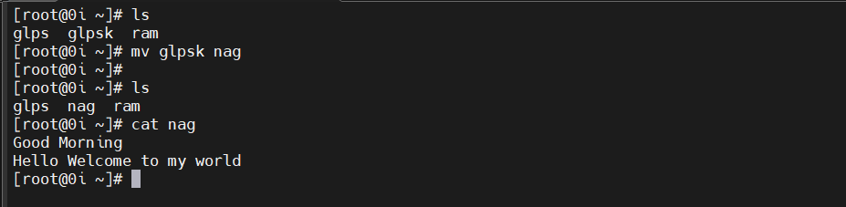

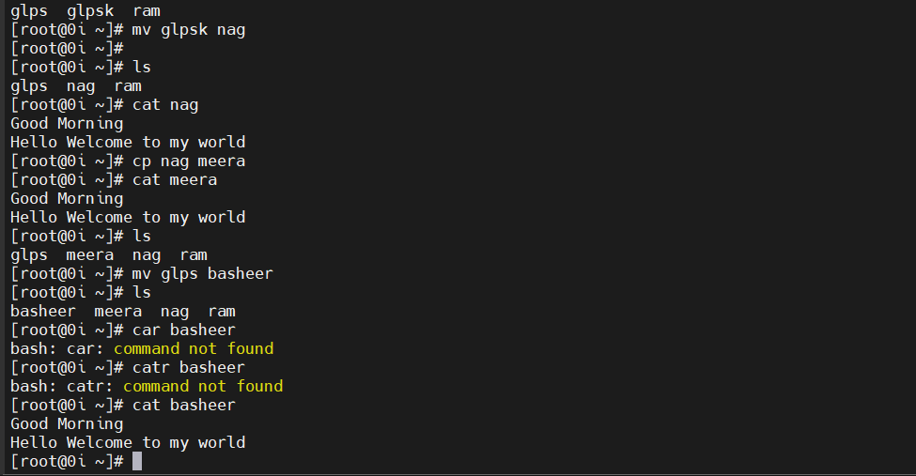

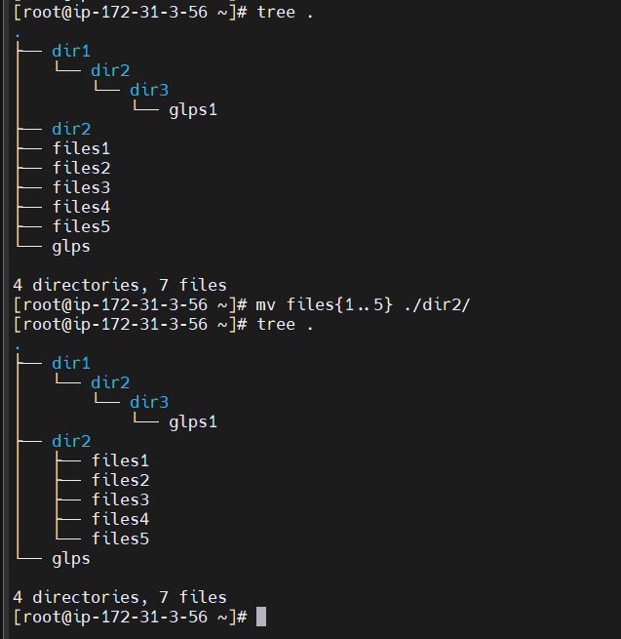

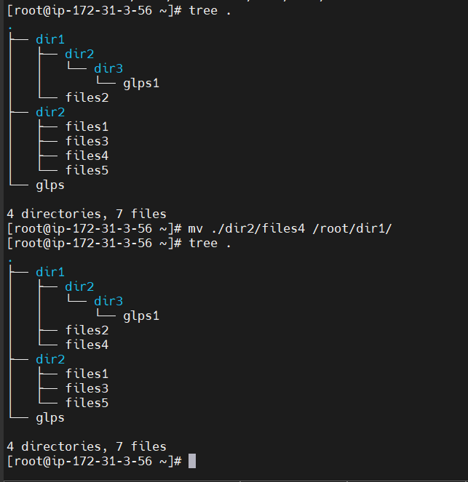

**rm file2** : to remove file2 (sachin50)

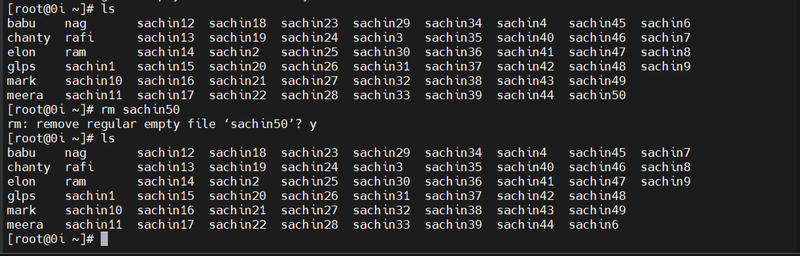

**rm file4 -f :** to remove file4 forcefully ( sachin6)

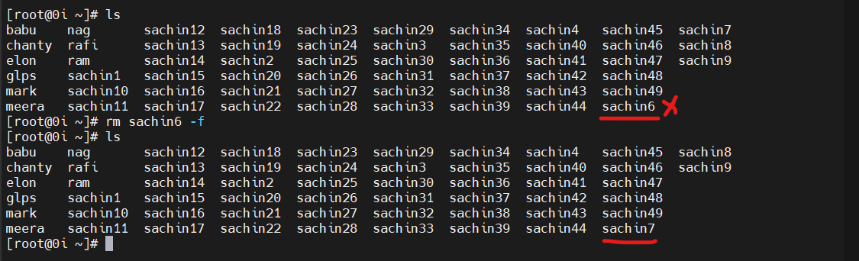

**rm * -f** : to remove all files forcefully

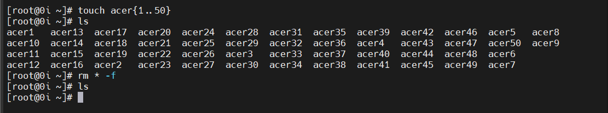

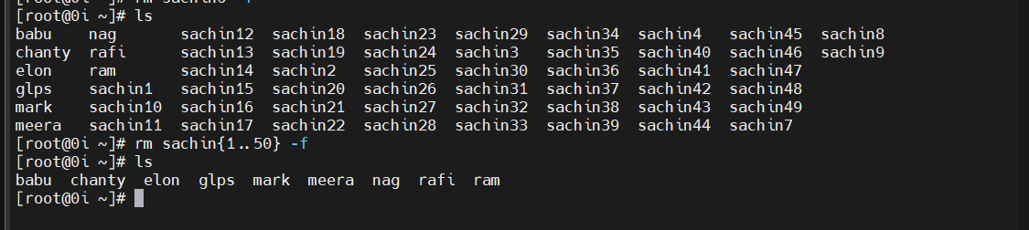

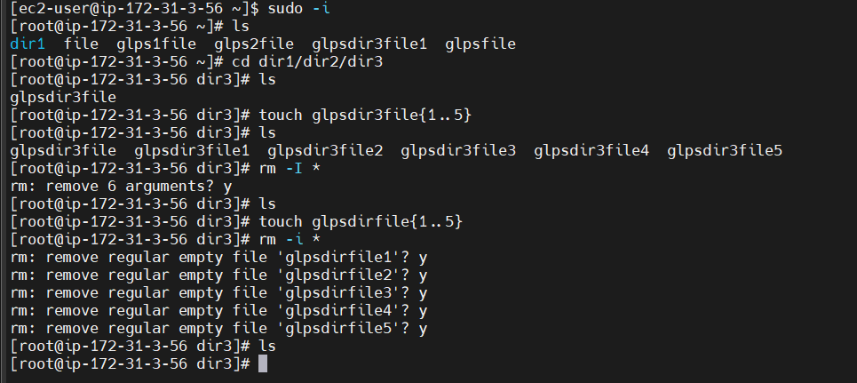

**rm j* -f** : to remove all the files starting with j

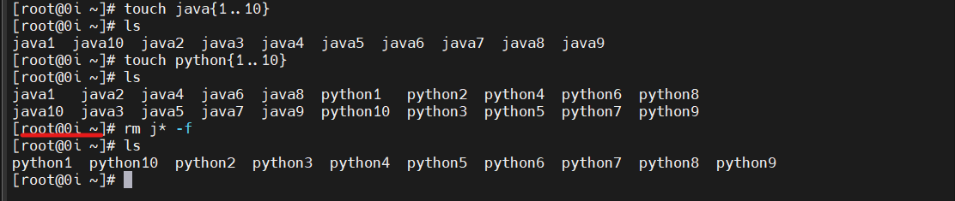

**ll -a / ls -a** : to list the hidden files

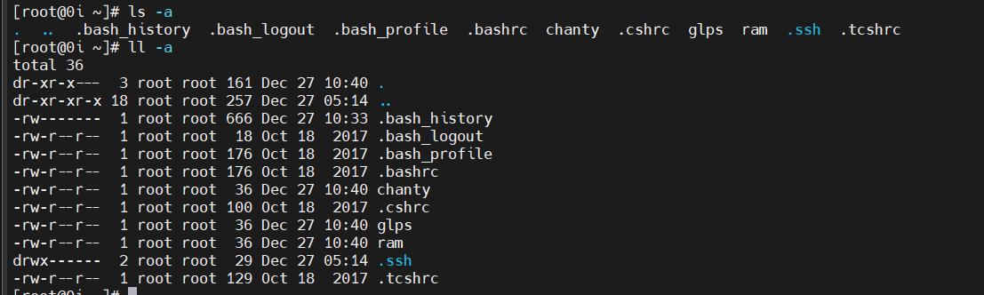

man : to know aout details description about commands

**man ls**

wc file1 : to see number of lines, words & characters.

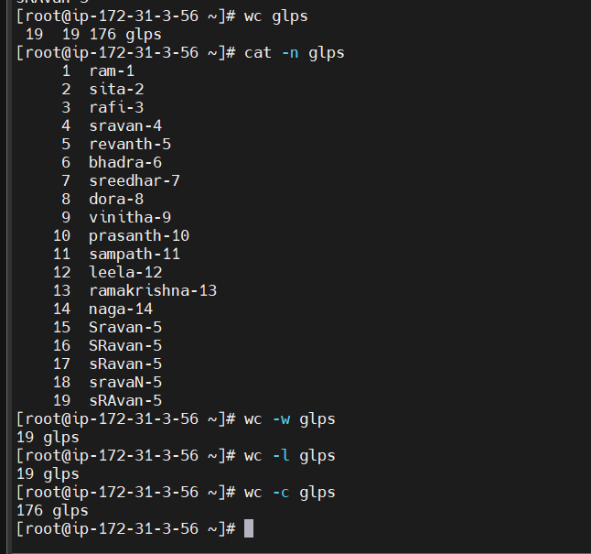

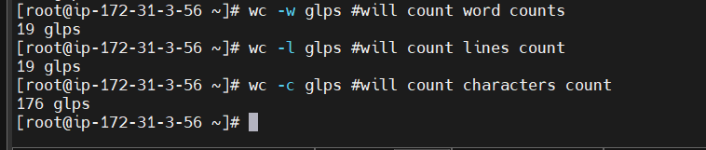

head file2 : to print top 10 lines

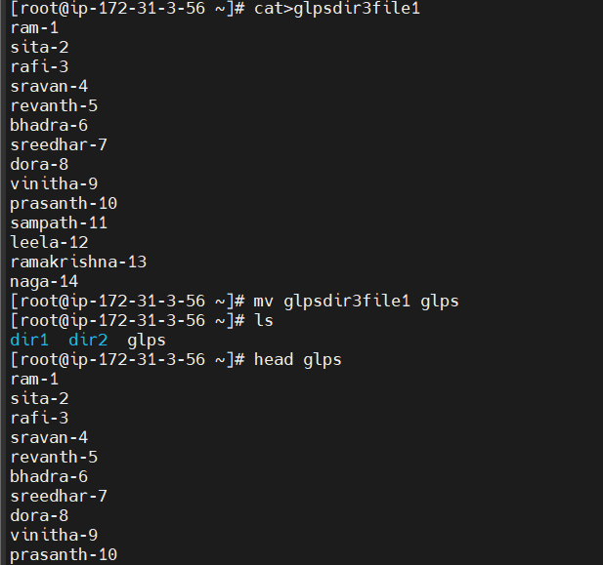

head -7 file2 : to print top 7 lines

head -5 file2 : to print top 5 lines

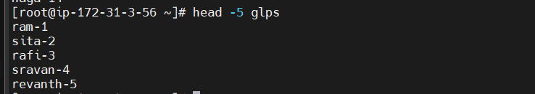

tail file2 : to print bottom 10 lines

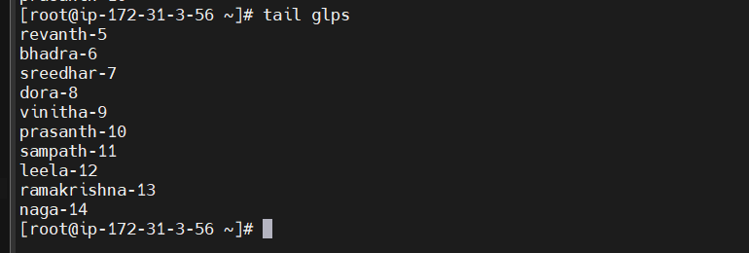

tail -7 file2 : to print bottom 7 lines

tail -5 file2 : to print bottom 5 lines

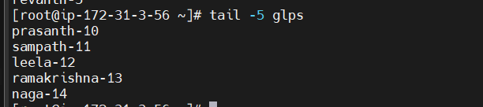

sed -n '6,16p' file2 : to print form line numbers 6 to 16

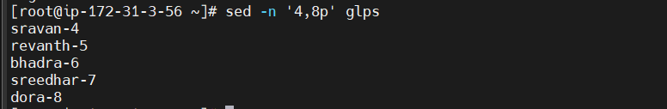

**FOLDERS = DIRECTORIES**

**mdkir dir1** : **to create a folder**

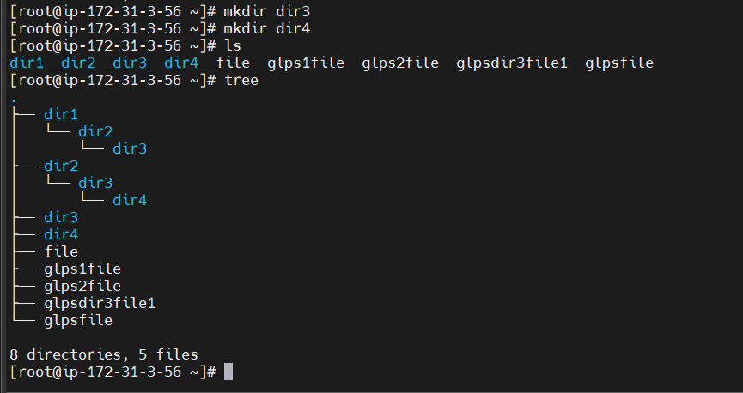

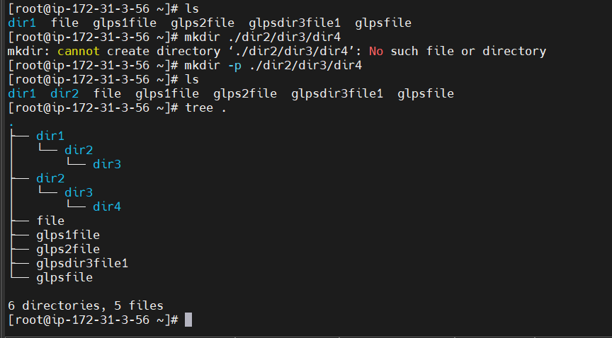

cd dir1 : to go inside the directory

cd .. : to go back one directory

rmdir dir1 : to remove a directory

echo "hai dora" > file3

**echo “ Hello all ** “ | sudo tee /etc/profile.d/filename**

**echo “Hello sample file” | sudo tee /etc/profile.d/file.txt**





===============================================================

DAY-03:

STATIC: We can't modify

DYNAMIC: We can mofify

VI/VIM EDITOR: Used to edit files and insert content.

i: used to modify/insert content

esc: to get out from insert mode

3. SAVE MODE:

:w : to save

:q : to quit

:wq : to save & quit

! : forcefully

2. INSERT MODE:

A : End of line

I : Starting of line

O : Create new line above existing line

o : Create new line below existing line

1. COMMAND MODE:

yy : copies single line

p : paste single line

dd : delete single line

u : undo

nyy : copies n lines

np : pastes n line

ndd : delete n lines

nu : undo n times

gg : top of file

shift+g : bottom of file

:15 : to go to line 15

:set number: print lines inside the file

**HARDWARE:**

**cat /proc/meminfo : to show memory information**

**lsmem : to show memory information**

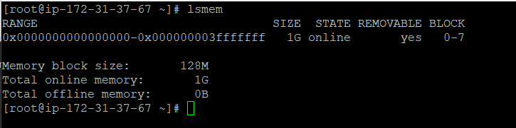

**cat /proc/cpuinfo :** to show cpu information

**lscpu** : to show cpu information

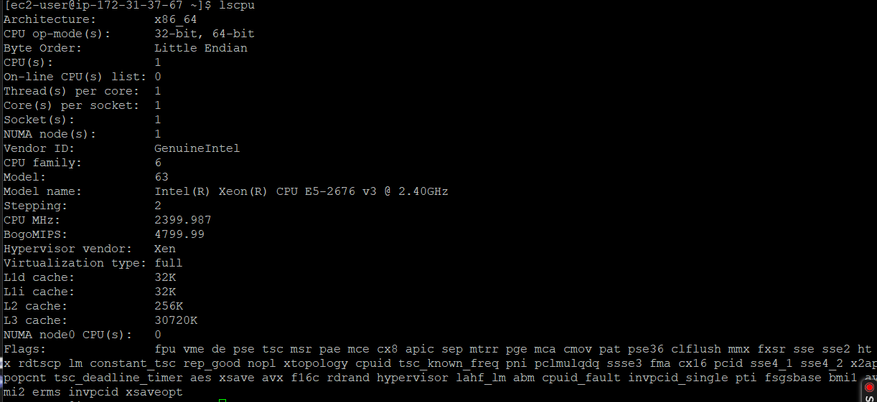

**fdisk -l** : to show the ebs volume info

**lsblk**  : to show the ebs volume info

**df** : to show the mount point

**df -m / -h** : to show the mount point in mb

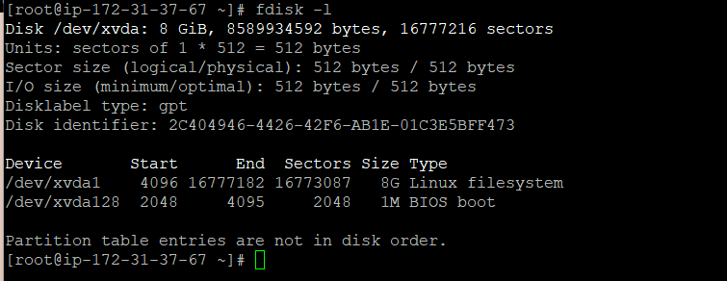

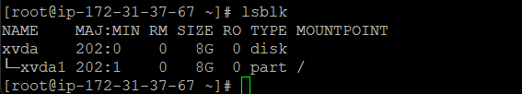

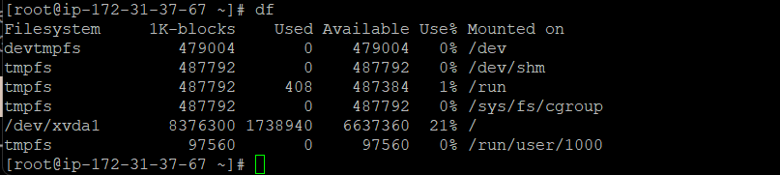

cat /etc/os-release : to print flavoure

free : to show how much ram is available

free -m : to show how much ram is available

yum install lshw -y : to install the package

lshw : to show the hardware information.

====================================================================================================================

USERS:

ec2-user: he is the default user.

root: he is the admin, he will have all permissions.

superuser:

he is a normal user created by root user.

normal user -- > visudo -- > super user

**useradd user**: to create a user

[ec2-user@ip-172-31-45-77 ~]$ sudo useradd vinitha

[ec2-user@ip-172-31-45-77 ~]$ sudo useradd rafi

[ec2-user@ip-172-31-45-77 ~]$ ls /home/

dora ec2-user glps rafi vinitha

**cat /etc/passwd**: to see the users list.

**[ec2-user@ip-172-31-45-77 ~]$** **cat /etc/passwd**

root:x:0:0:root:/root:/bin/bash

bin:x:1:1:bin:/bin:/sbin/nologin

daemon:x:2:2:daemon:/sbin:/sbin/nologin

adm:x:3:4:adm:/var/adm:/sbin/nologin

lp:x:4:7:lp:/var/spool/lpd:/sbin/nologin

sshd:x:74:74:Privilege-separated SSH:/var/empty/sshd:/sbin/nologin

rngd:x:998:996:Random Number Generator Daemon:/var/lib/rngd:/sbin/nologin

rpcuser:x:29:29:RPC Service User:/var/lib/nfs:/sbin/nologin

nfsnobody:x:65534:65534:Anonymous NFS User:/var/lib/nfs:/sbin/nologin

ec2-instance-connect:x:997:995::/home/ec2-instance-connect:/sbin/nologin

ec2-user:x:1000:1000:EC2 Default User:/home/ec2-user:/bin/bash

glps:x:1001:1001::/home/glps:/bin/bash

dora:x:1002:1003::/home/dora:/bin/bash

user -- > GROUP & FOLDER

**cat /etc/group**: to see the groups list.

**[ec2-user@ip-172-31-45-77 ~]$** **cat /etc/group**

root:x:0:

bin:x:1:

daemon:x:2:

sys:x:3:

adm:x:4:ec2-user

tty:x:5:

disk:x:6:

lp:x:7:

ssh_keys:x:998:

rpc:x:32:

libstoragemgmt:x:997:

sshd:x:74:

ec2-instance-connect:x:995:

slocate:x:21:

postdrop:x:90:

postfix:x:89:

chrony:x:994:

tcpdump:x:72:

ec2-user:x:1000:

glps:x:1001:

devops:x:1002:

dora:x:1003:

**ls /home**: to show user folder on home

[ec2-user@ip-172-31-45-77 ~]$ ls /home/

ec2-user glps

[ec2-user@ip-172-31-45-77 ~]$ sudo useradd dora

[ec2-user@ip-172-31-45-77 ~]$ ls /home/

dora ec2-user glps

**passwd user**: to assign password for user

[ec2-user@ip-172-31-45-77 ~]$ sudo passwd glps

Changing password for user glps.

New password:

Retype new password:

passwd: all authentication tokens updated successfully.

[ec2-user@ip-172-31-45-77 ~]$ sudo passwd dora

Changing password for user dora.

New password:

Retype new password:

passwd: all authentication tokens updated successfully.

**id dora**: to show the user info

[ec2-user@ip-172-31-45-77 ~]$ id glps

uid=1001(glps) gid=1001(glps) groups=1001(glps)

[ec2-user@ip-172-31-45-77 ~]$ id dora

uid=1002(dora) gid=1003(dora) groups=1003(dora)

[ec2-user@ip-172-31-45-77 ~]$ id ec2-user

uid=1000(ec2-user) gid=1000(ec2-user) groups=1000(ec2-user),4(adm),10(wheel),190(systemd-journal)

[ec2-user@ip-172-31-45-77 ~]$ id 1001

uid=1001(glps) gid=1001(glps) groups=1001(glps),1002(devops)

[ec2-user@ip-172-31-45-77 ~]$ id 1002

uid=1002(dora) gid=1003(dora) groups=1003(dora),1002(devops),1006(dellboomi)

**Add User to group** : adding users to groups

[ec2-user@ip-172-31-45-77 ~]$ sudo usermod -aG devops glps

[ec2-user@ip-172-31-45-77 ~]$ sudo usermod -aG dellboomi dora

[ec2-user@ip-172-31-45-77 ~]$ sudo usermod -aG selinium vinitha

[ec2-user@ip-172-31-45-77 ~]$ id glps

uid=1001(glps) gid=1001(glps) groups=1001(glps),1002(devops)

[ec2-user@ip-172-31-45-77 ~]$ id dora

uid=1002(dora) gid=1003(dora) groups=1003(dora),1006(dellboomi)

[ec2-user@ip-172-31-45-77 ~]$ id vinitha

uid=1003(vinitha) gid=1004(vinitha) groups=1004(vinitha),1007(selinium)

**Removing User from Group**

[ec2-user@ip-172-31-45-77 ~]$ sudo gpasswd -d glps devops

Removing user glps from group devops

[ec2-user@ip-172-31-45-77 ~]$ id glps

uid=1001(glps) gid=1001(glps) groups=1001(glps)

[ec2-user@ip-172-31-45-77 ~]$ sudo gpasswd -d dora dellboomi

Removing user dora from group dellboomi

[ec2-user@ip-172-31-45-77 ~]$ id dora

uid=1002(dora) gid=1003(dora) groups=1003(dora)

[ec2-user@ip-172-31-45-77 ~]$ sudo usermod -aG devops dora

[ec2-user@ip-172-31-45-77 ~]$ id dora

uid=1002(dora) gid=1003(dora) groups=1003(dora),1002(devops)

[ec2-user@ip-172-31-45-77 ~]$ sudo usermod -aG dellboomi dora

[ec2-user@ip-172-31-45-77 ~]$ id dora

uid=1002(dora) gid=1003(dora) groups=1003(dora),1002(devops),1006(dellboomi)

To Check the list of users in Group

[ec2-user@ip-172-31-45-77 ~]$ sudo lid -g devops

glps(uid=1001)

dora(uid=1002)

[ec2-user@ip-172-31-45-77 ~]$ sudo lid -g dellboomi

dora(uid=1002)

[ec2-user@ip-172-31-45-77 ~]$ sudo lid -g selinium

vinitha(uid=1003)

NOTE: in linux password will not be visible.

password -- > more than 8 char.

username should not be given as password.

To create super user:

1. create user (useradd dora)

2. password (passwd dora)

3. visudo -- > 100 -- > yy & p -- > root=dora

su - rajesh : to login to super user

NOTE: In linux if you are on non root use sudo command

root -- > normal -- > visudo -- > super user

**Who \ Whoami :** to check the user details

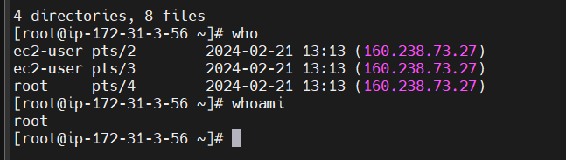

**logout** or **ctrl d** used to exit from super user.



=============================================================

-rw-r--r-- 1 root root 0 Jun 8 16:02 file1

TYPE OF FILES:

- : Regular file

b : Blocked file

c : Charcter file

d : Directory

l : link file

PERMISSION:

rw-r--r--

r : read : 4

w : write : 2

x : executable : 1

[ec2-user@ip-172-31-45-77 ~]$ ls

file.txt sample

[ec2-user@ip-172-31-45-77 ~]$ ll

-rw-rw-r-- 1 ec2-user ec2-user 29 Feb 22 05:51 file.txt

-rw-rw-r-- 1 ec2-user ec2-user 29 Feb 22 05:51 sample

[ec2-user@ip-172-31-45-77 ~]$ chmod u+x sample

[ec2-user@ip-172-31-45-77 ~]$ chmod g+x sample

[ec2-user@ip-172-31-45-77 ~]$ chmod o+wx sample

[ec2-user@ip-172-31-45-77 ~]$ ll

-rw-rw-r-- 1 ec2-user ec2-user 29 Feb 22 05:51 file.txt

-rwxrwxrwx 1 ec2-user ec2-user 29 Feb 22 05:51 **sample**

[root@ip-172-31-45-77 ~]# ll /home/

total 0

drwx------ 2 dora dora 83 Feb 22 05:35 dora

drwx------ 3 ec2-user ec2-user 125 Feb 22 05:51 ec2-user

drwx------ 2 glps glps 83 Feb 22 05:36 glps

drwx------ 2 rafi rafi 62 Feb 22 04:39 rafi

drwx------ 2 vinitha vinitha 62 Feb 22 04:39 vinitha

[root@ip-172-31-45-77 ~]# ll /home/

total 0

drwx------ 2 dora dora 83 Feb 22 05:35 dora

drwx------ 3 ec2-user ec2-user 125 Feb 22 05:51 ec2-user

drwx---r-- 2 glps glps 83 Feb 22 05:36 glps

drwx------ 2 rafi rafi 62 Feb 22 04:39 rafi

drwx------ 2 vinitha vinitha 62 Feb 22 04:39 vinitha

[root@ip-172-31-45-77 ~]# chmod o+r /home/ec2-user

[root@ip-172-31-45-77 ~]# ll /home/

total 0

drwx------ 2 dora dora 83 Feb 22 05:35 dora

drwx---r-- 3 ec2-user ec2-user 125 Feb 22 05:51 ec2-user

drwx---r-- 2 glps glps 83 Feb 22 05:36 glps

drwx------ 2 rafi rafi 62 Feb 22 04:39 rafi

drwx------ 2 vinitha vinitha 62 Feb 22 04:39 vinitha

user : rw- : 4+2+0 : 6

group : r-- : 4+0+0 : 4

others : r-- : 4+0+0 : 4

chmod 777 file1

chmod 666 file2

[root@ip-172-31-45-77 ~]# chmod 707 /home/ec2-user

[root@ip-172-31-45-77 ~]# ll /home/

drwx------ 2 dora dora 83 Feb 22 05:35 dora

drwx---rwx 3 ec2-user ec2-user 125 Feb 22 05:51 ec2-user

drwx---r-- 2 glps glps 83 Feb 22 05:36 glps

drwx------ 2 rafi rafi 62 Feb 22 04:39 rafi

drwx------ 2 vinitha vinitha 62 Feb 22 04:39 vinitha

[root@ip-172-31-45-77 ~]# chmod 777 /home/ec2-user

[root@ip-172-31-45-77 ~]# ll /home/

drwx------ 2 dora dora 83 Feb 22 05:35 dora

drwxrwxrwx 3 ec2-user ec2-user 125 Feb 22 05:51 ec2-user

drwx---r-- 2 glps glps 83 Feb 22 05:36 glps

drwx------ 2 rafi rafi 62 Feb 22 04:39 rafi

drwx------ 2 vinitha vinitha 62 Feb 22 04:39 vinitha

After given read permission to directory ec2-user now glps user access ec2-user user directory

[root@ip-172-31-45-77 ~]# chmod 777 /home/ec2-user

[root@ip-172-31-45-77 ~]# ll /home/

drwx------ 2 dora dora 83 Feb 22 05:35 dora

drwxrwxrwx 3 ec2-user ec2-user 125 Feb 22 05:51 ec2-user

drwx---r-- 2 glps glps 83 Feb 22 05:36 glps

drwx------ 2 rafi rafi 62 Feb 22 04:39 rafi

drwx------ 2 vinitha vinitha 62 Feb 22 04:39 vinitha

[root@ip-172-31-45-77 ~]# logout

[ec2-user@ip-172-31-45-77 ~]$ sudo su glps

[glps@ip-172-31-45-77 ec2-user]$ ls

file.txt sample

[glps@ip-172-31-45-77 ec2-user]$ ls /home/dora

ls: cannot open directory /home/dora: Permission denied

[glps@ip-172-31-45-77 ec2-user]$ exit

[ec2-user@ip-172-31-45-77 ~]$ sudo su dora

[dora@ip-172-31-45-77 ec2-user]$ pwd

/home/ec2-user

[dora@ip-172-31-45-77 ec2-user]$ cd ..

[dora@ip-172-31-45-77 home]$ ll

total 0

drwx------ 2 dora dora 83 Feb 22 05:35 dora

drwxrwxrwx 3 ec2-user ec2-user 125 Feb 22 05:51 ec2-user

drwx---r-- 2 glps glps 83 Feb 22 05:36 glps

drwx------ 2 rafi rafi 62 Feb 22 04:39 rafi

drwx------ 2 vinitha vinitha 62 Feb 22 04:39 vinitha

[dora@ip-172-31-45-77 home]$ cd dora

[dora@ip-172-31-45-77 ~]$ cd ..

[dora@ip-172-31-45-77 home]$ chmod 707 dora (# read,write,xecute permission given to Dora directory for other users)

[dora@ip-172-31-45-77 home]$ ll

drwx---rwx 2 dora dora 83 Feb 22 05:35 dora

drwxrwxrwx 3 ec2-user ec2-user 125 Feb 22 05:51 ec2-user

drwx---r—2 glps glps 83 Feb 22 05:36 glps

drwx------ 2 rafi rafi 62 Feb 22 04:39 rafi

drwx------ 2 vinitha vinitha 62 Feb 22 04:39 vinitha

[dora@ip-172-31-45-77 home]$ exit

[ec2-user@ip-172-31-45-77 ~]$ sudo su glps

[glps@ip-172-31-45-77 ec2-user]$ cd ..

[glps@ip-172-31-45-77 home]$ cd ec2-user

[glps@ip-172-31-45-77 ec2-user]$ ls /home/dora

[glps@ip-172-31-45-77 ec2-user]$

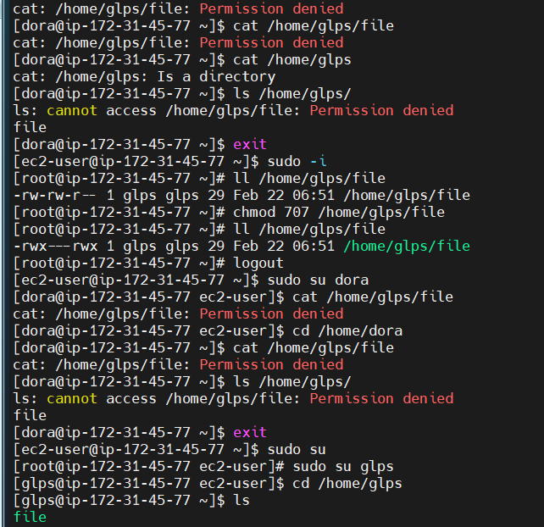

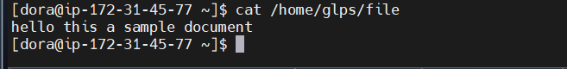

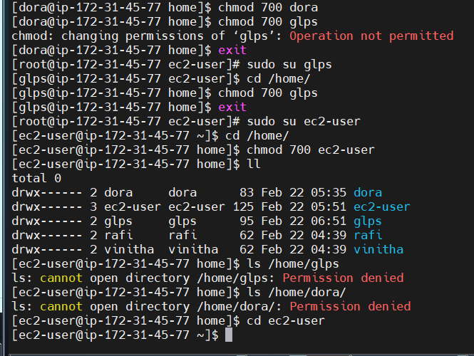

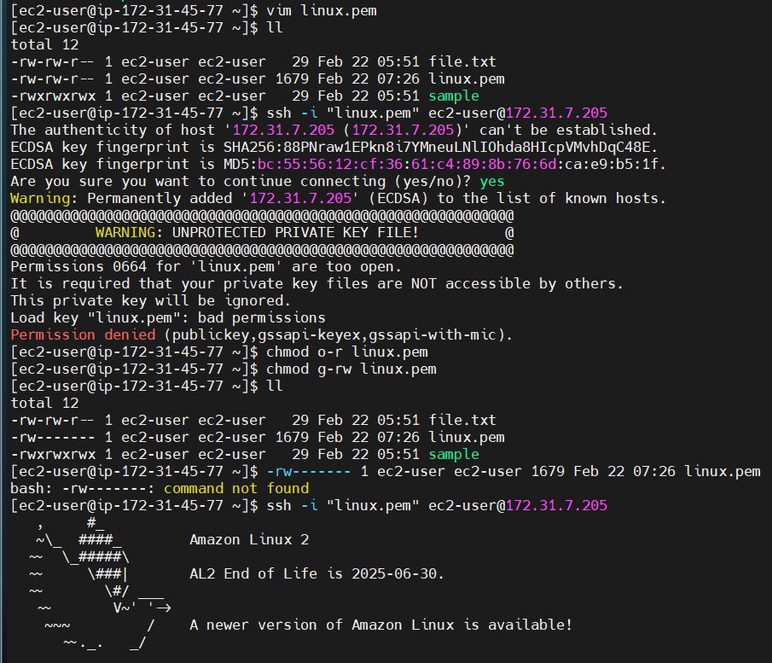



1 : acl -- > access control list

**chown glps file1**: to make glps as owner to file1

[ec2-user@ip-172-31-45-77 ~]$ ls -l

-rw-rw-r-- 1 ec2-user ec2-user 29 Feb 22 05:51 file.txt

-rw------- 1 ec2-user ec2-user 1679 Feb 22 07:26 linux.pem

-rwxrwxrwx 1 ec2-user ec2-user 29 Feb 22 05:51 sample

[ec2-user@ip-172-31-45-77 ~]$ **sudo chown glps sample**

[ec2-user@ip-172-31-45-77 ~]$ ls -l

-rw-rw-r-- 1 ec2-user ec2-user 29 Feb 22 05:51 file.txt

-rw------- 1 ec2-user ec2-user 1679 Feb 22 07:26 linux.pem

-rwxrwxrwx 1 glps ec2-user 29 Feb 22 05:51 sample

**chgrp dora file1**: to make dora as group to file1

[ec2-user@ip-172-31-45-77 ~]$ sudo chgrp glps sample

[ec2-user@ip-172-31-45-77 ~]$ ls -l

total 12

-rw-rw-r-- 1 ec2-user ec2-user 29 Feb 22 05:51 file.txt

-rw------- 1 ec2-user ec2-user 1679 Feb 22 07:26 linux.pem

-rwxrwxrwx 1 glps glps 29 Feb 22 05:51 sample

chown user:group file2 : to make dora user&group for file2

[ec2-user@ip-172-31-45-77 ~]$ ls -l

-rw-rw-r-- 1 ec2-user ec2-user 29 Feb 22 05:51 file.txt

-rw------- 1 ec2-user ec2-user 1679 Feb 22 07:26 linux.pem

-rwxrwxrwx 1 glps glps 29 Feb 22 05:51 sample

[ec2-user@ip-172-31-45-77 ~]$ sudo chown dora:dora file.txt

[ec2-user@ip-172-31-45-77 ~]$ ls -l

-rw-rw-r-- 1 dora dora 29 Feb 22 05:51 file.txt

-rw------- 1 ec2-user ec2-user 1679 Feb 22 07:26 linux.pem

-rwxrwxrwx 1 glps glps 29 Feb 22 05:51 sample

chown rajesh:dora file1: rajesh as user & dora as group

[ec2-user@ip-172-31-45-77 ~]$ ls -l

-rw-rw-r-- 1 dora dora 29 Feb 22 05:51 file.txt

-rw------- 1 ec2-user ec2-user 1679 Feb 22 07:26 linux.pem

-rwxrwxrwx 1 glps glps 29 Feb 22 05:51 sample

[ec2-user@ip-172-31-45-77 ~]$ sudo chown glps:dora file.txt

[ec2-user@ip-172-31-45-77 ~]$ ls -l

-rw-rw-r-- 1 glps dora 29 Feb 22 05:51 file.txt

-rw------- 1 ec2-user ec2-user 1679 Feb 22 07:26 linux.pem

-rwxrwxrwx 1 glps glps 29 Feb 22 05:51 sample

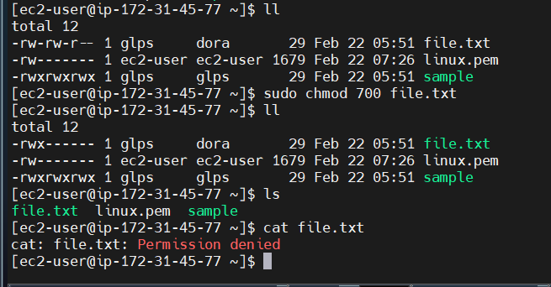

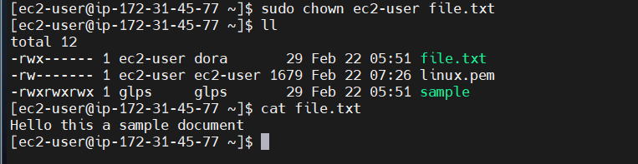

groupadd devops : to create devops group

usermod -aG devops dora : to add dora user to devops group

usermod -aG aws dora : to add dora user to aws group

gpasswd --delete dora devops : to remove dora user form devops group

userdel dora : to delete dora user

=======================================================================================================

DAY-05:

GREP : Global Regular Expression Print

to search for a particular word

grep is file1 : to search word is on file1

grep IS file1 -i : to avoid the case sensitive

grep IS file1 -i -v : to avoid the line which is having word is

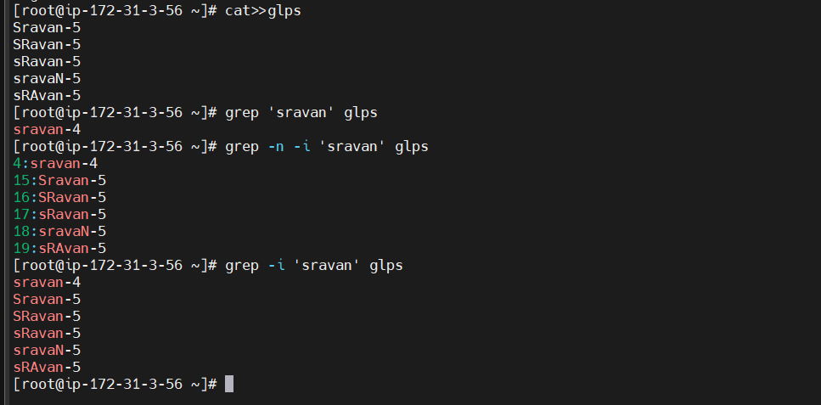

cat file1 | grep is : to search word is on file1

cat file1 | grep IS -i : to avoid the case sensitive

cat file1 | grep IS -iv : to avoid the line which is having word is

| : is pipe sysmbol -- > to work with pipe we need to have 2 commands

here 1 st command output will be input of 2 nd command.

lscpu | grep cpu -i

lsmem | grep memory -i

dmesg | grep image -i

SED: Stream Editor -- > to replace words in a file.

%s/is/abc/ -- > to replace is with abc

sed '3c/abc/' file1 -- > to replce 3rd line in a file

sed 's/linux/unix/' file1-- > single word replace

sed 's/linux/unix/; s/session/class/' file1 -- > multi word replace

cat file1 -n -- > to print line numbers in a file

sed '=' file1 -- > to print line numbers in a file

sed -n '5,13p' file1 -- > to print line 5 to 13

sed -e '5,13p' file1 -- > to print line 5 to 13 double times

**Locate :** it will locate the file in a database

* we need to install locate package

**Sudo yum install locate -y**

* we need to update db

**Sudo updated**

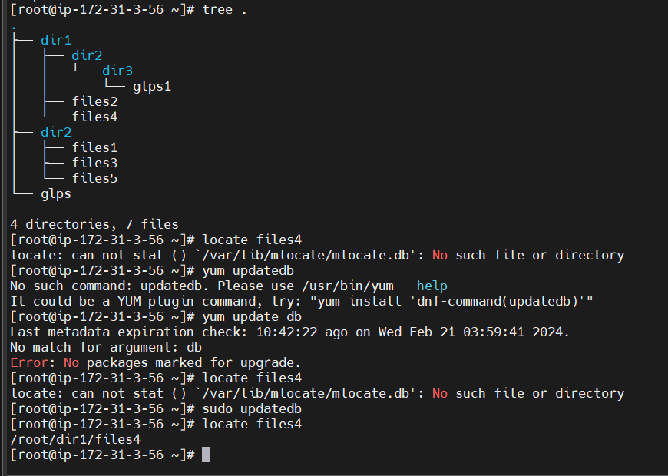

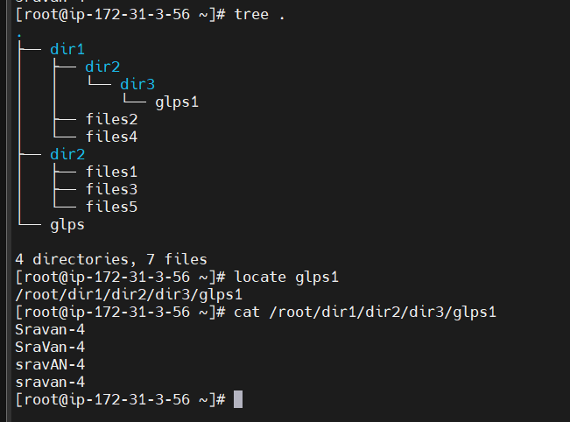

**Find :** to find the files * in specific / entire locations

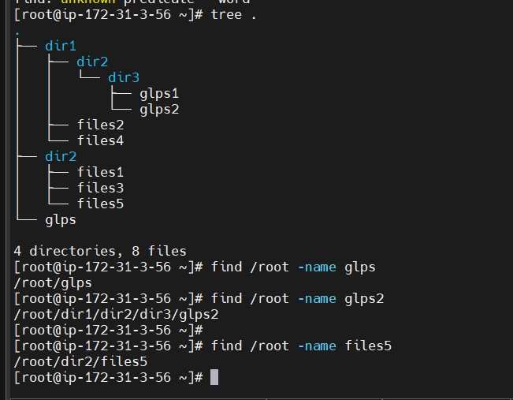

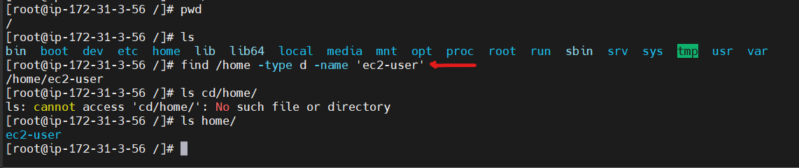

**[root@ip-172-31-3-56 /]# find ~ -name files4**

**/root/dir1/files4**

**[root@ip-172-31-3-56 /]# cd ~**

**[root@ip-172-31-3-56 ~]# find / -type d -name 'ec2-user'**

**/home/ec2-user**

**[root@ip-172-31-3-56 ~]# find ~ -type f -name 'file1'**

**[root@ip-172-31-3-56 ~]# find ~ -type f -name 'files1'**

**/root/dir2/files1**

**NETWORKING:**

**ip addr**

**ip addr show**

**hostname -i**

**ifconfig -- >** all the 4 commands used to show ip address

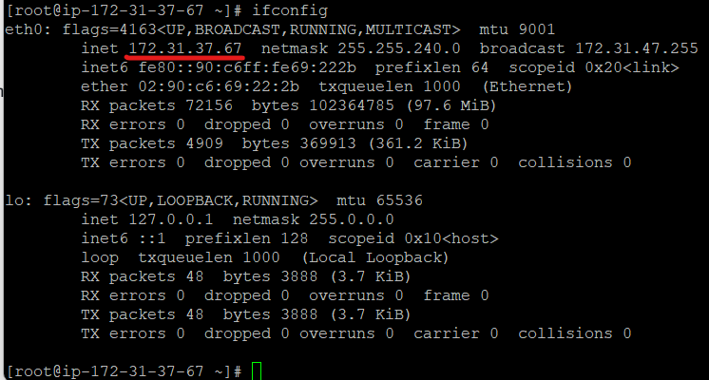

root@ip-172-31-37-29:/home/ubuntu# **ps -ef ( to know running applications)**

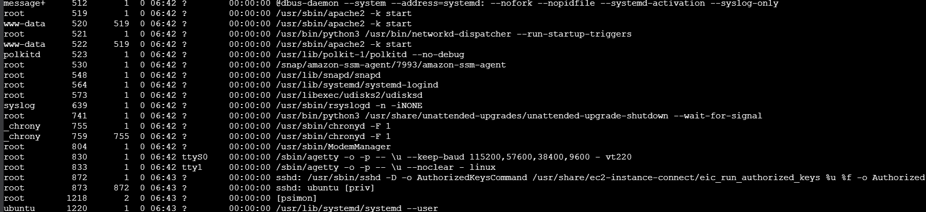

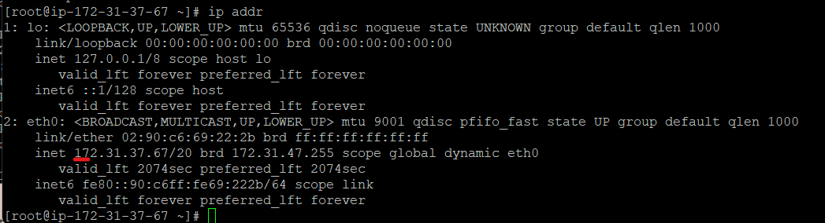



ping google.com -- > to get response form server

ping -c 4 google.com

netstat --- > to show active internet connections

ps -- > to check the process

kill -9 32555 -- > to kill a process

ps aux -- > to list process in ids

readlink -f $(which java): to find the path of package



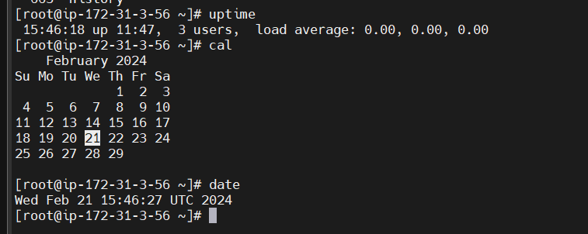

**alias :**

**vi .bashrc**

alias d='docker'

alias ds='docker stop'

alias dr='docker rm'

alias dc='docker ps -a'

alias di='docker images'

alias v='vi'

alias dri='docker run -it'

**source .bashrc**

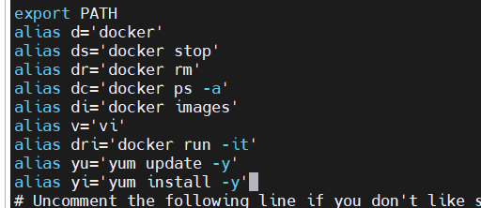

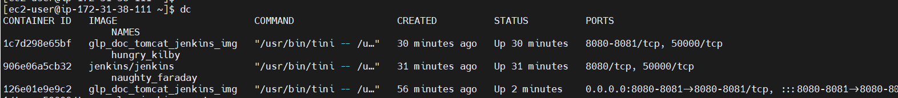

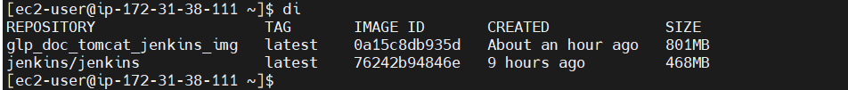

**awk** command

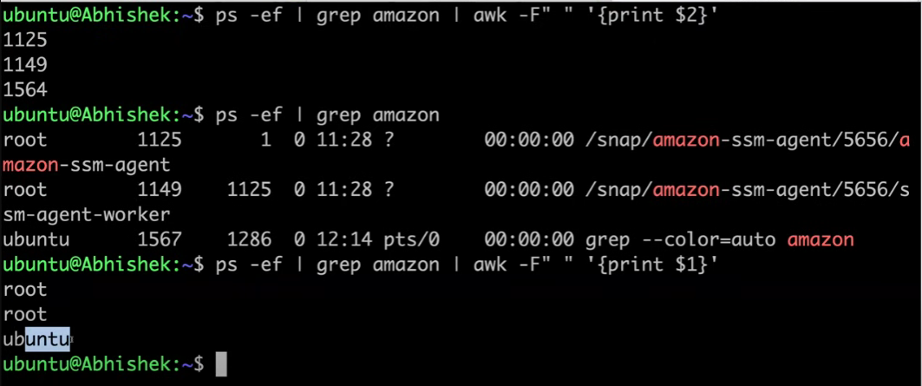

root@ip-172-31-37-29:/home/ubuntu# **ps -af | awk -F " " '{print $2}'**

PID

1166

1168

1169

22402

74531

74532

Set commnads

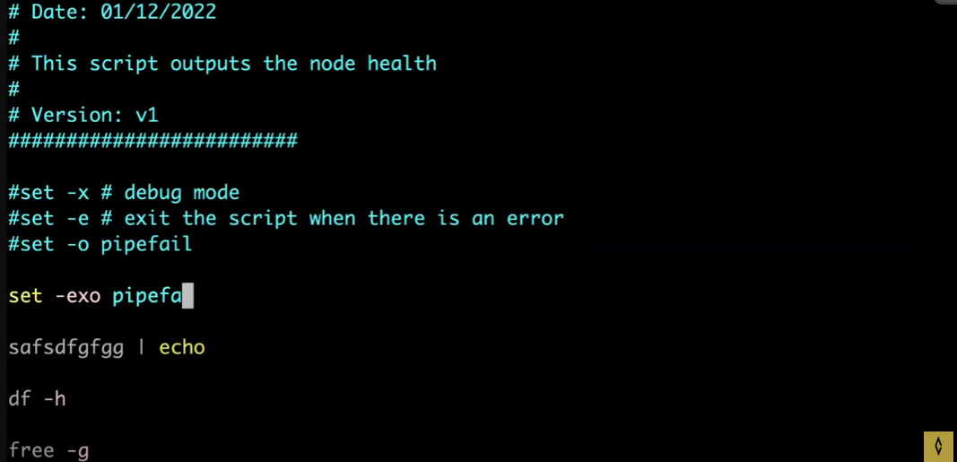

LINUX DIRECTORY SYSTEM:

FHS

bin : it stores all the binary files and also it stores the commands that had been executed by the user.

sbin : it stores the commands that had been executed by the super user.

boot : it contains boot images & boot files.

dev : it contains all the device files

etc : it contains all the host specific system configuration files.

lib : it contains all the library files of the system.

lib64 : it contains all the library files of the system of 64 bit.

mnt : it is used for the mounting purpose.

opt : it stores all the file details of the 3 rd party when it installed.

proc : it is used to see all the processing related files (Hardware details).

srv : it stores all the service related information provided by system.

sys : it stores any new changes that obtained while changing Hardware.

tmp : it stores temperory files and have access to all.

usr : it contains loca

l system files which are continuing with the old system architecture.

var : it stores all the system services.

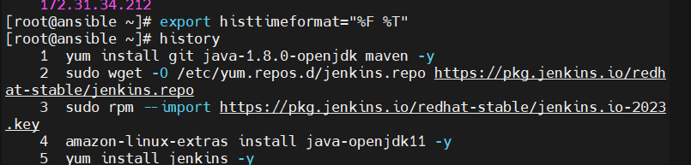

1 yum install git java-1.8.0-openjdk maven -y

2 sudo wget -O /etc/yum.repos.d/jenkins.repo https://pkg.jenkins.io/redhat-stable/jenkins.repo

3 sudo rpm --import https://pkg.jenkins.io/redhat-stable/jenkins.io-2023.key

4 amazon-linux-extras install java-openjdk11 -y

5 yum install jenkins -y

6 update-alternatives --config java

7 systemctl start jenkins.service

8 cat /var/lib/jenkins/secrets/initialAdminPassword

9 systemctl restart jenkins.service

10 date

11 cd /var/lib/jenkins/workspace/jenkins_webhook-test/target/

12 ll

13 date

14 top

15 df

16 ipconfig

17 ifconfig

18 systemctl start jenkins

19 update-alternatives --config java

20 java -version

21 top

22 htop

23 yum install htop -y

24 htop

25 passwd root

26 vim/etc/ssh/sshd_config

27 vim /etc/ssh/sshd_config

28 systemctl restart sshd

29 systemctl status sshd

30 amazon-linux-extras install ansible2 -y

31 yum install python3 python3-pip -y

32 yum install python python-pip python-dlevel -y

33 python version

34 vim /etc/ansible/hosts

35 hostname -i

36 ansible -m yum -a "name=git state=present"

37 ansible all -m yum -a "name=httpd state=present"

38 ansible -m yum -a "name=httpd state=present"

39 ls

40 yum update -y

41 hostnamectl set-hostname glps

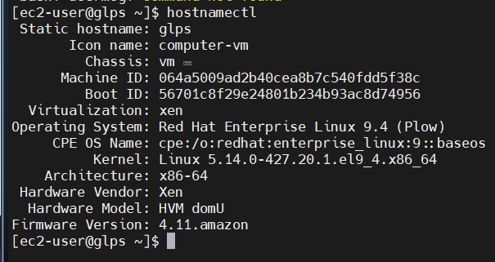

42 sudo -i

43 clear

44 passwd root

45 nano /etc/ssh/sshd_config

46 vim /etc/ssh/sshd_config

47 systemctl restart sshd

48 systemctl status sshd

49 vim /etc/ssh/sshd_config

50 systemctl status sshd

51 amazon-linux-extras install ansible2 -y

52 yum install python python-pip -y

53 yum install python3 python3-pip -y

54 yum install python3 python3-pip pyhon-dlevel -y

55 yum install pyhon-dlevel -y

56 python3

57 yum install python3 python3-pip -y

58 hostname -i

59 vim /etc/ansible/hosts

60 ssh-keygen

61 ssh-copy-id root@172.31.41.21

62 ssh 172.31.41.21

63 ssh 172.31.34.212

64 host -i

65 hostname -i

66 ssh 172.31.41.21

67 ssh 172.31.34.212

68 hostname -i

69 ansible all -a "yum install git -y"

70 git version

71 git -v

72 ansible all

73 ansible all --list- hosts

74 ansible all --list-hosts

75 ansible test --list-hosts

76 ansible test[0] --list-hosts

77 ansible test[1] --lists-hosts

78 ansible test[1] --list-hosts

79 export histtimeformat="%F %T"

80 history