Remote Modules Access From **GitHub**

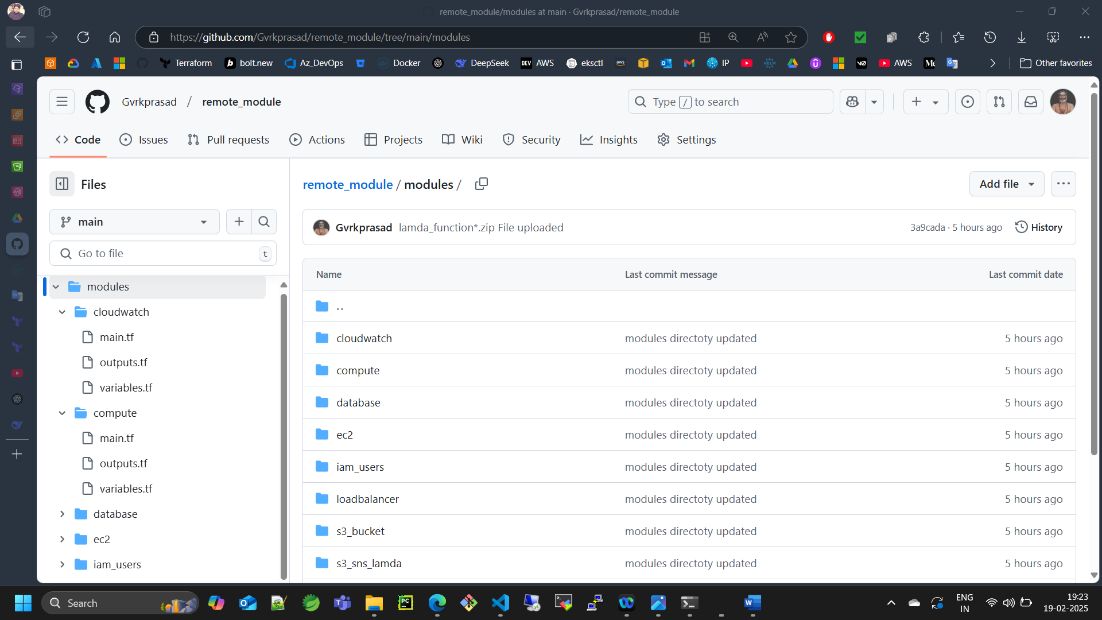

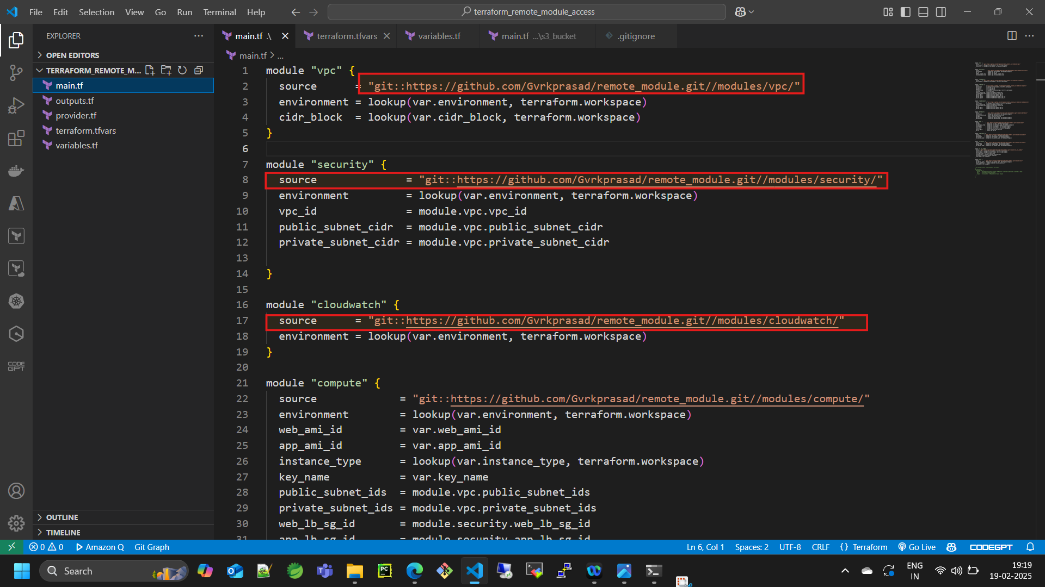

Then initialise terraform

1. terraform init
2. terraform plan
3. terraform apply

Remote Modules Access from **S3_BUCKET**

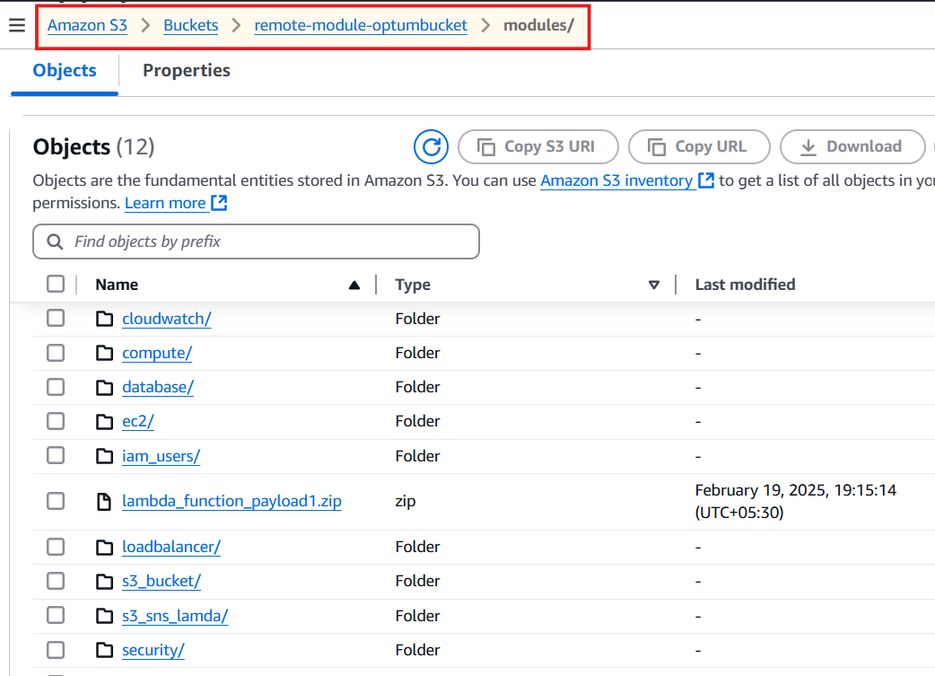

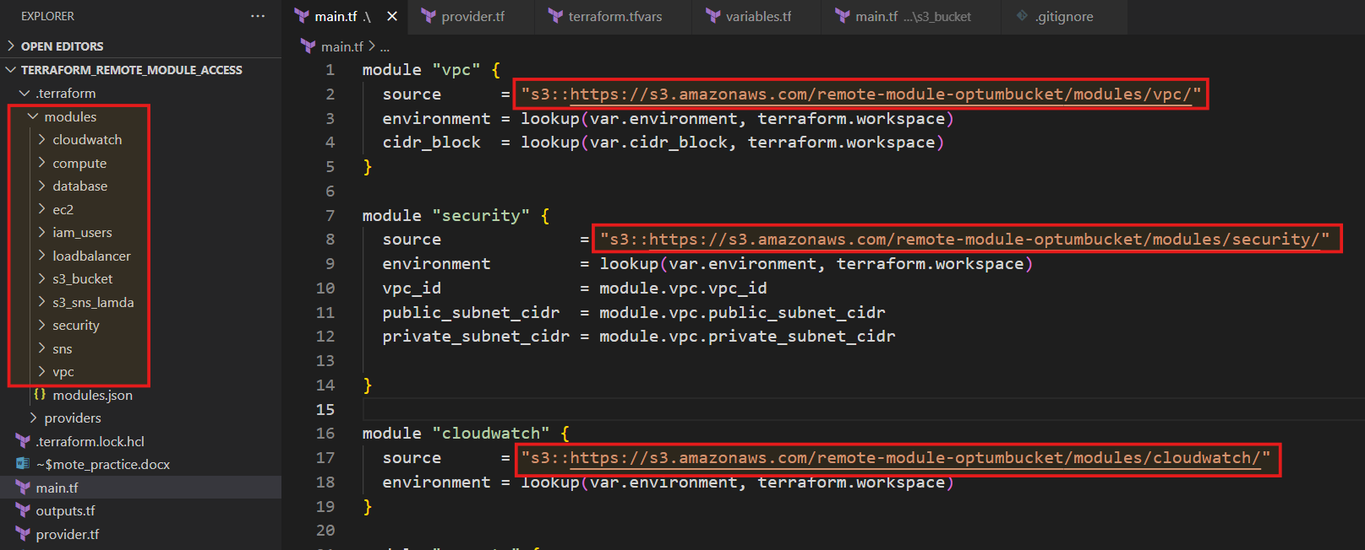

Then initialise terraform

1. terraform init
2. terraform plan
3. terraform apply

