**DBMS LAB 01 - ER Diagram for a Hair Salon Business**

**Diagram:**

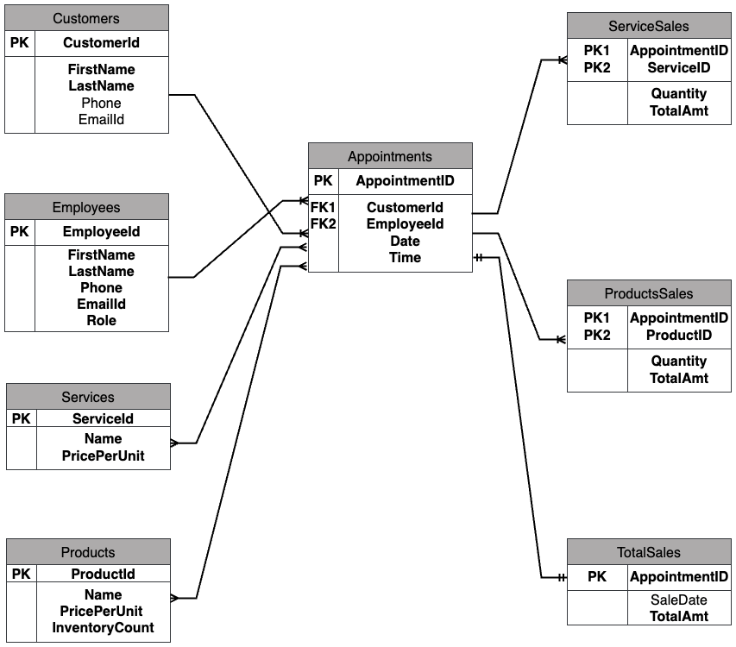

**Assumptions:**  
1. One employee does all the services to a customer in an appointment.

2. Multiple services and products can be sold in an appointment.  
3. Prices of services and products won't change.

**Relationships:**

1. **Customers - Appointments (1 to Many)**

One customer can have multiple appointments, but each appointment is only for one customer.

1. **Employees - Appointments (1 to Many)**

An employee can handle multiple appointments, but each appointment is attended by only one employee.

1. **Appointments - Services (Many to Many)**

Multiple services can be done in an appointment, and many appointments can use any service.

1. **Appointments - Products (Many to Many)**

Multiple products can be sold in an appointment, and many appointments can sell any product.

1. **Appointments - ServiceSales (1 to Many)**

Many service sales can be done in an appointment, but one service sale is only for an appointment because of composite primary keys.

1. **Appointments - ProductSales (1 to Many)**

An appointment can have multiple product sales, but each product sale is associated with one appointment.

1. **Appointments - TotalSales (1 to 1)**

TotalSales represent total bill amount in an appointment, so 1 row in TotalSales have only 1 AppointmentID and vice versa.

**Note:**

I used a separate table for total sales instead of including it in the appointments table, because I want to avoid null values while creation of appointment. We can’t get total amount until the appointment is finished and it stays Null till then. In that case a sparse table is better, but I wanted to use a separate table to store total bill amount.