**DBMS LAB 01 - ER Diagram for a Hair Salon Business**

**Diagram:**

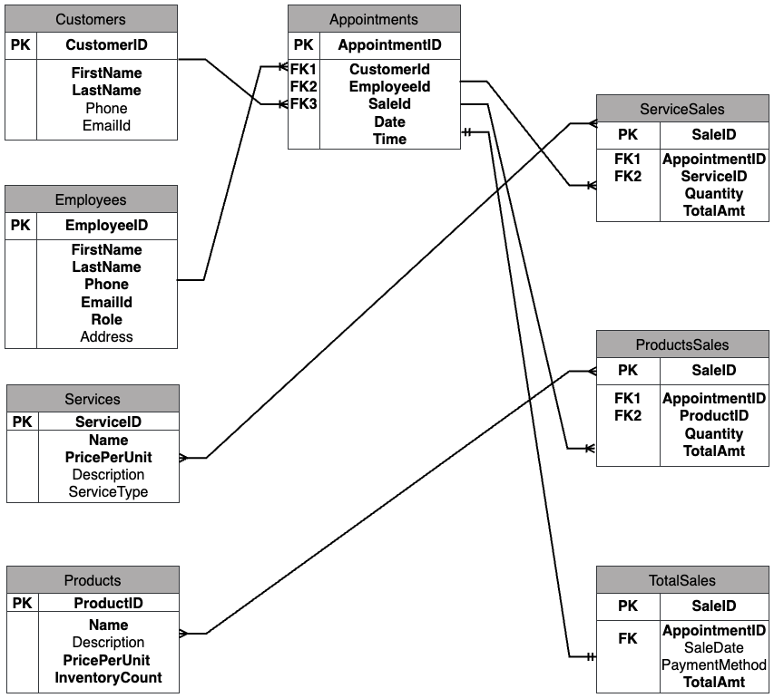

**Table descriptions:**

**Customers:** Contains customer information including unique id, first, last names, contact information.

**Employees**: Contains employee details like unique id, first & last names, contact information, position at salon and address.

**Services**: This table contains the details about services provided at salon, description, type and the amount charged for the service.

**Products**: Tracks the inventory count of all the products available for sale and their prices.

**Appointments**: This table holds information about the list of appointments done at the salon, customer id, employee who attended to the customer, unique sale id, date and time of appointment.

**ServiceSales**: Tracks the services done in an appointment.

**ProductSales**: Tracks the products sold in an appointment.

**TotalSales**: Contains the final bill amount, payment methods and sale date in a sale.

**Assumptions / Design Choices:**

* One employee does all the services to a customer in an appointment.
* Multiple services and products can be sold in an appointment.
* Prices of services and products won't change.
* SaleID is unique for each AppointmentID.

**Relationships:**

|  |  |  |
| --- | --- | --- |
| **Customers – Appointments** | **1 to Many** | One customer can have multiple appointments, but each appointment is only for one customer. |
| **Employees - Appointments** | **1 to Many** | An employee can handle multiple appointments, but each appointment is attended by only one employee |
| **Appointments - ServiceSales** | **1 to Many** | Many service sales can be done in an appointment, but one service sale / saleID is only for an appointment. |
| **Appointments - ProductSales** | **1 to Many** | An appointment can have multiple product sales, but each product sale is associated with one appointment. |
| **Appointments - TotalSales** | **1 to 1** | TotalSales represent total bill amount in an appointment, so 1 row in TotalSales have only 1 AppointmentID and vice versa. |
| **ServiceSales - Services** | **Many to Many** | Multiple services can be done in a service sale, and many service sales can use any service. |
| **ProductSales - Products** | **Many to Many** | Multiple products can be sold in a product sale, and many product sales can sell any product. |

**Note:**

I used a separate table for total sales, service sales and product sales instead of including in the appointments table, because I want to avoid null values while creation of appointment. We can’t get total amount until the appointment is finished and it stays Null till then. Also, there can be null values in one of service or product sale id at any row. In that case a sparse table is better, but I wanted to use separate tables.