**DBMS LAB 02 - ER Diagram for a Bakery**

**Diagram:**

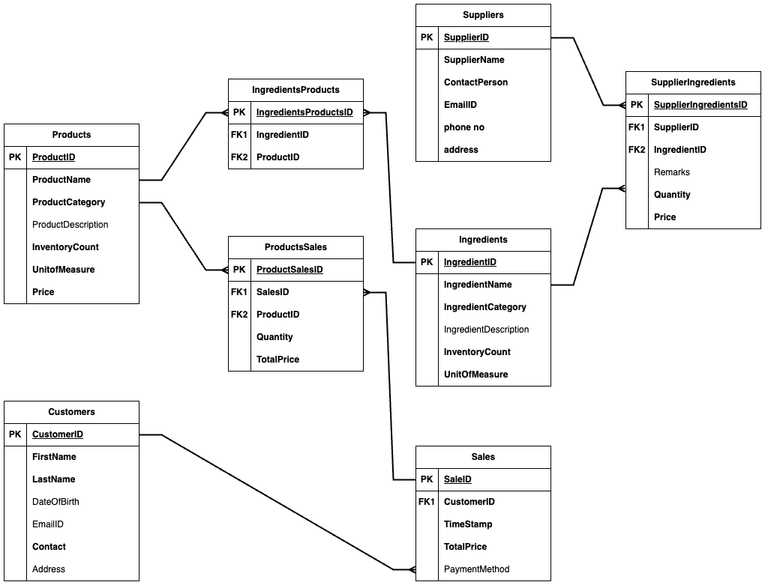

**Table descriptions:**

**Customers:** Contains customer information including unique customer id, first and last names, contact information, date of birth and address.

**Products**: Tracks the inventory count of all the products available for sale and their prices.

**Suppliers**: Stores supplier’s details like the contact person’s name, email id, phone number, address, etc.

**Ingredients**: This table stores the inventory count of the ingredients in bakery and their prices.

**IngredientsProducts**: This is a linking table to track the ingredients used in products.

**SuppliersIngredients**: This is a linking table to record the purchases of ingredients from suppliers.

**Sales**: Tracks the amount and time of sales made by customers in the bakery.

**ProductSales**: This is a linking table that tracks the number of products sold in a sale id.

**Assumptions / Design Choices:**

* Multiple products can be sold to multiple customers.
* Any ingredient can be taken from any supplier.
* Many ingredients can be used in many products.

**Relationships:**

|  |  |  |
| --- | --- | --- |
| **Customers – Sales** | **1 to Many** | One customer can have multiple sale ids, but each sale id is unique for customer. |
| **Sales - ProductsSales** | **1 to Many** | Many product sales can be done in a single sale id, but each product sale id is for one sale id. |
| **Products - ProductsSales** | **1 to Many** | One product can be part of many sales transactions. |
| **Products - IngredientsProducts** | **1 to Many** | One product can be made with multiple ingredients |
| **Ingredients - IngredientsProducts** | **1 to Many** | One ingredient can be used in making of multiple products. |
| **Ingredients - SuppliersIngredients** | **1 to Many** | One ingredient can be purchased from many suppliers |
| **Suppliers- SuppliersIngredients** | **1 to Many** | One supplier can supply multiple ingredients. |