Intro to DBMS

Project-2

**ER Diagram**:

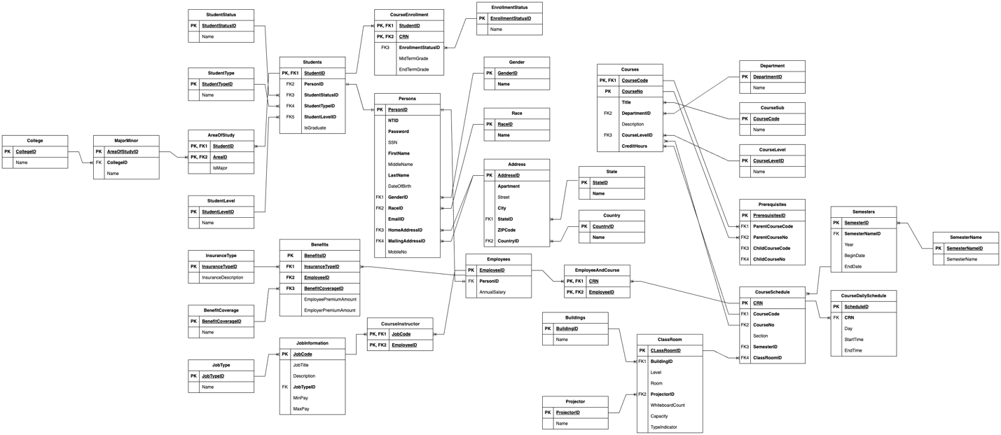

**Modifications in Design Choices**:

* Created EnrollmentStatus table to be used as reference in CourseEnrollment table.
* Modified the Benefits table to have one PK, 3 FKs - InsuranceType, BenefitCoverage, EmployeeID to let the Employee have multiple insurances, benefits.
* Removed IsFaculty column in JobInformation as there is 'Faculty' in JobType.
* Merged StartHour, StartTime columns in CourseDailySchedule Table into StartTime and set it as TIME datatype. Same with EndHour, EndTime columns.