ExtentReports
- Test Details
- Analysis
Automation Report

- 2018-05-28 15:10:43
- v2.41.0

Total Tests

Total Steps

Total Time Taken (Current Run) 0h 1m 19s+372ms

Total Time Taken (Overall) 0h 1m 19s+372ms

Start 2018-05-28 15:09:24

End 2018-05-28 15:10:43

Tests View

test(s) passed
test(s) failed, others

Steps View

step(s) passed
step(s) failed, others

Pass Percentage

Environment
Param | Value
User Name | EbizVinod
OS | Windows 10
Java Version | 1.8.0_171
Host Name | DESKTOP-7J9QVL8

Tests

- Pass
- Fail
- Skip

- Clear Filters

·

·

- loginWithCredentials fail
- 2018-05-28 15:09:24
- Status | - Timestamp | - StepName | - Details
 | - 15:10:01 | - Test Failed | 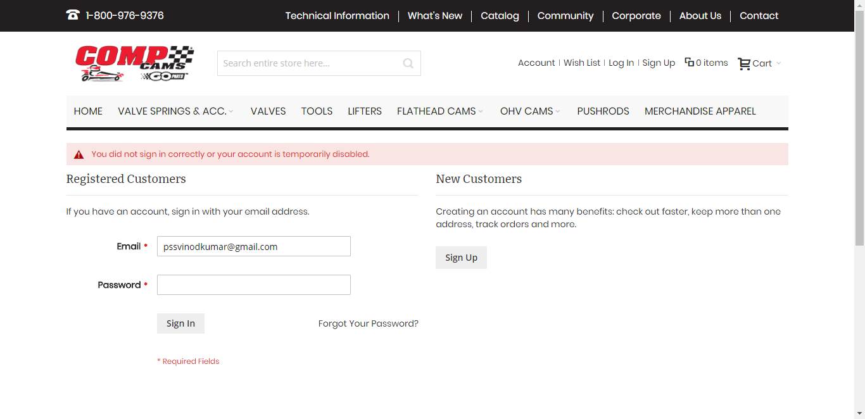
 | - 15:10:02 | - Test Failed
- loginWithCredentials fail
- 2018-05-28 15:10:02 2018-05-28 15:10:43 0h 0m 41s+184ms
- Status | - Timestamp | - StepName | - Details
 | - 15:10:38 | - Test Failed

Configure Tests Count Setting
Parent Tests Only (Does not include child nodes in counts)
Parent Tests Without Child Tests + Child Tests
Child Tests Only
Save

Select status
Pass
Fail
Fatal
Error
Warning
Skipped
Info
Unknown
Save

