NewProductBigCommerce Documentation
Created by: David Barnes
Last Updated: 4/24/2026
Version: 0.5.1
Requirements Option 1: data.csv (sample included)
Requirements Option 2: sqlcmd and products.txt
Requirements Option 3: dataSQL.csv (generated by Option 2)
Requirements Option 4: sqlcmd and BigCommerceProducts.txt

How to Use
This is a tool meant to generate a baseline .csv file to import for new products on BigCommerce. This script DOES support creating multiple products in a single run. At the moment, you have two pathways for how to accomplish this. The first, and most manual way, is with “Option 1. Process data.csv” which requires a “data.csv” file which gets converted into an import-ready .csv file for BigCommerce. The second way, which requires SQL database access, involves Option 2 through Option 4 and requires reading the documentation below to properly understand. I highly recommend also reading the “Final Notes” section as it contains some useful information for using this tool that comes from me actually using the tool and noting quirks or things to keep in mind.

Option 1. Process data.csv:

A file named "data.csv" must be included in the same folder as the script being run; an example file is included in the dropbox folder where you found this script so you know what it should look like. In the "data.csv" file, new products are identified by when the "Product" value changes and it will use the values in "Product", "Search Keywords", "Name", "Price", and "Item Type" in that entry to create the product-level information.

For variants, enter the "UPC", "Primary Barcode", "Size", and "Width" data in those columns. The script will look at the "Primary Barcode" and "Size" to determine if it needs to create variant rows, so those two fields are mandatory. "UPC" and "weight" are optional.

The easiest way I'm aware of to get this information is actually using the “Generate dataSQL.csv” feature which utilizes Celerant’s database, but for the non-database method it is to manually check the Barcodes under Products in Celerant if the amount of variants is small. If it's something larger like pants or footwear where you can have many unique variations, you can run the "Export for Min-Max Adjustments" report to get everything but the UPCs. Then you can collect UPCs either manually via the Barcodes page or you can sometimes get them from the vendor's b2b site. Details on how to do this are usually under Vendor Notes.

Please reference the "data (example shoe/pet/apparel).csv" files included in the "Examples" folder to see how this should look, and the “About the Fields in data.csv and dataSQL.csv” section for up to date details on the data.csv file. Your data.csv file should look something like this:
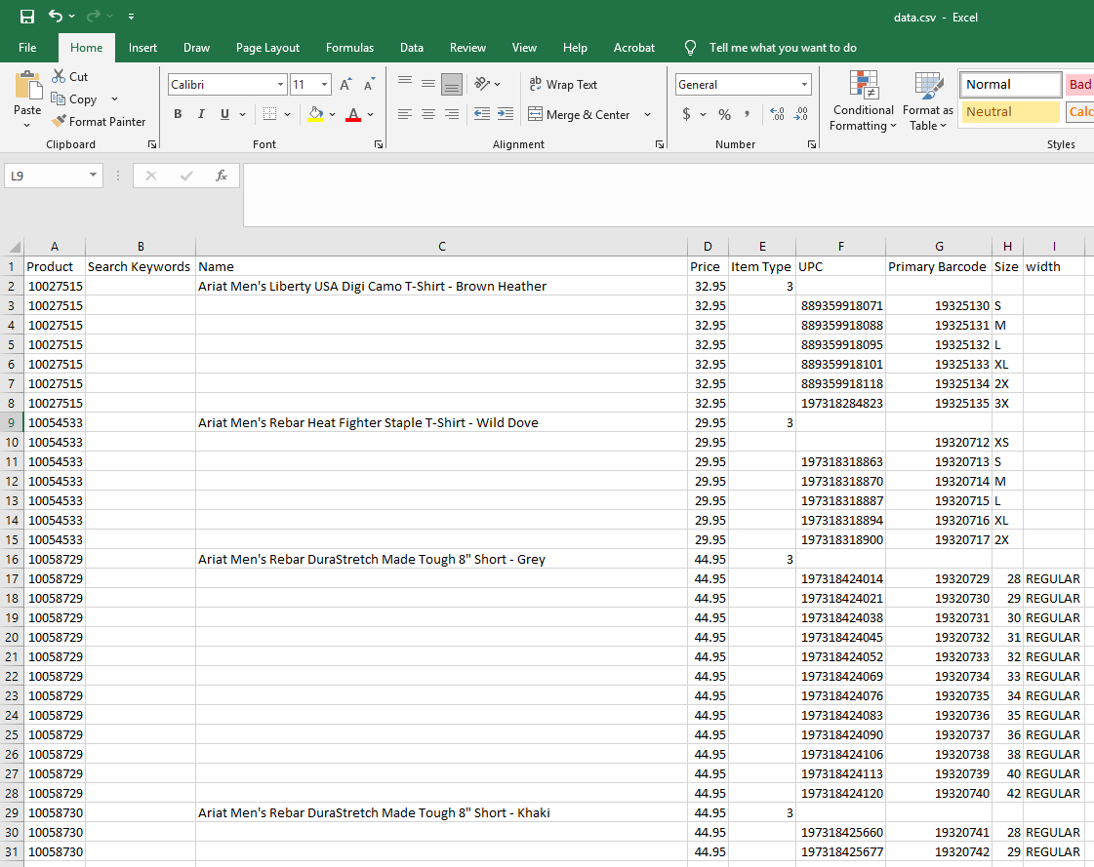

The generated NewProductsMM-dd-HH-mm-ss.csv file will be in the "Output" folder (the folder will be created if it does not exist)

Option 2. Generate dataSQL.csv (Required: products.txt)

A new feature of this script is the ability to generate a .csv file with the help of a SQL (database) script. This has the capability to grab everything you need EXCEPT a properly formatted "Name" as our internal product description is shortened compared to what we would list the item as on the web store. Because of this, there are TWO menu options associated with this process.

The first option is “2. Generate dataSQL.csv (Required: products.txt”)". This option will generate a file called "dataSQL.csv" with the same formatting as the normal "data.csv" file used prior.

The first thing you will need to do this option is to fill "products.txt" with the product codes you are importing data for. This should be one product code per line and you can simply copy a selection of Product codes from the “New Products for Web” Google spreadsheet or an equivalent dataset. You can also just manually collect the Product codes if you wish.
Here is an example of what products.txt should look like:

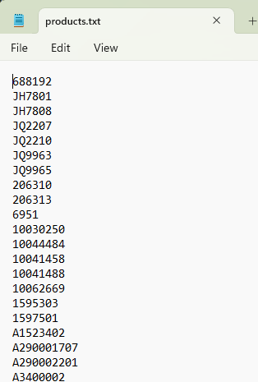

You will need to install a tool called "sqlcmd" in order to run this. You can do so by running this in the command line or Powershell:

winget install sqlcmd

When you enter this command, you will get an output indicating it is installing. Once you have installed it, entering the same command again will show the below text. If you are seeing that, it means sqlcmd is successfully installed. No admin credentials are necessary.

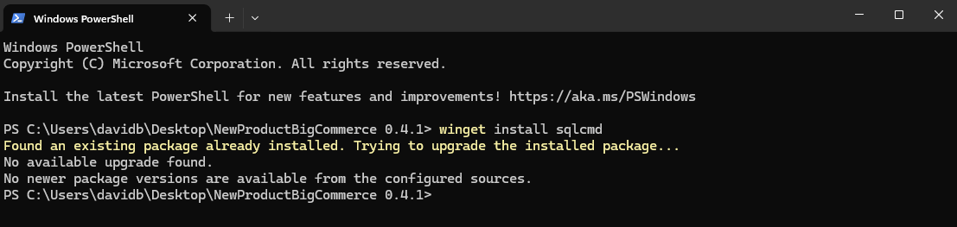

You will also need to know the password for the Celerant database. If you do not have this, you will need to go through AJ to obtain it.

After you run "2. Generate dataSQL.csv (Required: products.txt)” and generate a "dataSQL.csv" file, it is important to open that file and clean up the Product "Name" values to match our naming conventions. You CAN do this in BigCommerce if you want, however this tool generates "Search Keywords" values based on the "Name" of each product, so if you don't fix the "Name" values until after the import, you won't have as clean "Search Keywords" values. If you don't care about this, then go ahead and move on to the next step. Otherwise, take care of that first.

Your window should look like this after running this option:

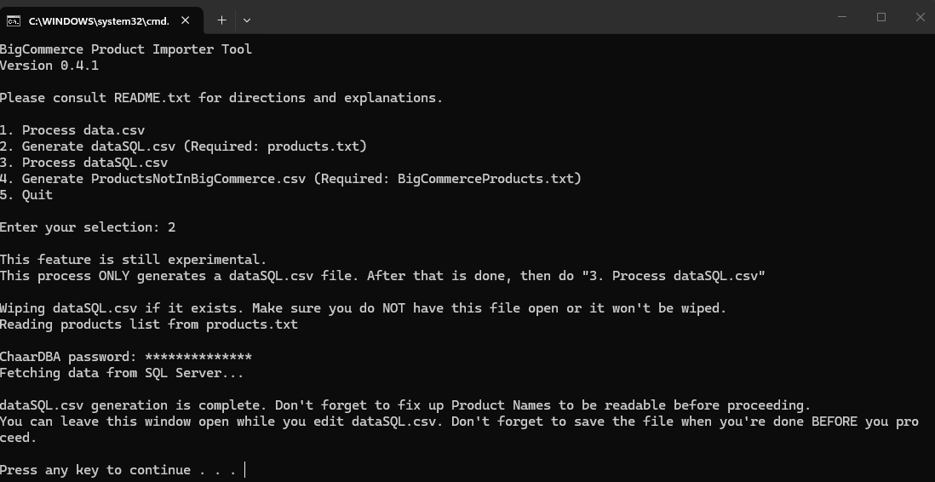

After you press a key to continue, you will be returned to the menu. This is the only option in this script that behaves this way and is because you are meant to run Option 3. afterwards. Your next step is to run "3. Process dataSQL.csv".

While editing dataSQL.csv, be VERY CAREFUL about Excel changing cell values due to automatic data type conversions or rounding. In particular, you want to watch the Primary Barcode, UPC, and Size columns. Primary Barcode and UPC will often be shown in Scientific Notation and if you save this file without converting those columns to “Number”, it will overwrite those values to contain the text version of that Scientific Notation meaning when this value gets written elsewhere, it will lose the last half a dozen or so digits. For Size, you want to watch that decimal values don’t get rounded. Excel may change a value of 7.5 to 8. If your sizes go 7, 7.5, 8, 8.5, 9, 9.5, 10 and Excel rounds it, it’ll look like: 7, 8, 8, 9, 9, 10, 10. BigCommerce WILL alert you of this and fail to import any products that have this issue, so this is less of a worry than the Primary Barcodes and UPCs, but it is still good to know.

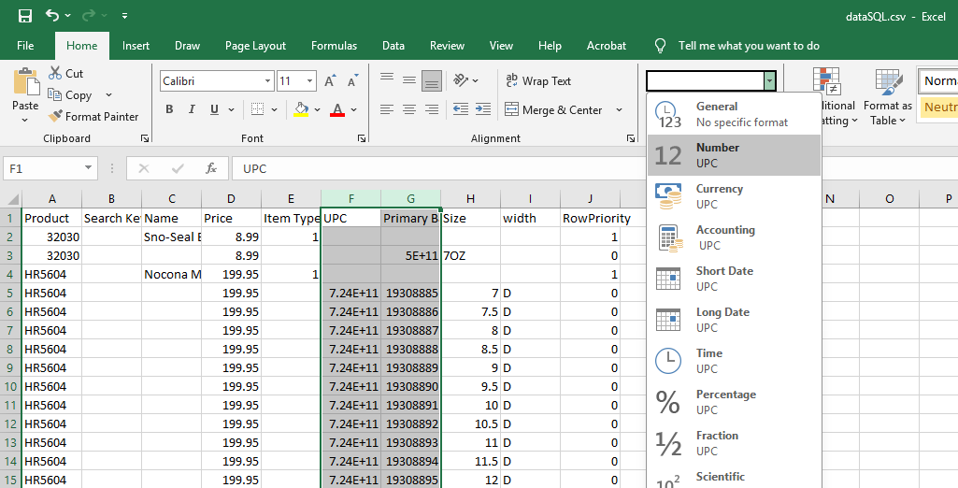
Highlight the relevant columns (You don’t need to set the Size column’s data type, just watch that it doesn’t change while resizing columns) and set to Number. You will see decimals appear.

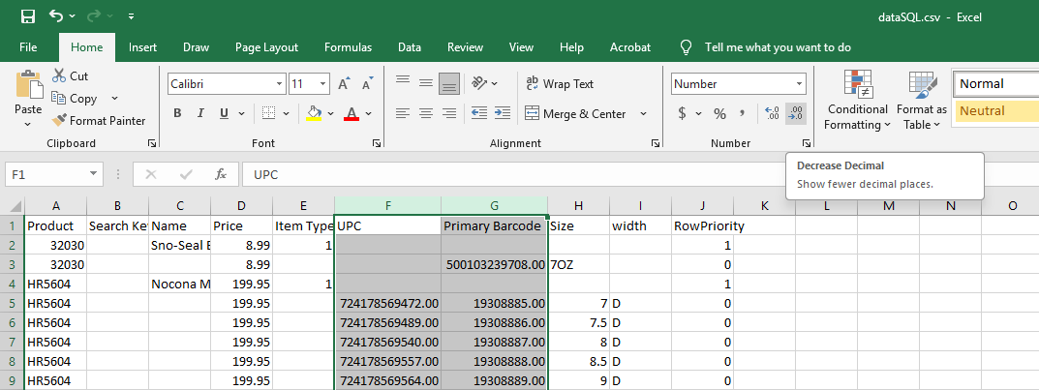
Hit the Decrease Decimal button twice to get back to whole numbers.

Option 3. Process dataSQL.csv
You can leave the command prompt open between the previous step and this one and update the "dataSQL.csv" while it's open, just make sure you don't edit the file while it's processing anything. This file is actively read line-by-line during this step so if you are messing with the data, you may end up creating a malformed output file.

As this script runs, you will see the exact line-by-line output of what is being written to the new output file that you would upload to BigCommerce.txt. You do not need to review any data on this window and should look at the final NewProductsMM-dd-HH-mm-ss.csv file. This output on the window is primarily for you to have an indication of progress and also to have an at-a-glance view of the data to be able to see any obvious mistakes that would be significant enough that you would start over.

Here are some screenshots of the start, middle, and end of this process. Note that the formatting of the “Name” value in the below screenshots are not what you would use and you would need to clean them up to be readable. They are like this in my screenshots just because I was testing a large sample size:

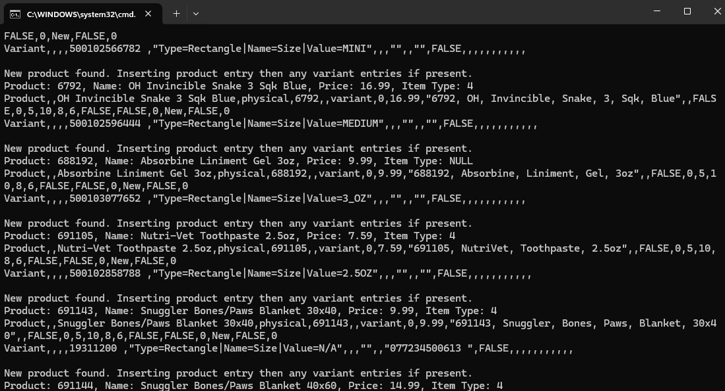

After you run this step, you will have a NewProductsMM-dd-HH-mm-ss.csv file in the "Output" folder just like you do for the manual option and it will be ready for import into BigCommerce.

At this point, it is very important to OPEN this file and verify the contents. Make sure your SKU value contains the Product code for an item=Product row and the UPC/EAN value is blank. There should be Search Keywords containing the Product code as well as all the words in the Name. There should also always be a Price defined on this row. For an item=Variant row, make sure the SKU is the Primary Barcode and the UPC/EAN has the UPC code. The Options value should contain a longer string of characters containing the Size and optionally the Width. There should be no values under Price unless the Price varies from the Product’s base price. All columns should line up with their header and if you see any rows that are offset from the rest, that indicates a problem occurred with the script and is related to special characters in a text field like Name. Your output file’s formatting should look similar to this:
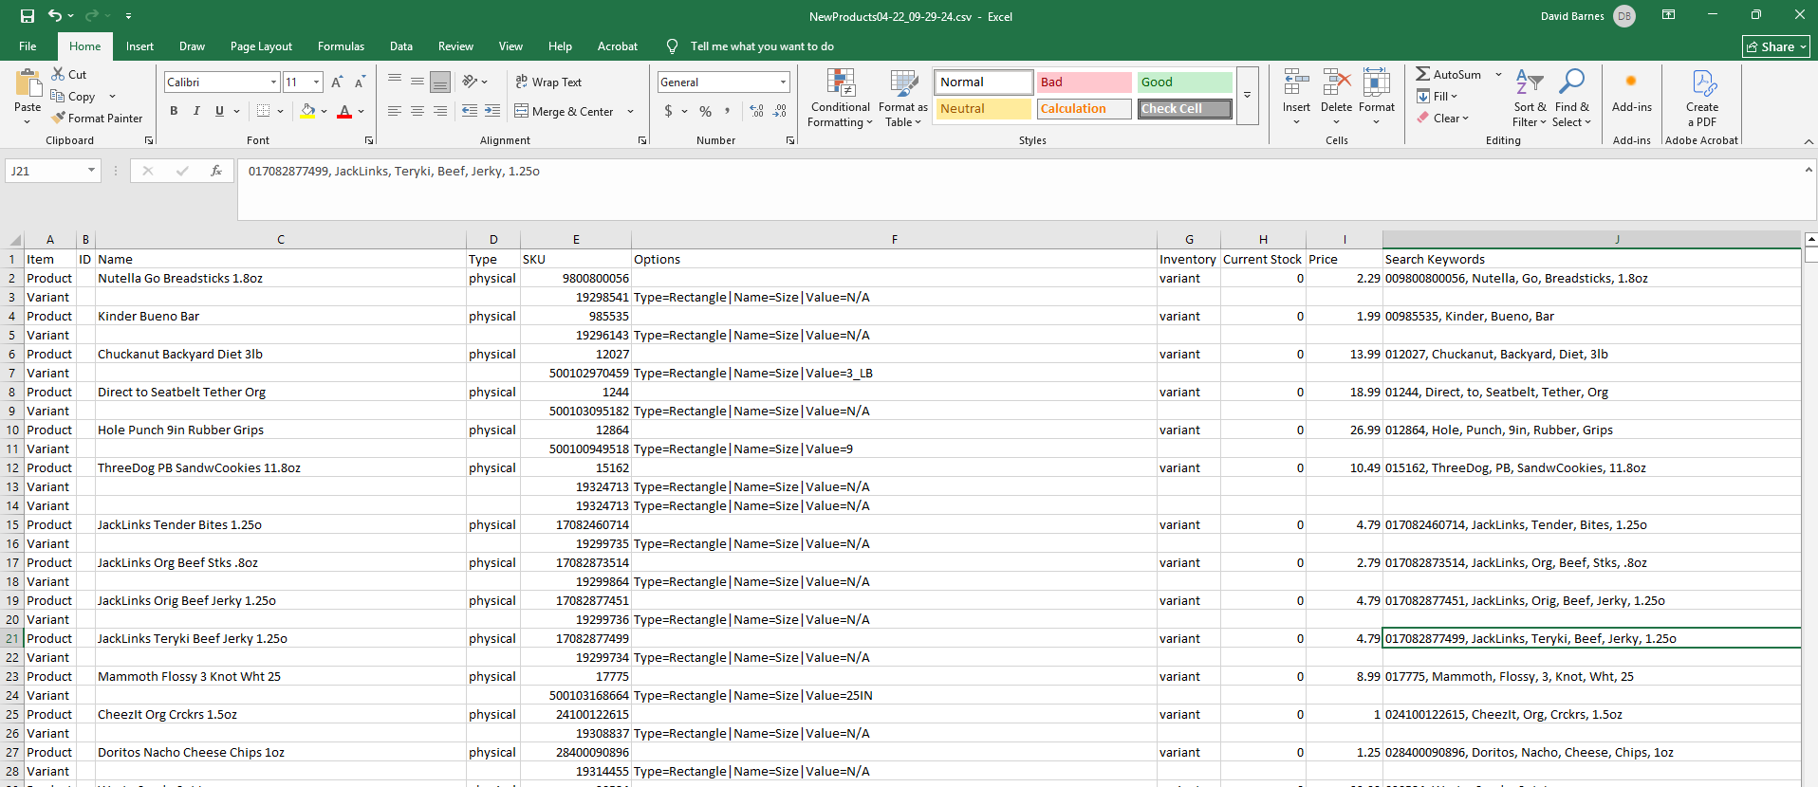

Option 4. Generate ProductsNotInBigCommerce.csv (Required: BigCommerceProducts.txt)
This is the newest feature of this tool and it generates a near-comprehensive collection of Celerant products that are NOT in BigCommerce. It accomplishes this by performing the following actions:
- Read in an input of BigCommerceProducts.txt which is really just the contents of the “Export SKUs” feature in BigCommerce and using the Product SKUs values. It will give you a file named skus-YYYY-MM-DD.csv. You can just rename it to BigCommerceProducts.txt or you can copy and paste it into a new file. Note that this file contains the PRIMARY BARCODE values and NOT the Product codes.

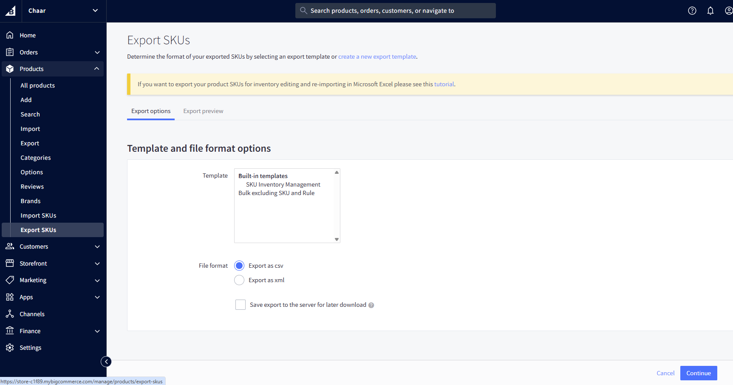
- Strip away any quotes and leading/trailing whitespaces present. The file that comes from BigCommerce has a handful of rows that have tabs which causes them to be wrapped in quotations in the .csv file. This likely comes from how these items are inputted in BigCommerce and COULD be fixed manually. Nonetheless, the data exists and this step therefore exists to normalize the data.
- In batches of 300 Primary Barcodes, run the query “Queries\BigCommerceProducts.sql” using the list of 300 products as the input parameter. This will generate another list of Product codes that correlate with the Primary Barcodes.
- Once all Product codes have been collected, another SQL query is dynamically built. This query creates a temporary database table that holds every Product code we collected. Then, another query “Queries\ProductsNotInBigCommerce.sql” is appended to this larger query. This final query will output a selection of Products that are NOT present in the list we provide as input which should be the Products that are in Celerant but NOT in BigCommerce.

Just like with the previous SQL-related options, you need to be careful here since you’re relying on data coming from both BigCommerce and Celerant’s database as opposed to having been thoughtfully filled out by a human. Because of this, we can run into issues relating to non-standard configuration on both of these fronts.

If an item is in BigCommerce, but the Primary Barcodes used in that item’s variants don’t or no longer match what’s in Celerant, it will be picked up as not existing.

If an item is in Celerant with a Primary Barcode that just doesn’t match what the BigCommerce item has (like if Celerant’s item has the UPC as the Primary Barcode, or more than one “SKU” barcode exists and the one that’s selected as Primary Barcode doesn’t match BigCommerce’s), it will also appear as not existing.

If an item is in BigCommerce but has no Variants, it will be counted as not existing as well. If your ProductsNotInBigCommerceMM-dd-HH-mm-ss.csv has a Product that, when you search the Product code, appears in BigCommerce then it means the Product page exists but that Product has no variants. In that situation, I would probably fix that page manually. Check the “Final Notes” section for another explanation of this with some examples.

Using Options 2-4 Together

Because of the considerations you need to make with these options, I would not use Option 4 to generate a FULL list of items that to be generated with Option 2. Instead, I would use the following methodology to use this feature:

- Run Option 4 to get an updated list of “Products in Celerant that PROBABLY aren’t in BigCommerce”
- Then pick a sub-selection of those products, such as all Ariat footwear. Copy those Product codes (PRODUCT column in ProductsNotInBigCommerceMM-dd-HH-mm-ss.csv) into products.txt.
- Give your Product codes a glance to make sure nothing is obviously off about the data.
- Run Option 2 to generate the dataSQL.csv file.
- Give your dataSQL.csv file a look to make sure nothing is wrong. The things you are looking for here are that the number of kinds of variants are accurate. If there are extra SKUs or UPCs for a Product in Celerant, it may generate additional Variant rows at this step that need to be deleted. If a Product in Celerant as a UPC as its Primary Barcode, you will see that reflected. You probably don’t want to touch this in Celerant as Primary Barcodes are important, but just something to keep in mind. You can see an example of duplicate Variant rows caused by having multiple UPCs tied to a single product here:
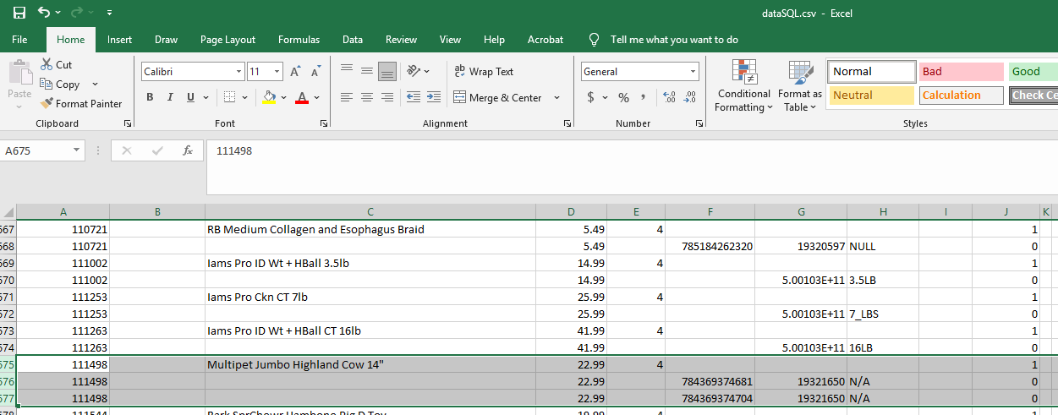
- Update all the Names in dataSQL.csv to reflect what you’d actually like them to be in BigCommerce. I recommend it at this step because it’s faster and also because the Search Keywords are generated based on the Name so having the Name correct at this point ensures more optimal Search Keywords.
- Run Option 3 to generate your NewProductsMM-dd-HH-mm-ss.csv file.
- Give this file a look as well. Any issues that were in your dataSQL.csv file relating to extra Variant options will exist in this file as well, so you can opt to handle it at this step if you wish. What really matters is those Variants get removed at SOME point prior to being uploaded.
- Go into BigCommerce and import them. A useful feature in BigCommerce is that it will not import a Product if any of the SKU variants for that Product already exist in another one.
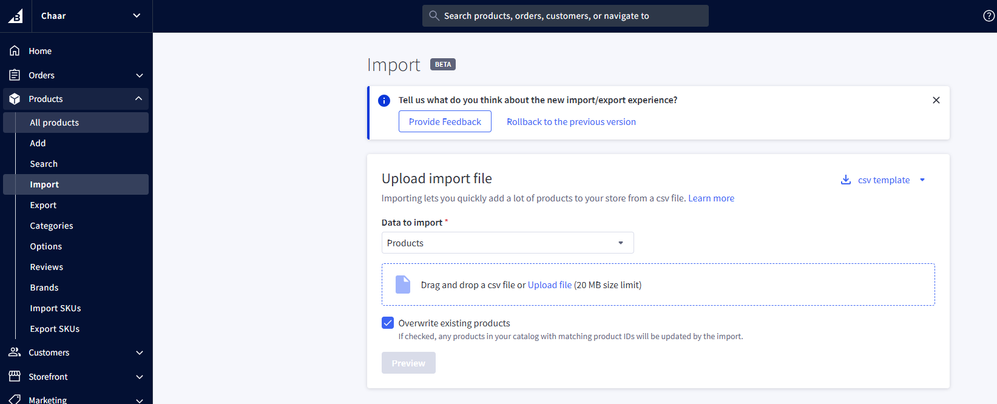
- Once this is done, you can repeat the first step and the Products you’ve added should no longer appear in that list meaning you can use this process to whittle away at the list batch by batch as you like.

About the Fields in data.csv and dataSQL.csv
Below will be a brief description about all of the fields used in the data.csv file.

NOTE: Product-level info needs to be in the row ABOVE all the variant rows. I initially had the product-level info in the same row as whatever the first variant info would be, but it caused a price on the first variant to be manually assigned each time which was undesirable.

Product: The Product number/value as used in Celerant. This value is mandatory on a Product-level entry and optional on Variant-level entries.

Search Keywords: These are comma-separated values used to search for items on the storefront. This script will include both the product code and each individual word used in the "Name" of the product. This should be sufficient for any particular product, but if a single product has variants that represent more than the base product code (separately sized items of the same type that are listed as variants despite having different product values), you can add those to the field. Otherwise, just leave this blank.

Name: The name of the product page (some special characters not supported by this tool)

Price: The price of the item. If there are multiple variants of the same price, the price only needs to be in the first row. If you DO input a price for every variant, if it matches the default price of the product (the Price value on the product-level row), the price value will be blank in the Output file so that it adopts the default price and isn't expicitly set to a specific price. Any variants with different prices than the product's base price should have a value inputted in its row and it'll show on the page for that variant.

Item Type: I added this option to handle Weight/Height/Width/Depth options. It doesn't seem like these need to be EXACT or anything, but different types of items still do have at least generally different values, so I created some standard values based on checking examples on BigCommerce:

1 - Shoes:
TaxClass=1 (0 is Taxable, 1 is Tax-Free)
Weight=5
Width=15
Height=10
Depth=5

2 - Insoles/Socks:
TaxClass=1
Weight=1
Width=5
Height=3
Depth=1

3 - Apparel:
TaxClass=1
Weight=2
Width=7
Height=7
Depth=2

4 - Pet Supplies/Food:
TaxClass=0
Weight=5
Width=10
Height=8
Depth=6

If you think there should be different default values, you can let me know and I'll update these values. The values for pet supplies/food in particular are conservative because there is a wide variance, so much sure to update those to proper values afterward as they will affect what we charge for shipping.

NOTE: I mentioned it already, but just remember that product-level info needs to be in the row ABOVE your variant rows. If you have a product that has three variants, there should be FOUR rows that contain the following info:
Product info
Variant 1 info
Variant 2 info
Variant 3 info

UPC: The UPC code found under the "Barcodes" menu in Celerant. This field is optional and its absence usually indicates the item doesn't exist, is discontinued, we don't carry it, or we have never received it. So make sure to make it not purchasable on BigCommerce if you want to include a variant with no UPC.

Primary Barcode: This is the Primary Barcode value found under "Barcode" that should have a "SKU" type. This field is mandatory and BigCommerce can detect duplicates so if your import gets an error on a product because of a duplicate SKU/Primary Barcode, it's because it already exists. While variants are technically optional, in order for any product's inventory to be tracked it must have variants so in that sense variants are NOT optional. I may update this script to make this more clear later.

Size: The value for the "Size" variant type. Technically there isn't a specific name for a default variant type but Size is used for everything when there are variants, so it is default in this script. If the product does not have a Size, you can use something like "One Size" to indicate it only comes in one size.

width: The second most common variant type, this one is optional and correlates mostly to footwear.

Color: The third most common variant type, you will find this on some pet items like collars, or on some pants.

RowPriority: This row can be ignored. It only exists to help me sort the data and should any appear in the dataSQL.csv file. It should not affect any of the processes even if you delete the column altogether.

Using the SQL Database
We recently got read-only access to the Celerant database which holds all the data we need. In the “Queries” folder is a file called dataCsvQuery.sql that can retrieve all the data that needs to be present in data.csv. When you select the menu option to "Import data from SQL Database", you are running this script and sending the output to a new file called "dataSqlTemp.csv". The script cleans the data up a little (the sqlcmd output adds a couple extra rows of junk that needs to be removed) and creates another file called "dataSQL.csv". This is the file that will be processed when you select the "Process dataSQL.csv" option.

Do not manually edit ANY files in the “tmp” folder unless you know what you are doing. These files are generated to help the script work and do not need any human intervention.

If you're not me or AJ and need/want database access, contact AJ.

Things you need to still update in BigCommerce
Not everything can realistically be handled with this script with the most obvious example being the Description because that involves HTML/Styling. Below is a non-exhaustive list of things that need to be configured in BigCommerce following the import:

1. Visible on Storefront checkbox (Disabled intentionally with this script)
2. Brand
3. Categories
4. Description
5. Images
6. Inventory (Just set to "On variant level" if applicable)
6a. Make sure to make sure the SKU/UPC values look good while you're on this page just as a sanity check
7. Dimensions & Weight (Only if the default values this script used aren't applicable)

Final Notes
When working with Option 1, I find it simplest to work with the same data.csv file open and just modify it (by deleting all the rows after the header) rather than create a new file each time. Keep in mind though that if you copy and paste information into Excel such that deleting the data leaves behind formatted empty cells (like a border), the script may see those empty formatted cells as non-empty and will create an extra phantom product at the end of the csv file. The script looks specifically at the "Product" field when determining if it needs to make a new row so if you have empty cells that still have formatting on them, just delete the rows outright instead of deleting the data. You can also just delete the row in the output file as well.

Weight & Dimensions are pretty important in the context of web sales because that is what produces the estimated shipping costs. If you have a 10-pound item with large dimensions but the dimensions on BigCommerce reflect something much smaller/lighter, we will charge lower shipping costs than will cost us to actually ship it resulting in a loss on the shipping fees.

Purchasability, the option to enable/disable the ability to purchase from the web store, CANNOT be configured with the modern importer tool which is relevant to pet food in particular. The legacy importer tool is still available which DOES allow the configuration of this value, but the formatting on the imported .csv is slightly different. I plan to look into adding an option for a modern/legacy import, but currently that is not available with this tool.

If you're adding pet food in just one size, search BigCommerce to see if a parent product page exists with other sizes already so we don't have multiple pages for the same product.

Sometimes, particularly with PET category items, you will have one product that comes in different sizes but each individual size is its own product with its own product code rather than being more similar to footwear with sizes/widths included in the matrix of a single product. In BigCommerce, we will want those products to all be under a single page. In that situation, you need to manually edit the data.csv or dataSQL.csv file to handle that. The base product’s product code can just be any of the included items (probably whatever the first one in the list is) and then you make each size a variant with its proper barcodes. Prices will need to be inputted so they’re not all the same price.

There are a few ways for “Option 4. Generate ProductsNotInBigCommerce.csv” to include products that technically exist already. This tool searches by Celerant’s Primary Barcode and tries to match on BigCommerce’s SKU. If a product exists in both systems but the Primary Barcode and SKU don’t match, it will appear in the list of missing products. Since we create BigCommerce product pages with the actual Product Code as the parent item’s SKU, BigCommerce will actually warn you about a duplicate SKU during the import. This is okay, and actually pretty convenient because it will tell you exactly which products already exist and you can use that information to go check their pages and update the SKUs to match the Primary Barcodes. If inventory was incorrect because of that, you can Import SKUs after finishing your current batch and make sure inventory numbers are updated.

It is basically impossible to get Excel to NOT remove leading zeroes on Barcodes without spending extra time to use more advanced features like Power Query to import data.csv or dataSQL.csv as tables. I don’t have a good answer yet to deal with this when there are many values like this, but ultimately the only number that matters in terms of NEEDING to be this accurate is the Primary Barcode/SKU as this is the value that gets checked for syncing up inventory. If you see a Product Code having this happen, feel free to ignore. If you see Primary Barcodes or even UPCs doing this, try to pay extra attention and use your discretion to determine if you need to DO anything special. It is worth keeping in mind that even if Excel removes the leading zeroes, that zero still exists UNTIL you save with Excel. You can tell which numbers have leading zeroes by opening them in a text editor like Notepad or Notepad++. So, if you find a single Primary Barcode/SKU with a leading zero, you could open that file in Notepad then add the zero back to the number after you save with Excel. This may actually be a good case for NOT editing product names in dataSQL.csv and doing it in BigCommerce because if you do that, you will not need to edit dataSQL.csv at all meaning you can import the products with proper Primary Barcodes since you never needed to edit them in Excel. You would need to edit names and add the Search Keywords manually, but that is preferable having inventory not be correct.

TODO
1. Figure out why the "Inventory" selection doesn't get set to "On variant level" and defaults to "Do not track" even though I have the proper value set. I am wondering if it's because the product is being important from scratch and didn't already exist. This may not be a value I can set at this scope.

2. Add support for the Legacy Importer

Useful resources for David (can ignore if you're not me)
Batch script character escaping rules: https://stackoverflow.com/questions/6828751/batch-character-escaping

Do not allow online purchasability for: pet food (freeze dried ok, air dried is NOT)/cat litter/bedding/large pet beds

Available in store only. Visit our Locations page for store locations.

/A flag before setting a variable makes it an integer

,.*$ - Regular Expression to target first comma through the end of a line

Update History

03/31/2026 0.1.0
Initial version - Support for single product creation with optional variants via data.csv

04/02/2026 0.2.0
Support for multiple product creation handled entirely in data.csv, no more user prompts for product-specific info

04/09/2026 0.2.1
Cleaned up logging to make it more readable

04/10/2026 0.3.0
Added Search Keywords to data.csv. Script will also generate keywords for this field based on the product code and the name.
Added data sanitization to Size, Width, and Search Keywords to properly handle double quotes, dashes, and slashes.
Changed comment syntax from :: to REM because Batch hates it when inside a block
Changed data.csv formatting such that the first variant starts on the NEXT line after the product information. This was to fix price logic affecting the first variant too.

04/14/2026 0.3.1
Loosened requirement on needing to copy + paste the Product code in every row, will now assume the current product if on a variant row and Product cell is empty
Loosened requirement on Price formatting. If Price is present for variants but matches the default product-level price, it'll be blank on the output and not explicitly set.

04/15/2026 0.4.0
Added SQL importer
Requires products.txt which has a product code on each line

04/21/2026 0.5
Added Missing Products in BigCommerce generator (documentation needed)
Requires BigCommerceProducts.txt which has a primary barcode on each line
Minor refactoring
Filtered out Inactive items from SQL-based processes
dataCsvQuery.sql now sorts by Brand then Product rather than just Product to help group together items from the same brand
Removed ‘PRODUCT Formatted’ column because it’s unnecessary. It can be added back later if needed.

04/24/2026 0.5.1
Added support for Color in data.csv and dataSQL.csv
Added some extra data sanitization to allow for quotes and ampersands in product names and search keywords

