
Smart Attendance System
LAB REPORT
Project Report: Database Management Systems

Muhammad Awab Abdullah | 2024358
Muhummad Shareq Usman | 2024465
Ali Akbar | 2024615
Abdul Rehman Asif | 2024027

1.Introduction
This project develops a face recognition-based student attendance management system with the database backend of PostgreSQL. The goal was to replace manual rollcall with an automated pipeline, where a trained vision model recognizes students and the database logs their presence in real time. Development was tracked on Jira in four epics, with the database layer being the first to be finished as every other part – the GUI, the recognition runtime, and the access control – depends on a stable, well-structured schema.

2. Database Schema
The schema is made up of eleven tables related to a central users entity. The design cleanly separates concerns - authentication, identity, academic activity, and audits - have their own region of the schema, shown in the ER diagram.
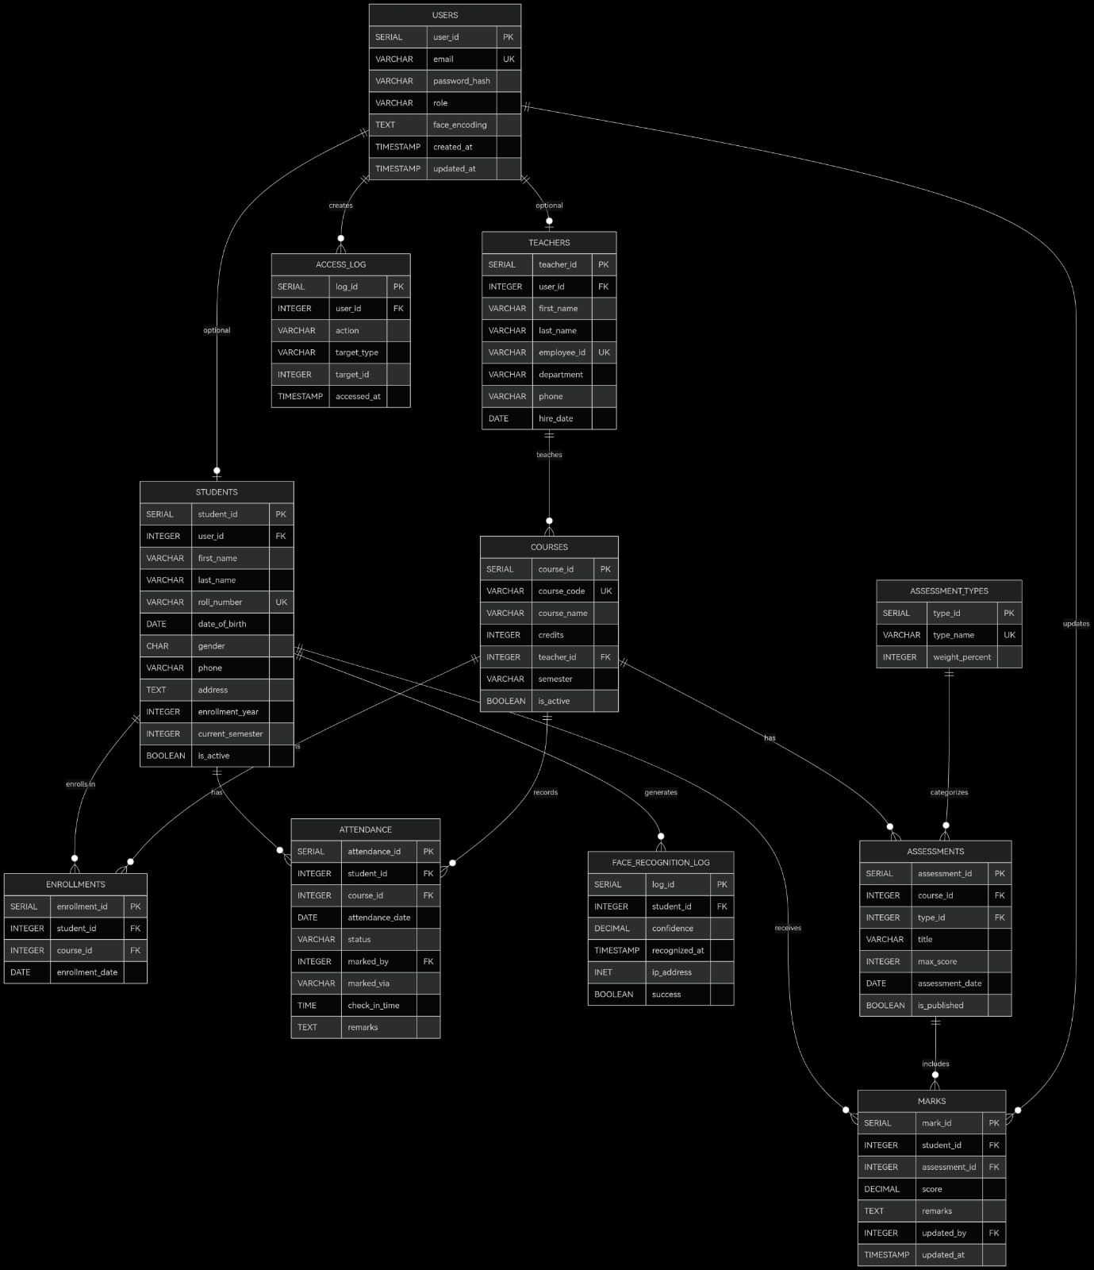
Figure 1: Entity Relationship Diagram -Smart Attendance System

USERS
The main authentication table for the whole system. It stores the email (unique), an encrypted password hash, a role field with a CHECK constraint limiting the values to 'teacher' or 'student', and a face encoding TEXT column, which contains the numerical vector generated by the recognition model. Here the encoding is kept, and one join solves both identity and biometric data without a need for a separate lookup table.
TEACHERS and PUPILS
Both tables extend the user record with profile-specific fields, and link back to USERS via a unique foreign key on user_id, enforcing a one-to-one relationship between an account and a person. TEACHERS contains employee_id (unique), department, phone, and hire date. STUDENTS contains roll number (unique), date of birth, gender, phone, address, enrollment year, current semester.
COURSES and ENROLLMENTS
COURSES has a code, name, credit hours, assigned teacher, semester and an is_active boolean. ENROLLMENTS removes the many-to-many relationship between students and courses. It has only student_id, course_id and enrollment_date. The first two columns are combined in a unique constraint so there are no duplicate registrations.
ATTENDANCE
The practical core of the system. Each row depicts one student’s status for one course on one date. Key design decisions are as follows:
• status is limited to 'present' or 'absent'
• marked_via differentiates between ’face_id’ (automated) and ’manual’ (teacher override)
• check_in_time records the precise time of arrival for lateness analysis
• Unique constraint between the three columns (student_id, course_id, attendance_date) ensures that there can only be one record for each student for each class session.
FACE_RECOGNITION LOG
Logs every recognition attempt, successful or not. It includes a confidence score (a decimal between 0 and 1), the IP address of the device that triggered it, a timestamp, and a success boolean. This table is a complete audit trail -failed attempts that never result in an attendance record persisted, and that’s important for accountability and debugging.

ASSESSMENTS, ASSESSMENT_TYPES, MARKS
ASSESSMENT_TYPES has the category definitions (quiz, assignment, midterm, final) and a weight percentage for each. The separating of types from individual assessments means that weights are set once and used by reference instead of being repeated. ASSESSMENTS is used to record assessments related to a course and a type.

ACCESS_LOG
Captures the operations of the users across the whole system. Each significant event creates a record in this table with details about the acting user, action performed, object type being acted upon, and ID of the object acted upon.
Indexing
To optimize performance, indexing has been done on all the frequently looked-up fields:
•attendance(student_id), attendance(course_id), attendance(attendance_date)
•marks(student_id), marks(assessment_id)
•face_recognition_log(student_id)
•enrollments(student_id), enrollments(course_id)

3. Normalisation
Normalisation was one of the goals in the design of this database schema. This schema is in 1NF because each attribute is an atomic attribute while each table has a well-defined primary key; course enrolments are stored as multiple entries in ENROLLMENTS table, not as comma-separated list in STUDENTS table.
This schema is also at 2NF since non-key attributes depend on the whole primary key. For instance, status, method and check-in time in ATTENDANCE all refer to the instance of (student, course, date).
There are no transitive dependencies in the schema as data is stored in its rightful place. We store assessment type percentage in ASSESSMENT_TYPES table and do not repeat it in ASSESSMENTS. Teacher department data is stored in TEACHERS table and not in COURSES table.
Finally, in Boyce-Codd normal form we have a requirement that every determinant in a table should be a superkey. Course code in COURSES table is UNIQUE along with course_id, thus it is also a superkey. Similarly, email in USERS table is UNIQUE along with user_id. Finally, in MARKS the only determinant of score and remarks attributes is the composite (student_id, assessment_id).

4. Face Detection and Matching
In the vision part of the process, a YOLO-based model (best.pt) is used for detecting and matching the faces of students. Upon successfully detecting the face, the program searches for the corresponding student from the database and records the attendance automatically with marked_via equal to 'face_id'. In parallel, a record is inserted into the table FACE_RECOGNITION_LOG with the value of confidence. In case of failed recognition, only the log file will contain success = FALSE, while no attendance record will be created.
Model Training Results
Figure 4 displays the training loss in the form of train/cls_loss metric over 70 training epochs. As shown, the initial loss is about 4.2, meaning the model learns everything from scratch at that point. Next, the loss decreases drastically during the first ten epochs before continuing to decline steadily, reaching less than 0.5 by epoch 70. The red dotted line traces the actual values throughout training, proving stability and consistency without any unexpected spikes. Thus, it can be concluded that the training was highly successful in terms of convergence.

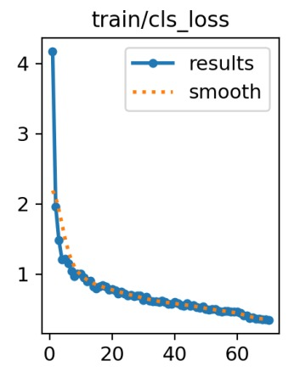
Figure 2: YOLO Model

5.Project Management – Jira
PostgreSQL Database (KAN-12 till KAN-19) - DONE
This was accomplished first and comprised schema design and normalisation, database integrity and constraints setup and creating all entity tables (users, teachers, courses, students, attendance, and assessment including marks). Ticket ordering was done in accordance with that logic: schema & constraints prior to data and data prior to application logic.

Access Control System – Role Based (KAN-14) - DONE
Permission schema definition. Permission checks are carried out on the database level (CHECK constraints on the role field) rather than the application layer by use of foreign keys relations from user to teacher, and both to student.
YOLO Model Training (KAN-9, KAN-10, KAN-11) - IN REVIEW
It includes gathering and annotating data set, configuring environment, model training and tuning. Detection pipeline is working and under validation with respect to student database entries.
Integration & Testing (KAN-15, KAN-16, KAN-20, KAN-21) – IN REVIEW
It includes face detection verification against student database entry, SQL query tuning for performance, reporting generation and GUI integration.

6. Conclusion
The database is the heart of the entire system. Using normalisation, redundancy is eliminated and update anomalies are avoided for all eleven tables. The segregation of the USERS, TEACHERS, and STUDENTS table helps in keeping authentication free from role-based data. The combination of the ATTENDANCE and FACE_RECOGNITION_LOG table provides the system both with its transaction logs and a full audit log. The system is now on the right path towards providing an automatic yet auditable solution for attendance management with a scalable schema.

