JavaScript WebService : Classes JavaScript ←→ Classes C#

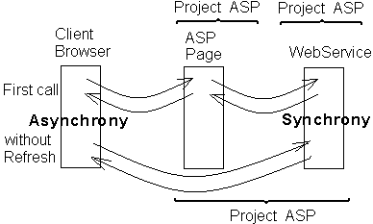

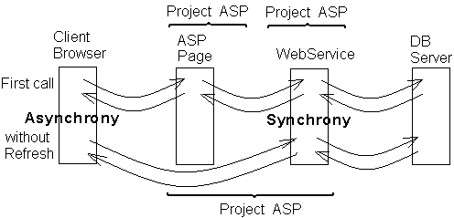

Plus_JavaScript_WebService Default.aspx.cs
public partial class _Default : System.Web.UI.Page
{
protected void Page_Load(object sender, EventArgs e)
{
Button1.Attributes.Add("onclick", "javascript:Plus_Click();return false;");
Button2.Attributes.Add("onclick", "javascript:HeeloWorld_Click();return false;");
}
}
- - - - - - - - - - - - - - - - - - - - - - - - - - - - - - - - - - - - - - -
Default.aspx
<script language="javascript">

// function Plus_Click()
// {
// var first = parseInt(document.getElementById('TextBox1').value);
// var second = parseInt(document.getElementById('TextBox2').value);
// WebService.plus ( first, second, onRequestComplete );
// }
// function HeeloWorld_Click()
// {
// WebService.HelloWorld ( onRequestComplete );
// }
// function onRequestComplete ( result )
// {
// document.getElementById('Label1').innerText = result.toString();
// }

function Plus_Click()
{
var first = parseInt(document.getElementById('TextBox1').value);
var second = parseInt(document.getElementById('TextBox2').value);
WebService.plus ( first, second, onRequestComplete , null, 'Label1'); }
function Minus_Click()
{ ……
}
function onRequestComplete (result, context)
{
document.getElementById(context).innerText = result.toString();
}
</script>
<asp:ScriptManager ID="ScriptManager1" runat="server">
<Services>
<asp:ServiceReference Path="WebService.asmx" />
</Services>
</asp:ScriptManager>
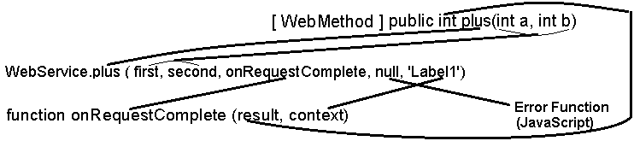

↓ ↓ ↓ ↓ ↓ ↓ ↓

[WebService(Namespace = "http://tempuri.org/")] WebService.cs
[WebServiceBinding(ConformsTo = WsiProfiles.BasicProfile1_1)]
[ScriptService]
public class WebService : System.Web.Services.WebService {

public WebService () { }

[ WebMethod ]
public int plus(int a, int b)
{ return a + b;
}
[ WebMethod ]
public int minus(int a, int b)
{ return a - b;
}
}
- - - - - - - - - - - - - - - - - - - - - - - - - - - - - - - - - - - - - - -
Plus_JavaScript_PageMethods Default.aspx.cs
using System.Web.Services;

public partial class _Default : System.Web.UI.Page
{
protected void Page_Load(object sender, EventArgs e)
{
Button1.Attributes.Add("onclick", "javascript:Plus_Click();return false;");
Button2.Attributes.Add("onclick", "javascript:Minus_Click();return false;");
}

[WebMethod]
public static int plus(int a, int b)
{ return a + b;
}
[WebMethod]
public static int minus(int a, int b)
{ return a - b;
}
}
- - - - - - - - - - - - - - - - - - - - - - - - - - - - - - - - - - - - - - -
Default.aspx
<script language="javascript">
function Plus_Click()
{
var first = parseInt(document.getElementById('TextBox1').value);
var second = parseInt(document.getElementById('TextBox2').value);
PageMethods.plus ( first, second, onRequestComplete , null, 'Label1');
}
function Minus_Click()
{ …… }
function onRequestComplete ( result , context)
{
document.getElementById(context).innerText = result.toString();
}
</script>

<asp:ScriptManager ID="ScriptManager1"
EnablePageMethods="true" runat="server" />

Plus_Minus_Fraction_JavaScript_Class_WebService FractionCSharp.cs
[Serializable]
public class FractionCSharp
{
public int num, denom;
public FractionCSharp ( )
{ num = 0; denom = 1;
}
public FractionCSharp ( int n, int d)
{ num = n; denom = d;
}
public static FractionCSharp operator +( FractionCSharp A, FractionCSharp B)
{ return new FractionCSharp (A.num * B.denom + A.denom * B.num, A.denom * B.denom);
}
public static FractionCSharp operator -( FractionCSharp A, FractionCSharp B)
{ return new FractionCSharp ( A.num * B.denom - A.denom * B.num, A.denom * B.denom);
}
}
- - - - - - - - - - - - - - - - - - - - - - - - - - - - - - - - - - - - - - -
WebService.cs
[ScriptService]
public class WebService : System.Web.Services.WebService {
[WebMethod]
public FractionCSharp [ ] plus_minus (FractionCSharp A, FractionCSharp B)
{
return new FractionCSharp [2] { A + B, A - B };
}
}
- - - - - - - - - - - - - - - - - - - - - - - - - - - - - - - - - - - - - - -
Default.aspx.cs
protected void Page_Load(object sender, EventArgs e)
{ Button1.Attributes.Add("onclick", "javascript:Plus_Minus_Click();return false;");
}
- - - - - - - - - - - - - - - - - - - - - - - - - - - - - - - - - - - - - - -
Default.aspx
<script language="javascript">
function FractionJavaScript (n, d) ///// class FractionJavaScript
{
this.num = n;
this.denom = d;
}
function Plus_Minus_Click ()
{
var first = new FractionJavaScript (parseInt(document.getElementById('TextBox1').value),
parseInt(document.getElementById('TextBox2').value ));
var second = new FractionJavaScript(parseInt(document.getElementById('TextBox3').value),
parseInt(document.getElementById('TextBox4').value ));

WebService.plus(first, second, onRequestComplete);
}
function onRequestComplete(result)
{
document.getElementById('Label1').innerText = result[0].num;
document.getElementById('Label2').innerText = result[0].denom;
document.getElementById('Label3').innerText = result[1].num;
document.getElementById('Label4').innerText = result[1].denom;
}
</script>

שמות שדות במחלקות FractionCSharp ו- FractionJavaScript זהים.
Plus_Minus_Fraction_JavaScript_ClassWithFunction_WebService
<script language="javascript">
function FractionJavaScript (n, d) ///// class FractionJavaScript
{
this.num = n;
this.denom = d;
this.ShowIntoLabels = ShowIntoLabels;
}
function ShowIntoLabels(Lab_1, Lab_2)
{
document.getElementById(Lab_1).innerText = this.num;
document.getElementById(Lab_2).innerText = this.denom;
}
function Plus_Minus_Click () { …….. }
function onRequestComplete(result)
{
result[0].ShowIntoLabels = ShowIntoLabels;
result[0].ShowIntoLabels('Label1', "Label2");

result[1].ShowIntoLabels = ShowIntoLabels;
result[1].ShowIntoLabels('Label3', "Label4");
}
</script>

