Shared Layouts
Controllers → MyController → NameAndPrice Method → Right Click → Add View

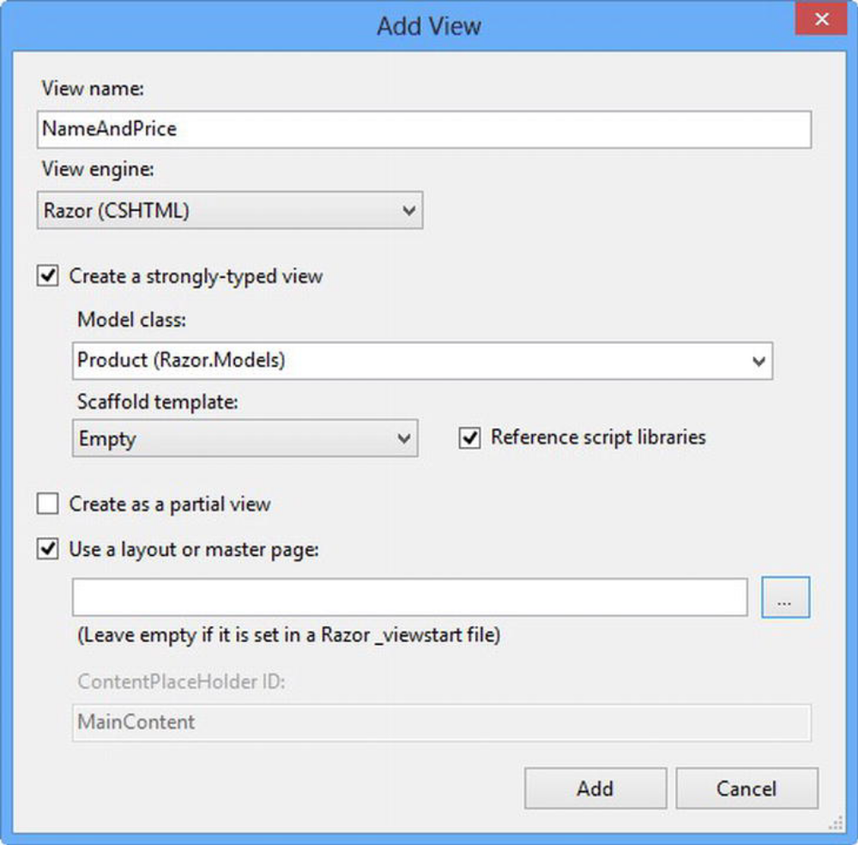

Run /My/NameAndPrice !!!!!!!!!!!!!!!!!!!!!!

