MVC (Model View Controller) design pattern

New MVC Project
VS → New → Project → Visual C# → Web → ASP.NET Web Application → Empty V MVC

Add Controller
(Solution Explorer) Controllers (Right Click) → Add → Controller → (New Name) AAAController

Routing
Run → http://localhost:55933/ ERROR
Run → http://localhost:55933/AAA AAA – Controller name
Run → http://localhost:55933/AAA/Index

Add View
public ActionResult Index()
{
return View();
}

Function Index (Right click) → Add View → V Use a Layout or Master Page (delete V)
Directory View → AAA → File Index.cshtml

@{
Layout = null;
}

<!DOCTYPE html>

<html>
<head>
<meta name="viewport" content="width=device-width" />
<title>Index</title>
</head>
<body>
<div>
aaaaaaaaaaaaaaaaaaaaaaaaaaaaaaaaaaa
</div>
</body>
</html>

Run in browser

Add Model
(Solution Explorer) Models (Right Click) → Add → Class → (New Name) myModel

- - - - - - - - - - - - - - - - - - - - - - - - - - - - - - - - - - - - - - - - - - - - - - - - - - - - - - - - - - - -
The @ character starts inline expressions, single statement blocks, and multi-statement blocks
- - - - - - - - - - - - - - - - - - - - - - - - - - - - - - - - - - - - - - - - - - - - - - - - - - - - - - - - - - - -

Pass data from Controller to View

Controller
public ViewResult Index()
{
// ViewBag.myAAA = "AAAAAAAAAAAAAAAAAAA";
ViewData["myAAA"] = "AAAAAAAAAAAAAAAAAAA";
return View();
}
View
Index.cshtml show ViewBag, ViewData Data Value
<div>
@ ViewBag.myAAA !!!!!!!!!!!!!!!!!
@ViewData["myAAA"] !!!!!!!!!!!!!!!!!
</div>
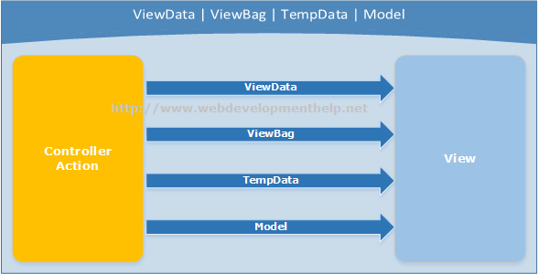

Difference between ViewBag & ViewData:
- ViewData is a dictionary of objects that is derived from ViewDataDictionary class and is accessible using strings as keys.
- ViewBag is a dynamic property that takes advantage of the new dynamic features in C# 4.0.
- ViewData requires typecasting for complex data type and check for null values to avoid error.
- ViewBag doesn’t require typecasting for complex data type.
TempData:
TempData is also a dictionary derived from TempDataDictionary class and stored in short lives session and it is a string key and object value. The difference is the life cycle of the object. TempData keeps the information for the time of an HTTP Request. This mean only from one page to another. This also works with a 302/303 redirection because it’s in the same HTTP Request. It helps to maintain data when you move from one controller to other controller or from one action to other action. In other words, when you redirect, “Tempdata” helps to maintain data between those redirects. It internally uses session variables. Temp data use during the current and subsequent request only means it is used when you are sure that next request will be redirecting to next view. It requires typecasting for complex data type and check for null values to avoid error. It is generally used to store only one time messages like error messages, validation messages.

The following classes derive from the ActionResult class and can be used as an action method’s return type:
ViewResult | Used to return a view to render HTML in the browser. This is the most common ActionResult
PartialViewResult | Similar to ViewResult, it returns a partial view
ContentResult | Used to return any type of content. By default, it is used to return plain text, but the actual content type can be explicitly defined (e.g. text/xml).
EmptyResult | This is the equivalent of a void method—it is by definition an action result object, but it does nothing
FileResult | Used to return binary content (e.g., if you want to download a file).
HttpUnauthorizedResult | You can return an  HttpUnauthorizedResult object when the request tries to access restricted content that, for example, is not available to anonymous users. The browser is then redirected to the login page
JavaScriptResult | Used to return JavaScript code.
JsonResult | Used to return an object in JavaScript Object Notation (JSON) format.
RedirectResult | Used to perform an HTTP redirect to another URL. You can define it as a temporary (code 302) or permanent (code 301) HTTP redirect.
RedirectToRouteResult | used to perform an HTTP redirect, but to a  specific route rather than a URL.

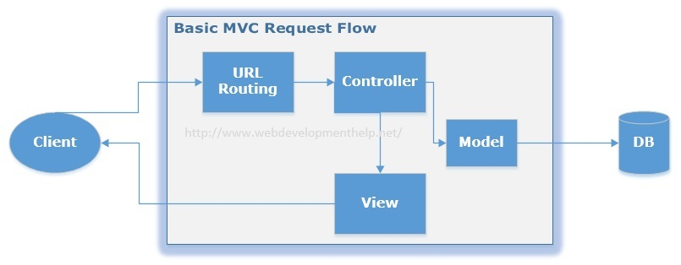

Creating database
App_Data → Add → New Item → SQL Server Compact Database
Database1.sdf (double Click) → Tables → Create Table
Adding model
Models → Add → Class
public class MyModel
{
public int Id { get; set; }
public string Family { get; set; }
public string Name { get; set; }
}
Adding Context
Models → Add → Class MyModelContext : DbContext
using System.Data.Entity;
Root project → Manage NuGet packages → Entity Framework
Root project → Manage NuGet packages → SqlServerCompact
Adding Controller and View
Controllers → Add → Controller MyDbController
Method Create
Views → Add → View Create

Let’s

View Vs Partial View
View | Partial View
View contains the layout page | Partial view does not contain the layout page
_viewstart page is rendered before any view is rendered | Partial view does not check for a _viewstart.cshtml. We cannot place any common code for a partial view within the _viewStart.cshtml page.
View may have markup tags like html, body, head, title, meta etc. | The Partial view is specially designed to render within the view and as a result it does not contain any mark up.
Partial view is more lightweight than the view. We can also pass a regular view to the RenderPartial method.
If there is no layout page specified in the view, it can be considered as a partial view. In razor, there is no distinction between views and partial views as in the ASPX view engine (aspx and ascx).

