Master Page

MasterPage.master File Addition : WebSite → Add New Item → Master Page

WebForm1.aspx MasterPage.master Result

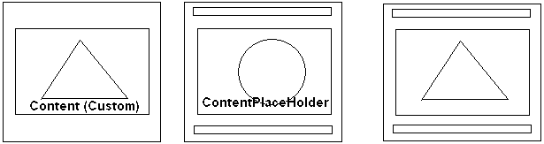



- - - - - - - - - - - - - - - - - - - - - - - - - - - - - - - - - - - - - - - - - - - - - - - - - - - - - - - - - - - - - - - -

MastePage_Dynamic Default.aspx.cs

protected void Page_Load(object sender, EventArgs e)
{
}
protected void Button1_Click(object sender, EventArgs e)
{
Session["MasterPages"] = "firstMasterPage.master";
Server.Transfer(Request.FilePath);
}
protected void Button2_Click(object sender, EventArgs e)
{
Session["MasterPages"] = "secondMasterPage.master";
Server.Transfer(Request.FilePath);
}
protected void Page_PreInit(object sender, EventArgs e)
{
if (Session["MasterPages"] != null)
Page.MasterPageFile = (string)Session["MasterPages"];
}

