Multiple Document Interface MDI : Container, Client, Child

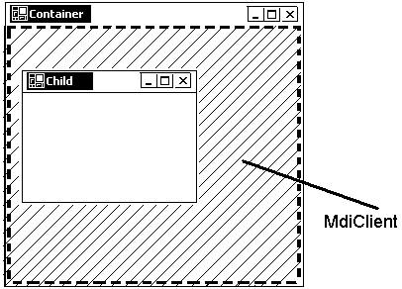

ב- MDI ישנם שלושה סוגים של חלונות:
--- Container חלון חיצוני. כדי חלון רגיל יהי Container צריך לשנות property :
Form.IsMdiContainer = true.
רקה של Container הוא בצבע אפור קהה

--- Client חלון נסתר. מטרתו - הכלת חלונות "ילדים".
ל- Client אין שם מסוים. גישה עליו ע"י סריקה כל פקדים על Container בסגנון

foreach(Control control in Controls)
{
MdiClient mdiClient = control as MdiClient;
if ( mdiClient != null )
return mdiClient;
}
בלחיצת עכבר על Container, אירוע Click מקבל Client ולא Container .

--- Child חלון רגיל. הוא מקושר עם חלון ע"י property : Form.MdiParent

Controls and MdiCildren Collections

 | Collections
 | Controls | MdiChildren
 | Empty (Count = 0) | Empty (Length = 0)
this.IsMdiContainer = true;  רקע אפור | Count = 1 ( MdiClient)
Child myChild = new Child();  myChild.MdiParent = this;  myChild.Show(); |  | Length = 1
Button myButton = new Button();  this.Controls.Add(myButton);  MdiClient גבוהה יותר מרמת ה- Butoon רמת ה-  (MdiClient מעל Button) | Count = 2

Simple_MDI Container.cs
public partial class Container : Form
{
public Container()
{
InitializeComponent();
MdiClient myMdiClient = myGetMdiClient();
myMdiClient.Click += new EventHandler ( myMdiClient_Click );

Child myChild_1 = new Child("Child 1");
myChild_1.MdiParent = this;
myChild_1.Show();
Child myChild_2 = new Child("Child 2");
myChild_2.MdiParent = this;
myChild_2.Show();
}
private void InitializeComponent()
{
. . . . . . . .
this.IsMdiContainer = true;
}

private MdiClient myGetMdiClient()
{
foreach(Control control in Controls)
{
MdiClient tempMdiClient = control as MdiClient;
if (tempMdiClient != null)
return tempMdiClient;
}
return null;
}
private void myMdiClient_Click(object sender, System.EventArgs e)
{
MessageBox.Show("Click on Container");
((MdiClient)sender).BackColor = Color.Yellow;
}
}
- - - - - - - - - - - - - - -
Child.cs
public Child(string title)
{
this.Text = title;
}
private void Child_Click(object sender, System.EventArgs e)
{
MessageBox.Show("Click on " + this.Text);
}

Pictures_MDI Container.cs
public partial class Container : Form
{
private void InitializeComponent()
{
. . . . . . . .
this.menuItemWidow.MdiList = true;
}
private void menuItemExit_Click(object sender, System.EventArgs e)
{ Close();
}
private void menuItemCascade_Click(object sender, System.EventArgs e)
{ this.LayoutMdi( MdiLayout.Cascade );
}
private void menuItemHorizontal_Click(object sender, System.EventArgs e)
{ this.LayoutMdi( MdiLayout.TileHorizontal );
}
private void menuItemVertical_Click(object sender, System.EventArgs e)
{ this.LayoutMdi( MdiLayout.TileVertical );
}

private void menuItemMinimizeAll_Click(object sender, System.EventArgs e)
{
foreach (Form frm in this.MdiChildren)
{
frm.WindowState = FormWindowState.Minimized;
}
}
private void menuItemFlower_Click(object sender, System.EventArgs e)
{
Child my_Child_Flower = new Child();
my_Child_Flower.MdiParent = this;
my_Child_Flower.Text = "Flower";
my_Child_Flower.pictureBox1.Image = Image.FromFile( "../../Flower.jpg");
my_Child_Flower.Show();
}
private void menuItemNight_Click(object sender, System.EventArgs e)
{
Child my_Child_Night = new Child();
my_Child_Night.MdiParent = this;
my_Child_Night.Text = "Night";
my_Child_Night.pictureBox1.Image = Image.FromFile( "../../Night.jpg" );
my_Child_Night.Show();
////// my_Child_Night.SendToBack();
}
}
MdiLayout

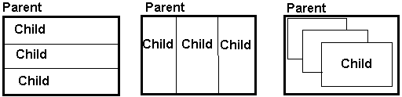

TileHorizontal TileVertical Cascade

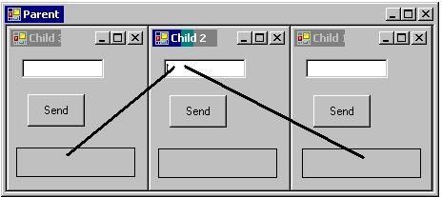

Mdi_Childs_Message Parent.cs
public partial class Parent : Form
{
public Parent()
{
int counter = 3;
this.Width = 0;
for (int i = 0; i < counter; i++) {
Child tempChild = new Child((i + 1).ToString());
tempChild.MdiParent = this;
this.Width += tempChild.Width;
כדי להתיעם Parent לרוחב של שלושה Childs ///
tempChild.Show();
}
}
עובדת פעם אחת ש- Form פעם ראשונה מופיע על מסך (אפשר להשתמש ב-Load ) ////
private void Parent_Shown (object sender, EventArgs e)
{ this.LayoutMdi(MdiLayout.TileVertical);
}
}
- - - - - - - - - - - - - - - - - - - - - - - - - - - - - - - - - - - -
Child.cs
public partial class Child : Form
{
public Child(string newId)
{ this.Text += " " + newId;
}
private void button1_Click(object sender, EventArgs e)
{
foreach ( Child tmpChild in this.MdiParent.MdiChildren )
if (ReferenceEquals(tmpChild, this) != true)
כדי לא לשלוח הודע לעצמי ////
tmpChild.label1.TextInOut = textBox1.Text;
}
}
- - - - - - - - - - - - - - - - -
this this.MdiParent this.MdiParent.MdiChildren
Child Parent all Childs (collection )
Button שלחץ ל-

