הכלה | הורשה
UserControl | Inherit Control  (Derived Control) | Custom Control
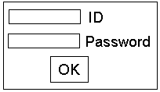 | Label  /  /  /  /  Blinking_Label | Control  /  /  /  /  Round_Button

Simple_UserControl Form1.cs

public class Form1 : System.Windows.Forms.Form
{
UserControl1 myUserControl = new UserControl1();

public Form1()
{
myUserControl.Location = new System.Drawing.Point(40, 8);
this.Controls.Add(myUserControl);
}

private void button1_Click(object sender, System.EventArgs e)
{
label1.Text = "Hello, " + myUserControl.TextOut + " !";
}
}
- - - - - - - - - - - - - - - - -
UserControl1.cs
public class UserControl1 : System.Windows.Forms.UserControl
{
public string TextOut
{
get
{
return textBox1.Text;
}
}
}

- - - - - - - - - - - - - - - - - - - - - - - - - - - - - - - - - - - - - - - -

Program to UserControl testing:

C:\Program Files\ Microsoft Visual Studio 10.0\Common7\IDE\UserControlTestContainer.exe

Addition UserControl to ToolBox :

UserControl → dll
ToolBox → All Windows Forms → Choose Items

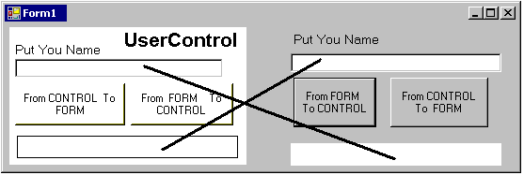

UserControl_and_Form Form1.cs

public class Form1 : System.Windows.Forms.Form
{
UserControl1 myUserControl;

public string TextInOut
{ get
{ return textBox1.Text;
}
set
{ label2.Text = value;
}
}
public Form1()
{ myUserControl = new UserControl1();
myUserControl.Location = new System.Drawing.Point(5, 5);
this.Controls.Add(myUserControl);
}

private void button_FormToControl_Click(object sender, System.EventArgs e)
{ myUserControl.UserControl_TextInOut = "Hello, " + textBox1.Text + " !";
}
private void button_ControlToForm_Click(object sender, System.EventArgs e)
{ label2.Text = "Hello, " + myUserControl.UserControl_TextInOut + " !";
}
}
- - - - - - - - - - - - - - - - - - - - - - - - - - - - - - - - - - - - - - - -
UserControl1.cs
public class UserControl1 : System.Windows.Forms.UserControl
{
public string UserControl_TextInOut
{ get
{ return textBox1.Text;
}
set
{ label2.Text = value;
}
}
private void UserControl_ControlToForm_Click(object sender, EventArgs e)
{ ((Form1)(this.Parent)).Form_TextInOut = "Hello, " + textBox1.Text + " !";
}
private void UserControl_FormToControl_Click(object sender, EventArgs e)
{ label2.Text = "Hello, " + ((Form1)(this.Parent)).Form_TextInOut + " !";
}
}
סגנון לא טוב: UserControl לא יכול לדעת לאיזה Form או UserControl אחר ישימו אותו (כדי לעשות casting ל- Form1 )
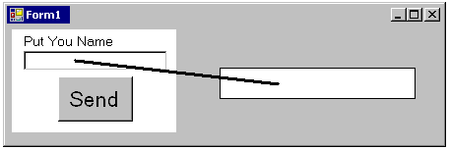

UserControl_Event Form1.cs
public partial class Form1 : Form
{
UserControl1 myUserControl;
public Form1()
{ InitializeComponent();
myUserControl = new UserControl1();
myUserControl.Location = new System.Drawing.Point(5, 5);
this.Controls.Add(myUserControl);
myUserControl.myEvent += new myDelegate(myFunction);
הרשמת /// Event
}
private void myFunction(object sender, myEventArgs e)
{
label1.Text = "Hello, " + e.myString + " !";
}
}
- - - - - - - - - - - - - - - - - - - - - - - - - - - - - - - - - - - - - - - -
UserControl1.cs

public delegate void myDelegate(object sender, myEventArgs e);
הגדרת delegate (סוג) ///
public partial class UserControl1 : UserControl
{
public event myDelegate myEvent;
הגדרת event מסוג /// delegate
private void button1_Click(object sender, EventArgs e)
{
myEventArgs myEventArgs_temp = new myEventArgs(textBox1.Text);
הגדרת משתנה (object) מסוג /// myEventArgs
if (myEvent != null)
myEvent( this, myEventArgs_temp);
זריקת /// Event
}
}
- - - - - - - - - - - - - - - - - - - - - - - - - - - - - - - - - - - - - - - -
myEventArgs.cs
public class myEventArgs : EventArgs
{
private string str;
public myEventArgs(string S)
{ str = S;
}
public string myString
{
get
{ return str;
}
}
}
בכל שאלה בסגנון הזנקת אירוע והעברת משתנים ע"י myEventArgs

- מגדירים מחלקה myEventArgs - בהתאם לנתונים שצריך להעביר מ- UserControl ל- Form.
- ב- UserControl (ההגדרה לא הכרחית כאן, אפשר להגדיר ב- Form ) מגדירים delegate
public delegate void myDelegate(object sender, myEventArgs e);
- ב- UserControl מגדירים event מסוג myDelegate
public event myDelegate myEvent;
- ב- UserControl בפונקציה כלשהי
--- מגדירים אובייקט מסוג myEventArgs
--- בודקים ש- eventעבר הרשמה
--- מזניקים event - myEvent
- ב- Form כותבים פונקצית תגובה ל- myEvent
- ב- Form (בדרך כלל ב-constructor ) מבצעים "הרשמה" של event - myEvent מ- UserControl.
פונקציה מסעיף 5 היא פרמטר בהגדרת delegate בפעולה
myUserControl.myEvent += new myDelegate(#######);

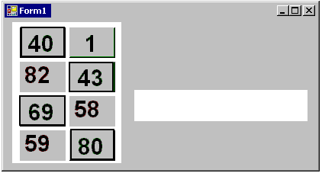

UserControl_Different_Controls_Messages Form1.cs

private UserControl1 myUserControl1;
public Form1()
{
myUserControl1 = new UserControl1();
myUserControl1.Location = new Point(10, 10);
this.Controls.Add(myUserControl1);
myUserControl1.myEvent += new myDelegate(fromUser);
}
private void fromUser(object sender, myEventArgs e)
{ label1.Text = e.myStrText + " from " + e.myStrType;
}
- - - - - - - - - - - - - - - - - - - - - - - - - - - - - - - - - - - - - - - -
UserControl1.cs
public delegate void myDelegate(object sender, myEventArgs e);

public partial class UserControl1 : UserControl
{
public event myDelegate myEvent;

public UserControl1()
{ Random myRand = new Random();
for (int i = 0; i < 16; i++)
{
Control tempControl;
if (myRand.Next(0, 2) == 0)
tempControl = new Label();
else
tempControl = new Button();

tempControl.Font = new Font("Arial", 22, FontStyle.Bold);
tempControl.Text = myRand.Next(1, 99).ToString();
tempControl.Size = new Size(60, 40);
tempControl.Location = new Point( . . . . . . . .);
tempControl.BackColor = Color…………..;
tempControl.Click += new System.EventHandler(commonClick);
this.Controls.Add(tempControl);
} }
private void commonClick(object sender, EventArgs e)
{
string sText = ((Control)sender).Text;
string sType = sender.GetType().Name;

myEventArgs myEventArgs_temp = new myEventArgs(sText, sType);
if (myEvent != null)
myEvent(this, myEventArgs_temp);
} }
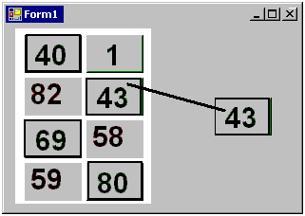

UserControl_Different_Controls__CopyControl Form1.cs

private UserControl1 myUserControl1;
Control myControl;
public Form1()
{ myUserControl1 = new UserControl1();
myUserControl1.Location = new Point(10, 10);
this.Controls.Add(myUserControl1);
myUserControl1.myEvent += new myDelegate(fromUser);
}
private void fromUser(object sender, myEventArgs e)
{
this.Controls.Remove(myControl);
מחיקת Control קודם ///
if (e.mControl.GetType().Name == "Button")
myControl = new Button();
else
myControl = new Label();
myControl.Text = e.mControl.Text;
myControl.BackColor = e.mControl.BackColor;
myControl.Font = e.mControl.Font;
myControl.Size = e.mControl.Size;
myControl.Location = new Point(250, 150);
this.Controls.Add(myControl);
}
- - - - - - - - - - - - - - - - - - - - - - - - - - - - - - - - - - - - - - - -
UserControl1.cs
public partial class UserControl1 : UserControl
{
public UserControl1()
{ . . . . . . . . . }
private void commonClick(object sender, EventArgs e)
{
myEventArgs myEventArgs_temp = new myEventArgs((Control)sender);
if (myEvent != null)
myEvent(this, myEventArgs_temp);
} }
- - - - - - - - - - - - - - - - - - - - - - - - - - - - - - - - - - - - - - - -
myEventArgs.cs
public class myEventArgs : EventArgs
{
public Control mControl;
public myEventArgs(Control tControl)
{ mControl = tControl ;
} }
כדי להוריד פקד myControl מ- myUserControl
myUserControl.Controls.Remove(myControl);

אם ידוע מיקום (int index) של myControl באוסף פקדים
myUserControl.Controls.RemoveAt(index);

אם ל- ידוע Name
myControl.Name = "aaaaaaaaaaaaaaaaaa";
myUserControl. Controls.RemoveByKey("aaaaaaaaaaaaaaaaaa");

כדי להוריד את כל הפקדים מ- myUserControl
myUserControl.Controls.Clear();

- - - - - - - - - - - - - - - - - - - - - - - - - - - - - - - - - - - - - - - -

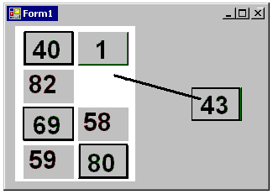
UserControl_Different_Controls__ MoveControl Form1.cs

private void fromUser(object sender, myEventArgs e)
{
this.Controls.Remove(myControl);

myControl = e.mControl;
myControl.Location = new Point(250, 150);
this.Controls.Add(myControl);

e.mUserControl.Controls.Remove(e.mControl);
}

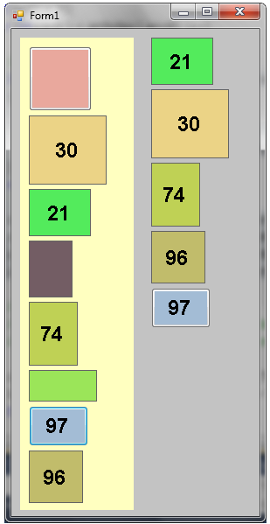
UserControl_Different_Controls__Sorting Form1.cs
int[] sorting (string[] arrStr)
{
SortedList mySortedList = new SortedList();
Random myRand = new Random();

for (int i = 0; i < arrStr.Length ; i++)
if (arrStr[i] != "")
mySortedList.Add(int.Parse(arrStr[i]) + myRand.Next(1000) * 0.00001, i);
int[] returnArr = new int[mySortedList.Count];
for (int i = 0; i < mySortedList.Count; i++)
returnArr[i] = (int)(mySortedList.GetByIndex(i));
return returnArr;
}
private void fromUser(object sender, myEventArgs e)
{
if (arrControls_Form != null)
for (int i = 0; i < arrControls_Form.Length; i++)
this.Controls.Remove(arrControls_Form[i]);

string[] arrStr = new string[e.arrControls.Length];
for (int i = 0; i < e.arrControls.Length; i++)
arrStr[i] = e.arrControls[i].Text;

int[] arrIndex = sorting(arrStr);
arrControls_Form = new Control[arrIndex.Length];
int lastY = 10;
for (int i = 0; i < arrIndex.Length; i++)
{
//////////// Copy controls
if (e.arrControls[arrIndex[i]].GetType().Name == "Label")
{
arrControls_Form[i] = new Label();
((Label)arrControls_Form[i]).TextAlign = ContentAlignment.MiddleCenter;
((Label)arrControls_Form[i]).BorderStyle = BorderStyle.FixedSingle;
}
else
arrControls_Form[i] = new Button();
arrControls_Form[i].Font = e.arrControls[arrIndex[i]].Font;
arrControls_Form[i].Size = e.arrControls[arrIndex[i]].Size;
arrControls_Form[i].BackColor = e.arrControls[arrIndex[i]].BackColor;
arrControls_Form[i].Text = e.arrControls[arrIndex[i]].Text;

//////////// Move controls
// arrControls_Form[i] = e.arrControls[arrIndex[i]];
// myUserControl1.Controls.Remove(arrControls_Form[i]);

arrControls_Form[i].Location = new Point(160, lastY);
lastY += arrControls_Form[i].Size.Height + 5;
this.Controls.Add(arrControls_Form[i]);
}
}
- - - - - - - - - - - - - - - - - - - - - - - - - - - - - - - - - - - - - - - -
UserControl1.cs
private void commonClick(object sender, EventArgs e)
{
if (((Control)sender).Text == "")
((Control)sender).Text = myRand.Next(1, 99).ToString();
else
((Control)sender).Text = "";
}
private void UserControl1_Click(object sender, EventArgs e)
{
myEventArgs myEventArgs_temp = new myEventArgs(arrControls_User);
if (myEvent != null)
myEvent(this, myEventArgs_temp);
}
- - - - - - - - - - - - - - - - - - - - - - - - - - - - - - - - - - - - - - - -
myEventArgs.cs
public class myEventArgs : EventArgs
{
public Control[] arrControls;
. . . . . . .
}
- - - - - - - - - - - - - - - - - - - - - - - - - - - - - - - - - - - - - - - - - - - - - - - - - - - - - -
Lambda Expression
(x, y) The argument names.
=> Separates argument list from result expression.
x + y Return result of expression

List<Control>.Sort((x, y) => int.Parse(x.Text) - int.Parse(y.Text)); Sort by text
List<Control>.Sort((x, y) => x.Width - y.Width); Sort by width
List<Control>.Sort((x, y) => x.Width * x.Height - y.Width * y.Height); Sort by Area
- - - - - - - - - - - - - - - - - - - - - - - - - - - - - - - - - - - - - - - - - - - - - - - - - - - - - -

private List<Control> ListControls_Form = new List<Control>();

private void fromUser(object sender, myEventArgs e)
{
for (int i = 0; i < ListControls_Form.Count; i++)
this.Controls.Remove(ListControls_Form[i]);
ListControls_Form.Clear();

for(int i = 0; i < e.arrControls.Length; i++)
if (e.arrControls[i].Text != "")
{
//////////// Copy controls
Control tempControl;
if (e.arrControls[i].GetType().Name == "Label")
{
tempControl = new Label();
((Label)tempControl).TextAlign = ContentAlignment.MiddleCenter;
((Label)tempControl).BorderStyle = BorderStyle.FixedSingle;
}
else
tempControl = new Button();

tempControl.Font = e.arrControls[i].Font;
tempControl.Size = e.arrControls[i].Size;
tempControl.BackColor = e.arrControls[i].BackColor;
tempControl.Text = e.arrControls[i].Text;

ListControls_Form.Add(tempControl);

//////////// Move controls
// ListControls_Form.Add(e.arrControls[i]);
// myUserControl1.Controls.Remove(e.arrControls[i]);
}

ListControls_Form.Sort((x, y) => int.Parse(x.Text) - int.Parse(y.Text));

int lastY = 10;
for (int i = 0; i < ListControls_Form.Count; i++)
{
ListControls_Form[i].Location = new Point(200, lastY);
lastY += ListControls_Form[i].Size.Height + 5;
this.Controls.Add(ListControls_Form[i]);
}
}

