Marshal-by-reference remoting architecture

Client application domain Server application domain

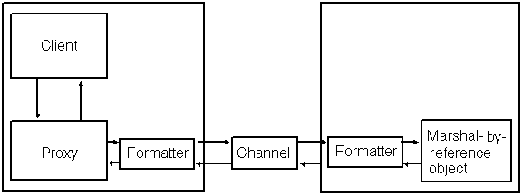

MBR (marshal-by-reference) objects: The caller receives a proxy to the remote object.
MBV (marshal-by-value) objects: The caller receives a full copy of the object in its own application domain.

Configuring an MBR Object
public class AAAAAA : MarshalByRefObject
{...}

Configuring an MBV Object
[Serializable]
public class BBBBB
{...}

Proxy
The proxy looks and feels like the real object. Calls received by the proxy, however, are transmitted to the remote object through a channel connecting the two application domains. We say that an object served by a proxy has been marshaled by reference because the object isn’t copied to the client’s application domain; the client merely holds a reference to the object. That reference is the proxy.

Channels and Serialization Formatters

Channels | Client-Server location | Serialization Formatters
TCP channel  (Transmission Control Protocol) |  | Binary Formatter
HTTP channel  (Hypertext Transfer Protocol) |  | Soap Formatter
IPC channel  (Inter-Process Communication) | Local Computer | Binary Formatter

Programmed and Declaration Configuration

Marshal by reference object in Server:

SingleCall Factory Singleton

 | שייך ל- | זמן חיים Life cycle
SingleCall | אחת Client | זמן ביצוע של פעלה
Factory | אחת Client | Client זמן חיים של
Singleton | Clients כל | Server זמן חיים של

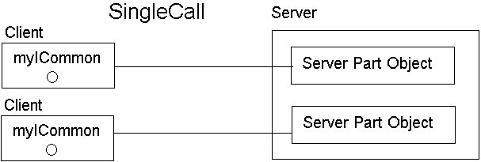

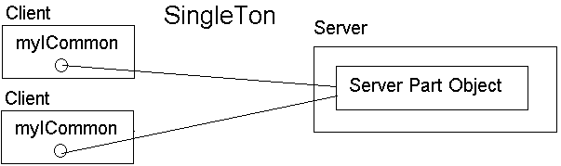

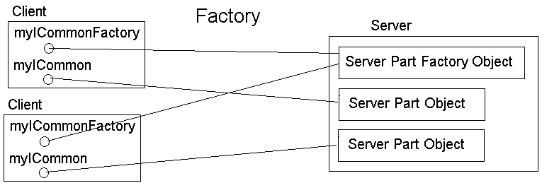

פקדים (Button, Label, …) לא מעוברים בתקשורת

להוספת namespace
using System.Runtime.Remoting.Channels.Http;
בכל פרויקט צריף להוסיף reference:
(Solution Explorer) References → Add Reference → Assemblies → Framework →
System.Runtime.Remoting → V →

Plus int without Remoting Common
namespace Common
{
public class CommonPart
{
public int plus (int a , int b)
{
return a + b;
}
}
}
- - - - - - - - - - - - - - - - - - - - - - - - - - - - - - - - - - - - - - - - - - - - - - - - - -
using Common; Client
namespace Client
{
public class Form1 : System.Windows.Forms.Form
{
CommonPart myCommonPart;

public Form1()
{
……
myCommonPart = new CommonPart();
}
private void button1_Click(object sender, System.EventArgs e)
{
textBox3.Text = (myCommonPart.plus(Int32.Parse(textBox1.Text),
Int32.Parse(textBox2.Text))).ToString();
}
}
}

namespace Common Plus int SingleCall Common
{
public interface ICommon
{
int plus ( int a, int b );
}
}
- - - - - - - - - - - - - - - - - - - - - - - - - - - - - - - - - - - - - - - - - - - - - - - - - -
using System.Runtime.Remoting; Server
using System.Runtime.Remoting.Channels.Http;
using System.Runtime.Remoting.Channels;
using Common;
namespace Server
{
public class Form1 : System.Windows.Forms.Form
{
public Form1()
{ ……
HttpChannel chnl = new HttpChannel(1234);
ChannelServices.RegisterChannel(chnl, false);

RemotingConfiguration.RegisterWellKnownServiceType(
typeof(ServerPart), "_Server_", WellKnownObjectMode.SingleCall);
}
}
class ServerPart : MarshalByRefObject, ICommon
{
public int plus (int a, int b)
{ return a + b;
}
}
}
- - - - - - - - - - - - - - - - - - - - - - - - - - - - - - - - - - - - - - - - - - - - - - - - - -
using System.Runtime.Remoting; Client
using System.Runtime.Remoting.Channels.Http;
using System.Runtime.Remoting.Channels;
using Common
namespace Client
{
public class Form1 : System.Windows.Forms.Form
{
ICommon myICommon;
public Form1()
{
public Form1()
{ ………
HttpChannel channel = new HttpChannel();
ChannelServices.RegisterChannel(channel, false);

myICommon = (ICommon)Activator.GetObject(
typeof(ICommon), "http://localhost:1234/_Server_");
}
private void button1_Click(object sender, System.EventArgs e)
{
textBox3.Text = (myICommon.plus(Int32.Parse(textBox1.Text),
Int32.Parse(textBox2.Text))).ToString();
}
}
}
namespace Common Plus Fraction SingleCall Common
{
[Serializable]
public class Fraction // Class to Marshall - By - Value
{ . . . . . . . . . . . }
public interface IFraction
{ Fraction Plus ( Fraction A, Fraction B);
} }
- - - - - - - - - - - - - - - - - - - - - - - - - - - - - - - - - - - - - - - - - - - - - - - - - -
namespace Server Server
{
public class Form1 : System.Windows.Forms.Form
{
public Form1()
{ ……………
HttpChannel chnl = new HttpChannel(1234);
ChannelServices.RegisterChannel(chnl, false);

RemotingConfiguration.RegisterWellKnownServiceType(
typeof(ServerPart), "_Server_", WellKnownObjectMode.SingleCall);
}
}
class ServerPart: MarshalByRefObject, IFraction
{
public ServerPart() {}
public Fraction Plus (Fraction A, Fraction B)
{
return new Fraction(A.fieldNum * B.fieldDenom +
A.fieldDenom * B.fieldNum, A.fieldDenom * B.fieldDenom);
}
}
}
- - - - - - - - - - - - - - - - - - - - - - - - - - - - - - - - - - - - - - - - - - - - - - - - - -
namespace Client Client
{
public class Form1 : System.Windows.Forms.Form
{
IFraction myIFraction;

public Form1()
{ ……….
HttpChannel channel = new HttpChannel();
ChannelServices.RegisterChannel(channel, false);

myIFraction = (IFraction)Activator.GetObject(
typeof(IFraction), "http://localhost:1234/_Server_");
}
private void button1_Click(object sender, System.EventArgs e)
{
Fraction A = new Fraction( Int32.Parse(textBox1.Text), Int32.Parse(textBox2.Text));
Fraction B = new Fraction( Int32.Parse(textBox3.Text), Int32.Parse(textBox4.Text));
Fraction C = myIFraction.Plus(A, B );
textBox5.Text = C.fieldNum.ToString();
textBox6.Text = C.fieldDenom.ToString();
}
}
}

Plus Minus int Factory Common
namespace Common
{
public interface ICommon
{
int Plus (int a);
int Minus(int a);
void Reset();
}
public interface ICommonFactory
{
ICommon getNewInstance();
} }
- - - - - - - - - - - - - - - - - - - - - - - - - - - - - - - - - - - - - - - - - - - - - - - - - -
namespace Server Server
{
public partial class Form1 : Form
{
public Form1()
{ …….
HttpChannel chnl = new HttpChannel(1234);
ChannelServices.RegisterChannel(chnl, false);

RemotingConfiguration.RegisterWellKnownServiceType(
typeof(ServerPartFactory), "_Server_", WellKnownObjectMode.Singleton);
}
}

class ServerPart : MarshalByRefObject, ICommon
{
private int currentResult;
public int Plus(int A)
{
currentResult += A;
return currentResult;
}
public int Minus(int A)
{
currentResult -= A;
return currentResult;
}
public void Reset()
{
currentResult = 0;
}
}
class ServerPartFactory : MarshalByRefObject, ICommonFactory
{
public ServerPartFactory()
{
}
public ICommon getNewInstance()
{
return new ServerPart ();
}
}
}
- - - - - - - - - - - - - - - - - - - - - - - - - - - - - - - - - - - - - - - - - - - - - - - - - -

namespace Client Client
{
public class Form1 : System.Windows.Forms.Form
{
public ICommon myICommon;
public Form1()
{ …..….
HttpChannel channel = new HttpChannel();
ChannelServices.RegisterChannel(channel, false);

ICommonFactory myICommonFactory = (ICommonFactory)Activator.GetObject(
typeof(ICommonFactory), "http://localhost:1234/_Server_");

myICommon = myICommonFactory.getNewInstance();
}
private void buttonPlus_Click(object sender, EventArgs e)
{
label1.Text += " + " + textBox1.Text;
labelResult.Text = myICommon.Plus(int.Parse(textBox1.Text)).ToString();
}
private void buttonMinus_Click(object sender, EventArgs e)
{
label1.Text += " - " + textBox1.Text;
labelResult.Text = myICommon.Minus(int.Parse(textBox1.Text)).ToString();
}
private void buttonReset_Click(object sender, EventArgs e)
{
label1.Text = "";
textBox1.Text = "";
labelResult.Text = "";
myICommon.Reset();
}
}
}

