**Arnel Gwen Nuqui**

**BSInfoTech 4C**

**System Administration and Maintenance Laboratory Activity #1:**

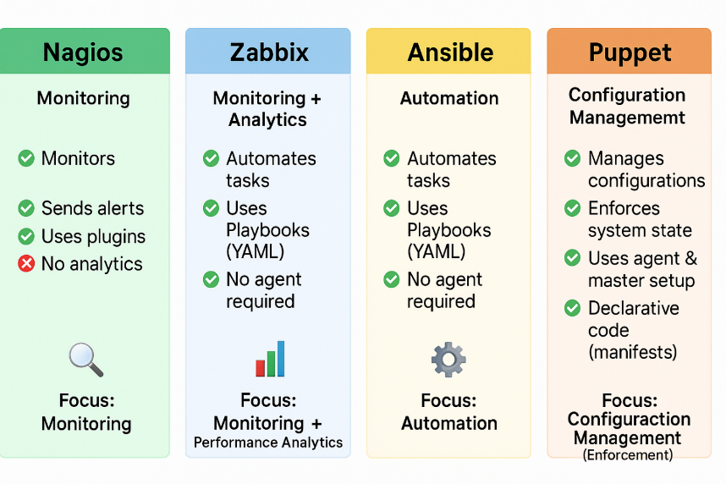

1. Nagios – For Monitoring

What is this tool used for?

Nagios watches over your computers, servers, and networks. It checks if everything is working properly and tells you if something breaks.

What are its key features or capabilities?

* Checks if devices and services are online
* Sends alerts through email or text
* Can be customized using plugins
* Shows logs of what happened
* Has a web interface you can check

How it does generally works (in simple terms):

It runs regular checks on your systems using small tools (called plugins). If something is wrong (like a server is offline), it will notify the admin.

What kind of organizations or scenarios would benefit from it using this tool?

Schools, companies, or anyone with many computers or services to manage.

Give one example situation where this tool would be useful?

A school uses Nagios to monitor its lab computers. If a computer crashes, Nagios alerts the IT team so they can fix it quickly.

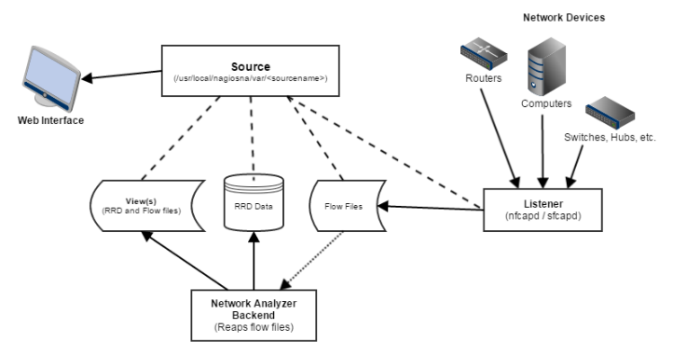

2. Zabbix – For Monitoring and Data Analysis

What is this tool used for?

Zabbix is like Nagios but smarter. It not only checks if things are working, but also helps you understand how well they’re working.

What are its key features or capabilities?

* Monitors servers, apps, and networks in real-time
* Shows data in graphs and dashboards
* Alerts you if something is wrong
* Can connect with other systems
* Works with or without installing agents

How it does generally works (in simple terms):

It gathers data using small programs (agents) or remotely. Then it shows this data in charts and sends alerts if needed.

What kind of organizations or scenarios would benefit from it using this tool?

Big companies, especially those needing graphs and performance analysis.

Give one example situation where this tool would be useful?

An online store uses Zabbix to watch their servers during big sales. If the traffic goes too high, they get notified and add more resources.

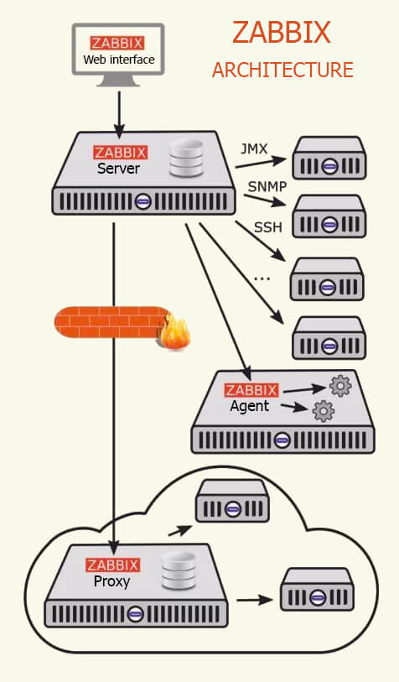

3. Ansible – For Automation

What is this tool used for?

Ansible is a tool to save time. It helps you do the same setup or task on many computers automatically.

What are its key features or capabilities?

* No need to install it on other machines
* Uses easy-to-read files (YAML) to list tasks
* Works well with cloud services
* Safe and simple to use

How it does generally works (in simple terms):

You write a list of tasks in a file (called a playbook). Ansible connects to computers using SSH and runs those tasks one by one.

What kind of organizations or scenarios would benefit from it using this tool?

Admins or developers who manage many servers and want to save time.

Give one example situation where this tool would be useful?

A startup uses Ansible to install apps, users, and settings on new computers. It takes 5 minutes instead of doing it manually.

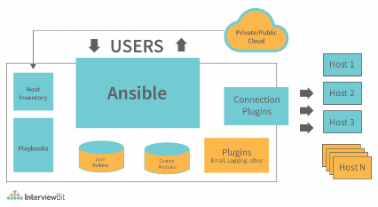

4. Puppet – For Configuration Management

What is this tool used for?

Puppet makes sure that all your systems stay the same. If something changes, Puppet puts it back.

What are its key features or capabilities?

* Uses code to describe how a system should look
* Automatically fixes wrong settings
* One central server controls many devices
* Keeps track of changes

How it does generally works (in simple terms):

You write a "rule" (called a manifest) for how a system should look. Puppet agents check in with the server and apply those rules.

What kind of organizations or scenarios would benefit from it using this tool?

Companies that need to keep hundreds of machines exactly the same (like banks or government).

Give one example situation where this tool would be useful?

A government office uses Puppet to make sure all PCs have the same settings and security patches. If someone changes it, Puppet fixes it.

