

COLLEGE OF COMPUTING AND INFORMATICS
PUTRAJAYA CAMPUS

SEMESTER 2 2025/2026

SOFTWARE CONSTRUCTION & METHODS (CSEB5223)

LAB 2 ASSIGNMENT PART 1

SEMESTER 2 2025/2026

PROGRAMME : BACHELOR OF SOFTWARE ENGINEERING (HONS.)
GROUP ASSIGNMENT : GROUP 6
PROJECT TITLE : STUDENT LEARNING MANAGEMENT SYSTEM (SLMS)
LECTURER NAME : TS. DR. LOO YIM LING
GROUP MEMBERS :
No. | Full Name | Student ID
1 | ARIFAH NUR IMAN BINTI MOHD FADZILAH | BSW01085214
2 | REYHANA MARSYA BINTI AHMAD SAIFULLIZAN | BSW01085069
3 | DESHINI A/P SELVAKUMAR | SW01083593

GITHUB REPOSITORY URL: https://github.com/Gwigle/SLMS-CSEB5223-Group6.git

Table of Contents
1.0 Introduction 3
2.0 Use Case Design 4
2.1 Actors 4
2.1 Use Cases 4
2.2 Use Case Diagram 5
3.0 Class Design 6
3.1 Class Relationships 8
3.2 UML Class Diagram 10
4.0 Documentation Formatting 11
5.0 Coding File Formatting 11
6.0 Naming Conventions – Dictionary 12
7.0 Function and Methods Modularity 13
7.1 Principles of Modularity Applied in SLMS 13
7.2 Method-Level Modularity 14
7.3 Reusability of Methods 14
7.4 Low Coupling and High Cohesion 15
7.5 Summary of Modularity Benefits in SLMS 15
8.0 Continuous Integration Rules 16
9.0 References 18

Introduction
The Student Learning Management System (SLMS) is a console-based Java application designed to manage students, lecturers and courses in a centralized system. It allows users to register, enroll in courses, submit assignments, upload learning materials, view grades and maintain course data efficiently.

The objective of Lab 2 is to draft the plan and design of SLMS, including use case design, class design, documentation and coding standards, naming conventions, modular functions and continuous integration practices.

This project applies object-oriented programming principles, emphasizes modularity and maintainability, and follows version control practices using GitHub for collaborative software construction.

The system is implemented in Java as a console-based application, providing a structured environment for learning software construction methods and best practices.

Use Case Design

Actors
    - Student: enrolls in courses, views materials, submits assignments, views grades
    - Lecturer: creates courses, uploads materials, grades assignments, searches and edits courses
    - Administrator: manages users, assigns roles, manages courses, monitors system activity

Actor | Use Case | Description
Admin/ Student/ Lecturer | Log in/ Log out | Users log in and log out their accounts to the system.
Admin | Manage Users | Admin adds/removes users and assigns roles.
Admin | Manage Courses | Admin manages all courses and assigns lecturers.
Student | View Courses | Student can view enrolled and available courses.
Student | Enroll Course | Student enrolls in selected courses.
Student | Submit Assignment | Student submits assignments for grading.
Student | View Grades | Student checks assignment and course grades.
Lecturer | Create Course | Lecturer creates a new course.
Lecturer | Upload Material | Lecturer uploads lecture notes, coursework, assignments and resources.
Lecturer | Grade Assignment | Lecturer grades student submissions.
Lecturer | Search/Edit/Delete Course | Lecturer can search and modify courses they teach.

Use Cases

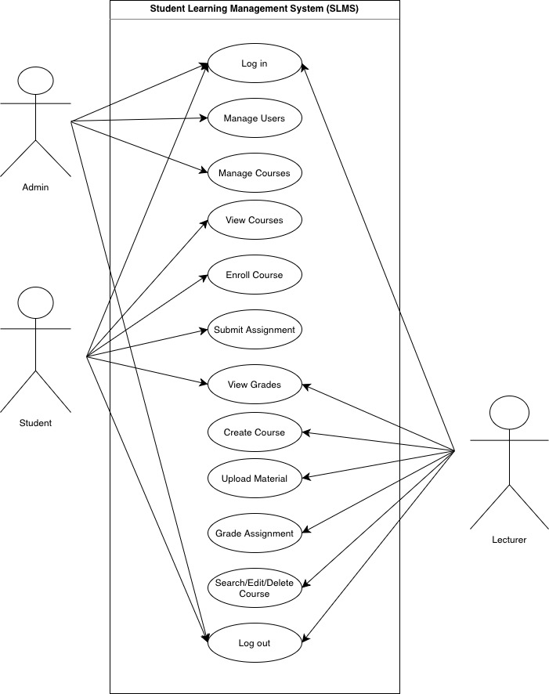
Use Case Diagram

Class Design
Class | Attribute | Method
User | userId : String  name : String  email : String  password : String  role : String  isLoggedIn : boolean | login(), logout(), viewProfile()
Student | studentId : String  enrolledCourses : List(Course)  submissions : List(AssignmentSubmission) | enrollCourse(course), submitAssignment(assignment, file), viewGrades()
Lecturer | lecturerId : String  teachingCourses : List(Course) | createCourse(course), uploadMaterial(course, material), gradeAssignment(submission, grade), searchCourse(courseCode), editCourse(course)
Administrator | adminId : String  managedCourses : List(Course)  users : List(User) | addUser(user), removeUser(user), assignRole(user, role), manageCourses()
Course | courseCode : String  courseName : String  description : String  lecturer : Lecturer  students : List(Student)  materials : List(Material)  assignments : List(Assignment) | addStudent(student), removeStudent(student), addMaterial(material), addAssignment(assignment)
Material | materialId : String  title : String  content : String  uploadDate : Date | view(), download()
Assignment | assignmentId : String  title : String  description : String  dueDate : Date  submissions : List(AssignmentSubmission) | viewAssignment(), receiveSubmission(submission)
AssignmentSubmission | submissionId : String  student : Student  assignment : Assignment  submissionDate : Date  filePath : String  grade : double  feedback : String | submit(), viewGrade()

Class Relationships
Inheritance Relationships (IS-A)
Parent class | Child Class | Relationship Type | Description
User | Student | Inheritance | Student is a type of User
User | Lecturer | Inheritance | Lecturer is a type of User
User | Administrator | Inheritance | Administrator is a type of User

Association Relationships
Class A | Relationship | Class B | Multiplicity | Description
Lecturer | teaches | Course | 1 : 0..* | One lecturer can teach zero or many courses
Course | taught by | Lecturer | 1 : 1 | One course is taught by exactly one lecturer
Administrator | manages | Course | 1 : 0..* | One administrator can manage zero or many courses
Student | enrolls in | Course | 1 : 0..* | One student can enroll in zero or many courses
Course | has enrolled | Student | 1 : 0..* | One course can have zero or many enrolled students

Composition Relationships (Strong Whole-Part)
Whole Class | Part Class | Multiplicity | Description
Course | Material | 1 : 0..* | Course contains materials; if course is deleted, materials are also deleted
Course | Assignment | 1 : 0..* | Course contains assignments; if course is deleted, assignments are also deleted

Aggregation Relationships (Weak Whole-Part)
Whole Class | Part Class | Multiplicity | Description
Assignment | AssignmentSubmission | 1 : 0..* | Assignment receives submissions; submissions can exist independently

UML Class Diagram
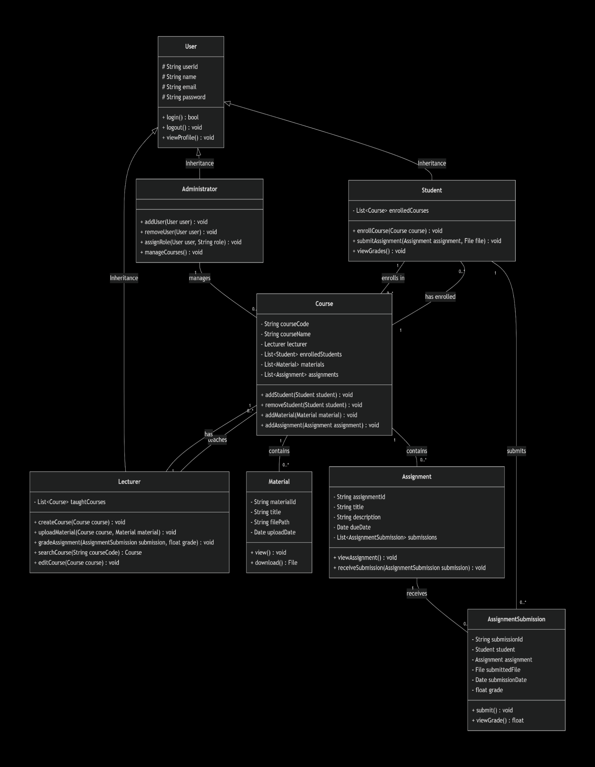

Documentation Formatting
- Font: Times New Roman, 12
- Headings: Bold, Times New Roman, 12
- Paragraph: Justified
- Line spacing: 1.5

Coding File Formatting
To maintain consistency and readability, the following coding file formatting standards
are applied in the SLMS project:
- Programming Language: Java
- File Naming: Each class is stored in a separate .java file.
- Indentation: 4 spaces indentation is used for code blocks.
- Brackets Style: Opening braces { are placed on the same line as the class or method declaration.
Comments:
- Single-line comments use //
- Multi-line comments use /* */
Class Structure Order:
  - Package declaration (if any)
  - Import statements
  - Class declaration
  - Attributes (variables)
  - Constructors
  - Methods

- File Header: Every file must begin with a comment block containing the file name, author name, and a brief description of the class.
- Line Length: Limit code lines to 120 characters to avoid horizontal scrolling.
- Imports: Group imports by package and avoid using wildcards (e.g., use import java.util.Scanner; instead of java.util.*;).
- White Space: Use a single blank line between methods and after variable declarations to improve scannability.

Naming Conventions – Dictionary
Naming Conventions
Element | Convention | Example
Class | PascalCase | Student, Course, AssignmentSubmission
Method | camelCase | login(), submitAssignment()
Variable | camelCase | studentId, courseCode
Constant | UPPER_CASE | MAX_COURSES
File Name | Same as class name | Student.java
Boolean Variable | Starts with is/has | isLoggedIn, hasSubmitted

Naming Dictionary
Name | Type | Description
User | Class | Parent class for all system users
Student | Class | Represents a student in the system
Lecturer | Class | Represents a lecturer who manages courses
Administrator | Class | Represents system administrator
Course | Class | Stores course information
Material | Class | Represents learning materials uploaded by lecturer
Assignment | Class | Represents assignments for courses
AssignmentSubmission | Class | Stores student assignment submission
login() | Method | Allows user to log into system
logout() | Method | Allows user to log out of system
enrollCourse() | Method | Allows student to enroll in course
submitAssignment() | Method | Allows student to submit assignment
uploadMaterial() | Method | Allows lecturer to upload learning materials

Function and Methods Modularity
Modularity in software construction and methods refers to dividing a system into separate, independent modules where each module contains everything needed to execute a specific functionality. In the Student Learning Management System (SLMS), we apply modularity principles to ensure our methods are reusable and maintainable.

Principles of Modularity Applied in SLMS
- Single Responsibility Principle (SRP)
- Each class and method performs only one clear responsibility.
Example:
- login() in User class only handles authentication.
- enrollCourse() in Student class only handles course enrollment.
- gradeAssignment() in Lecturer class only handles grading logic.
- This prevents large, complex methods and makes debugging easier.

- Separation of Concerns
- Each class handles a specific part of the system:
- User-related operations - User, Student, Lecturer, Administrator
- Course management - Course
- Learning content management - Material
- Assessment management - Assignment, AssignmentSubmission
- For example:
      - Course manages students, materials and assignments.
      - AssignmentSubmission only handles submission details and grading information.
- This ensures that system components are loosely coupled.

- Encapsulation
- All attributes are declared as private and accessed using getter and setter methods.

Method-Level Modularity
- Each method is:
- Short and focused
- Clearly named using capitalCase
- Designed to perform one logical action
- Reusable where possible

Reusability of Methods
- Common functionality is reused through inheritance.
Example:
- login() and logout() are defined in the User parent class.
- Student, Lecturer, and Administrator inherit these methods.
This avoids code duplication and ensures consistency across all user types.

Low Coupling and High Cohesion
- SLMS follows:
- High Cohesion: Each class focuses on related tasks only.
- Low Coupling: Classes interact through method parameters rather than directly modifying each other’s internal data.
- Example:
      - Student does not directly modify Course data fields.
      - It calls course.addStudent(this) instead.

Summary of Modularity Benefits in SLMS
- Maintainability - Small, focused methods are easier to update and debug
- Reusability - Utility methods and service classes prevent code duplication
- Readability - Method names clearly indicate what each function does
- Scalability - New features can be added by creating new methods without breaking existing ones
- Collaboration - Team members can work on different methods simultaneously with minimal conflicts

Continuous Integration Rules
Continuous Integration (CI) is a software development practice that ensures code changes from all team members are regularly integrated, tested and merged into the main branch. In the SLMS project, CI helps maintain a stable, working codebase, detect issues early and streamline collaboration among students, lecturers and administrators.

Branching and Pull Requests
- The main branch is protected, and no direct commits are allowed.
- Developers work on feature or bugfix branches, named clearly to reflect their purpose.
- All code changes are submitted via Pull Requests (PRs), reviewed by at least one team member.
- The team leader approves and merges PRs, ensuring quality control.

Commit Message Standards
- Commit messages follow the format: [Module] Short Description
- Guidelines: present tense, concise, descriptive, and avoid vague messages.
- Examples:
  - [Course] Added search functionality
  - [Student] Implemented profile editing
  - [Assignment] Fixed validation error

Testing and Code Validation
- Code must compile and pass all local tests before submission.
- Unit tests ensure new features do not break existing modules.
- Automated PR checks verify runtime stability and functionality.

Repository Structure
- Organized folders support modularity, maintainability and collaboration.
- Documentation is kept up to date with each code addition.
/SLMS
/src
/course
/student
/assignment
/tests
/docs
README.md

Collaboration Practices
- Team members must pull before pushing to prevent conflicts.
- Clear communication is required for changes via GitHub issues or project boards.
- Code reviews help share knowledge and enforce best practices.

References
- Moodle Development. (n.d.). MoodleDev – Moodle developer documentation. https://moodledev.io/
- Moodle. (n.d.). Moodle: The open-source learning platform (Source code). GitHub. https://github.com/moodle/moodle
- SourceMaking. (n.d.). SourceMaking: Software design patterns, refactoring, and UML examples. https://sourcemaking.com/
- GitByBit. (n.d.). GitByBit: Git tutorials, tips, and guides. https://gitbybit.com/

