R Notebook

Tree squirrels are the same key prey identified on Vancouver Island (Ethier 1999) but not from other regions of the Pacific Northwest, where the key prey is generally grouse (Watson et al. 1998, Thraikill et al. 2000, Bloxton 2002, Lewis et al. 2006). The key prey from my study area is more similar to those identified elsewhere in western North America, where the most important prey species is also mammalian, generally either a sciurid or a leporid. This unexpected result may be in part the product of methodological differences between my study and others conducted in the Pacific Northwest. When the results from studies across temperate rainforest ecosystems are standardized (data from pooled pellets-and-remains or remains only, measured by counts), the difference between British Columbia and other regions in the Pacific Northwest is much less pronounced. However, the proportion of mammalian prey in the diet, particularly tree squirrels, remains markedly higher within my study area see (Figure 1). This is likely the result of relatively high tree squirrel abundance within my study area, which is much greater (Ransome & Sullivan 2003) than in other temperate rainforest ecosystems (reviewed in Carey et al. 1995). No Pacific Northwest study has assessed goshawk diet and and absolute prey abundance simultaneously (but see Ethier 1999), but regional data on tree squirrel abundance hint that, as abundance varies, so may goshawk specialization. Across two ecological zones present in my study area I observed only minor variation in goshawk diet and no variation in the dominance of tree squirrels in the diet, indicating a slight difference in the prey community of these two zones but a similar abundance of tree squirrels. Overall, these results suggest goshawks in my study area pursue a specialized generalist (Elmhagen et al. 2000) foraging strategy–a generalist predator opportunistically exploiting a locally abundant prey source.

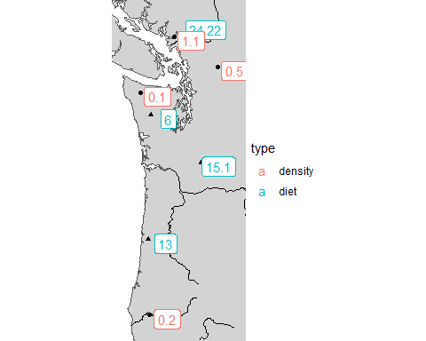

Figure 1: this is a caption