ReadME

* This readme is for running the training and testing code files.
* The file names tensor_training_code.py is the file that contains code for training the model.
* The data provided in the link() is necessary for successful execution of this file.
* The data has two folders, mixed_train and mixed_test respectively.

**For tensor_training_code.py**

* Kindly change the directory for train data providing the location for mixed_train at line number 159. The snapshot below shows the same:

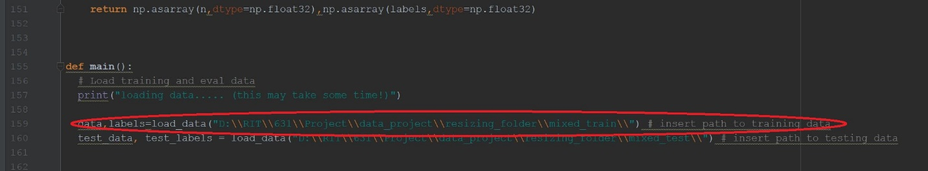

* Kindly change the directory for test data by providing the location for mixed_test at line number 160. The snapshot below shows the same:

A close up of a device

Description generated with high confidence

* Kindly change the directory for storing the checkpoints and tensorflow metadata by providing the location at line number 169. The snapshot below shows the same:

[You can provide any location here where you would like tensorflow to store few meta data files. These metadata files will contain information for the entire trained model once the training process is completed.]

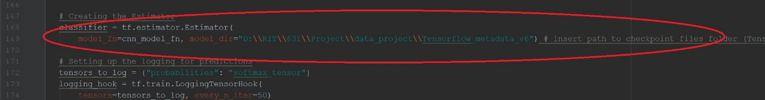

* Run the above code in python and results will displayed using the standard out.

**For tensor_test_code.py**

* Kindly change the directory for train data by providing the location for mixed_train at line number 157. The snapshot below shows the same:



* Kindly change the directory for test data by providing the location for mixed_test at line number 158. The snapshot below shows the same:

A close up of a device

Description generated with high confidence

* Kindly change the directory for storing the checkpoints and tensorflow metadata by providing the location at line number 166. The snapshot below shows the same:[provide the path to Tensorflow_metadata_v5 folder here]



* Run the above code in python and results will displayed using the standard out. Expected output will be test accuracy, testing confusion matrix, training accuracy and training confusion matrix.

Kindly Note- The files provided in the Tensorflow_metadata_v5 folder are the checkpoints stored after training the entire model. These files are required by the tensor_test_code.py to load the model we trained on our machine. Using these files, tensor_test_code.py will be able to produce the accuracies in few seconds using our pretrained model.