注：笔试题四jar包和笔试题word为同一级目录

笔试题一

1. 找到所有data包含空JsonObject的数据

答：36593,71109,71838,88217

SELECT id  
FROM json_data_52e3cb5d23853bbea3dbe693b65345d9bb7966c1  
WHERE *EXISTS* (  
 SELECT 1  
 FROM *json_tree*(**data**)  
 WHERE type = 'array'  
 AND (value LIKE '%null%' OR value NOT LIKE '%,%')  
);

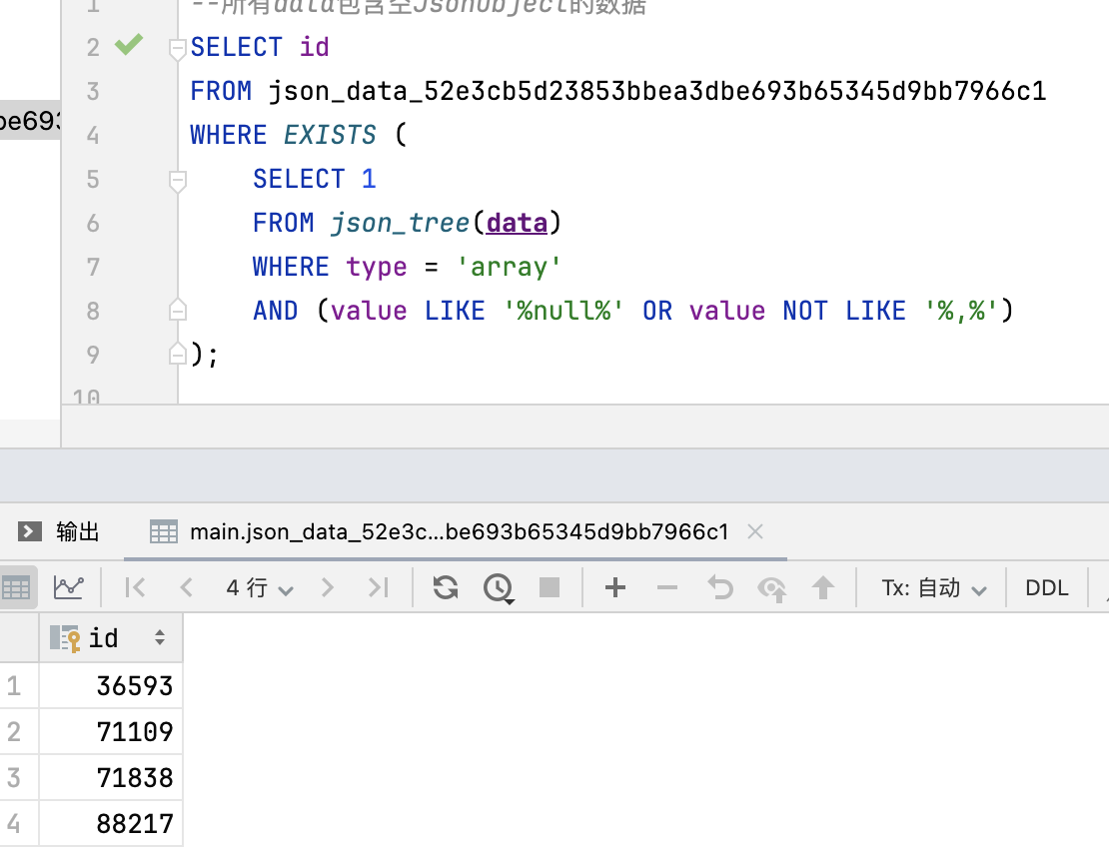

1. 找到所有data中包含JsonArray的值中有null的数据

答：22187,26790,49329,69019

SELECT id  
FROM json_data_52e3cb5d23853bbea3dbe693b65345d9bb7966c1  
WHERE *EXISTS* (  
 SELECT 1  
 FROM *json_each*(**data**)  
 WHERE *TRIM*(value) = '{}'  
);

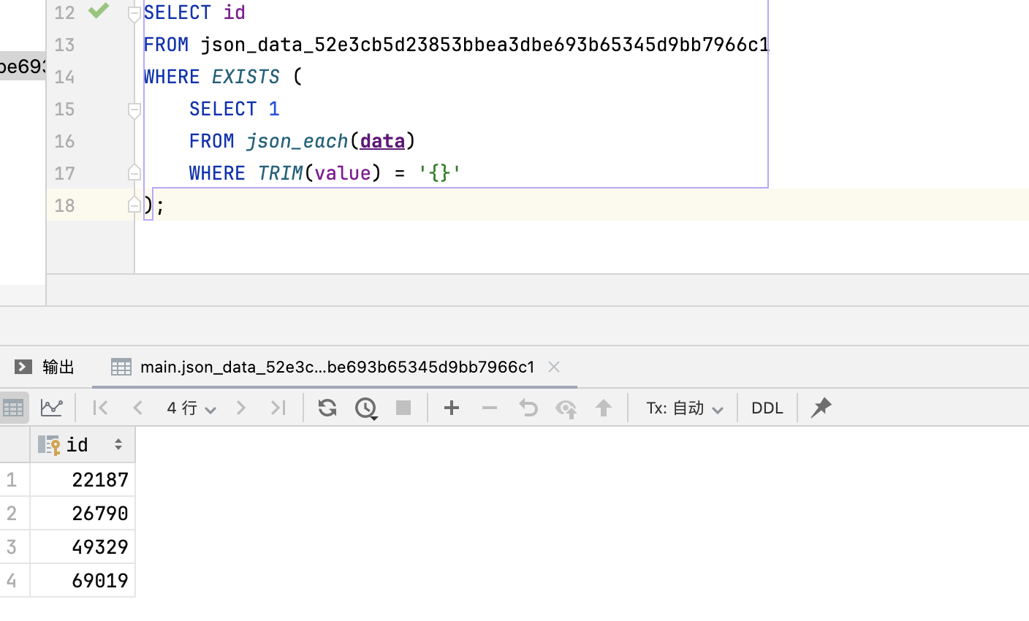

笔试题四

