DIP Project One

1. Image enhancement

(1) In the natural environment, the photos taken are often disturbed by light, resulting in too bright or too dark photos. Therefore, we need to use certain methods to process the photos to make their pixel distribution more balanced. Please process the too dark Figure 1.1. (Figure 1.2 is a referencing image after processing)

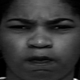

Figure 1.1 Before Processing

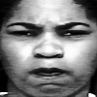

Figure 1.2 After Processing

(2) The following picture contains salt noise. Since the school emblem pattern in Figure 1.3 is white, the use of filter denoising will also cause certain losses to the image itself. Please keep the clarity of the school emblem as much as possible while denoising. Note: during the experiment, please adjust the picture to the size of 440 * 280, and the processed picture will also be saved according to this size. (Figure 1.4 is a referencing image after processing)



Figure 1.3 Before Processing



Figure 1.4 After Processing

2. Morphological Algorithms in *The Catcher in the Rye.*

*The Catcher in the Rye(*《麦田里的守望者》*)*,a novel by J. D. Salinger （杰罗姆·大卫·塞林格), is famous for its themes of angst, alienation, and as a critique on superficiality in society(*Wikipedia*). Now, there are two interesting questions about the last chapter of the novel for you to solve.

To begin with, please recap the knowledge about morphological reconstruction by reading the section 9.6 of the *digital images processing* (which is already in the folder). Note that although prof Lu may not mention morphological reconstruction during the lecture, all of you can fully understand it easily.

Then you can solve the following two questions, note that question 2.2 is **OPTIONAL**.

(1) There are two text images in ./*Q2_images* called *rye_catcher_c_1* and *rye_catcher_e_1* separately, please fill the holes of all characters in the image. (Figure 2.1 is an image before processing while Figure 2.2 is a referencing image after processing)

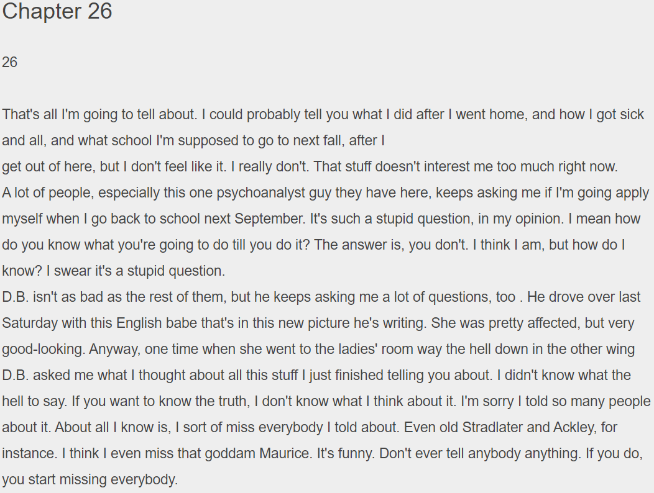

Figure 2.1 Before Processing

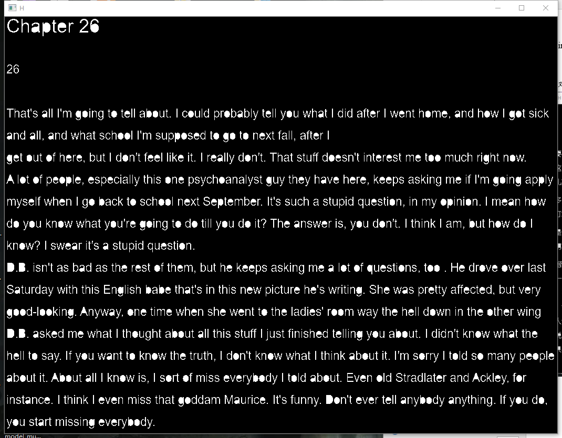

Figure 2.2 After Processing

(2) (**OPTIONAL**) There are two text images in ./*Q2_images* called *rye_catcher_c_2* and *rye_catcher_e_2* separately in which the leftmost characters are cut by image boarder, please clear the characters cut by boarder and guarantee that the rest of characters are complete. (Figure 2.3 is an image before processing while Figure 2.4 is a referencing image after processing)

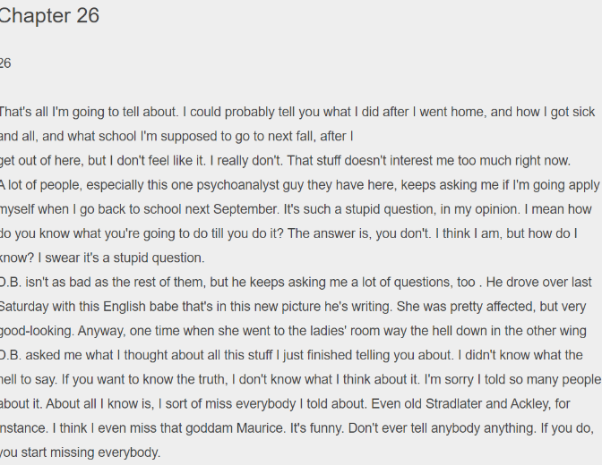

Figure 2.3 Before Processing

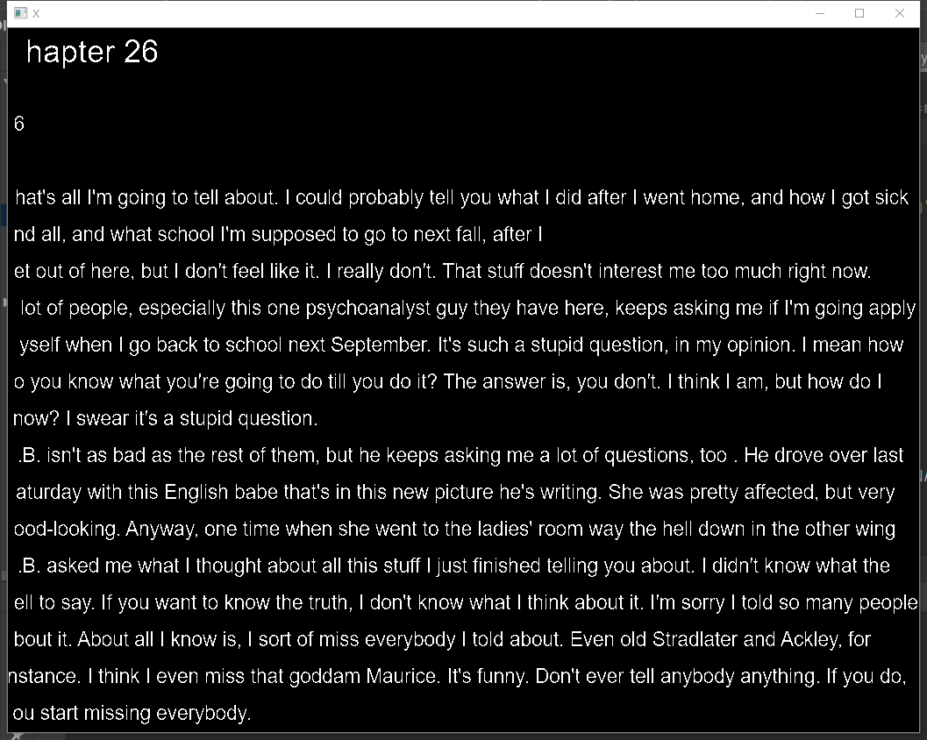

Figure 2.4 After Processing

Tips:

(1) You may find algorithms in the section 9.6 of the *digital images processing*, make sure you fully understand them and implement the algorithms **BY YOURSELF**.

(2) Make sure your code can handle **ANY SIZE** of input images since we may use other input images to test your code.

(3) For question 2.1, some Chinese characters such as “田”, “回”, “日” nd so on, your algorithm may return a square which is fully filled like $∎$, that is OK.

(4) It’s OK to output a binary image with 0, 1 values.

(5) Question 2.2 is **OPTIONAL**.

Attention

(1) The programing language is not limited.

(2) You **cannot** call any third party library for **key** **processing steps**,but functions use to I/O images, visualization or do mathematics are allowed. Take python as an example, you **cannot** call any function from cv2 **except** I/O functions in cv2 or visualization functions in cv2 and you **can** use numpy to do mathematics.

(3) You need to submit the source code and a brief report **in English**.

(4) Submission format: ‘Pro1_student ID_name.zip/rar’,

and Please send to: [295153721@qq.com](mailto:295153721@qq.com).

(5) Deadline: 30, Oct.

(6) Take it easy and Have fun! Most important: Do it by yourself!