DIP Project Two: Facial Expressions Recognition

1. Introduction

Hello everyone, how is everything? There has been a long time since Project One, we believe all of you have done it well. Now, welcome to Project Two.

Project Two is about a task called “Facial Expressions Recognition (FER)”. The analysis of facial expressions plays a fundamental role in various applications such as psychology study, digital entertainment, human-computer interaction and healthcare. Generally, a person’s facial expressions can be classified into seven classes: happy, sad, surprise, fear, anger, disgust and neutral. Given an input face image, the purpose of FER is to output a proper class of its facial expression. In other words, you can regard FER as an image multi-classification task.

2. Framework

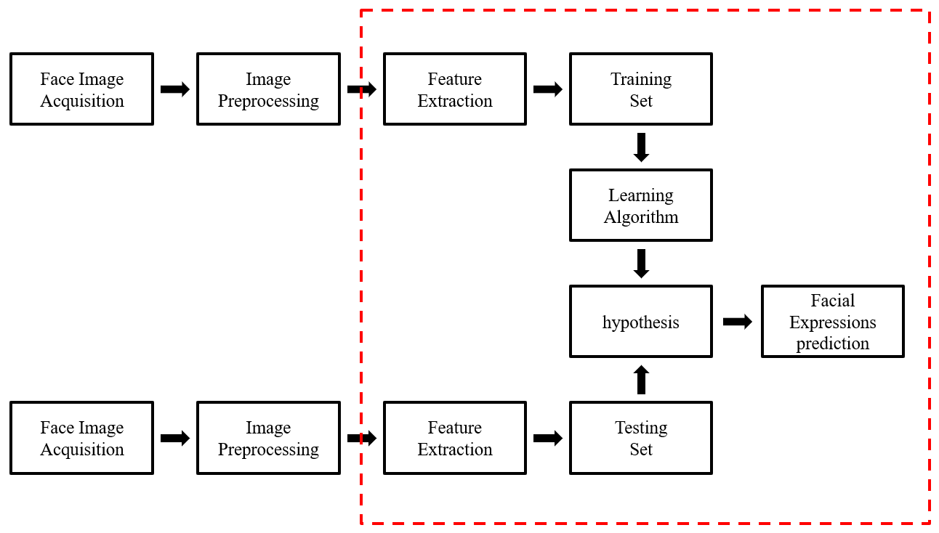

Figure 1. Recognition Framework

Figure 1 is a typical framework for Facial Expressions Recognition. Now, we have done face image acquisition and images preprocessing for you, all you need is to do feature extraction and implement an algorithm to do classification.

3. Feature Extraction

3.1 Texture Feature Extraction

Texture feature is one of the most important features in FER since different facial expressions have will produce unique facial texture. Local Binary Pattern (LBP) and Gabor filters are two common algorithms to extract texture feature. As shown in Figure 2, 2.a is a visualization of LBP feature in face while 2.b is a visualization of Gabor feature. Also, you can try other texture feature as well such as Histogram of Gradient (HoG) and so on.

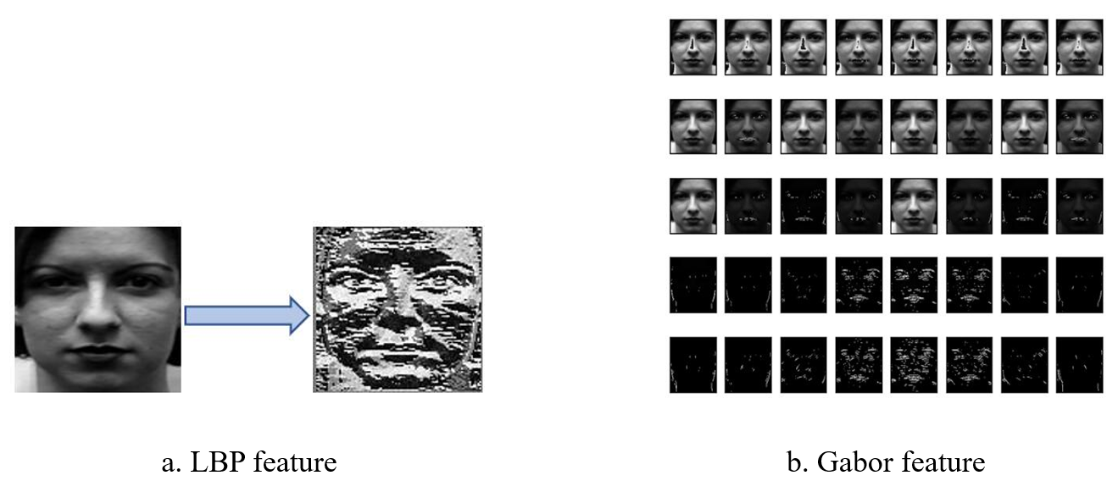

Figure 2. Two typical texture features

3.2 Feature reduction and feature fusion

Once you have done texture feature extraction, you may find it difficult to utilize it directly to do classification since the feature dimensionality is relatively high. Therefore, you should do feature reduction by some common methods such as Principal Component Analysis (PCA), Linear Discriminant Analysis (LDA), etc.

In addition, feature fusion is also a feasible idea to improve classification accuracy. If you have extracted more than one feature, try to sum, multiply, concatenate them to get a fused feature. You may try other feature fusion methods, but do not waste much time on it, focusing on feature extraction step will be more helpful.

4. Classification

After getting proper feature vectors of face images, you should implement an algorithm to complete FER task. You can choose any multi-classification algorithm you known, such as K-Nearest Neighbors (KNN), etc., for unsupervised method or Logistic Regression (LR), Support Vector Machine (SVM), etc., for supervised method.

In the end, you should utilize your algorithm to give each face image in test dataset a predicted class label, and evaluate your algorithm by computing classification accuracy.

5. Dataset

There are 1236 face images in total, we have already split them into train set and test set. For both train set and test set, we offer you a “.txt” file which contains corresponding facial expressions class labels, the number 1,2,3,4,5,6,7 represents seven classes “neutral”, “happy”, “sad”, “surprise”, “fear”, “anger”, and “disgust” separately.

Please use the images in folder “./dataset/train” for training classification algorithm and recognize the images in folder “./dataset/test” and give your recognition accuracy.

Attention

(1) The programing language is not limited and this time you **can** call third party functions.

(2) Besides aforementioned feature extraction, feature reduction, feature fusion and classification methods, you can try any other methods you want to improve your recognition accuracy. If you **refer** **to** others’ papers, please **attach your references list** at the end of your report.

(3) Although Neural Networks seem to perform well in feature extraction, please **DO NOT** use any NN-related method to do feature extraction.

(4) For this project you can work in teams, each team **is up to two classmates**. Each group needs to submit the source code and a brief report **in English**. Please use the **report template** in folder.

(5) Submission format: ‘Pro2_student ID_name.zip/rar’,

and Please send to: [469023493@qq.com](mailto:469023493@qq.com).

(6) Deadline: 10, Nov.

(7) Take it easy and Have fun! Most important: Do it by yourself!