Software Requirements Specification
for
Student Attendance Management System (SAMS)
Version 1.0
Prepared by Team 1
Name | SRN
Cheethirala Sai Santosh | PES1UG24CS127
Deepak B | PES1UG24CS143
Epari Subhransi | PES1UG24CS161
Gyaan S Shetty | PES1UG24CS178

Date: 03-10-2026

Table of Contents
Revision History
1. Introduction
1.1 Purpose
1.2 Intended Audience
1.3 Product Scope
1.4 References
2. Overall Description
2.1 Product Perspective
2.2 Product Functions
2.3 User Classes and Characteristics
2.4 Operating Environment
2.5 Design and Implementation Constraints
2.6 Assumptions and Dependencies
3. External Interface Requirements
3.1 User Interfaces
3.2 Software Interfaces
3.3 Communications Interfaces
4. Analysis Models
5. System Features
6. Other Nonfunctional Requirements
6.1 Performance Requirements
6.2 Safety Requirements
6.3 Security Requirements
6.4 Software Quality Attributes
6.5 Business Rules
7. Other Requirements
Appendix A: Glossary
Appendix B: Field Layouts
Appendix C: Requirement Traceability Matrix

Revision History
Name | Date | Reason For Changes | Version
Team 1 | 03-10-2026 | Initial version | 1.0

1. Introduction

1.1 Purpose
This document specifies the software requirements for the Student Attendance Management System (SAMS) version 1.0. SAMS is a web based application built using Python and Django for recording student attendance and generating attendance reports. This SRS covers the complete system.

1.2 Intended Audience
This document is for:
- Developers - to know what has to be built
- Testers - to write test cases from the requirements
- Faculty evaluator - to review the project
- Admin staff - who will be the actual users of the system
Section 2 gives the overall description, Section 3 the interface requirements, Section 4 the use case diagram, Section 5 the functional requirements and Section 6 the non functional requirements.

1.3 Product Scope
Currently attendance is taken on paper and later entered into excel sheets, which takes time and leads to mistakes in calculating percentages. Students also dont know thier attendance until the shortage list comes out at the end of the semester.
SAMS solves this by:
- letting faculty mark attendance online from a laptop or phone
- calculating attendance percentage automaticaly
- generating reports in PDF and Excel
- letting students check thier attendance anytime
- sending an email when attendance goes below 75%

1.4 References
- IEEE Std 830-1998, Recommended Practice for Software Requirements Specifications
- Django Documentation - https://docs.djangoproject.com
- SE Mini Project Guidelines and Problem Statements, Section C

2. Overall Description

2.1 Product Perspective
SAMS is a new, standalone system that replaces the manual attendance register. It is not part of any existing system. It has three tiers:
Tier | Technology
Front end | HTML, CSS, Bootstrap (Django templates)
Back end | Python, Django
Database | MySQL

The system also connects to an external email (SMTP) server to send mails.

2.2 Product Functions
- Login and logout for Admin, Faculty and Student
- Manage students, faculty, subjects and classes
- Mark and update attendance
- View subject wise attendance
- Generate attendance reports and shortage list (PDF / Excel)
- Send shortage email to students below 75%
- Apply for leave and approve / reject leave

2.3 User Classes and Characteristics
User Class | Description | Usage
Admin | College office staff / HOD. Manages students, faculty, subjects and classes. Full access. | Occasional
Faculty | Teachers. Mark attendance, generate reports, approve leave. Most important user class. | Daily
Student | Views own attendance and applies for leave. Mostly uses mobile. | Frequent

2.4 Operating Environment
Component | Requirement
Server OS | Windows 10+ or Ubuntu 20.04+
Runtime | Python 3.10+, Django 4.2
Database | MySQL 8.0
Client | Any modern browser (Chrome, Firefox, Edge) on laptop or mobile

2.5 Design and Implementation Constraints
- Must be developed in Python using Django (as per problem statement)
- MySQL must be used as the database
- Web application only, no mobile app
- Must be completed within the semester by a team of 4
- Code on GitHub, sprints tracked in JIRA

2.6 Assumptions and Dependencies
- College provides student and subject lists in Excel format
- A Gmail SMTP account is available for sending emails
- Faculty have a device with internet during class
- Depends on third party libraries: reportlab (PDF) and openpyxl (Excel)

3. External Interface Requirements

3.1 User Interfaces
- Web interface built with HTML, CSS and Bootstrap
- Role based dashboard shown after login
- Navigation bar with only the options allowed for that role
- Forms show error messages for invalid input
- Attendance page shows the student list with a checkbox for each student
- Pages work on both laptop and mobile screens

3.2 Software Interfaces
Software | Purpose
MySQL 8.0 | Stores all data, accessed through Django ORM
Gmail SMTP | Sending shortage and leave emails
reportlab | Generating PDF reports
openpyxl | Reading student Excel uploads and generating Excel reports

3.3 Communications Interfaces
- HTTPS between browser and server
- SMTP on port 587 with TLS for emails

4. Analysis Models
Figure 1 shows the use case diagram with the three actors - Admin, Faculty and Student.
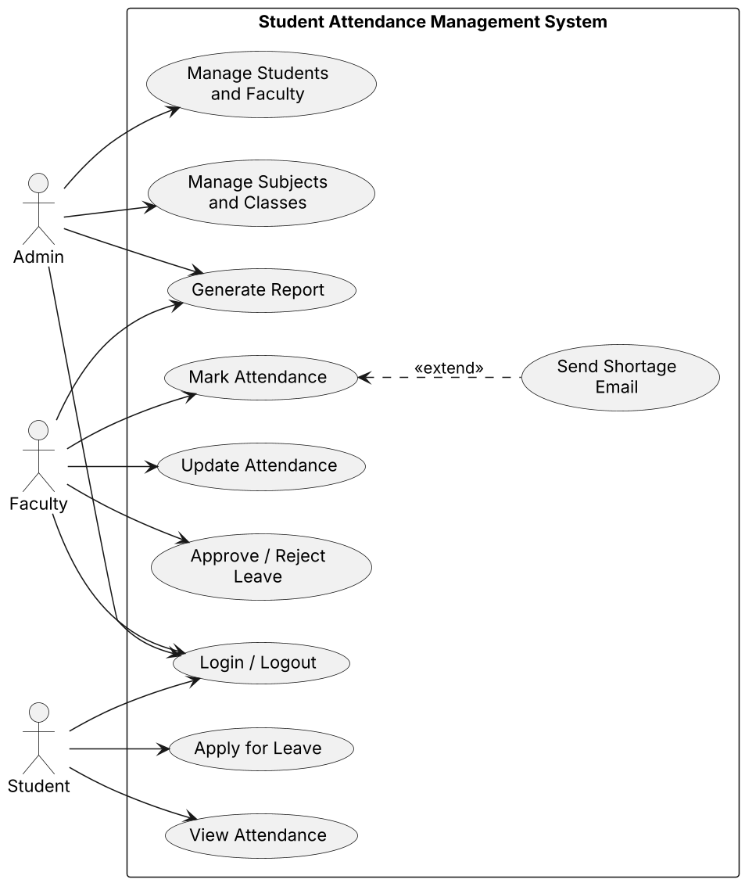
Figure 1: Use case diagram

5. System Features

5.1 User Login and Management
Description and Priority: Lets users login and lets admin manage user accounts. Priority - High.
Stimulus / Response:
User Action (Stimulus) | System Response
User enters correct ID and password | Dashboard for that role is shown
User enters wrong password | "Invalid username or password" shown
Admin submits add student form | Student saved, success message shown

Functional Requirements:
ID | Requirement
REQ-1 | The system shall allow Admin, Faculty and Students to login using thier ID and password.
REQ-2 | The system shall show a different dashboard for each role after login.
REQ-3 | The Admin shall be able to add, edit and delete student and faculty accounts.
REQ-4 | The Admin shall be able to upload a list of students from an Excel file.

5.2 Subject and Class Management
Description and Priority: Lets admin set up subjects and classes so attendance can be taken. Priority - High.
Stimulus / Response:
User Action (Stimulus) | System Response
Admin adds subject and assigns faculty | Subject saved and shown on faculty dashboard

Functional Requirements:
ID | Requirement
REQ-5 | The Admin shall be able to add subjects with subject code, name and semester.
REQ-6 | The Admin shall be able to create classes (semester + section) and assign students to them.
REQ-7 | The Admin shall be able to assign a faculty to a subject for a class.

5.3 Mark Attendance
Description and Priority: Lets faculty take and correct attendance for thier class. Priority - High.
Stimulus / Response:
User Action (Stimulus) | System Response
Faculty selects subject, class, date and hour | Student list shown
Faculty marks absentees and submits | Attendance saved, confirmation shown

Functional Requirements:
ID | Requirement
REQ-8 | The Faculty shall be able to mark each student present or absent for a selected subject, class, date and hour.
REQ-9 | The system shall not allow attendance to be marked twice for the same subject, class, date and hour.
REQ-10 | The Faculty shall be able to update attendance within 3 days of marking it.
REQ-11 | The system shall recalculate attendance percentage of each student after every submission.

5.4 View Attendance and Reports
Description and Priority: Lets students see attendance and faculty/admin generate reports. Priority - High.
Stimulus / Response:
User Action (Stimulus) | System Response
Student opens My Attendance | Subject wise percentage shown
Faculty selects class, subject, dates and clicks Generate | Report created and downloaded

Functional Requirements:
ID | Requirement
REQ-12 | The Student shall be able to view thier attendance percentage for each subject.
REQ-13 | The Faculty and Admin shall be able to generate an attendance report for a class and subject between two dates.
REQ-14 | The report shall be downloadable in PDF and Excel format.
REQ-15 | The system shall generate a shortage list of students below 75% attendance.

5.5 Shortage Email and Leave
Description and Priority: Warns students of low attendance and handles leave requests. Priority - Medium.
Stimulus / Response:
User Action (Stimulus) | System Response
Student attendance drops below 75% | Email sent to student
Student submits leave form | Request sent to faculty
Faculty approves leave | Those days marked as Leave

Functional Requirements:
ID | Requirement
REQ-16 | The system shall send an email to the student when thier attendance in any subject falls below 75%.
REQ-17 | The Student shall be able to apply for leave by giving dates and reason.
REQ-18 | The Faculty shall be able to approve or reject a leave request.
REQ-19 | Approved leave days shall not be counted as absent.

6. Other Nonfunctional Requirements

6.1 Performance Requirements
ID | Requirement
NFR-1 | Every page shall load within 3 seconds with upto 100 users at the same time.
NFR-2 | Submitting attendance for a class of 70 students shall take less than 2 seconds.
NFR-3 | A full semester report for one class and subject shall be generated within 5 seconds.

6.2 Safety Requirements
ID | Requirement
NFR-4 | The database shall be backed up once every day.
NFR-5 | Attendance records shall never be permanantly deleted, only updated.

6.3 Security Requirements
Security Objectives:
ID | Objective
SO-1 | Only authorised users can access the system and each user can only do what thier role allows.
SO-2 | Attendance data can only be changed by the faculty of that subject or the admin.
SO-3 | Personal details of students (email, phone) are kept confidential.

Security Requirements:
ID | Requirement | Objective
NFR-6 | Passwords shall be stored hashed using Django PBKDF2, never in plain text. | SO-1
NFR-7 | The system shall check the user role on every page and block pages not allowed for that role. | SO-1
NFR-8 | A student shall only be able to view thier own attendance. | SO-3
NFR-9 | User session shall expire after 30 minutes of no activity. | SO-1
NFR-10 | All forms shall be protected against CSRF and SQL injection. | SO-2
NFR-11 | Every change to an attendance record shall be logged with faculty name, date and time. | SO-2

6.4 Software Quality Attributes
Attribute | Requirement
Usability | A new faculty can mark attendance without any training.
Reliability | System available during college hours (8 AM - 5 PM) on working days.
Maintainability | Code split into seperate Django apps per module.
Portability | Runs on both Windows and Linux servers.

6.5 Business Rules
ID | Rule
BR-1 | Only Admin can add or delete students, faculty and subjects.
BR-2 | Only the faculty assigned to a subject can mark attendance for it.
BR-3 | Faculty can edit attendance only within 3 days; after that only Admin can.
BR-4 | Minimum 75% attendance per subject is needed for ESA eligibility (domain requirement).
BR-5 | Attendance % = (classes attended + approved leave) / classes conducted x 100 (domain requirement).

7. Other Requirements
- Student data must be handled as per university data rules.
- Only English language is supported in this version.

Appendix A: Glossary
Term | Meaning
SAMS | Student Attendance Management System
SRN | Student Registration Number
ESA | End Semester Assessment
HOD | Head of Department
ORM | Object Relational Mapping
CSRF | Cross Site Request Forgery
SMTP | Simple Mail Transfer Protocol
Shortage | Attendance below 75% in a subject

Appendix B: Field Layouts
Student Registration Fields
Field | Length | Data Type | Description | Mandatory
SRN | 13 | Alphanumeric | Student registration number | Y
Name | 50 | Text | Full name | Y
Email | 50 | Alphanumeric | College email ID | Y
Phone | 10 | Numeric | Mobile number | N
Semester | 1 | Numeric | 1 to 8 | Y
Section | 1 | Text | Section | Y
Department | 5 | Text | e.g. CSE | Y
Password | 20 | Alphanumeric | Changed on first login | Y

Report Fields
Attendance Report | Shortage Report
Subject Code and Name | Subject Code and Name
Class (Sem and Section) | Class (Sem and Section)
From Date / To Date | SRN
SRN | Student Name
Student Name | Classes Conducted
Classes Conducted | Classes Attended
Classes Attended | Attendance %
Leave Days | Email Sent (Y/N)
Attendance % | Faculty Name
Faculty Name | Generated On
Generated On

Appendix C: Requirement Traceability Matrix
Sl. No | Req ID | Brief Description | Architecture Ref | Design Ref | Code File Ref | Test Case ID | System Test Case ID
1 | REQ-1 | allow Admin, Faculty and Students to login using thier ID and password
2 | REQ-2 | show a different dashboard for each role after login
3 | REQ-3 | Admin can add, edit and delete student and faculty accounts
4 | REQ-4 | Admin can upload a list of students from an Excel file
5 | REQ-5 | Admin can add subjects with subject code, name and semester
6 | REQ-6 | Admin can create classes (semester + section) and assign students to them
7 | REQ-7 | Admin can assign a faculty to a subject for a class
8 | REQ-8 | Faculty can mark each student present or absent for a selected subject, class, date and hour
9 | REQ-9 | not allow attendance to be marked twice for the same subject, class, date and hour
10 | REQ-10 | Faculty can update attendance within 3 days of marking it
11 | REQ-11 | recalculate attendance percentage of each student after every submission
12 | REQ-12 | Student can view thier attendance percentage for each subject
13 | REQ-13 | Faculty/Admin can generate an attendance report for a class and subject between two dates
14 | REQ-14 | Report downloadable in PDF and Excel format
15 | REQ-15 | generate a shortage list of students below 75% attendance
16 | REQ-16 | send an email to the student when thier attendance in any subject falls below 75%
17 | REQ-17 | Student can apply for leave by giving dates and reason
18 | REQ-18 | Faculty can approve or reject a leave request
19 | REQ-19 | Approved leave days shall not be counted as absent

