CBCA246

ASSIGNMENT 3

S24BCAU0044

MEHUL MOHAN TYAGI

Task 1: Project Setup

Step 1: Create a New Jira Project

* Go to Jira dashboard.
* Click Create Project.
* Select Scrum as the project type.
* Choose Company-managed.
* Enter your Project Name (e.g., “PriorityTrack”).
* Set a project key.
* 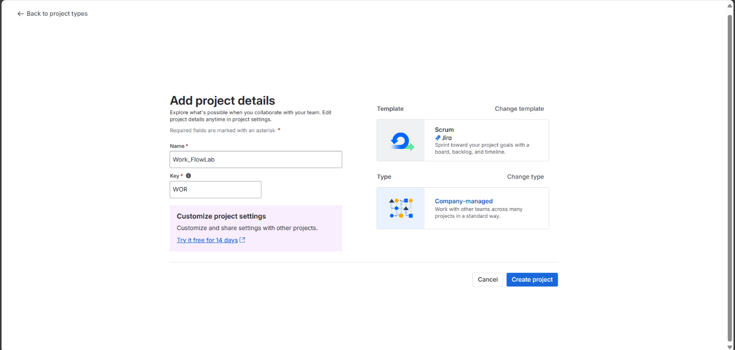Click Create.

Step 2: Explore Project Settings

* Navigate to Project Settings.
* Add a clear project description.
* Note the default workflow in use under Project Settings > Workflows.

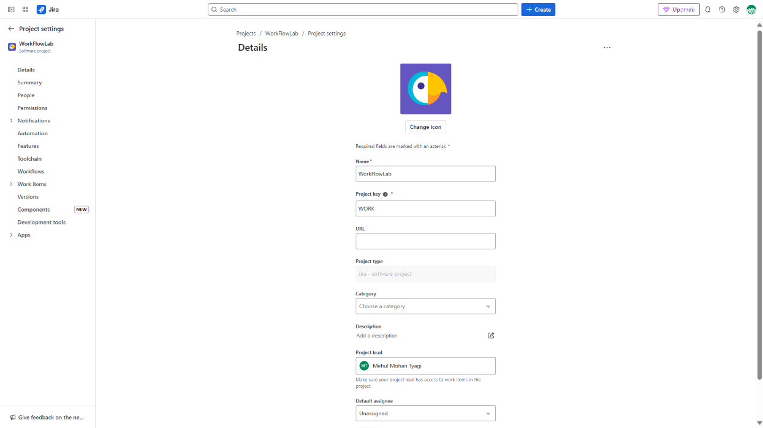

Task 2: Issue Creation, Prioritization & Workflow Interaction

Step 1: Create Multiple Issues

* Create at least:
  + 2 Stories
  + 2 Tasks
  + 1 Bug
* 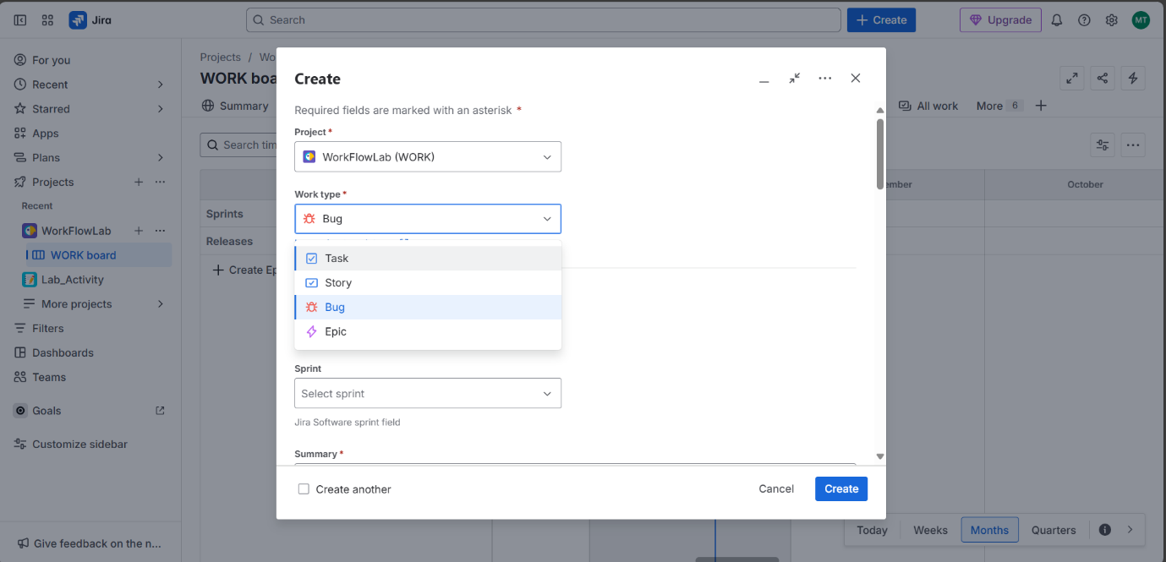Use Create Issue button

Step 2: Assign Priority to Each Issue

* When creating or editing issues, set their priority from: Highest, High, Medium, Low, Lowest.
  + Bugs: set to High or Highest
  + 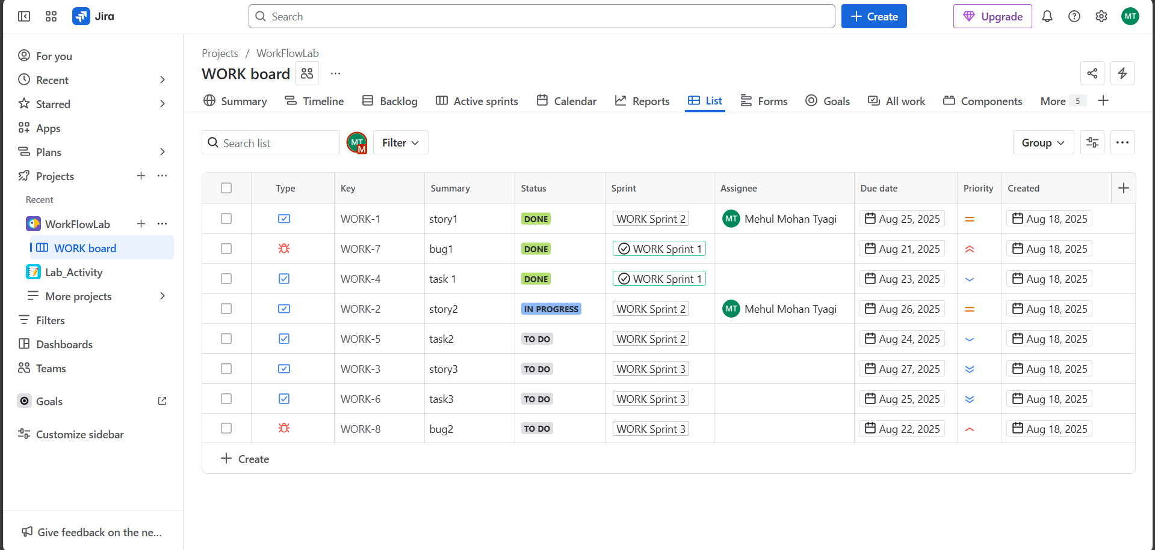Tasks/Stories: set to Medium or Low

Step 3: Track Issues on Scrum Board

* Use the board to move tasks across statuses (To Do → In Progress → Done).
* 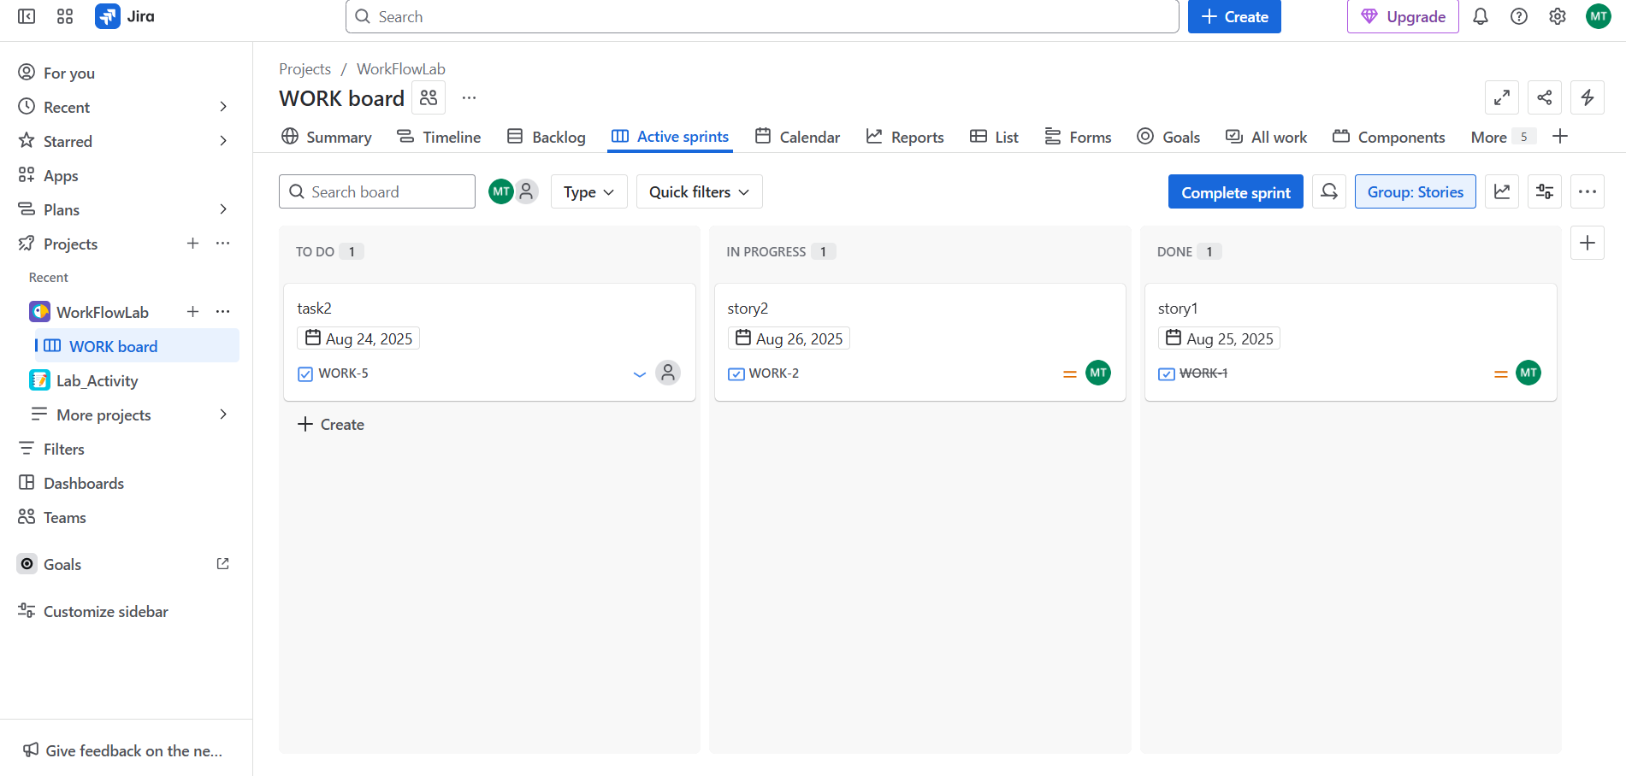Check if issue priority affects visibility or urgency.

Task 3: Workflow Customization

Step 1: Edit the Workflow

* Go to Project Settings > Workflows.
* 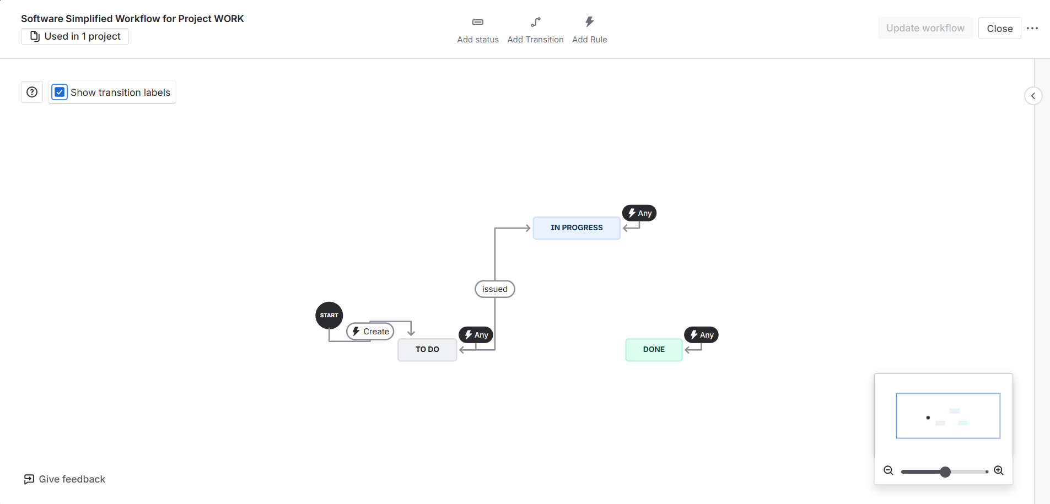Click Edit on the active workflow.

**Step 2: Make Required Changes**

* Condition: Allow only the *assignee* to move an issue to “In Progress.”

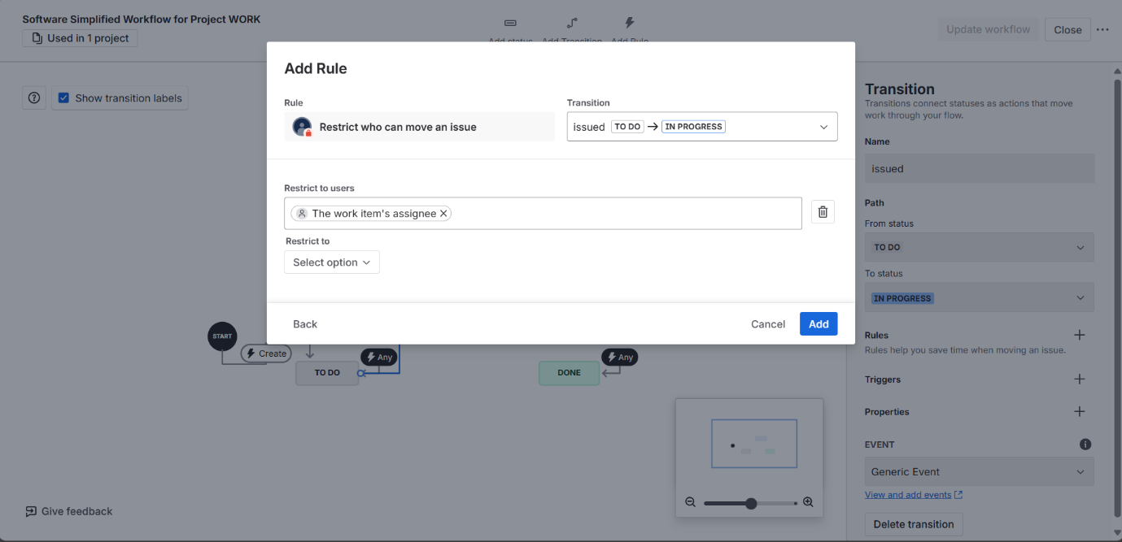

* 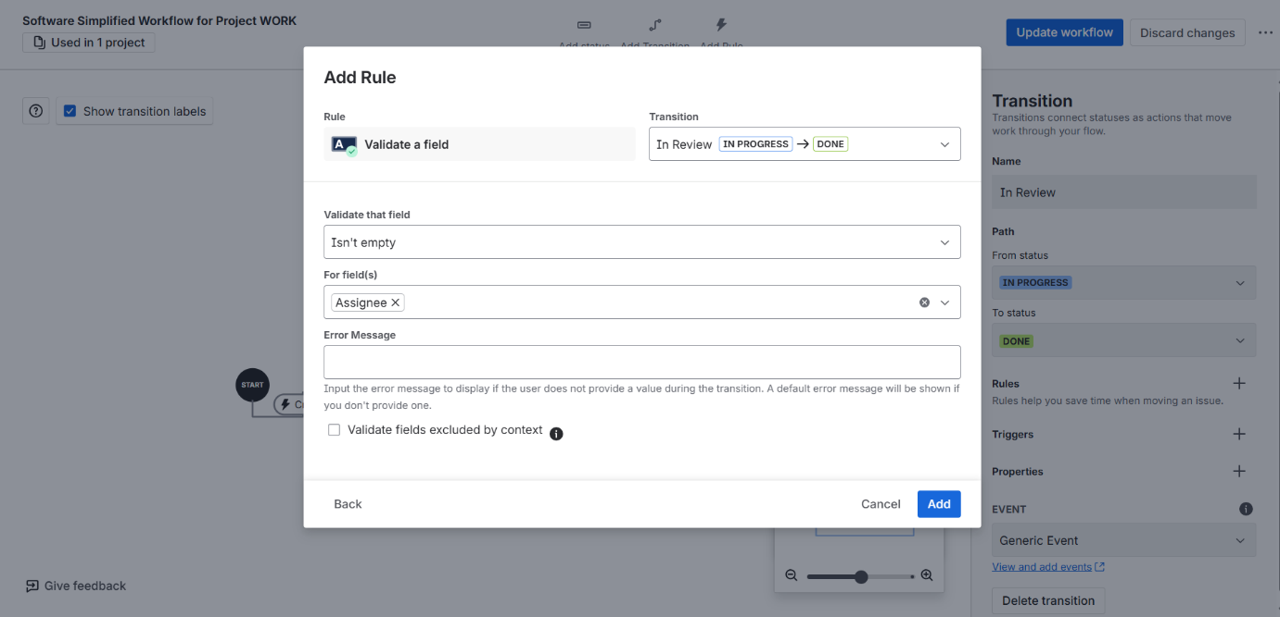Validator: Ensure the *assignee* field is not empty before “In Review.”
* 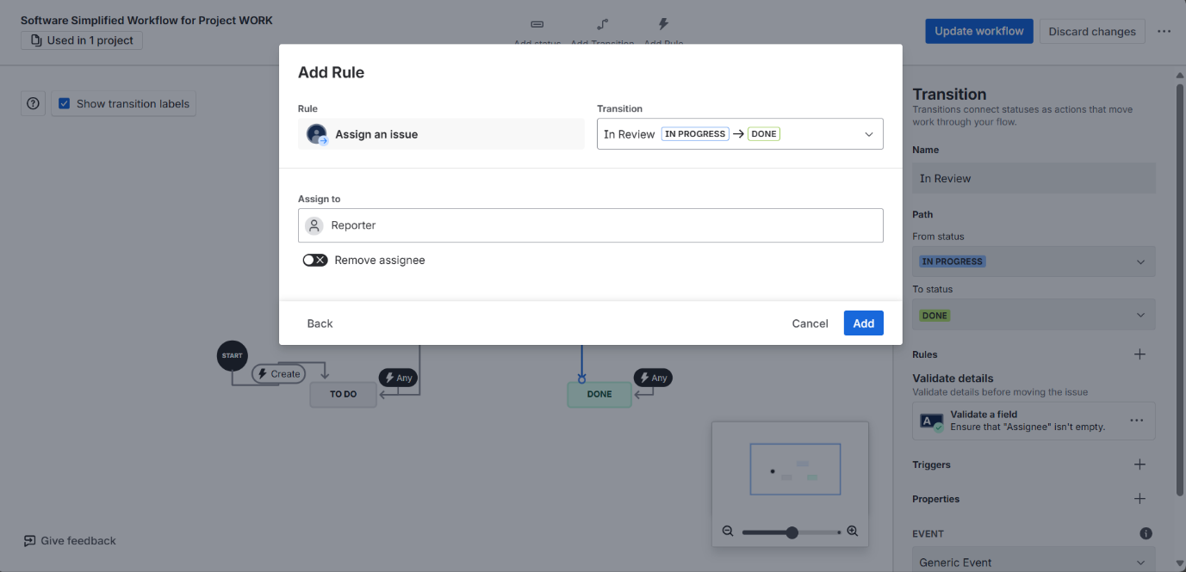Post Function: Auto-assign issue to the *reporter* or notify a group when moving to “Done.”

Task 4: Reporting & Dashboards

Step 1: Use Filters and Views

* Apply filters to show issues by Priority

Step 2: Create a Dashboard

* Go to Dashboards > Create new.
* Add gadgets:
  + Sprint Burndown
  + 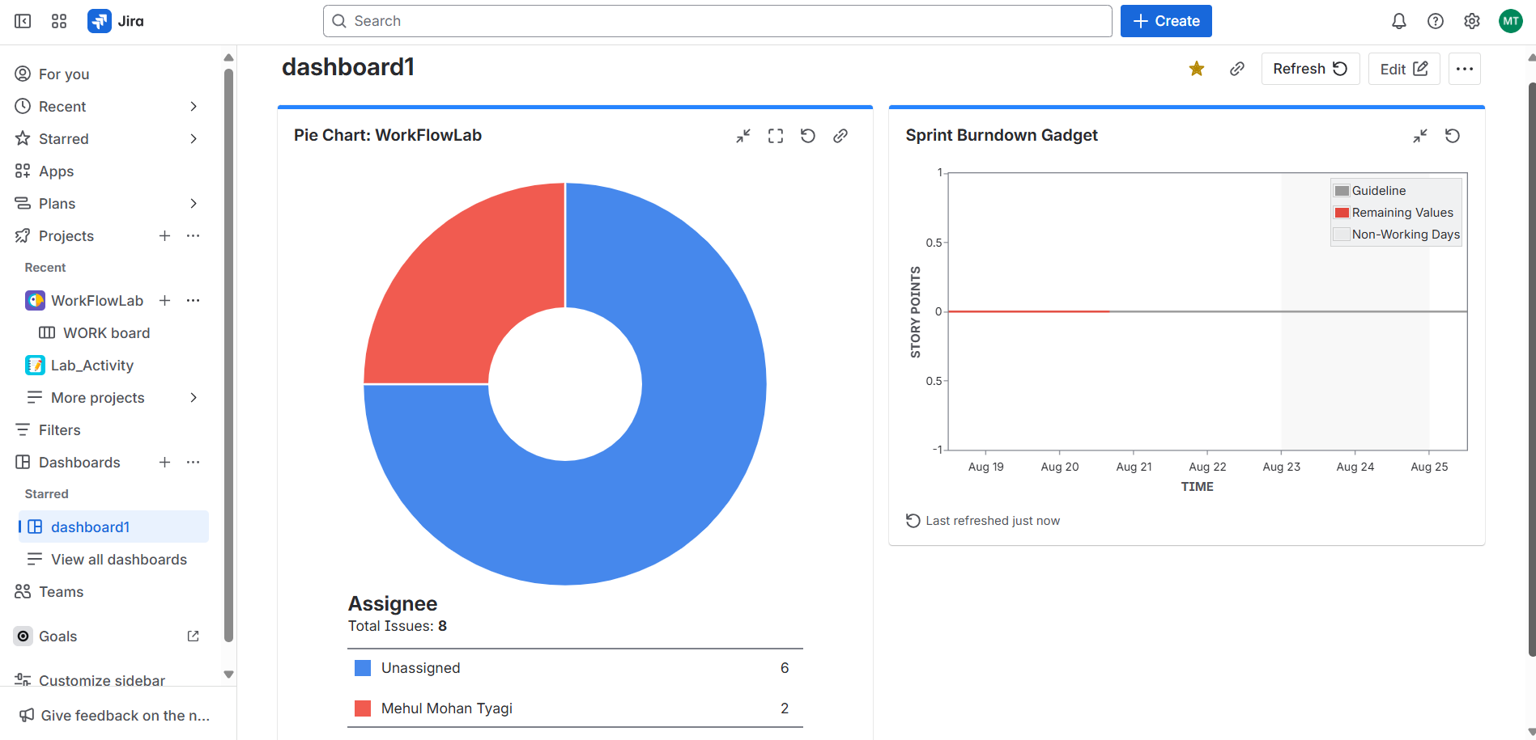Pie Chart by Assignee