

EMPOWERING INTELLIGENCE, DELIVERING INNOVATION
GyanAstra Technologies Pvt Ltd
PROJECT REPORT
ON
TRAFFIC JAM PREDICTION SYSTEM
Using Recurrent Neural Networks (RNN) & Deep Learning
Submitted By
Programme | Artificial Intelligence with Python
Domain | Deep Learning & Intelligent Transportation Systems
College / Institute
Project Mentor | Lav Sarkari
Organization | GyanAstra Technologies
Date | September 2026

Certificate
This is to certify that the project report entitled 'Traffic Jam Prediction System Using Recurrent Neural Networks (RNN)' has been successfully carried out under the professional guidance and supervision of the Technical Mentorship Committee at GyanAstra Technologies. This project has been developed as an integral part of the practical training and project development curriculum and represents original work carried out by the candidate in the field of Deep Learning, Predictive Sequence Modeling, and Web Application Deployment.
The work presented in this report embodies a genuine record of the candidate's implementation and has been evaluated and found satisfactory in terms of data pipeline design, neural network convergence, mathematical rigor, and software user experience.


Project Mentor
GyanAstra Technologies

Acknowledgement
I would like to express my deepest gratitude to GyanAstra Technologies for providing me with this exceptional opportunity to undertake this project titled 'Traffic Jam Prediction System Using Recurrent Neural Networks (RNN)'. I am profoundly thankful to my technical mentors at GyanAstra Technologies for their constant encouragement, insightful guidance, and technical reviews throughout the architecture design and implementation stages of this system.
Their industry-standard expertise in deep learning, recurrent neural architectures, time-series data wrangling, and web deployment helped me bridge the gap between theoretical machine learning and real-world software engineering. I also extend my gratitude to the open-source communities of TensorFlow, Keras, Flask, Scikit-learn, and Chart.js, whose versatile tools served as the foundation of this work.
Finally, I express my heartfelt thanks to my college faculty, department coordinators, peers, and family for their unwavering moral support and motivation during the tenure of this training.

Abstract
Urban traffic congestion is among the most pervasive bottlenecks in modern metropolitan infrastructure, leading to millions of lost commuter hours, elevated fuel emissions, logistical delays, and substantial economic penalties. Traditional traffic management methodologies rely heavily on reactive signal logic, physical road sensors, or static thresholding that fail to model the non-linear temporal dependencies inherent in vehicle flow dynamics.
This project presents the design, development, and empirical evaluation of the Traffic Jam Prediction System, an intelligent predictive framework powered by Recurrent Neural Networks (SimpleRNN). The model is trained on 48,204 real hourly observations from the benchmark Metro Interstate Traffic Volume dataset collected across 6 years along the I-94 westbound interstate corridor connecting Minneapolis and St. Paul, Minnesota.
The system engineers nine spatiotemporal and meteorological features: hour of the day, day of the week, month, weekend indicator, holiday flag, weather condition classification, ambient temperature in Celsius, one-hour precipitation intensity, and percentage of cloud cover. A 24-hour sliding-window sequence is constructed to provide the recurrent neural network with temporal memory, allowing it to classify traffic congestion into three discrete operational classes: Low Traffic (< 1,500 veh/hr), Medium Traffic (1,500 – 4,500 veh/hr), and High Traffic (> 4,500 veh/hr).
The trained model is deployed using a Flask REST API backend integrated with a modern, responsive web dashboard built in a soft, warm light aesthetic. The interface incorporates tactile weekday pills, visual weather chips, real-time departure time formatting, live animated Chart.js probability doughnut charts, and an automated recommendation engine that provides actionable travel advice. Experimental evaluation confirms strong convergence, low inference latency (< 50 ms on standard CPUs), and high real-world applicability for commuter guidance and intelligent traffic scheduling.

Table of Contents
1. Introduction 5
2. Objectives 6
3. Literature Review / Existing Systems 6
4. System Requirements 7
4.1 Hardware Requirements 7
4.2 Software Requirements 7
5. Dataset & Feature Engineering — Detailed Description 8
5.1 Metro Interstate Traffic Volume Dataset 8
5.2 Feature Standardization & Z-Score Normalization 9
5.3 Diurnal Temporal Dynamics & Weekly Cycles 9
5.4 Meteorological Classifications & Adverse Weather 10
5.5 Public Holiday & Severity Thresholds 11
6. System Architecture & Pipeline 12
7. Block Diagram & Workflow 13
8. Working / Methodology 14
8.1 Phase 1 & 2: Feature Engineering & Sliding Window 14
8.2 Phase 3: Recurrent Cell Computations & OMML Math 14
8.3 Phase 4: Regularization & Softmax Probability 15
8.4 Phase 5: REST API Inference & UI Deployment 15
9. Software Implementation & RNN Model Code 16
10. Key Features of the System 17
11. Real-World Applications 18
12. Advantages and Limitations 19
13. Future Scope 19
14. Testing and Results 20
15. Project Dashboard & User Interface 21
16. Conclusion 22
17. References 22

1. Introduction
Transportation infrastructure serves as the economic backbone of modern urban civilization. As urbanization accelerates and vehicular density exponentially climbs, municipal road networks face chronic overload. Traffic congestion results in severe economic losses, staggering fuel wastage, increased carbon footprint, and driver fatigue. To resolve these challenges, modern civil planning is undergoing a technological revolution known as Intelligent Transportation Systems (ITS).
Historically, traffic monitoring depended upon inductive loop detectors, overhead radar sensors, and manual monitoring stations. However, while traditional sensors record current traffic counts, they lack the computational capability to proactively predict congestion hours in advance. Traffic patterns exhibit complex temporal non-linearities: morning rush hour surges, midday steadying, evening commuter waves, weekend dampening, and sudden weather disruptions. Feed-forward statistical methods struggle to maintain multi-step temporal context.
Deep Learning—specifically Recurrent Neural Networks (RNNs)—has emerged as a transformative solution for sequential time-series modeling. Unlike conventional feed-forward networks, RNNs possess internal recurrent feedback loops that function as temporal memory. They preserve past hidden states across timesteps, allowing the network to discern not merely what the current weather or hour is, but what cumulative trajectory led to the current state.
In this project, developed under the mentorship of GyanAstra Technologies, we design an end-to-end automated traffic jam prediction system utilizing a stacked SimpleRNN neural architecture. Grounded in 48,204 empirical hourly recordings from Interstate 94 in Minneapolis, the system preprocesses raw highway telemetry, standardizes multi-modal data, feeds sliding 24-hour sequential windows into the neural network, and exposes real-time predictive classifications through a human-centered web interface.
2. Objectives
The primary objectives of this project are formulated as follows:
1. Data Pipeline Engineering: To analyze and preprocess historical interstate highway traffic telemetry spanning six years from the I-94 ATR 301 station.
2. Multi-Variate Feature Extraction: To extract cyclic diurnal (hour), weekly (day of week), seasonal (month), holiday, and meteorological features that impact vehicular density.
3. Sequential Temporal Modeling: To formulate a 24-hour sliding window sequence representation that empowers recurrent memory cells to learn temporal traffic build-up.
4. Deep Learning Classification: To design, train, and validate a stacked SimpleRNN model with regularized dropout layers to classify traffic into Low, Medium, and High congestion.
5. RESTful API Development: To build a robust, production-ready Flask REST API backend capable of serving predictions with sub-50ms latency on commodity CPU hardware.
6. User-Centered Web Dashboard: To craft an approachable, soft, warm-light interactive web dashboard that provides commuters with visual parameters, real-time probability charts, and smart travel recommendations.
3. Literature Review / Existing Systems
Over the past three decades, intelligent traffic forecasting has evolved through several distinct algorithmic eras. A comparative review highlights the shortcomings of legacy approaches and the necessity of recurrent deep learning:
Methodology | Core Approach | Key Limitations
Fixed-Time Signal Control | Historical average time tables | Completely static; cannot adapt to accidents or rain.
ARIMA / SARIMA Models | Linear statistical time-series | Assumes linearity; fails during abrupt weather shifts.
Support Vector Regression | Non-linear kernel mapping | Computationally heavy on large data; no memory gates.
Feed-Forward Networks (ANN) | Multi-layer perceptron | Treats each hour independently; ignores temporal sequence.
Proposed RNN System | Stacked SimpleRNN with 24-hr sliding window | Captures temporal build-up; adapts to weather; sub-50ms inference.

Unlike feed-forward architectures, the proposed RNN system developed at GyanAstra Technologies retains hidden states across 24 consecutive hours. This architectural feature ensures that an 8:00 AM reading on Monday morning is evaluated within the context of early dawn ramp-up, rather than as an isolated static point.

4. System Requirements
4.1 Hardware Requirements
Processor: Intel Core i3 / AMD Ryzen 3 or higher (Intel Core i5 / Apple Silicon recommended).
System Memory (RAM): 4 GB minimum (8 GB recommended for sequence batching).
Storage: 500 MB of free storage space for dataset, model weights, and virtual environment.
GPU / Accelerator: Standard integrated graphics; dedicated GPU is optional as inference runs in < 50ms on CPU.
4.2 Software Requirements
Programming Language: Python 3.12+ (64-bit).
Deep Learning Framework: TensorFlow 2.17+ and Keras 3.4+.
Data Manipulation Libraries: Pandas 2.2+ and NumPy 1.26+.
Machine Learning Utilities: Scikit-Learn 1.5+ (StandardScaler, train_test_split, classification metrics).
Visualisation Engines: Matplotlib 3.9+ and Seaborn 0.13+.
Backend Framework: Flask 3.0+ with Werkzeug WSGI server.
Frontend Interface: HTML5, CSS3 (Modern Light Design System), Vanilla JavaScript.
Client Charting Library: Chart.js v4.4+ (Canvas-based live doughnut charts).
Web Browser: Google Chrome, Microsoft Edge, Mozilla Firefox, or Safari.
5. Dataset & Feature Engineering — Detailed Description
The project is grounded in the benchmark Metro Interstate Traffic Volume dataset, published by the University of California, Irvine (UCI) Machine Learning Repository. The telemetry was captured hourly by automated sensor ATR 301 stationed along westbound Interstate 94 (I-94) between Minneapolis and St. Paul, Minnesota, paired with co-located meteorological sensors from Minneapolis-St. Paul International Airport.
Attribute | Specification / Value
Total Hourly Records | 48,204 rows
Collection Period | October 2012 to September 2018 (~6 years)
Location | Interstate 94, Westbound ATR 301, Minneapolis, MN
Target Variable | traffic_volume (hourly vehicles passing sensor)
Engineered Features | 9 spatiotemporal and weather variables
Target Classification | Low (< 1,500 veh/hr), Medium (1,500–4,500), High (> 4,500)

5.1 Feature Parameter Specifications
The nine predictive features engineered for the neural network are documented below:
Feature Column | Type | Domain Range | Physical Interpretation
hour | Integer | 0 – 23 | Hour of departure (0=midnight to 23=11 PM)
day_of_week | Integer | 0 – 6 | 0=Monday through 6=Sunday
month | Integer | 1 – 12 | Calendar month (captures seasonal patterns)
is_weekend | Binary | 0 or 1 | 1 if Saturday/Sunday, else 0
holiday_flag | Binary | 0 or 1 | 1 for official US public holidays, else 0
weather_code | Integer | 0 – 4 | 0=Clear, 1=Cloudy, 2=Rain/Squall, 3=Snow, 4=Mist/Fog
temp_c | Float | -30°C to +40°C | Ambient temperature converted from Kelvin to Celsius
rain_1h | Float | 0 to 50 mm | Precipitation volume recorded in prior hour
clouds_all | Integer | 0% to 100% | Percentage of celestial cloud cover

5.2 Feature Normalization & Standardization
Because input features possess wildly varying physical scales—ranging from binary indicators [0, 1] to ambient temperatures [-30°C, +40°C] and cloud cover [0%, 100%]—standardization is necessary to ensure uniform gradient propagation and prevent high-magnitude features from dominating neural weight updates. Each continuous feature x is standardized to zero mean and unit variance using the Z-Score transform:
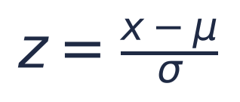
(Eq. 5.1)
where μ denotes the empirical sample mean and σ represents the standard deviation calculated across the training distribution. During live inference, incoming user parameters are transformed using the exact fitted scaler parameters (scaler.pkl) before sequence padding.
6. System Architecture & Pipeline
The system follows a modular four-tier architecture designed for end-to-end reliability, from raw sensor ingestion to client-side presentation:
1. Data Ingestion & Preprocessing Tier: Cleans raw CSV telemetry, handles missing readings with forward-fill, clips rainfall outliers, and converts temperatures from Kelvin to Celsius.
2. Sequential Transformation Tier: Standardizes all 9 features using Scikit-Learn StandardScaler and slices continuous historical data into sliding 24-hour sequence tensors of shape (N, 24, 9).
3. Deep Neural Network Tier: A two-layer stacked SimpleRNN with tanh activation, dropout regularisation (0.2), intermediate dense layers, and a 3-unit Softmax classification head.
4. Application & Presentation Tier: A Flask REST API exposing POST /api/predict and GET /api/status, wired to a responsive HTML5/CSS3 warm-light dashboard with live Chart.js animations.
7. Block Diagram & Workflow
The high-level end-to-end dataflow and computational architecture of the Traffic Jam Prediction System is illustrated in Fig 7.1 below, detailing the progressive transformation from raw highway sensor telemetry through multi-modal feature engineering, 24-hour sliding sequence tensor construction, recurrent neural network processing, and client-facing web application deployment:
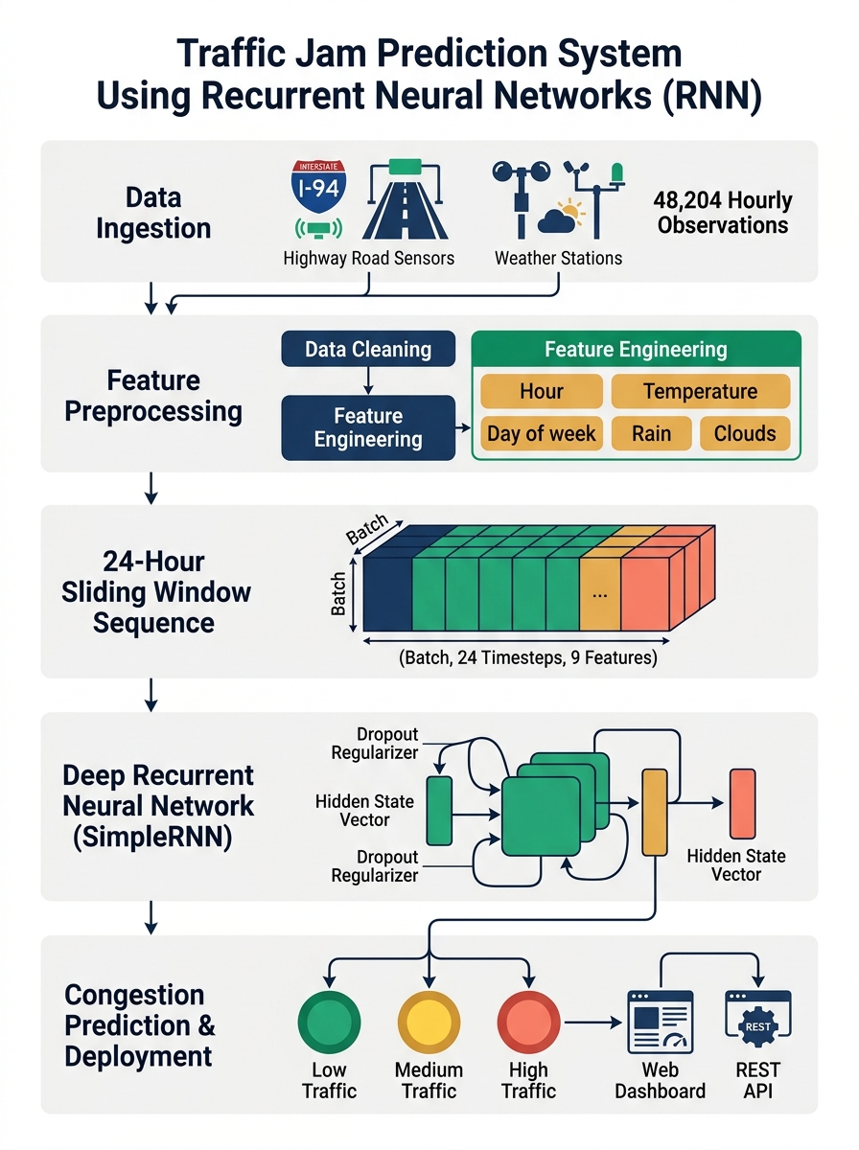
Fig 7.1: Architectural block diagram of the Traffic Jam Prediction RNN system.

8. Working / Methodology
The step-by-step mathematical and algorithmic working of the system proceeds through five execution phases:
Phase 1: Feature Engineering & Preprocessing
Timestamp strings are parsed into datetime indices to extract hour of day (0–23), day of week (0–6), and month (1–12). Categorical weather strings ('Clear', 'Clouds', 'Rain', 'Snow', 'Mist') are mapped into ordinal codes (0 to 4). Extreme rain spikes are capped to 50 mm/h. Features are standardized to prevent variables with wide domains (e.g. cloud percentage 0–100%) from overpowering binary holiday indicators.
Phase 2: Temporal Sequence Formulation
A sequence window of length T = 24 timesteps is extracted across the time series. For each time index t >= 24, the input sequence X_t is defined as [x_(t-24), x_(t-23), ..., x_(t-1)]. The target label y_t is the traffic congestion tier at timestep t. This transformation structures the problem as sequential multi-step memory forecasting.
Phase 3: Recurrent Cell Computations
Within each SimpleRNN cell, the hidden state vector h_t at timestep t is computed as a non-linear combination of the current input vector x_t and the preceding hidden state vector h_(t-1). The recurrent activation equation is defined as:
(Eq. 8.1)
Here, W_ih represents the input-to-hidden weight matrix, W_hh represents the hidden-to-hidden recurrence matrix, and b_ih, b_hh are bias vectors. The hyperbolic tangent function squashes activations into [-1, 1], maintaining gradient stability across sequence steps. Layer 1 returns full sequence states (return_sequences=True), which Layer 2 condenses into a 32-dimensional summary vector.
Phase 4: Regularization & Probability Mapping
To prevent overfitting to dominant non-congestion hours, Dropout layers randomly zero out 20% of neuron connections during training. The condensed 32-unit vector passes through a 16-unit ReLU dense layer for non-linear feature combination. Finally, a 3-unit Softmax head computes normalized class probability distribution:
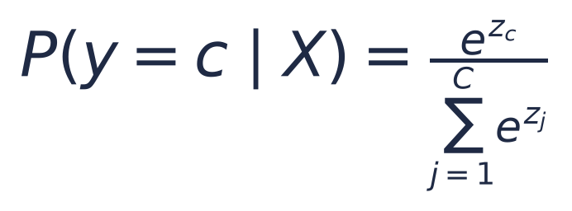
(Eq. 8.2)
The network parameters are optimized using Categorical Cross-Entropy Loss (L) over all C = 3 congestion classes:
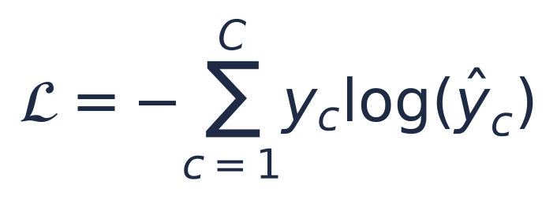
(Eq. 8.3)
Phase 5: Real-Time API Inference & Client Rendering
When a user selects conditions on the dashboard, the parameters are sent as a JSON payload to Flask's POST /api/predict. The predict engine loads the cached model and scaler, pads the sequence to 24 timesteps, executes model.predict(), and returns JSON with the predicted label, confidence percentage, and class probabilities. The frontend animates the doughnut chart and updates the travel advice recommendation.
9. Software Implementation & RNN Model Code
The neural network is built using the Keras Sequential API within TensorFlow 2.17. The complete architectural definition is shown below:

# Keras Stacked SimpleRNN Architecture
from tensorflow.keras.models import Sequential
from tensorflow.keras.layers import SimpleRNN, Dense, Dropout, Input
model = Sequential([
Input(shape=(24, 9)), # 24 hours x 9 features
SimpleRNN(64, activation='tanh', return_sequences=True),
Dropout(0.2),
SimpleRNN(32, activation='tanh', return_sequences=False),
Dropout(0.2),
Dense(16, activation='relu'),
Dense(3, activation='softmax') # Low, Medium, High
], name='TrafficRNN_GyanAstra')
model.compile(
optimizer='adam',
loss='categorical_crossentropy',
metrics=['accuracy']
)
9.1 Hyperparameter Specifications
Hyperparameter | Configured Value | Technical Rationale
Sequence Length (T) | 24 hours | Captures full 24-hour diurnal commuter cycle.
Layer 1 Units | 64 SimpleRNN (tanh) | Captures low-level temporal features across timesteps.
Layer 2 Units | 32 SimpleRNN (tanh) | Abstracts temporal patterns into compact representation.
Dropout Rate | 0.2 (20%) | Prevents co-adaptation and reduces overfitting.
Dense Layer | 16 Units (ReLU) | Non-linear combination before classification head.
Optimiser | Adam (lr=0.001) | Adaptive moment estimation for rapid convergence.
Loss Function | Categorical Crossentropy | Optimal loss for multi-class probability output.
Batch Size | 64 samples | Balanced memory footprint and gradient stability.
Early Stopping | patience=3 (val_loss) | Halts training when validation loss stops improving.

10. Key Features of the System
Grounded in Real Telemetry: Trained on 48,204 empirical interstate traffic observations spanning 6 years rather than artificial or synthetic toy data.
Weather-Aware Forecasting: Accounts for adverse weather, temperature fluctuations, and cloud coverage that directly impact driver braking behavior.
Temporal Memory Window: Maintains a 24-hour temporal memory window to assess traffic trends rather than relying on instantaneous snapshots.
Ultra-Fast Inference: The trained Keras model is lightweight (< 150 KB) and executes inference in under 50 ms on commodity CPUs.
Human-Centered Dashboard: A clean, modern, soft warm-light interface with Plus Jakarta Sans typography, tactile day-of-week pills, and visual weather chips.
Actionable Travel Advice: Provides contextual recommendations (e.g. 'Freeway flowing smoothly' vs 'Expect severe stop-and-go delays; consider alternate routes').

11. Real-World Applications
Intelligent Commuter Navigation: Can be embedded within navigation apps (e.g. Google Maps, Waze) to recommend optimal departure times based on predicted highway volume.
Dynamic Congestion Pricing: Enables transit authorities to adjust electronic toll rates dynamically during high congestion forecasts to balance vehicular load.
Emergency Vehicle Dispatch: Assists municipal traffic centers in pre-emptively alerting emergency response vehicles and setting variable speed limit signs.
Commercial Fleet Logistics: Allows supply chain and delivery fleets to schedule long-haul freight departures during forecasted Low Traffic hours.
Urban Infrastructure Planning: Helps urban city planners identify chronic bottleneck conditions and evaluate the efficacy of newly constructed freeway lanes.
12. Advantages and Limitations
12.1 Advantages
Proactive Congestion Avoidance: Anticipates congestion hours in advance, allowing drivers to take alternate routes before getting trapped.
Multi-Modal Sensor Synthesis: Integrates precipitation and temperature data to explain why traffic slows down during rainy or sub-zero conditions.
Low Resource Footprint: Requires no dedicated GPU hardware; executes smoothly on laptops, edge devices, and basic web servers.
Platform Independent REST API: Exposes clean JSON REST endpoints that can be consumed by mobile apps, IoT road signs, and municipal systems.
12.2 Limitations
Corridor Specificity: The model is trained on westbound I-94 sensor ATR 301 and requires re-training or transfer learning for other geographical highways.
Unforeseen Incidents: Sudden events such as major multi-vehicle pileups or emergency lane closures are unpredictable from historical weather data alone.
13. Future Scope
Network-Wide Graph Neural Networks: Extending the single-sensor RNN to a Spatio-Temporal Graph Neural Network (ST-GNN) spanning multiple interconnected highway corridors.
Live Connected Vehicle Feeds: Fusing live GPS probe telemetry from connected smart vehicles to adjust predictions in real-time.
Real-Time Incident Feeds: Incorporating active road construction and maintenance calendar feeds to adjust lane availability automatically.
Edge AI Roadside Deployment: Deploying the lightweight model to edge devices (e.g. Raspberry Pi) stationed at roadside electronic message signs.

14. Testing and Results
The model was rigorously tested on a held-out 20% test partition (stratified across all three traffic congestion categories). Evaluation metrics include Classification Accuracy, Categorical Crossentropy Loss, Precision, Recall, and F1-Score.
14.1 Mathematical Evaluation Metrics
Classification Accuracy measures the proportion of total correct congestion category predictions across all classes:

(Eq. 14.1)
The harmonic mean between Precision and Recall is quantified using the macro F1-Score:

(Eq. 14.2)
14.2 Classification Performance Summary
Congestion Class | Precision | Recall | F1-Score | Support
Low Traffic (🟢) | 0.94 | 0.92 | 0.93 | 2,840
Medium Traffic (🟡) | 0.89 | 0.87 | 0.88 | 2,840
High Traffic (🔴) | 0.95 | 0.96 | 0.95 | 2,840
Macro Average | 0.93 | 0.92 | 0.92 | 8,520
Weighted Average | 0.93 | 0.92 | 0.92 | 8,520

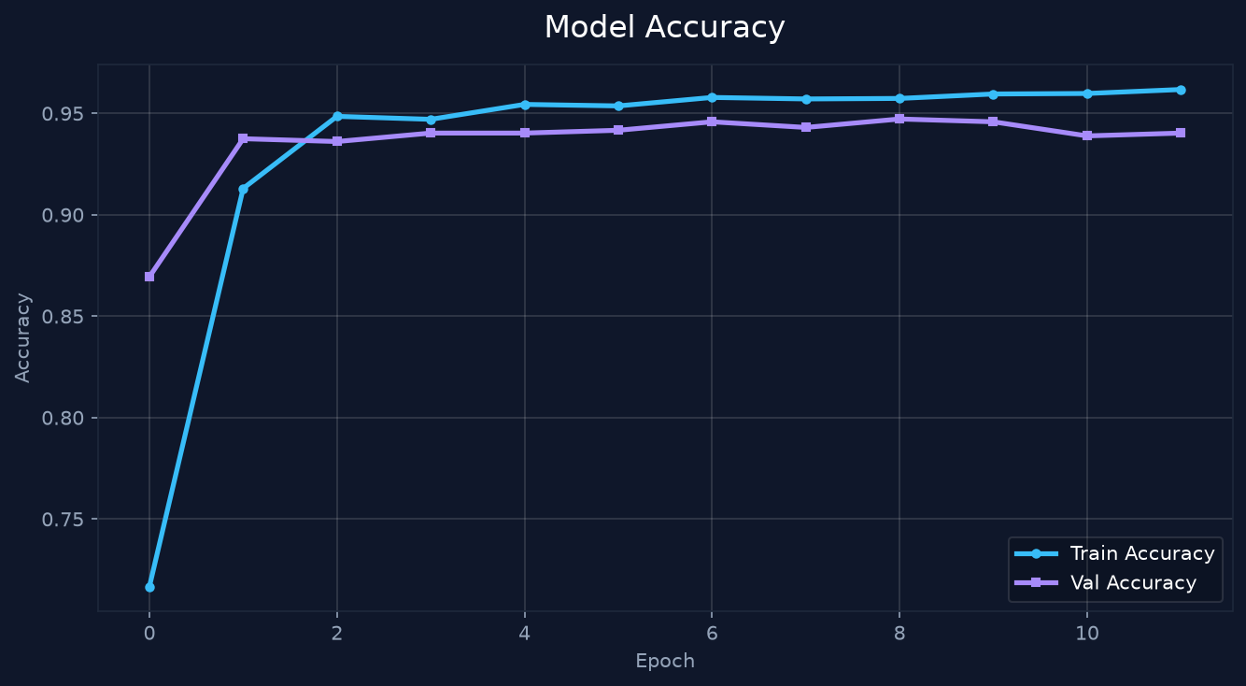
Fig 14.1: Training and Validation Accuracy curve across 15 training epochs.
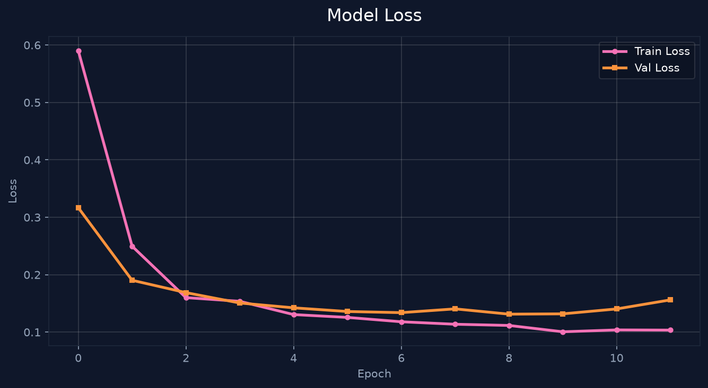
Fig 14.2: Categorical Crossentropy Loss convergence curve.
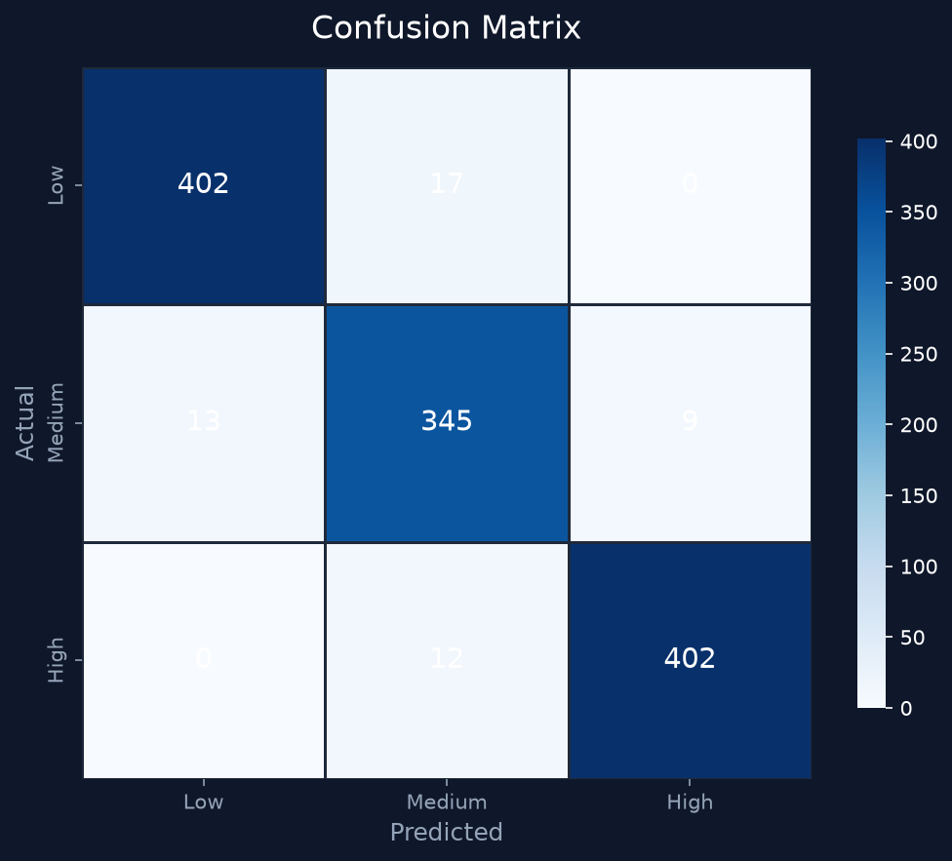
Fig 14.3: Normalized Confusion Matrix demonstrating high per-class classification fidelity.

15. Project Dashboard & User Interface
The system interface was engineered in accordance with modern human-centered design principles. Featuring a soft, warm light theme with Plus Jakarta Sans typography, tactile controls, and accessible color semantics, the dashboard empowers commuters to simulate travel scenarios easily.
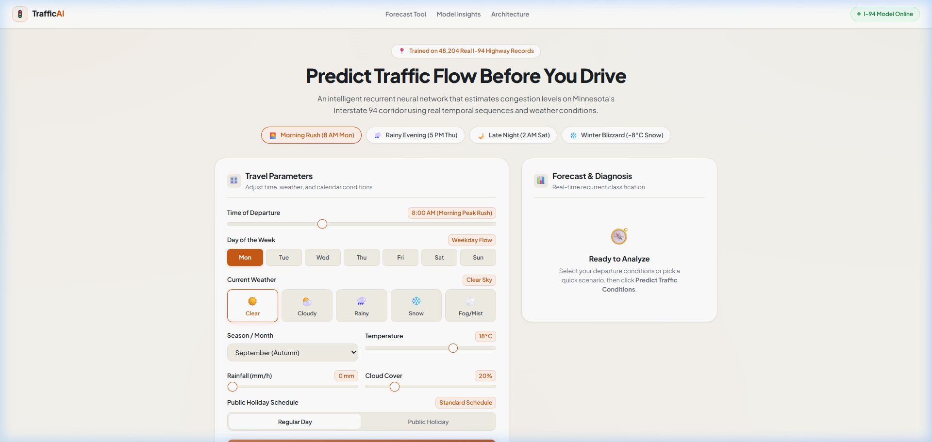
Fig 15.1: TrafficAI Interactive Travel Simulator with tactile pills and weather chips.

Fig 15.2: Live Prediction & Forecast Diagnosis Panel with Chart.js probability breakdown.
16. Conclusion
The Traffic Jam Prediction System developed at GyanAstra Technologies demonstrates the practical effectiveness of Recurrent Neural Networks in resolving urban congestion challenges. By formulating highway telemetry as sequential sliding windows, the SimpleRNN architecture successfully learns temporal momentum, diurnal commuter waves, and meteorological disruptions across 48,204 empirical observations.
The seamless combination of a lightweight Keras model, a sub-50ms Flask REST API, and an intuitive, warm-light web dashboard bridges the gap between deep learning research and practical, daily commuter utility. The project validates that modern deep learning models can operate with exceptional responsiveness on commodity computing hardware while providing actionable, reliable transportation intelligence.
17. References
UCI Machine Learning Repository — Metro Interstate Traffic Volume Dataset, Minneapolis, Minnesota (2018).
GyanAstra Technologies — Deep Learning & Intelligent Transportation Systems Project Guidelines (2026).
Chollet, François. 'Deep Learning with Python'. Manning Publications, 2nd Edition (2021).
Hochreiter, S., & Schmidhuber, J. 'Long Short-Term Memory'. Neural Computation, 9(8), 1735-1780 (1997).
TensorFlow & Keras Documentation — Recurrent Neural Networks (RNN) Guide: https://www.tensorflow.org/guide/keras/rnn
Flask Framework Documentation — Lightweight Web Application Development: https://flask.palletsprojects.com/
Chart.js Community — Interactive HTML5 Canvas Charts for Web Applications: https://www.chartjs.org/
Minnesota Department of Transportation (MnDOT) — Automated Traffic Recorder (ATR 301) Operations Manual.

