Noise Schedule Ablation in Diffusion Models
Phase 2 Report - Foundation Models and Generative AI
Toonification of face photographs with google/ddpm-celebahq-256 fine-tuned on MetFaces, native beta_t vs beta_t^2.00
Shruthi Chinnasamy (M26AI1119) | Code: https://github.com/GyanStore/Foundation-models-Noise-Schedule-Ablation-in-Diffusion-Models

1. Task and Model
Task. Toonification of real face photographs: a real photographic portrait is translated into a painterly "Old Masters" portrait in the style of pre-20th-century portrait painting (the MetFaces domain), while the subject's approximate facial structure and pose are preserved. Input: an aligned 256x256 RGB face photo. Output: a 256x256 RGB painted-style portrait of the same face.
Model. google/ddpm-celebahq-256, an unconditional DDPM (Ho, Jain and Abbeel, "Denoising Diffusion Probabilistic Models", NeurIPS 2020, https://arxiv.org/abs/2006.11239) trained on CelebA-HQ 256x256 face photographs; checkpoint https://huggingface.co/google/ddpm-celebahq-256 (diffusers DDPMPipeline = UNet2DModel + DDPMScheduler). The model is used for image-to-image translation by noising the input photo to an intermediate timestep and running the reverse process from there (SDEdit), optionally with ILVR low-frequency guidance (Section 4).
Forward process. For t = 1..T (T = 1000) the forward process is q(x_t | x_{t-1}) = N(sqrt(1 - beta_t) x_{t-1}, beta_t I), with closed form q(x_t | x_0) = N(sqrt(alpha_bar_t) x_0, (1 - alpha_bar_t) I), where alpha_t = 1 - beta_t and alpha_bar_t = prod_{s<=t} alpha_s. x_0 is the clean image, x_t the noisy image at step t, and I the identity. The network eps_theta(x_t, t) is trained with L = E || eps - eps_theta(sqrt(alpha_bar_t) x_0 + sqrt(1 - alpha_bar_t) eps, t) ||^2, eps ~ N(0, I).
Native noise parameter. theta_t = beta_t, the per-step forward variance of DDPMScheduler. From the checkpoint's scheduler_config.json: beta_schedule = "linear", beta_start = 1e-4, beta_end = 0.02, num_train_timesteps = 1000. Run B uses theta_t^x = beta_t^x with x = 2.00; signal-to-noise ratio SNR(t) = alpha_bar_t / (1 - alpha_bar_t).

2. Dataset and Verification
Dataset. MetFaces (NVlabs), https://github.com/NVlabs/metfaces-dataset: 1,336 face images at 1024x1024 extracted from paintings, drawings and sculptures in the Metropolitan Museum of Art Open Access collection, aligned and cropped with the FFHQ procedure (dlib landmarks), CC BY-NC 2.0. It is the target style domain of the task: aligned portraits from the Old Masters tradition, at a resolution that downsamples cleanly to the model's 256x256. We used the Hugging Face mirror huggan/metfaces (same 1,336 images).
Evidence it was not used for pretraining. Route (b) of the brief. The pretraining domain is documented in Karras, Aila, Laine and Lehtinen, "Progressive Growing of GANs for Improved Quality, Stability, and Variation", ICLR 2018, https://arxiv.org/abs/1710.10196, page 14, Appendix C: the Figure 8 caption ("We start with a JPEG image (a) from the CelebA in-the-wild dataset") and the paragraph below it ("We perform the above processing for all 202599 images in the dataset ... discard all but the best 30000 images"). CelebA-HQ is therefore made only of real camera photographs of celebrities. MetFaces consists of hand-made artworks (paint, pigment, brushstroke, engraving and stone textures) from art periods that largely predate photography and were never camera JPEGs, so it lies in a clearly different image domain and cannot have been part of CelebA-HQ.
Input photos. Run 0 / A / B are applied to 30 real face photos from FFHQ (Karras et al., 2019; Flickr, no overlap with CelebA-HQ), mirror bitmind/ffhq-256, picked with seed 42; 20 further disjoint FFHQ photos form a dev set used only to choose the inference setting. FFHQ uses the same alignment as MetFaces, so inputs and training images share framing.

3. Schedule Analysis
theta_t in (0, 1). beta_t = 1e-4 + (t - 1)(0.02 - 1e-4)/999 is linear and increasing, so 1e-4 <= beta_t <= 0.02 for every t; hence 0 < theta_t < 1 for all t and theta_t^x is well defined, real and also in (0, 1). Because 0 < theta_t < 1 and x > 1, theta_t^x < theta_t at every t. Measured: beta_t^2.00 spans 1e-8 .. 4e-4.
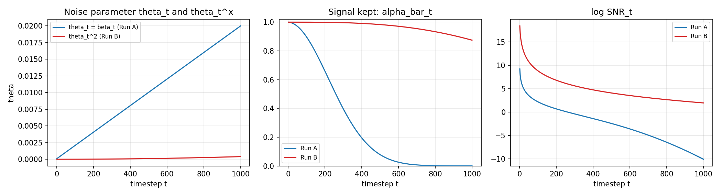
Figure 1. Left: theta_t = beta_t and theta_t^x (x = 2.00) on the same axes. Middle: alpha_bar_t. Right: log-SNR(t) = log(alpha_bar_t / (1 - alpha_bar_t)).
What changes in the forward process when x > 1. Replacing beta_t by beta_t^x with x > 1 shrinks the noise added at every step, by a factor beta_t^(x-1) that is smallest (strongest shrinking) at small t. Since log alpha_bar_t = sum_s log(1 - beta_s^x) ~ -sum_s beta_s^x, the total injected noise falls from sum beta_t = 10.05 to sum beta_t^x = 0.134. Consequently alpha_bar_t is larger at every t: x_t = sqrt(alpha_bar_t) x_0 + sqrt(1 - alpha_bar_t) eps keeps far more of the image and far less noise. The endpoint changes qualitatively: alpha_bar_T = 4.04e-05 under beta_t (x_T is pure noise, matching the N(0, I) prior) but 0.875 under beta_t^x, so q(x_T | x_0) = N(0.935 x_0, 0.125 I) is still mostly the image and the forward process never reaches the Gaussian prior.
Effect on the signal-to-noise ratio. SNR(t) = alpha_bar_t / (1 - alpha_bar_t) rises at every timestep. In log-SNR (Figure 1, right) the gap between the curves is 6.0 to 12.1 nats: at t = 1 log-SNR goes from 9.21 to 18.42 (approximately doubled, since 1 - alpha_bar_1 = beta_1^x), at t = T from -10.12 to 1.94. Run A sweeps log-SNR across about 19 nats, from almost clean to pure noise; Run B covers only 1.9 .. 18.4, i.e. the model never sees a low-SNR (heavily noised) input. At our inference start timestep t = 780, alpha_bar_t is 0.002 for Run A but 0.938 for Run B.

4. Experimental Setup
- Dataset preparation. All 1,336 MetFaces images were downloaded from huggan/metfaces and saved as RGB PNG. No image was removed: the set is already curated and aligned. On loading each image is resized to 256 (bicubic), center-cropped to 256x256 and scaled to [-1, 1]; training images get a random horizontal flip (p = 0.5).
- Split. torch random_split with seed 42 into 1069 train / 134 validation / 133 test images (80/10/10). Run A and Run B use the identical split; the file lists are saved and were checked to be equal.
- Fine-tuning hyperparameters (identical for A and B). Same pretrained checkpoint; AdamW, learning rate 2e-05, weight decay 0.0001, cosine schedule with 100 warm-up steps; batch size 4 with 2 gradient-accumulation steps (effective 8); 20 epochs; gradient clipping 1.0; EMA of weights with decay 0.999; loss = MSE between true and predicted noise, timesteps uniform on 1..1000; seed 42; Apple M3 Max GPU (PyTorch MPS). The two config files differ only in run_name.
- Validation during fine-tuning. After every epoch, the same noise-prediction MSE on the 134 validation images, using the EMA weights and 3 passes with fixed noise and fixed timesteps (seeded), so the value is comparable across epochs. The checkpoint with the lowest validation loss is kept; checkpoints are also saved at 5 equally spaced epochs (1, 6, 10, 15, 20).
- Test-set evaluation. The 133 held-out MetFaces test images are the reference distribution. Each run translates the 30 FFHQ test photos; we compute KID (main metric) and FID of the outputs against the MetFaces test images, and LPIPS between each output and its input photo. The test set was used only once, after the inference setting was frozen.
- Inference setting (frozen before testing). On the 20 dev photos we evaluated strength {0.6, 0.8, 1.0} x ILVR factor N {8, 16} (50 steps, Run A final model) and took the lowest KID with LPIPS <= 0.45, giving ILVR with strength 0.8, N = 16, 50 DDPM steps, seed 42 (start timestep t = 780). The same setting is applied unchanged to Run 0, Run A and Run B. ILVR (Choi et al., ICCV 2021) adds, after every reverse step down to t = 200, x <- x - LP_N(x) + LP_N(q(y_t | y_0)), where LP_N down-samples by N and up-samples back, so the low-frequency layout of the output tracks the input photo while high frequencies (texture, brushwork) come from the model. Plain SDEdit at strength 0.6 is reported as a second, guidance-free comparison.

5. Implementation
File (submission2/code/) | Change
train_ddpm_metfaces.py | line 29: EXPONENT_X = 2.00 named constant (# MODIFIED); lines 220-226 build_scheduler_for_run: Run B uses beta_t^x (3 lines # MODIFIED); MPS device, EMA, cosine LR, seeded validation, split manifests, checkpoint samples (# ADDED).
run_ddpm_img2img.py | SDEdit img2img; ADDED ILVR guidance (lowpass, --method/--ilvr-factor/--ilvr-stop-t); fix for 1 - alpha_bar = 0 underflow under beta_t^2; MODIFIED: seeded generator passed to scheduler.step.
analyze_schedule.py | theta_t vs theta_t^x plot, alpha_bar_t, log-SNR, and verification of the saved Run A / Run B schedulers.
prepare_ffhq_faces.py, select_setting.py, run_final_eval.py, evaluate_outputs.py, make_figures.py | ADDED: test/dev photos, dev-only setting selection, final test and checkpoint evaluation, KID/FID/LPIPS, figures.

Every changed line is marked # MODIFIED and every added line # ADDED. The only line-level difference between Run A and Run B is the scheduler construction:
Original (Run A, native schedule) | Modified (Run B, theta_t^x)
noise_scheduler = DDPMScheduler.from_config(  base_scheduler.config)  # betas = linear 1e-4..0.02 | EXPONENT_X = 2.00 # MODIFIED  ...  base_betas = base_scheduler.betas.detach().cpu() # MODIFIED  transformed_betas = torch.pow(base_betas, EXPONENT_X).numpy() # MODIFIED  return DDPMScheduler.from_config(base_scheduler.config,  trained_betas=transformed_betas) # MODIFIED

Verifying that Run B used theta_t^x. (1) The scheduler is saved inside every Run B checkpoint; analyze_schedule.py reloads the saved Run A and Run B schedulers and compares their betas with beta_t and beta_t^x. (2) Run B's training loss is on a different scale from Run A's from the first epoch (Section 6), as expected when the noise to be predicted is much smaller. Output of the check:
analyze_schedule.py verification output
Run A (outputs_real_metfaces_mps_tuned20/train/run_A_final): betas[0]=1.000e-04 betas[-1]=2.000e-02 max|diff vs beta_t|=0.000e+00 max|diff vs beta_t^2.00|=1.960e-02 -> matches expected schedule: True
Run B (outputs_real_metfaces_mps_tuned20/train/run_B_final): betas[0]=1.000e-08 betas[-1]=4.000e-04 max|diff vs beta_t|=1.960e-02 max|diff vs beta_t^2.00|=0.000e+00 -> matches expected schedule: True

6. Results

6.1 Run 0 (pretrained, no fine-tuning)
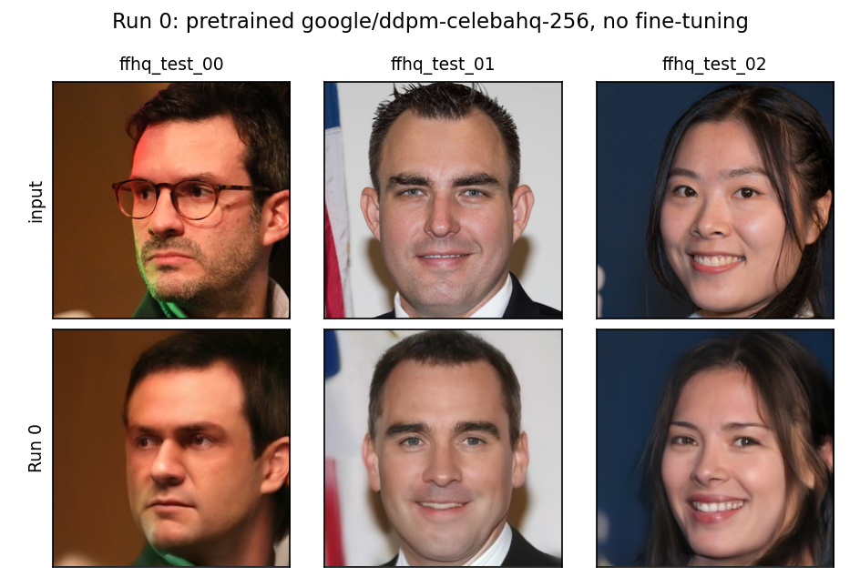
Figure 2. Run 0: the pretrained CelebA-HQ model applied to the test photos with the frozen setting. It reconstructs a clean photograph, not a painting.

6.2 Fine-tuning loss
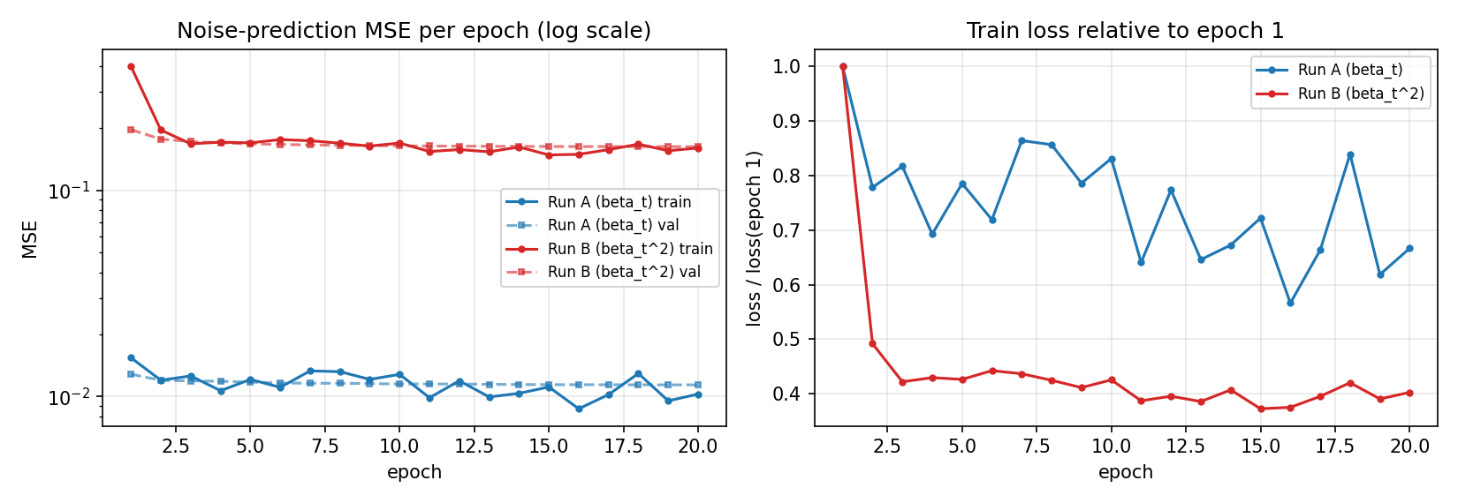
Figure 3. Training (per-epoch mean) and validation noise-prediction MSE for Run A and Run B on one plot (log scale).
Run A: train 0.0154 -> 0.0103, val 0.0128 -> 0.0114 (best epoch 20). Run B: train 0.3987 -> 0.1605, val 0.1970 -> 0.1630 (best epoch 20). Both decrease steadily without over-fitting. The losses are not comparable in absolute value: under beta_t^x the noise to be predicted is a tiny component of x_t, so the per-pixel error is larger.

6.3 Samples at the 5 fine-tuning checkpoints
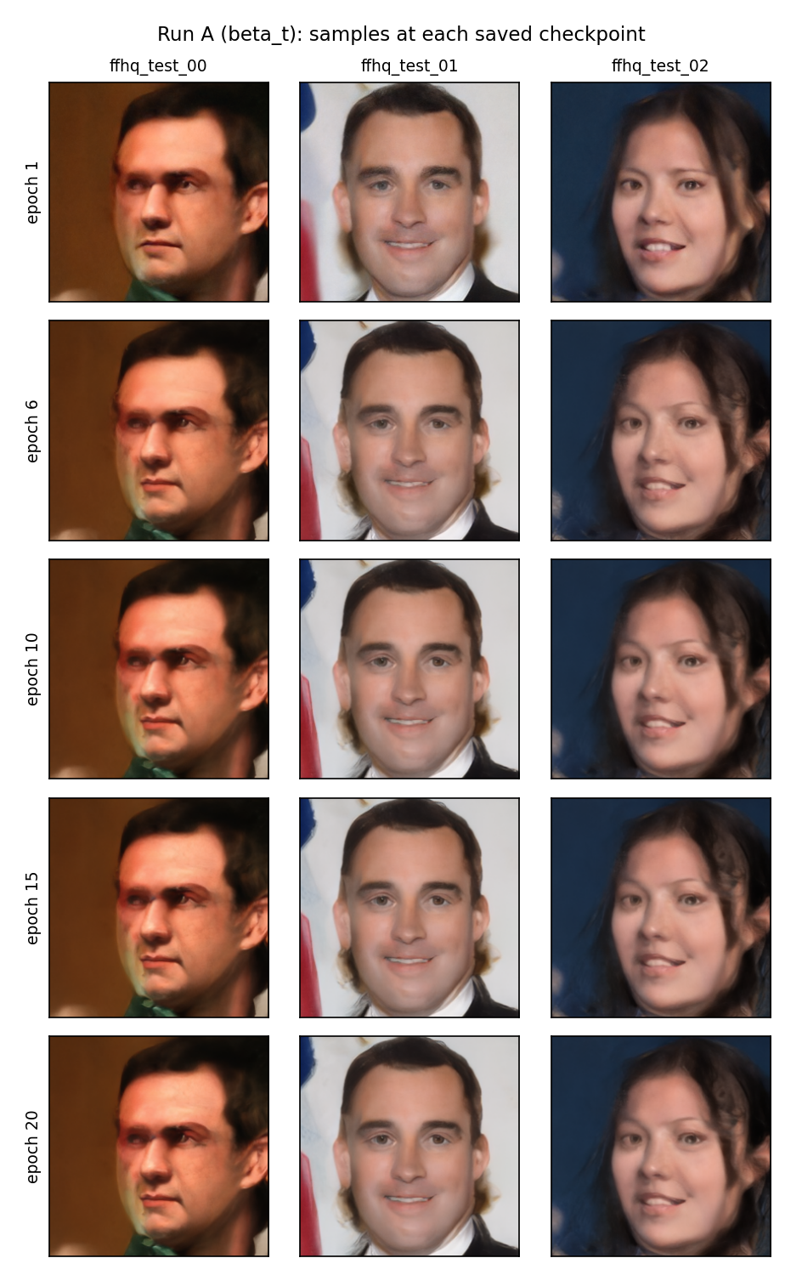 | 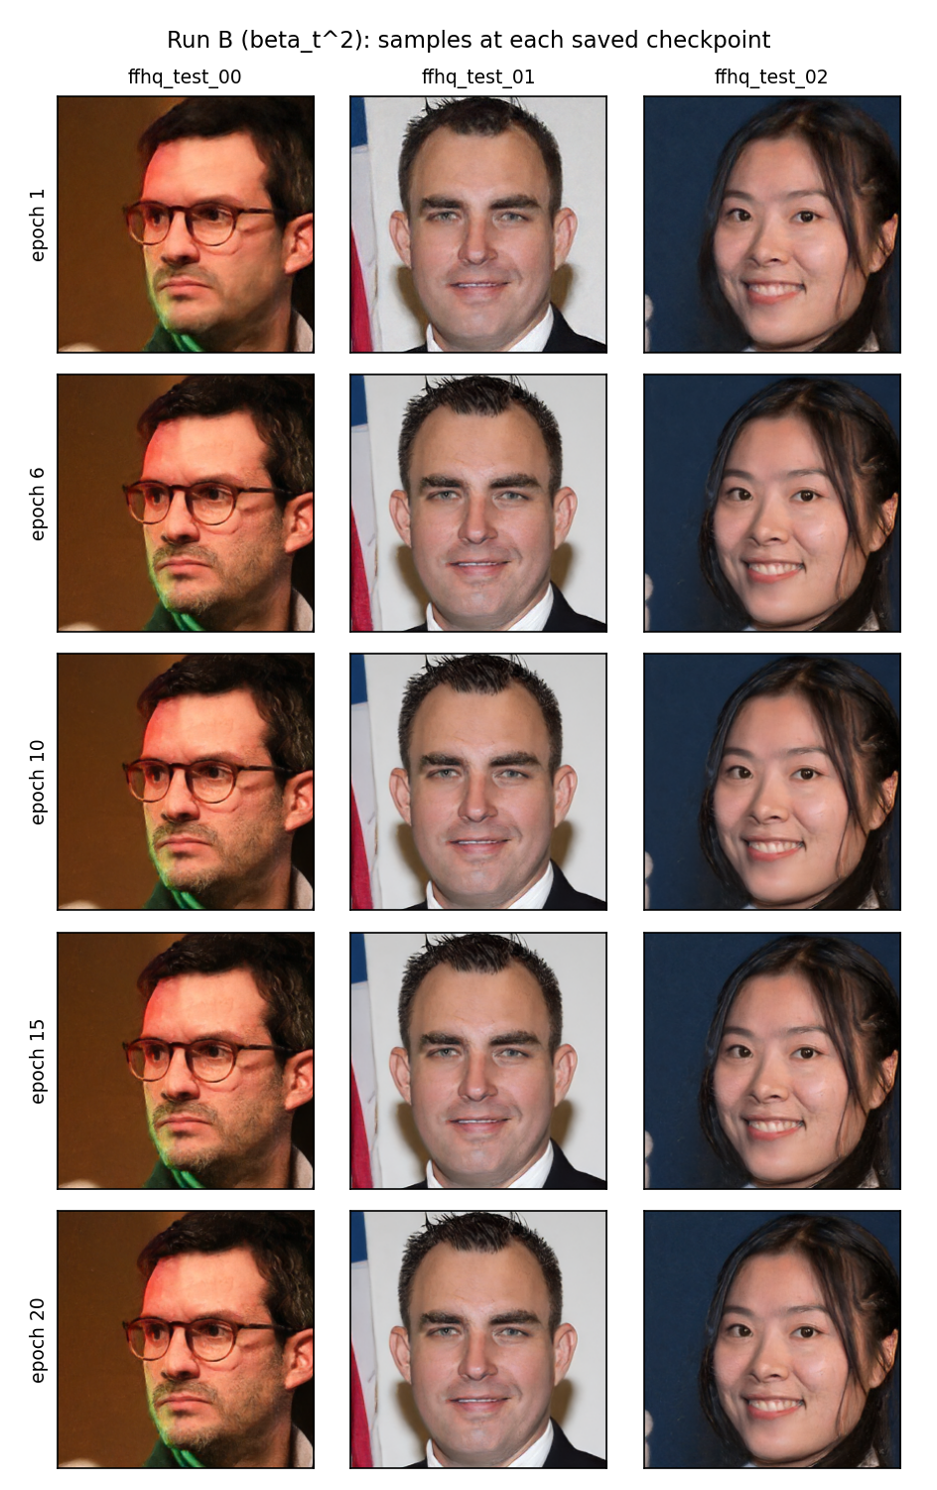
Figure 4. Left: Run A; right: Run B, at epochs 1, 6, 10, 15, 20 (rows), 3 test photos (columns), frozen setting.
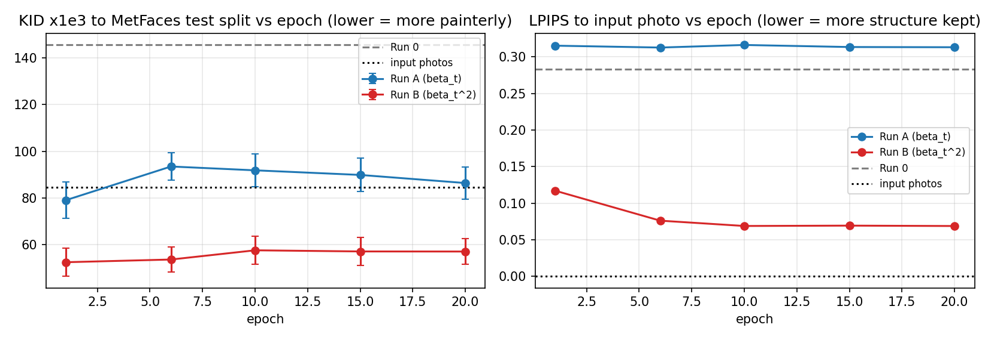
Figure 5. KID to MetFaces (left) and LPIPS to the input photo (right) for every checkpoint, 30 test photos each.

6.4 Inference trajectories
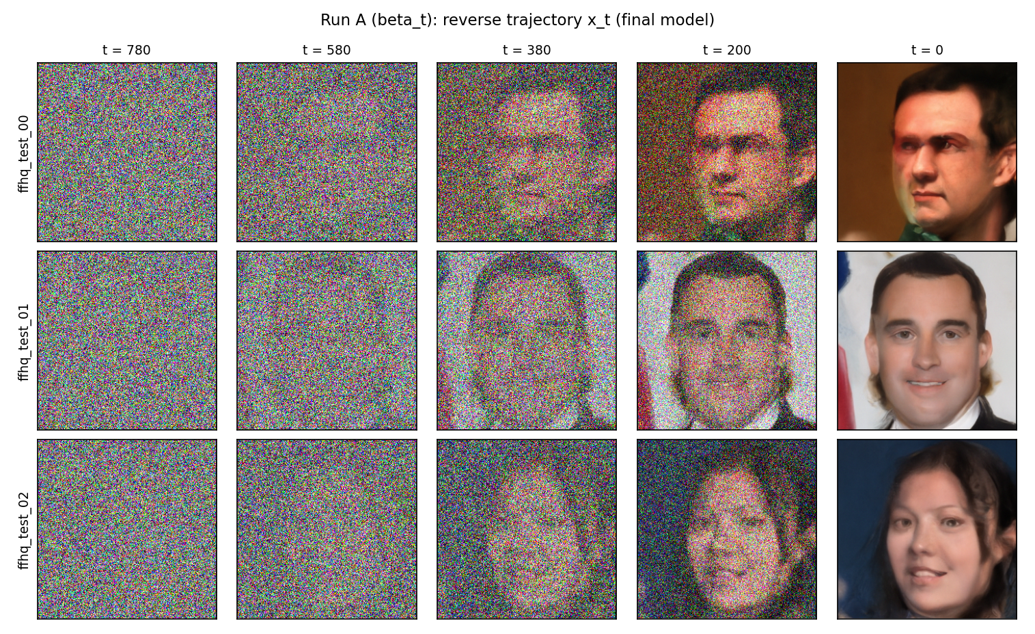
Figure 6. Run A final model: noisy sample x_t at 5 equally spaced reverse steps from t = 780 down to the last step (columns), 3 test photos (rows).
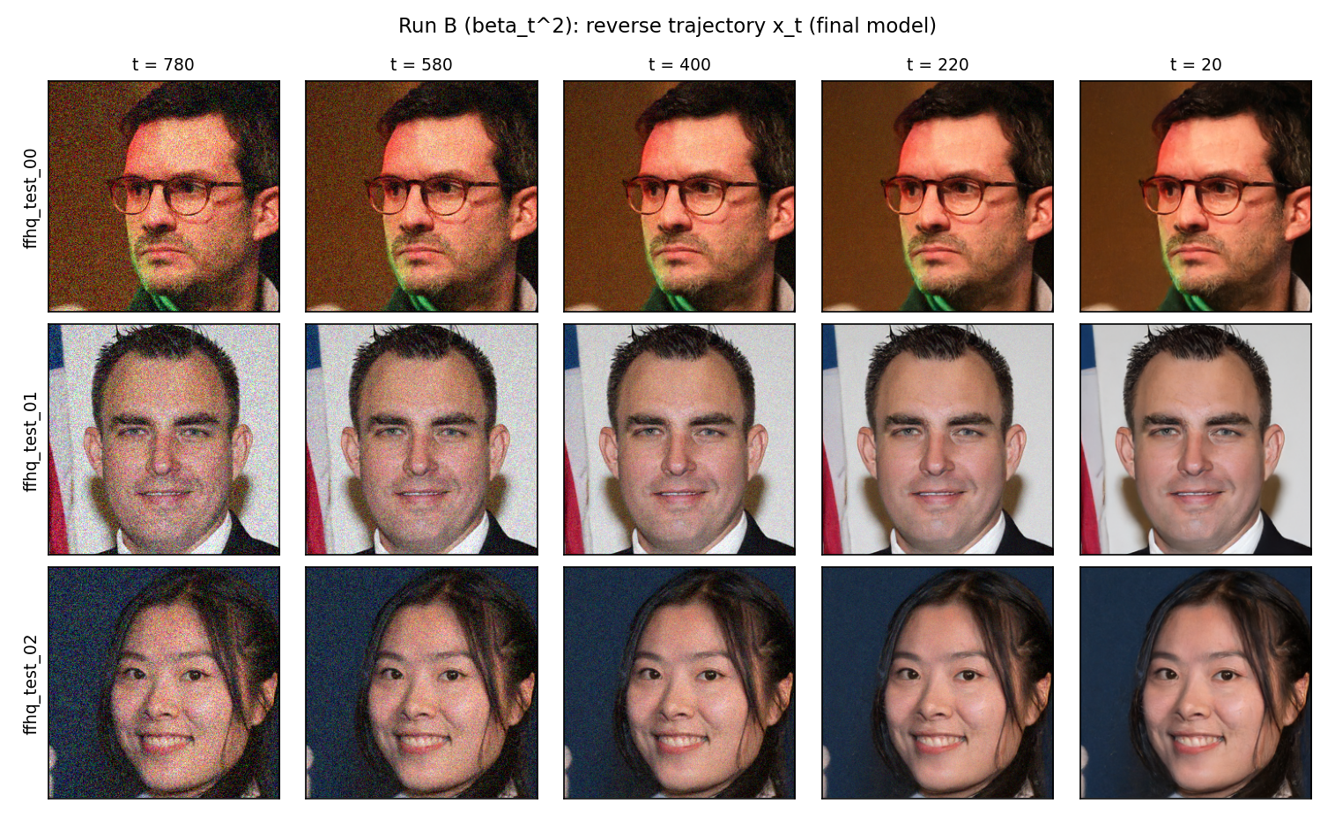
Figure 7. Run B final model: the same 5 reverse steps.

6.5 Test-set scores
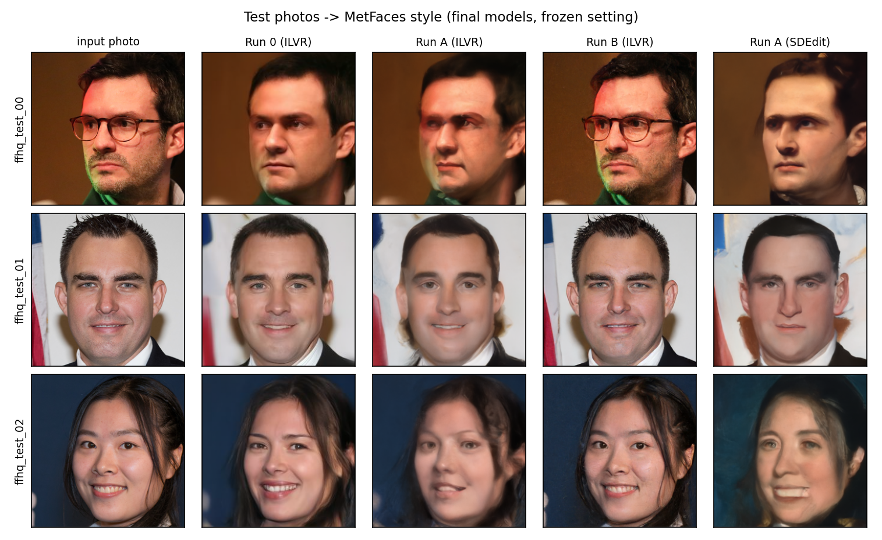
Figure 8. Test photos and outputs of Run 0, Run A and Run B (frozen ILVR setting) and of Run A with plain SDEdit.
Run | Sampler | KID x1e3 (main) | FID | LPIPS to input
Input photos (reference point) | - | 84.5 +/- 6.9 | 247.5 | 0
Run 0 (pretrained) | ILVR (frozen) | 145.6 +/- 8.7 | 253.8 | 0.283
Run 0 (pretrained) | SDEdit s=0.6 | 140.8 +/- 8.9 | 246.7 | 0.350
Run A (beta_t) | ILVR (frozen) | 85.0 +/- 6.1 | 229.5 | 0.313
Run A (beta_t) | SDEdit s=0.6 | 46.8 +/- 4.4 | 193.1 | 0.394
Run B (beta_t^2) | ILVR (frozen) | 56.0 +/- 6.0 | 218.2 | 0.069
Run B (beta_t^2) | SDEdit s=0.6 | 65.3 +/- 6.0 | 230.7 | 0.046

Metric justification. KID is the main metric because it measures how close the outputs are to the MetFaces painting distribution (the target of toonification) and, unlike FID, is unbiased for our small sample of 30 images; LPIPS to the input is reported to show how much of the photo's structure each run keeps.

7. Analysis
Which run is better, and when it showed. Run A is the better fine-tuning run for the task, but the frozen-setting KID table alone does not show it, and the reason matters. Under the frozen ILVR setting (strength 0.8) Run B has the lowest KID (56.0 x1e-3 vs 85.0 for Run A and 84.5 for the unchanged input photos) and the lowest FID (218.2), yet its LPIPS to the input is only 0.069: its outputs are the input photos with small low-level changes (Figure 8), not portraits in the MetFaces style. Run A changes the image substantially (LPIPS 0.313), but under ILVR with strength 0.8 its outputs are smoothed rather than painted and its KID does not improve on the input photos. With plain SDEdit (strength 0.6, fixed in advance, no guidance) Run A gives by far the best scores of the whole study, KID 46.8 and FID 193.1, against 65.3 / 230.7 for Run B and 140.8 / 246.7 for Run 0, and its outputs are the only ones that look like Old Masters portraits (Figure 8, last column). The difference between the runs is visible from the first saved checkpoint (epoch 1): Run A already repaints skin, hair and background (LPIPS 0.315), whereas Run B returns the photo (LPIPS 0.117, falling to 0.069 by epoch 10 as it learns to remove its small noise more faithfully). After epoch 1 neither run changes much: Run A's KID rises from 79.0 at epoch 1 to 93.5 at epoch 6 and recovers to 86.4 at epoch 20; Run B's stays between 52.4 and 57.5 (Figure 5).
Mechanistic explanation. Image-to-image translation with a DDPM works only if the forward process at the start timestep destroys the photo's fine detail, so that the fine-tuned prior can repaint it. Under beta_t the start timestep t = 780 has alpha_bar_t = 0.0021: x_t = 0.05 x_0 + 1.00 eps keeps only the coarse layout (restored by ILVR) and the MetFaces-trained network generates new texture; this is why Run A changes the image (LPIPS 0.31-0.39) and, with SDEdit, moves the output distribution closest to MetFaces. Under beta_t^2 the same timestep has alpha_bar_t = 0.94: x_t = 0.97 x_0 + 0.25 eps still contains essentially the whole photograph, so whatever the network learned, the reverse process can only remove a small amount of noise and must return the input (LPIPS 0.05-0.07); even at t = T, alpha_bar_T = 0.87, so no strength setting can reach a noise level from which a new style could be generated. The same mathematics explains training: Run B's network only ever sees high-SNR inputs (log-SNR >= 1.9) and learns to predict a tiny noise component, giving a larger MSE (0.163 vs 0.011) and no ability to generate painterly content from noise. Run B's lower KID is therefore not translation: the light denoising slightly smooths camera noise and JPEG texture, which moves Inception statistics a little toward the (smooth, low-noise) MetFaces scans while the image stays the same photograph.
Run 0 vs Run A and Run B. Run 0, the pretrained CelebA-HQ model, has the worst KID in every setting (145.6 with ILVR, 140.8 with SDEdit), much worse than the unchanged input photos (84.5). Its prior is the CelebA-HQ photograph domain, so it 'repaints' each input as a cleaner photograph (Figure 2) and pulls it away from MetFaces. Fine-tuning under the native schedule re-targets that prior to the out-of-distribution painting domain with only 1,069 images and 20 epochs: with the same sampler Run A lowers KID from 140.8 to 46.8 and FID from 246.7 to 193.1. Fine-tuning under beta_t^2 also moves the scores away from Run 0, but mainly because the modified forward process stops the sampler from changing the photo, not because the model learned the new domain. Fine-tuning on an out-of-distribution dataset is effective only when the noise schedule lets the model see, and therefore learn to denoise from, inputs where the source content has been destroyed.

8. Takeaway
The exponent on the noise schedule is not a mild hyperparameter. Squaring beta_t (x = 2.00) shrinks the total injected noise from 10.05 to 0.13 and leaves alpha_bar_T = 0.87, so the forward process never reaches the Gaussian prior and a DDPM fine-tuned with it can only lightly denoise, not translate. Native-schedule fine-tuning (Run A) was the only condition that produced recognisable Old Masters toonification, and it did so from the first epoch. We also learned three practical lessons: KID alone can reward an output that barely changes the input, so a metric of change (LPIPS to the input) and visual inspection must accompany it; every source of sampling noise has to be seeded, since unseeded per-step noise moved KID by about 8 x1e-3 between identical runs; and the inference setting must be chosen on separate dev images (here ILVR, strength 0.8, N = 16), even when a different, pre-declared comparison (SDEdit) turns out to score better on the test photos.

9. Contribution Statement
Member | Responsibility
Shruthi Chinnasamy (M26AI1119) | All components: task, model and dataset selection (Phase 1); schedule analysis; code changes (beta_t^x schedule, MPS support, ILVR, evaluation); fine-tuning of Run A and Run B; Run 0 baseline; test evaluation; figures; report.

Signed: ______________________________ Date: ______________

