# Linux-LogManagement

tail – Output the last part of files (useful for log monitoring)

Q How do you continuously monitor the latest entries in a log file, such as /var/log/syslog?

Ans: tail –f /var/log/syslog

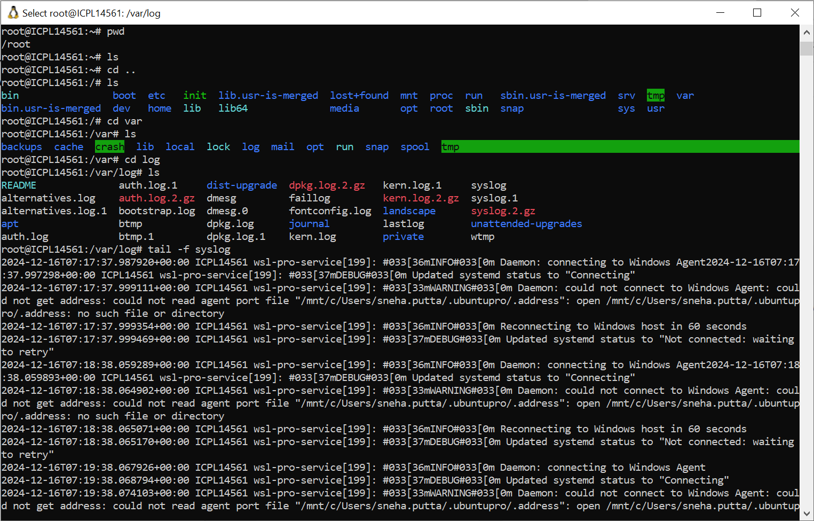

Q How can you display the last 50 lines of a file instead of the default 10?

Ans: tail -n 50 /var/log/syslog

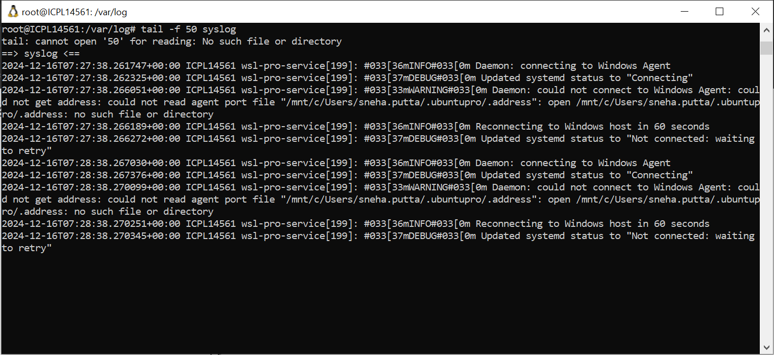

head – Output the first part of files

Q How do you view the first 20 lines of a log file?

Ans: head -n 20 /var/log/syslog

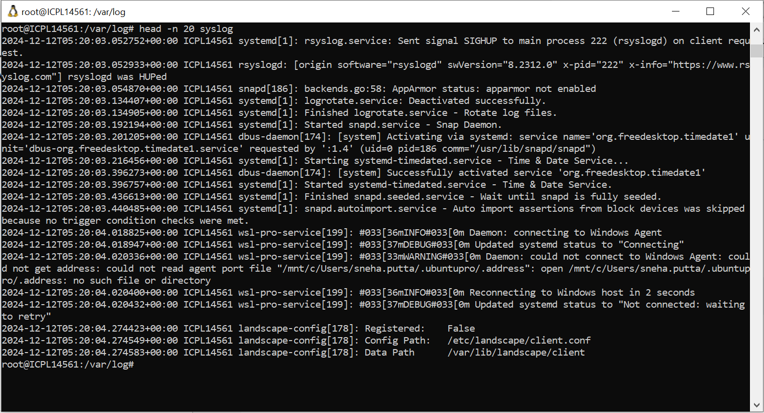

Q How do you combine head and tail to extract lines 11 to 20 from a file?

Ans: head -n 20 /var/log/syslog | tail -n 10

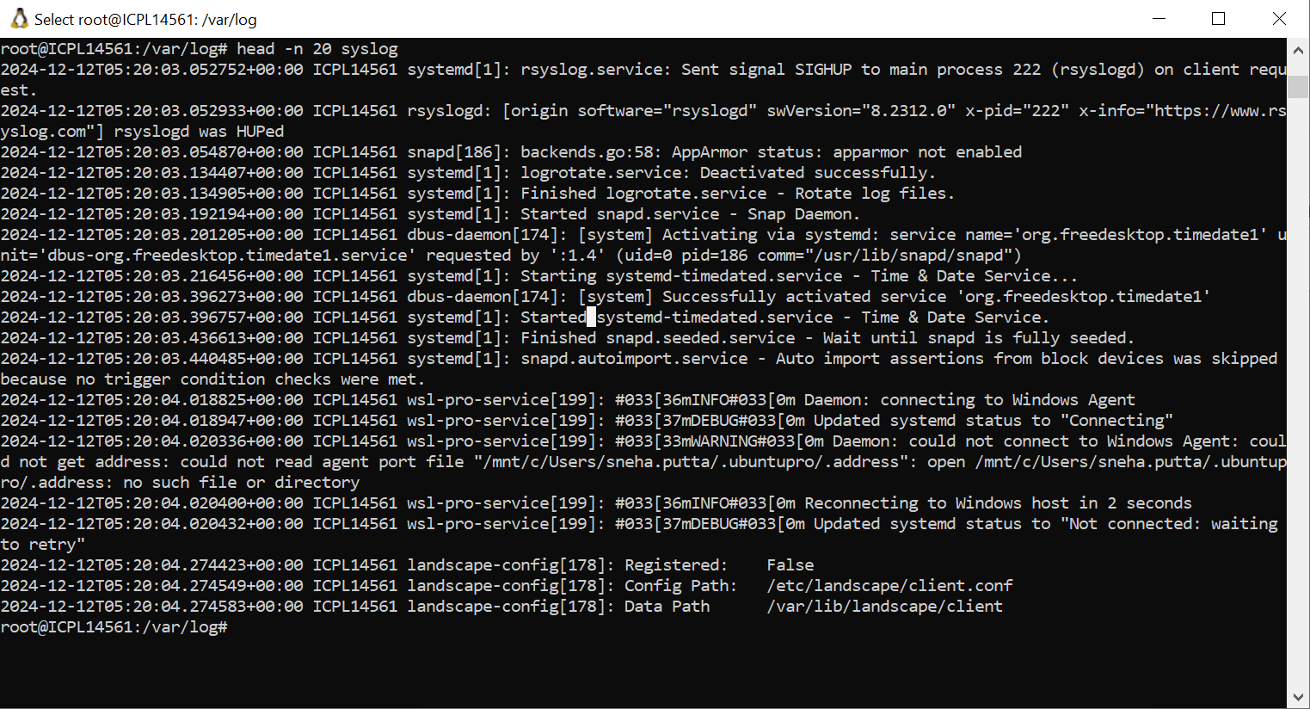

grep – Search file contents

Q How do you find all log entries in /var/log/syslog containing the word “error”?

Ans: grep "error" /var/log/syslog

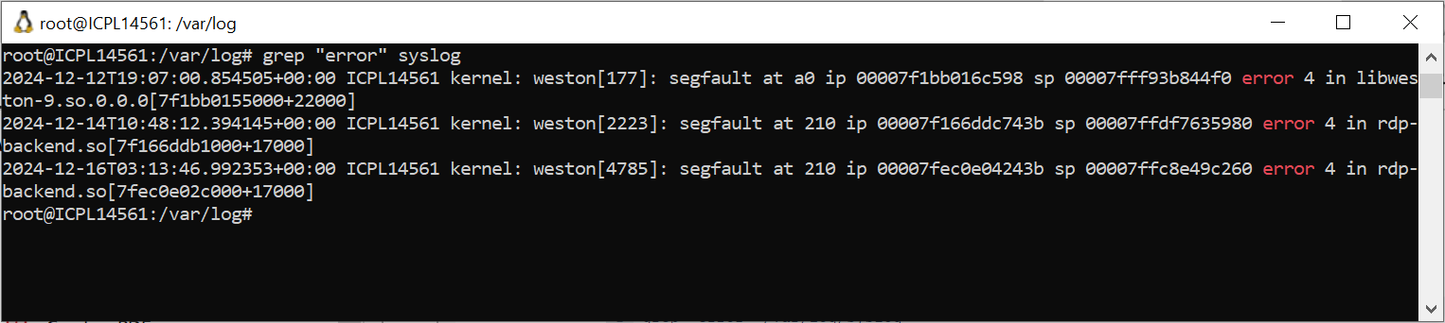

Q How can you search for log entries case-insensitively?

Ans: grep -i "error" /var/log/syslog

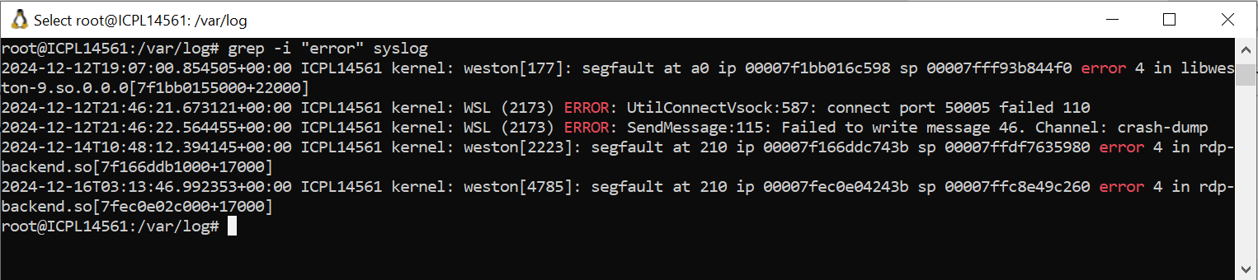

less – View file contents one page at a time

Q How do you navigate a large log file one screen at a time?

Ans: less /var/log/syslog

Q How can you search for the word “failed” within a file opened in less ?

Ans: /failed

Q

Ans:

Q

Ans:

Q

Ans:

Q

Ans:

Q

Ans:

Q

Ans:

Q

Ans:

Q

Ans:

Q

Ans:

Q

Ans:

Q

Ans:

Q

Ans:

# Tasks--Linux-FileDirectory

Q

Ans:

Q

Ans:

Q

Ans:

# Tasks-Linux-ProdSupportCommands

Q

Ans:

Q

Ans:

Q

Ans:

# Tasks--Linux-ArchivingCompression

Q

Ans:

Q

Ans:

Q

Ans:

# Tasks--Linux-ProcessManagementMonitoring

Q

Ans:

Q

Ans:

Q

Ans: