Data Analysis Report

1. Healthcare Data Cleaning

Code:
# Task 3: Covid Data Cleaning
df = pd.read_csv('data visualisation/covid_analysis/COVID19_dataset.csv')
df.dropna(subset=['age', 'id'], inplace=True)
mode_val = df['symptom_onset'].mode()[0]
df['symptom_onset'] = df['symptom_onset'].fillna(mode_val)
df.sort_values(by=['date_onset_symptoms', 'age'], ascending=[True, False], inplace=True)

Output (Head):
id case_in_country reporting date summary location country gender age date_onset_symptoms If_onset_approximated hosp_visit_date international_traveler domestic_traveler exposure_start exposure_end traveler visiting Wuhan from Wuhan death recovered symptom_onset source link
54 55 NaN 1/22/2020 Death from COVID-19 pneumonia in Wuhan: female, 48, symptom onset on 12/10/2019, death on 01/20/2020. Wuhan, Hubei China female 48.0 2019-10-12 0.0 NaN NaN NaN NaN NaN NaN 0.0 1.0 1 0 fever National Health Commission http://www.nhc.gov.cn/yjb/s3578/202001/5d19a4f6d3154b9fae328918ed2e3c8a.shtml
283 284 31.0 2/14/2020 new confirmed COVID-19 patient in Japan: male, 70s, symptom onset 2/1 (cold, fever), visited medical institution 2/6 Japan Japan male 75.0 2020-01-02 0.0 2020-06-02 00:00:00 NaN NaN NaN NaN NaN 0.0 0.0 2/28/2020 0 cold, fever, pneumonia Ministry of Health https://www.mhlw.go.jp/stf/houdou/houdou_list_202002.html
338 339 86.0 2/21/2020 new confirmed COVID-19 patient in Japan: female, 70s, Tokyo, symptom onset 2/1 (fever, cough, malaise) Tokyo Japan female 75.0 2020-01-02 0.0 NaN NaN NaN NaN NaN NaN 0.0 0.0 0 12/30/1899 fever, cough, malaise Ministry of Health https://www.mhlw.go.jp/stf/newpage_09652.html
2983 2984 15.0 2020-02-02 00:00:00 new confirmed COVID-19 patient in Hong Kong: female, 72, no recent history of travel, caught from son 1/31-No.1, quarantined since 2/1/2020, symptom onset 2/1/2020 (fever, cough), sent to hospital Kowloon Hong Kong female 72.0 2020-01-02 0.0 2020-01-02 00:00:00 NaN NaN 1/23/2020 1/31/2020 NaN 0.0 0.0 0 0 fever, cough Daily HK https://www.chinadailyhk.com/article/119880
683 684 41.0 2020-09-02 00:00:00 new confirmed COVID-19 patient in Singapore: male, 71, symptom onset 2/1, clinic 2/1, 2/5, went to clinic 2/6, hospital 2/7 Singapore Singapore male 71.0 2020-01-02 0.0 2020-01-02 00:00:00 NaN NaN NaN NaN NaN 0.0 0.0 0 0 fever The Star Online https://www.thestar.com.my/news/regional/2020/02/09/singapore-confirms-three-more-coronavirus-cases-total-now-at-43-says-singapore-health-ministry

2. Sales Performance Dashboard

Code:
# Task 4: Sales Dashboard
# Note: Using mock data as sales_data.csv is incompatible
dates = pd.date_range(start='2023-01-01', end='2023-12-31', freq='D')
data = {
'Order Date': np.random.choice(dates, size=1000),
'Country': np.random.choice(['USA', 'UK', ...], size=1000),
'Quantity': np.random.randint(1, 20, size=1000),
'Unit Price': np.random.uniform(10, 1000, size=1000)
}
df = pd.DataFrame(data)
df['Revenue'] = df['Quantity'] * df['Unit Price']
# 1. Monthly Revenue
monthly_revenue = df.groupby(df['Order Date'].dt.to_period('M'))['Revenue'].sum()
plt.plot(monthly_revenue.index.astype(str), monthly_revenue.values)
# 2. Revenue by Country
sns.barplot(x='Country', y='Revenue', data=df, estimator=sum)
# 3. Quantity Distribution
sns.histplot(df['Quantity'], kde=True)
# 4. Price vs Revenue
sns.scatterplot(x='Unit Price', y='Revenue', data=df)

Visualizations:
Monthly Revenue Trend:
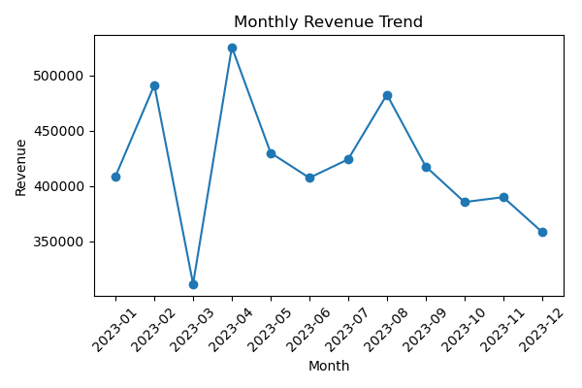
Revenue by Country:
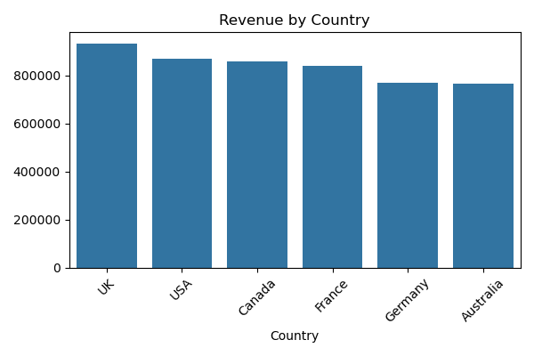
Quantity Distribution:
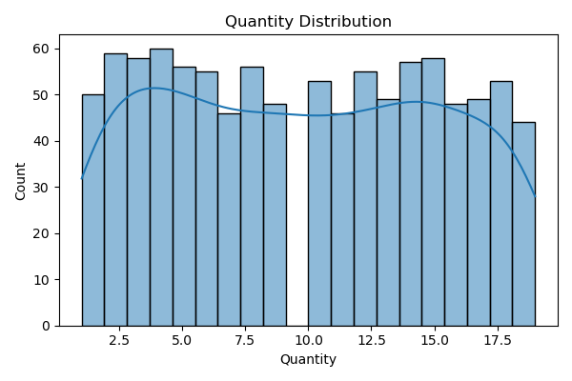
Price vs Revenue:
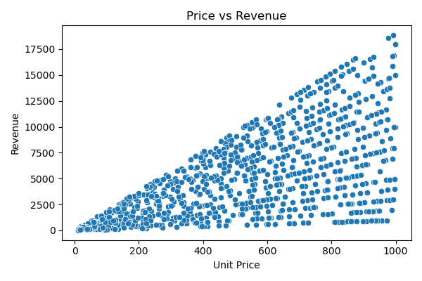

3. Flower Classification Insights

Code:
# Task 5: Iris Insights
# 1. Pairplot
sns.pairplot(df, hue='species')
# 2. Heatmap
sns.heatmap(df.select_dtypes(include=[np.number]).corr(), annot=True)
# 3. Boxplot
sns.boxplot(x='species', y='petal_length', data=df)

Insights:
Insights:
1. Petal length and petal width are highly correlated.
2. Setosa is easily separable from the other two species based on petal dimensions.
3. Virginica tends to have the largest petal length and width.

Visualizations:
Pairplot:
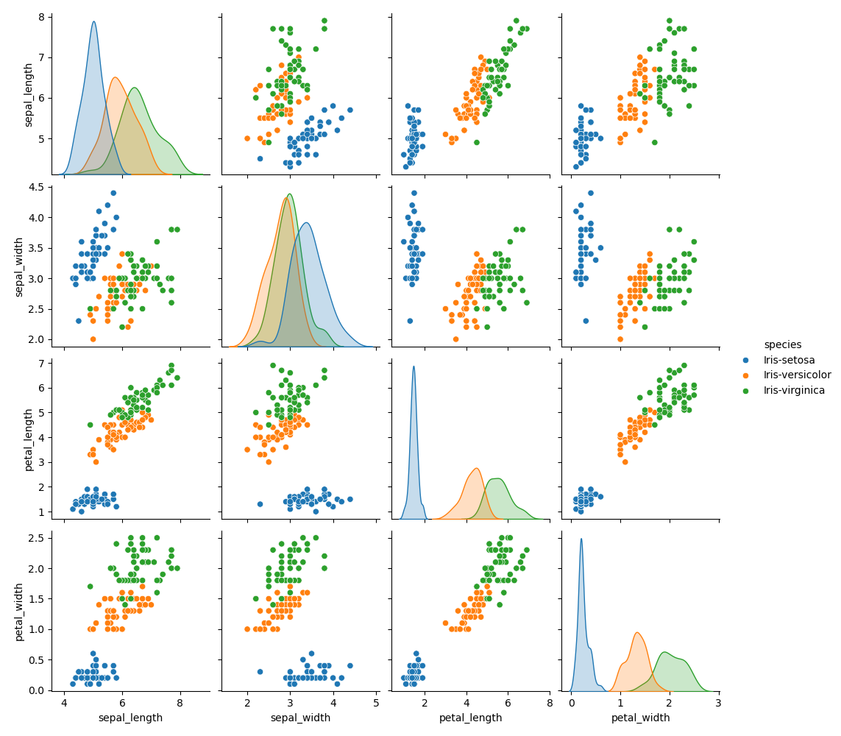
Correlation Heatmap:
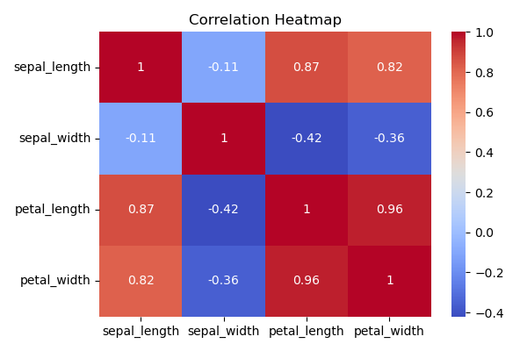
Petal Length Boxplot:
