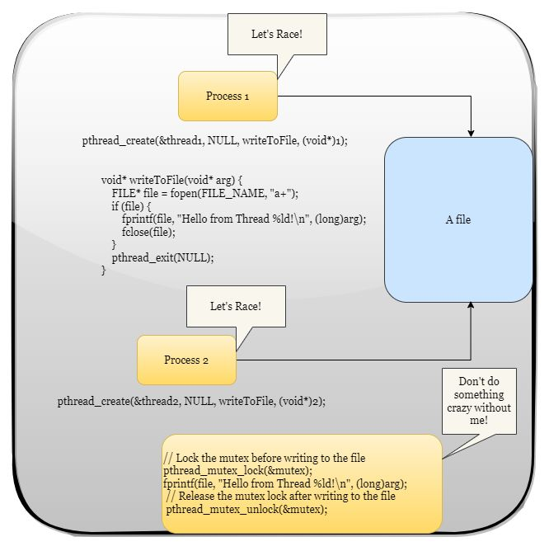

~~~ 𝑾𝒉𝒂𝒕 𝒊𝒔 𝒂 𝑹𝒂𝒄𝒆 𝑪𝒐𝒏𝒅𝒊𝒕𝒊𝒐𝒏? 𝑫𝒐𝒆𝒔 𝒊𝒕 𝒓𝒆𝒂𝒍𝒍𝒚 𝒎𝒂𝒕𝒕𝒆𝒓? ~~~
A race condition occurs when multiple threads or processes try to access and modify shared resources simultaneously, leading to unpredictable and erroneous results.
Synchronization techniques like Mutex or Semaphores are used by the process to access the shared resource at the time.
A Mutex (short for Mutual Exclusion) is a synchronization mechanism used in Linux to prevent multiple threads or processes from accessing a shared resource simultaneously. It locks the resource and ensures that only one thread or process can use the shared resource at any given time.
If the resource is available, a thread/process locks the mutex. If the mutex is locked when the process accesses it, the current thread will be put on hold until the resource is released. Mutex is like a ticket system that controls access to shared resources in Linux, ensuring that only one thread or process can use the resource at a time, thus avoiding conflicts and race conditions.
𝑯𝒐𝒘 𝒉𝒂𝒓𝒎𝒇𝒖𝒍 𝒄𝒂𝒏 𝒂 𝒓𝒂𝒄𝒆 𝒄𝒐𝒏𝒅𝒊𝒕𝒊𝒐𝒏 𝒃𝒆?
Therac-25" radiation therapy machine incidents that occurred in the 1980s.
The Therac-25 was a medical linear accelerator machine used for delivering radiation therapy to cancer patients. It was designed to provide high-precision treatment, but a race condition in the software controlling the machine caused it to deliver massive overdoses of radiation to some patients.
The race condition occurred when operators rapidly entered commands, such as adjusting the dose rate, while the machine was still processing previous commands. Due to a subtle software bug, the Therac-25's safety mechanisms were bypassed, and it allowed the machine to deliver radiation in high-dose "high-energy" mode without automatically reducing the dose to a safer level.
As a result, patients were exposed to radiation levels far beyond what was intended, leading to severe injuries and, in some cases, fatalities. The race condition made it challenging for the operators to detect the error before it caused harm.
This incident highlighted the importance of thorough software testing, rigorous verification of medical devices, and the critical need to identify and fix race conditions in safety-critical systems. It also resulted in significant improvements in medical device regulation and safety standards.

