**Arrays**

**---------------------------------------------------------------------------------------------------------------**

1) Write a C program to input 10 numbers through the keyboard into an array and

display the results of addition of even numbers and product of odd numbers.

#include<stdio.h>

int main()

{

int a[10], sum=0, product=1, ele, i;

ele=(sizeof(a)/sizeof(a[0]));

printf("Enter the numbers\n");

for(i=0; i<ele; i++)

scanf("%d", &a[i]);

printf("The entered elements are as follows:\n");

for(i=0; i<ele; i++)

printf("%d ", a[i]);

printf("\n");

for(i=0; i<ele; i++)

{

if((a[i]%2)==0)

{

sum=sum+a[i];

}

else

{

product=product*a[i];

}

}

printf("The sum of even numbers in an array is %d\n", sum);

printf("The product of odd numbers in an array is %d\n", product);

}

OR

#include<stdio.h>

int main()

{

int n, b, ele, i, j, sum=0, mul=1;

printf("Enter the count of elements you want to enter\n");

scanf("%d", &n);

int a[n];

ele=sizeof(a)/sizeof(a[0]);

printf("Enter the elements in the array\n");

for(i=0; i<ele; i++)

scanf("%d", &a[i]);

printf("The elements entered are as follows:\n");

for(i=0; i<ele; i++)

printf("%d\t", a[i]);

printf("\n");

for(i=0; i<ele; i++)

{

if(a[i]%2==0)

{

printf("%d ", a[i]);

sum=sum+a[i];

}

else

{

printf("%d ", a[i]);

mul=mul*a[i];

}

}

printf("\n");

if(sum>0)

printf("Total sum of even numbers entered are: %d\n", sum);

else

printf("Only Odd numbers are entered\n");

if(mul>1)

printf("Total product of odd numbers entered are: %d\n", mul);

else

printf("Only even numbers were entered\n");

2) Write a C program to input 10 numbers through the keyboard into an array and find the

biggest and smallest number in an Unsorted array without using any Sorting Technique.

#include<stdio.h>

int main()

{

int ele, a[10], biggest, smallest, i;

ele=(sizeof(a)/sizeof(a[0]));

printf("Enter array elements:\n");

for(i=0; i<ele; i++)

{

scanf("%d", &a[i]);

}

printf("The elements entered as follows\n");

for(i=0; i<ele; i++)

{

printf("%d ", a[i]);

}

printf("\n");

biggest=a[0];

smallest=a[0];

for(i=0; i<ele; i++)

{

if(biggest<a[i])

{

biggest=a[i];

}

}

for(i=0; i<ele; i++)

{

if(smallest>a[i])

{

smallest=a[i];

}

}

printf("The biggest number in an array is %d\n", biggest);

printf("The smallest number in an array is %d\n", smallest);

}

3) Write a C program to input 10 numbers through the keyboard and find the number

of prime numbers count, store them into a seperate array and display it.

#include<stdio.h>

int main()

{

int a[10], b[10], count=0, ele, ele1, i, j=0,k=0;

ele=(sizeof(a)/sizeof(a[0]));

printf("Enter the elements in an array:\n");

for(i=0; i<ele; i++)

{

scanf("%d", &a[i]);

}

printf("The entered elements are as follows:\n");

for(i=0; i<ele; i++)

{

printf("%d ", a[i]);

}

printf("\n");

for(i=0; i<ele; i++)

{

for(j=2; j<a[i]; j++)

if(a[i]%j==0)

{

break;

}

if(a[i]==j)

{

count++;

//for(j=0; j<count; j++)

//{

b[k++]=a[i];

//}

}

}

for(i=0; i<count; i++)

printf("%d ",b[i]);

printf("\n");

}

4) Write a C program to findout second largest and second smallest elements of an

unsorted array without using any Sorting Technique.

5) Write a C program to reverse the elements of a given array.

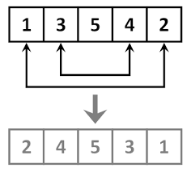

6) Write a C program to delete an element at desired position from an array.

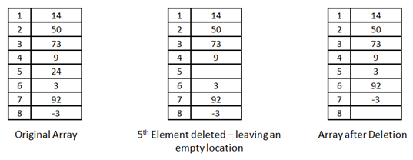

7) Write a C program to insert an element at desired position in an array.

For Example if 'A' is to be stored at '0' position then,

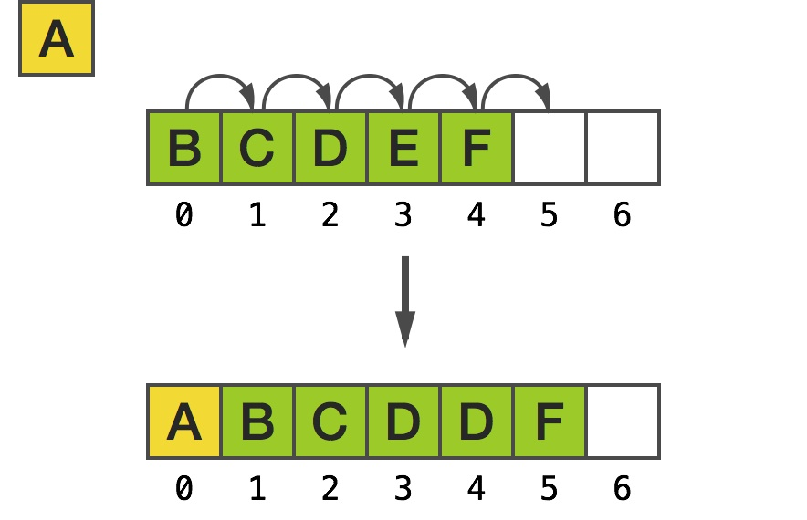

8) Write a C program which deletes the duplicate elements of an array.

A description...

9) Write a C program to find the duplicate elements of a given array and find the count of

duplicated elements.

Ex: if int a[] = {0,3,1,0,5,1,2,0,4,5}

output : -

The duplicate elements are existed in an array

0 -- 3 times

1 -- 2 times

5 -- 2 times

10) Write a program to print the non repeted numbers of a given array.

Ex : if int a[] = {0,3,1,0,5,1,2,0,4,5}

Output : 3, 2, 4

11) Write a program to copy the elements of one array into another array without duplicate

items as a first slot, and store duplicate elements as a second slot.

Ex: source array {10,2,4,5,2,1,3,4,6,5,8,9,2}

destination arrays {10,2,4,5,1,3,6,8,9} , { 2,2,4,5}

first slot second slot

Take two different arrays for first and second slots.

12) Write a C program to evaluate the following series. The series contains sum of

square of numbers from 1 to 'n'. Strore result of each term in an array. Calculate

value of ' S ' using array.

S = 1^2 + 2^2 + 3^2 + 4^2 + ------ n^2

= [ 1, 4, 9, 16, -------- n^2 ]

Suppose n = 4,

then S = 1^2+2^2+3^2+4^2;

S = 1+4+9+16;

S = 30.

1. Write a C program to implement the stack using arrays.

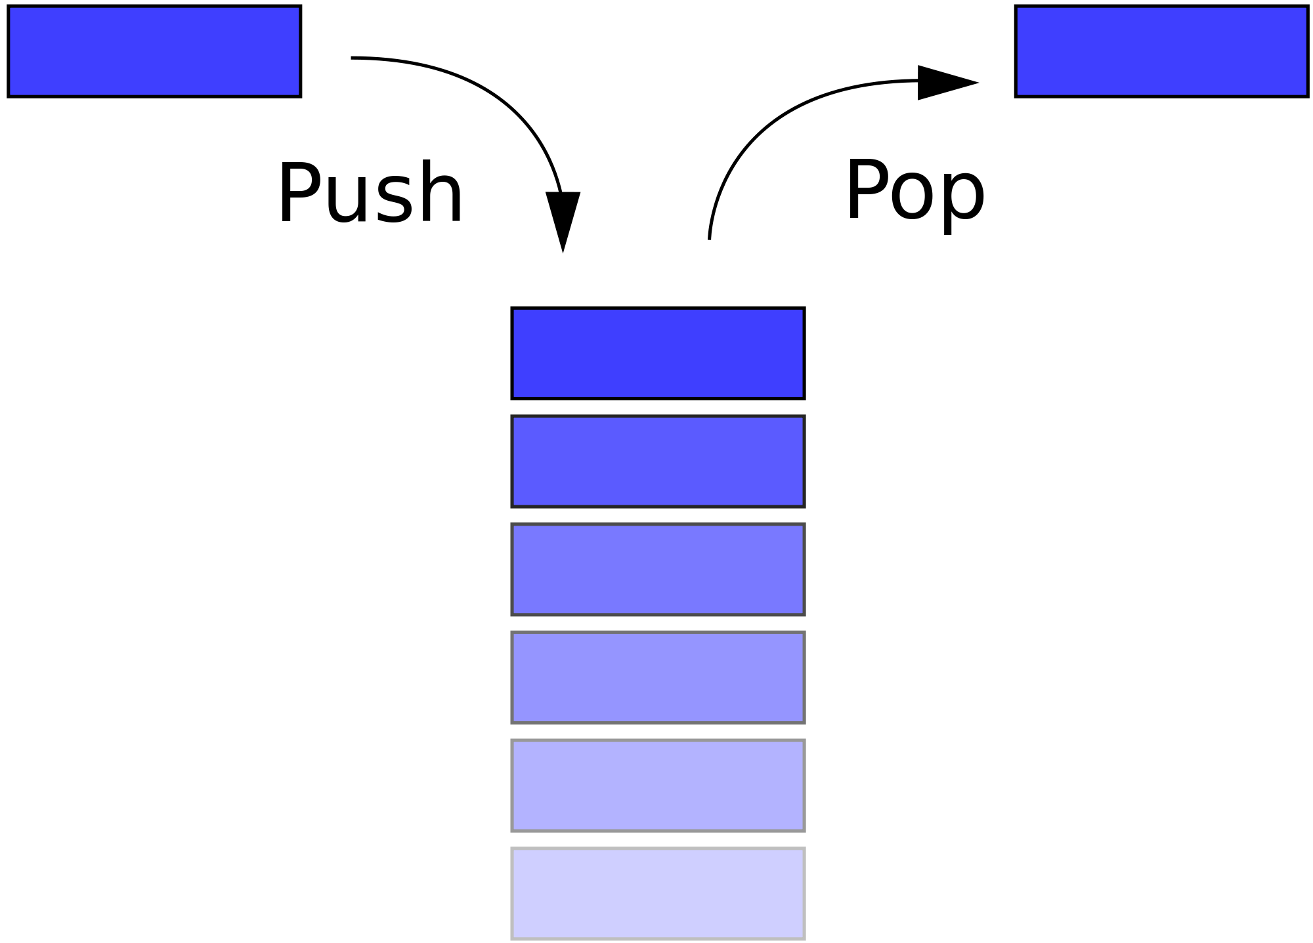

**STACK**

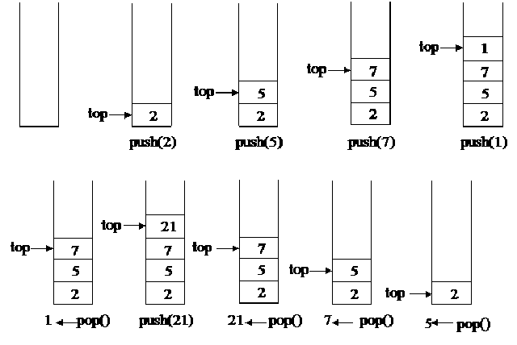

-------------------------------------------------------- END --------------------------------------------------------

Dear Students, if any mistakes found, Kindly inform to me.

A.Tandava Ramakrishna

Email: ramakrishna@vectorindia.org