

**University Department of Information and Communication Technology**

MGM University, Chhatrapati Sambhajinagar

**Second Year Project Report, 2024-25**

“Math Converter”

**Members:** 1. Gyaneshwar Kale 2206022

2. Aryan Rajput 2206024

A report submitted in part fulfillment of the course of

**Mini-Project**

**Supervisor:** Prof. Mohsin Ansari

Prof. Farisa Shaikh

**INDEX**

Sr no. Content Page no.

1. Abstract 3
2. Introduction 5
3. Literature Survey 6
4. Methodology 7
5. Result & Discussion 9
6. Diagrammatic Representation 11
7. Screenshots 12
8. Conclusion 14
9. References 16

* **ABSTRACT**

**1. Objective:**

* The project aims to develop a versatile, user-friendly converter tool capable of converting between different number systems, currencies, and units of measurement.

**2. Methodology:**

* For the number system converter, the tool uses inbuilt function of JavaScript to convert numbers between binary, decimal, octal, and hexadecimal systems.
* The currency exchange rate feature accesses exchange rate data from a reliable source to perform accurate currency conversions.
* The unit converter utilizes conversion factors for various units (e.g., length, weight, temperature etc.) to provide precise conversions.

**3. Key Findings:**

* The number system converter accurately converts numbers between different bases, aiding in computer science and digital electronics studies.
* The currency exchange rate feature provides precise currency conversions, facilitating international transactions and financial planning.
* The unit converter simplifies unit conversions for various fields such as physics, engineering, and everyday calculations.

**4. Conclusions:**

* The project successfully creates a converter tool that meets the requirements for accurate conversions across number systems, currencies, and units of measurement.
* **INTRODUCTION**
* The project is a comprehensive converter tool designed to handle conversions between different number systems, currencies, and units of measurement. It aims to simplify complex conversions and provide accurate results for users in various fields such as computer science, finance, and engineering.
* The number system converter component of the tool uses algorithms to convert numbers between binary, decimal, octal, and hexadecimal systems. This feature is useful for students and professionals working with digital electronics and computer programming.
* The currency exchange rate feature accesses real-time exchange rate data from a reliable source, enabling users to perform accurate currency conversions. This functionality is valuable for individuals and businesses involved in international transactions and financial planning.
* Additionally, the unit converter component of the tool provides conversion factors for various units of measurement, including length, weight, volume, and more. This feature simplifies unit conversions for users across different fields of study and work.
* Overall, the project aims to create a user-friendly and versatile converter tool that meets the diverse conversion needs of its users.
* **LITERATURE SURVEY**

1. Number System Converters:

* "Algorithm for Conversion of Decimal to Binary, Octal, and Hexadecimal" by P. S. Deshpande and S. P. Karmore presents algorithms for converting decimal numbers to binary, octal, and hexadecimal.

2. Currency Exchange Rate Calculators:

* "Development of an Online Currency Exchange Rate Calculator" by A. B. Adewale and O. E. Adebimpe describes the development of a web-based currency exchange rate calculator.

3. Unit Conversion Tools:

* "Unit Conversion Tools for Engineers" by R. J. Baker provides an overview of unit conversion tools and their applications in engineering.

4. Comprehensive Converter Software:

* "Development of a Comprehensive Unit Conversion Software" by L. A. Johnson and M. J. Smith describes the development of a software tool that integrates multiple conversion functionalities.
* ***Learning from Literature Survey:*** In our project we tried to combine all form of conversion in math, physics, electronics etc. at one single platform.
* **METHODOLOGY**

For your project, the methods and techniques used can vary depending on the specific functionalities you're implementing. Here's a general outline:

1. Data Collection:

* Number System Converter: Algorithms for converting between different number systems (binary, decimal, octal, hexadecimal) can be implemented using mathematical operations.
* Data collection involves receiving input numbers in one system and converting them to the desired system.
* Currency Exchange Rate: Exchange rate data can be collected from reliable sources. This data is used to provide up-to-date currency conversion rates.
* Unit Converter: Conversion factors for various units can be collected from standard references or databases. These factors are used to convert values between different units.

2. Data Analysis:

* Number System Converter: Analysis involves validating input numbers to ensure they are in the correct format for the selected number system. Conversion algorithms are then applied to convert the numbers.
* Currency Exchange Rate: Analysis includes processing the received exchange rate data and storing it in a format that can be easily accessed and used for currency conversions.
* Unit Converter: Analysis involves mapping units to their respective conversion factors and applying these factors to convert values between units.

3. Tools Used:

* Programming Languages: Languages like JavaScript, HTML and CSS can be used to implement the converter tool.
* Development Environments: IDEs (Integrated Development Environments) Visual Studio Code can be used for coding and testing the converter tool.
* Wallpapers: Used certain websites for high quality wallpapers to give user an immersive experience of website.

4. Implementation:

* Implement each component of the converter tool (number system converter, currency exchange rate, unit converter) using the selected programming language and tools.
* Ensure that the tool is user-friendly, with clear input and output interfaces for each conversion type.
* Test the tool thoroughly to ensure accurate and reliable conversions.
* Overall, the project requires a combination of functions, data processing, and user interface design to create a functional and efficient converter tool.
* **RESULT & DISCUSSION**

1. Number System Converter:

The converter accurately converts numbers between binary, decimal, octal, and hexadecimal systems.

The algorithm ensures precision and efficiency, making it a valuable tool for students and professionals working in computer science and digital electronics.

1. Currency Exchange Rate:

The tool provides real-time exchange rate data, enabling users to perform accurate currency conversions.

This feature is particularly useful for travellers, businesses, and investors who need up-to-date exchange rates for financial transactions.

1. Unit Converter:

The unit converter covers a wide range of units, including length, weight, volume, and more.

It simplifies complex unit conversions, making it an essential tool for professionals in fields such as engineering, physics, and chemistry.

1. User Experience:

The tool's user-friendly interface and efficient algorithms enhance the user experience, making conversions quick and easy.

1. Accuracy and Reliability:

The tool's algorithms for number system conversion and currency exchange rate provide accurate and reliable results.

This reliability is essential for users who rely on precise conversions for their work or studies.

1. Customizability:

The tool's ability to customize units and conversion options adds to its versatility. Users can tailor the tool to their specific needs, making it a flexible and adaptable solution for various conversion tasks.

1. Future Enhancements:

Future enhancements could include adding more conversion options, improving the user interface, and integrating additional features such as historical exchange rate data. These enhancements would further improve the tool's functionality and usability.

* Overall, the project's results demonstrate its effectiveness in providing accurate and efficient conversions for number systems, currencies, and units of measurement. The tool's user-friendly interface and reliable algorithms make it a valuable resource for professionals, students, and anyone needing quick and accurate conversions.
* **Diagrammatic Representation:**

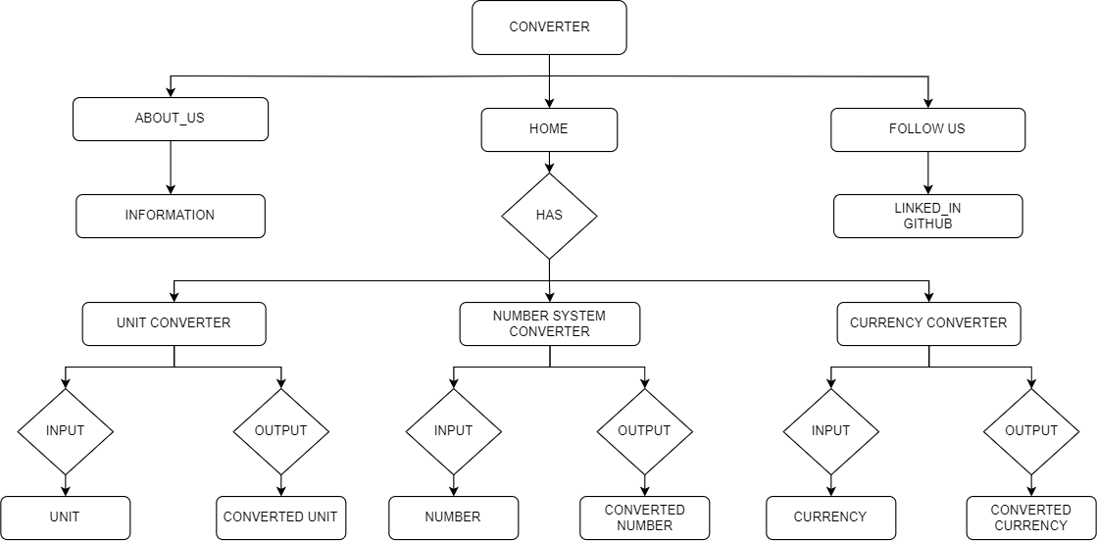

* **SCREENSHOTS**

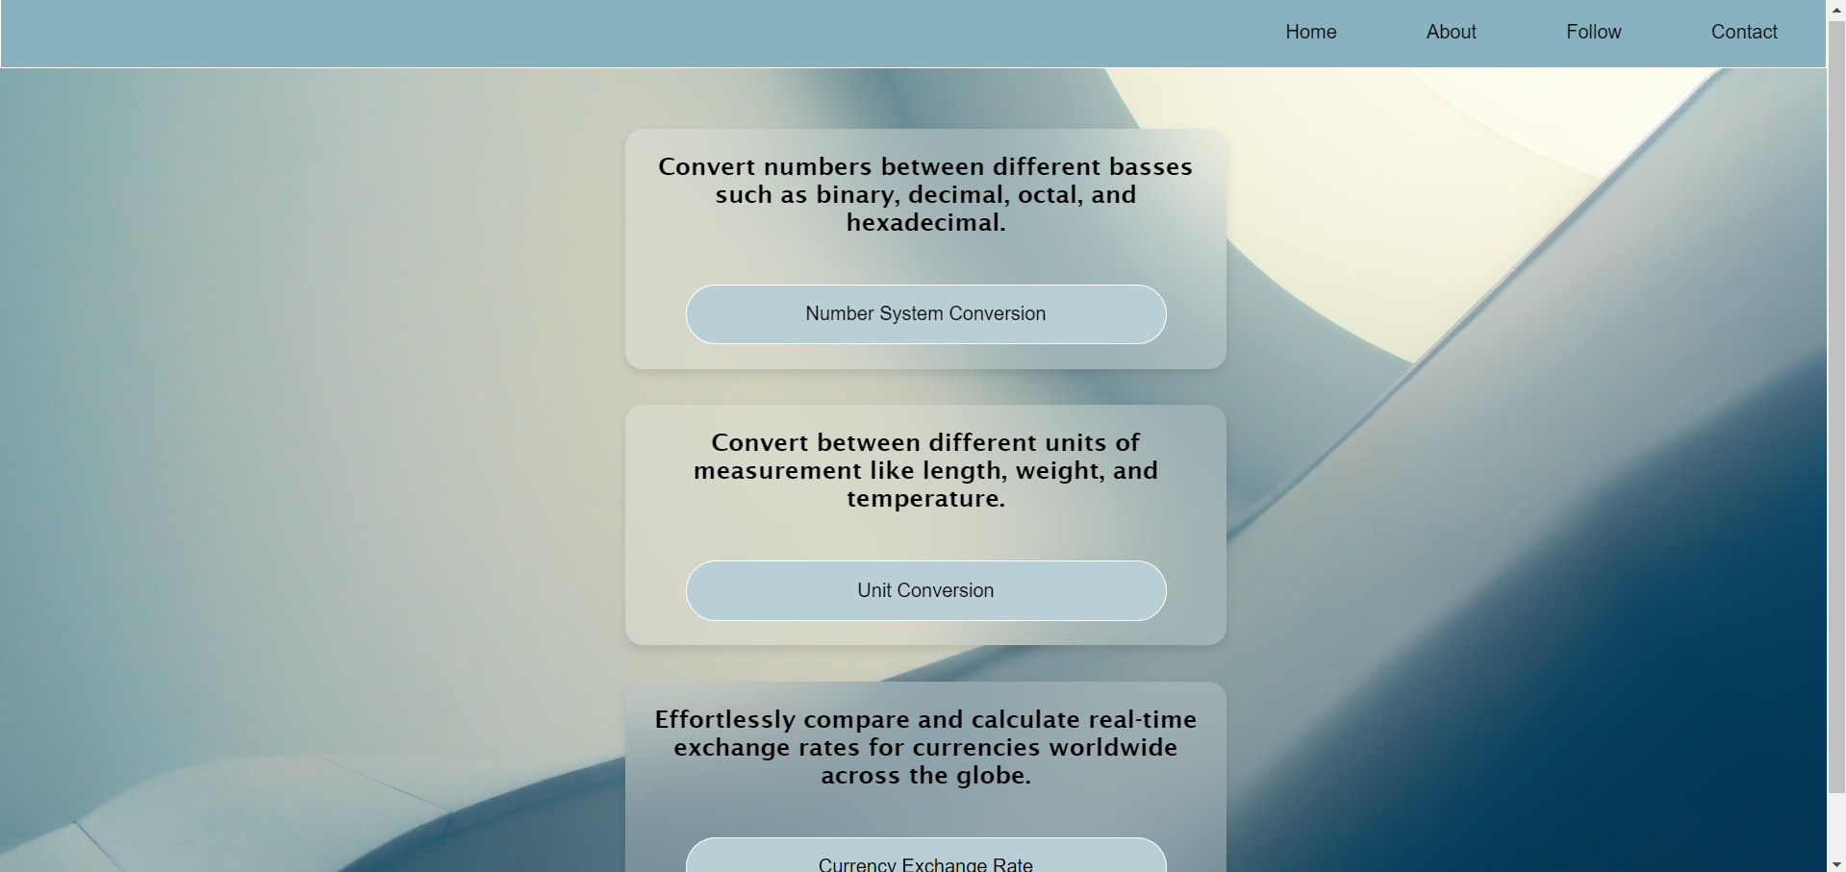**Home Page:**

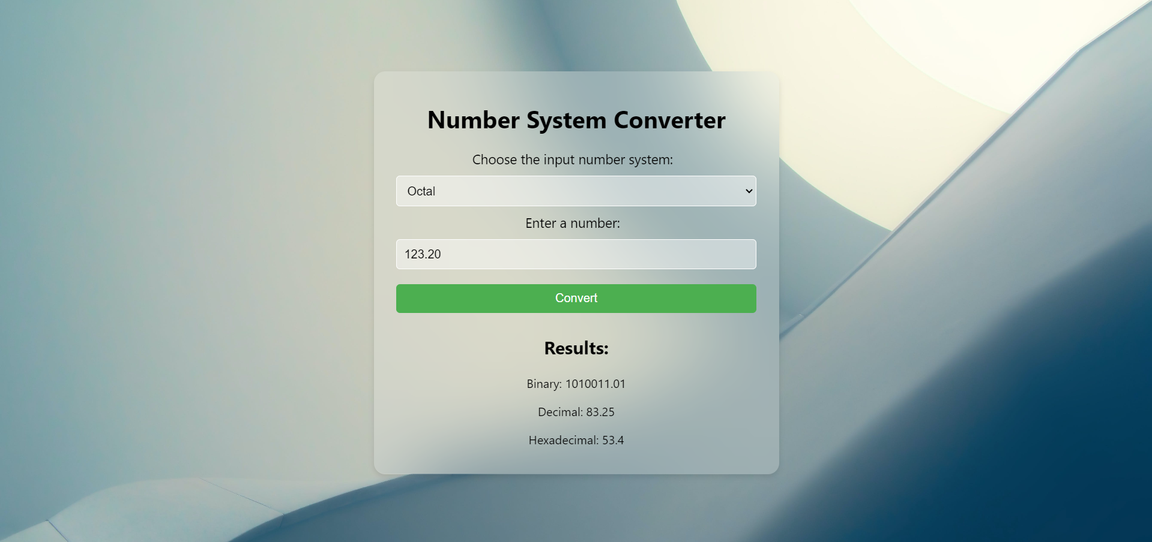**Number System Converter:**

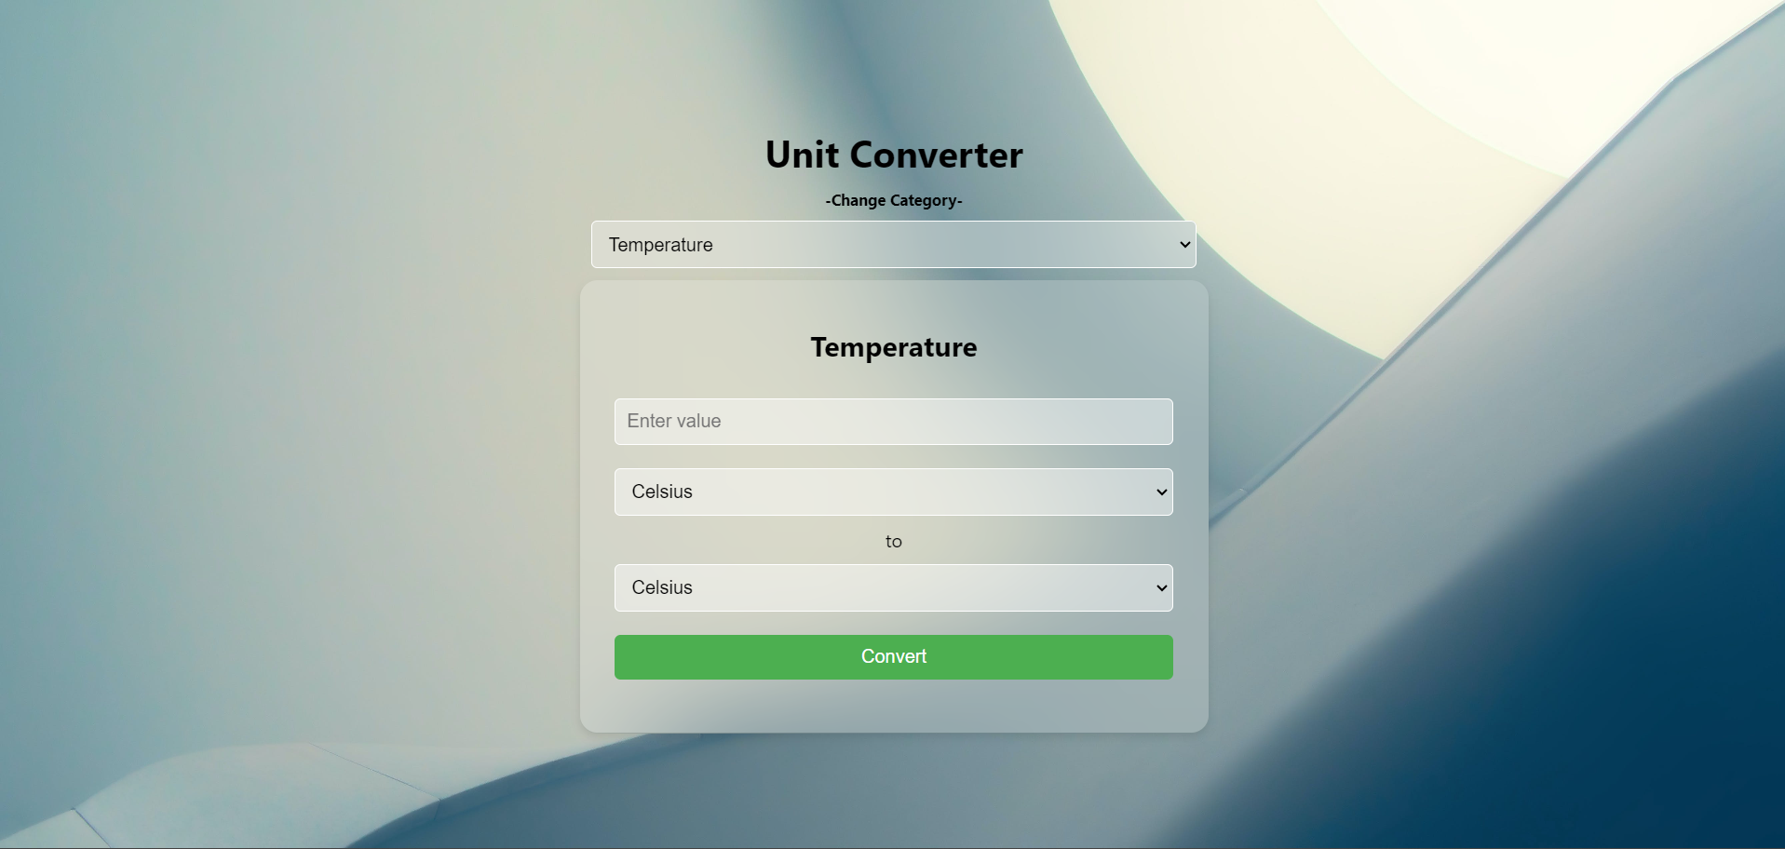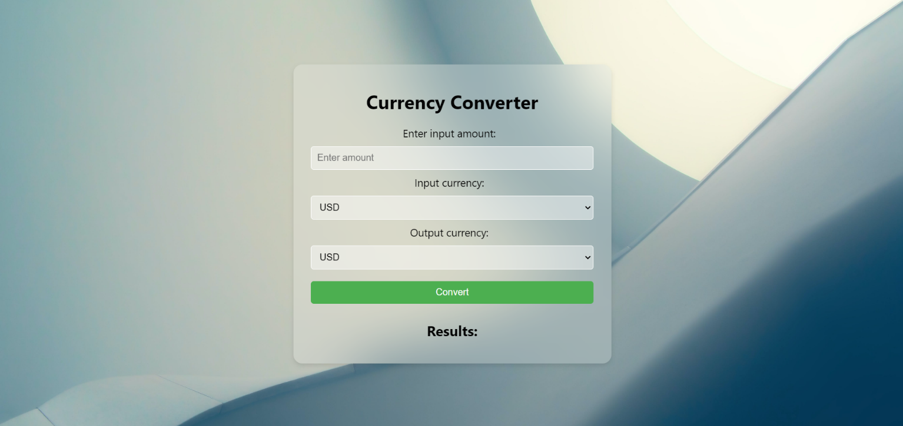**Unit Converter:**

**Currency Exchange Rate:**

* **CONCLUSION**
* In conclusion, the project has successfully developed a comprehensive converter tool that encompasses a number system converter, currency exchange rate calculator, and unit converter. This tool aims to simplify complex conversions across different domains and provide accurate results for users in various fields.
* The number system converter component of the tool efficiently converts numbers between binary, decimal, octal, and hexadecimal systems, catering to the needs of students and professionals in computer science and digital electronics. The currency exchange rate calculator accesses real-time exchange rate data to provide accurate currency conversions, benefiting individuals and businesses involved in international transactions. The unit converter covers a wide range of units, including length, weight, volume, and more, making it a valuable resource for professionals in engineering, physics, and everyday calculations.
* The user interface of the tool is designed to be intuitive and user-friendly, allowing users to easily input data and obtain accurate conversions. The tool's algorithms ensure precision and reliability in conversions, enhancing its usability and practicality for a wide range of conversion tasks.
* Overall, the project has achieved its objectives of developing a versatile converter tool that meets the diverse conversion needs of its users. Future enhancements could include adding more conversion options, improving the user interface, and integrating additional features to further enhance the tool's functionality and usability.
* **REFERENCES**

[**https://byjus.com/maths/decimal-to-binary/**](https://byjus.com/maths/decimal-to-binary/)

[**https://www.doubtnut.com/qna/634115700**](https://www.doubtnut.com/qna/634115700)

[**https://byjus.com/physics/unit-conversion/**](https://byjus.com/physics/unit-conversion/)

[**https://currencyapi.com/**](https://currencyapi.com/)*(for conversions)*

[**https://code.visualstudio.com/**](https://code.visualstudio.com/) *(IDE)*

[**https://www.pexels.com/**](https://www.pexels.com/)*(for wallpaper)*