
Report

Replication and Expansion of Gastric Cancer Pathway Enrichment Insights Using Independent GEO Datasets and Complementary Bioinformatics Tools.

Written report, Network and pathway analysis
Student: Leslie Nana Gyankokora Mingle.

Table of Contents

Introduction 1
Aim 1
Materials and Methods 1
Original work overview 1
Data collection 2
Differential expression analysis 2
Functional and pathway enrichment analysis 3
Network-based enrichment and pathway crosstalk analysis 3
Protein–protein interaction and hub-gene analysis 3
Survival analysis 3
Result 4
Discussion 5
References 6
Appendix 8

Introduction
This report is based on the article “Collagen Family and Other Matrix Remodeling Proteins Identified by Bioinformatics Analysis as Hub Genes Involved in Gastric Cancer Progression and Prognosis” by Chivu-Economescu et al. (2022). The study investigated gastric cancer using bioinformatics approaches to identify differentially expressed genes, enriched pathways, protein–protein interaction networks, and hub genes associated with disease progression and prognosis. The paper particularly emphasized collagen family genes and extracellular matrix remodeling proteins as important contributors to gastric cancer biology.
Gastric cancer remains a major global health challenge because of its high mortality rate and the complex molecular changes that drive its progression(Mamun et al., 2024). Like many cancers, gastric cancer is not caused by a single molecular event, but by coordinated changes in gene expression, signalling pathways, cell adhesion, extracellular matrix remodeling, and tumour–microenvironment interactions(Li et al., 2018). Therefore, analysing individual genes alone is not sufficient. Pathway and network-based analyses are needed to understand how these genes contribute to broader disease mechanisms(Liu & Chance, 2013).
Rather than treating validation as a simple attempt to reproduce the exact same genes, this report evaluates whether the same underlying biological mechanism is preserved. In this context, particular attention is given to extracellular matrix organization, collagen remodeling, focal adhesion, stromal activation, and tumour microenvironment changes as key features of gastric cancer progression.

Aim
The original study investigated whether shared changes in gene expression in gastric cancer could provide insight into disease progression and patient prognosis. It focused mainly on collagen and extracellular matrix-related genes because they are involved in tissue remodeling, invasion, and tumour–microenvironment interactions.
This report aims to verify and extend those findings using independent datasets and adjusted bioinformatics tools. Instead of only checking for the same genes, it tests whether the same biological themes, especially extracellular matrix remodeling, collagen organization, focal adhesion, and stromal activation, are still recovered.

Materials and Methods

Original work overview
The original study by Chivu-Economescu et al. used three gastric cancer microarray datasets from GEO: GSE103236, GSE13911, and GSE79973. Differential gene expression analysis was performed using GEO2R, with logFC ≥ 2 and p < 0.05 to identify differentially expressed genes. They then compared the three datasets using Venn diagrams to find genes that were consistently upregulated or downregulated across all datasets.
To understand what these shared genes might mean biologically, the authors performed functional enrichment analysis using DAVID and KEGG. They also built a protein–protein interaction network with STRING and used Cytoscape MCODE to detect highly connected gene modules and hub genes. Finally, they examined the clinical relevance of selected genes through survival analysis and immune infiltration analysis, helping to assess whether these genes could be useful as prognostic biomarkers or potential therapeutic targets in gastric cancer.
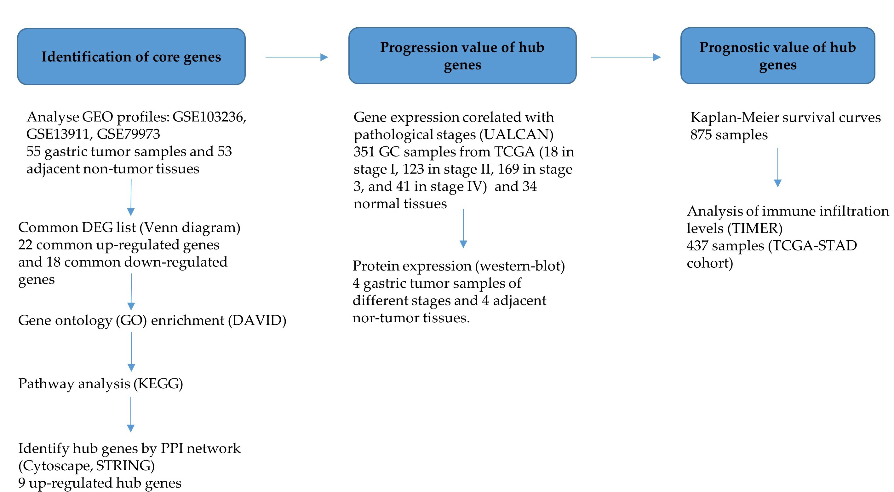
Figure 1.Design of the original work.

Data collection
In this report, the analysis was reproduced and expanded using three independent gastric cancer datasets: GSE19826, GSE54129, and GSE118916. These datasets were selected to test whether the biological findings of the original paper could be recovered in separate cohorts. Differential expression analysis was performed using GEO2R by comparing gastric cancer samples with normal or adjacent non-tumour samples. The significant upregulated and downregulated genes from each dataset were then processed in R, and Venn diagram analysis was used to identify common dysregulated genes across the three datasets.
Dataset | Platform | Tumor samples | Normal/control samples | Analysis tool
GSE19826 | Affymetrix Human Genome U133 Plus 2.0 Array | 12 | 15 | GEO2R
GSE54129 | Affymetrix Human Genome U133 Plus 2.0 Array | 111 | 21 | GEO2R
GSE118916 | Affymetrix Human Gene Expression Array | 15 | 15 | GEO2R

Differential expression analysis
Differential expression analysis was performed using GEO2R by comparing gastric cancer samples with normal or adjacent non-tumour samples in each dataset. Genes
Genes were considered significant using p < 0.05 and logFC ≥ 2. Upregulated genes were defined as genes with positive logFC values, while downregulated genes were defined as genes with negative logFC values. The same filtering approach was applied across all three datasets to ensure consistency before Venn diagram analysis. The significant gene lists from GSE19826, GSE54129, and GSE118916 were then processed in R to identify genes that were commonly dysregulated across all datasets. This step helped reduce dataset-specific noise and prioritised genes that showed reproducible expression changes in independent gastric cancer cohorts.

Functional and pathway enrichment analysis
To understand the biological meaning of the common dysregulated genes, functional enrichment analysis was performed. This report expanded the pathway analysis beyond the original study by using g:Profiler and comparing the results with traditional DAVID/KEGG enrichment analysis in the original paper.
This allowed the analysis to assess whether important pathways reported in the original work, especially extracellular matrix organization, collagen remodeling, focal adhesion, and tumour microenvironment-related processes, could also be detected using different enrichment tools.

Network-based enrichment and pathway crosstalk analysis
In addition to traditional enrichment analysis, network-based enrichment was performed using PathBIX. This step was included to explore pathway relationships and pathway crosstalk, rather than treating each pathway as an isolated gene list.
This adjustment made the analysis broader than the original work because it helped to show how related biological processes may interact in gastric cancer. This was particularly relevant for pathways linked to extracellular matrix remodeling, stromal activation, adhesion, and cancer progression.

Protein–protein interaction and hub-gene analysis
Protein–protein interaction analysis was carried out using STRING to examine how the common dysregulated genes interact at the protein level. The resulting network was then imported into Cytoscape for further analysis.
MCODE was used to detect highly connected gene modules within the network, while cytoHubba was used to rank important hub genes based on network connectivity. Combining these approaches helped to identify genes that may play central roles in the gastric cancer-associated network.

Survival analysis
Finally, survival analysis was performed using the Kaplan–Meier Plotter database to assess whether selected hub genes were associated with overall survival in gastric cancer patients. Since some genes were represented by more than one Affymetrix probe, the JetSet best probe set option was used to select the most representative probe. Patients were then grouped into high- and low-expression groups, and differences in survival were compared using Kaplan–Meier survival curves.

Result

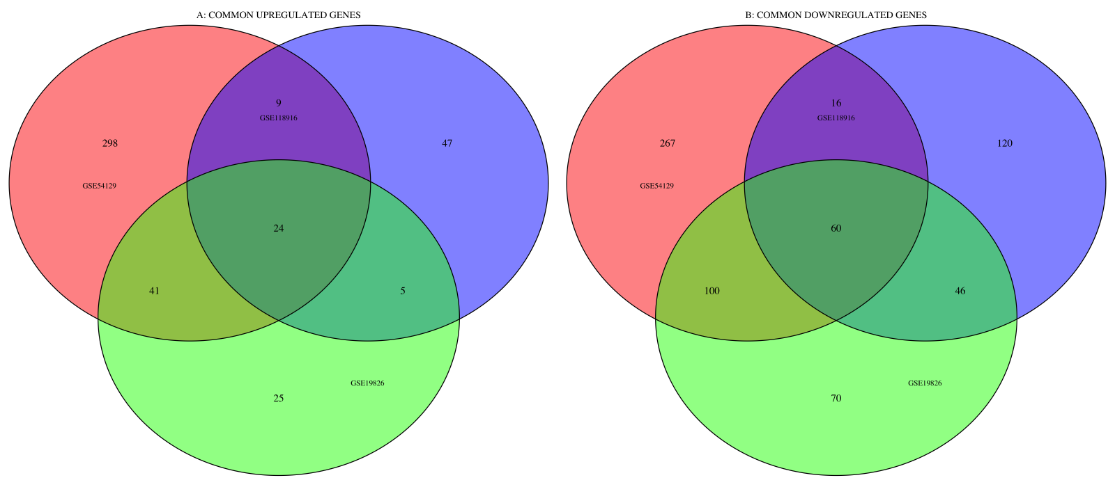
Figure 1. Venn diagram showing A. common upregulated genes and B. downregulated genes across the three gastric cancer datasets. The Venn diagram analysis identified 24 common upregulated genes and 60 common downregulated genes across the three independent gastric cancer datasets. This shows that a consistent set of genes was dysregulated across separate cohorts, despite differences in sample size, platform type, and control tissue composition. The common upregulated genes were dominated by extracellular matrix and stromal-associated genes, including collagen family members and matrix-remodelling genes such as COL1A1, COL1A2, COL6A3, THBS2, ASPN, COL10A1, and COL11A1. In contrast, several downregulated genes were linked to normal gastric epithelial function, including genes involved in mucosal protection, gastric acid secretion, and epithelial differentiation, such as GKN1, GKN2, TFF1, TFF2, ATP4A, ATP4B, PGC, and CLDN18. This suggests that gastric cancer progression in these datasets involved both activation of stromal/ECM-remodelling programmes and loss of normal gastric epithelial identity.

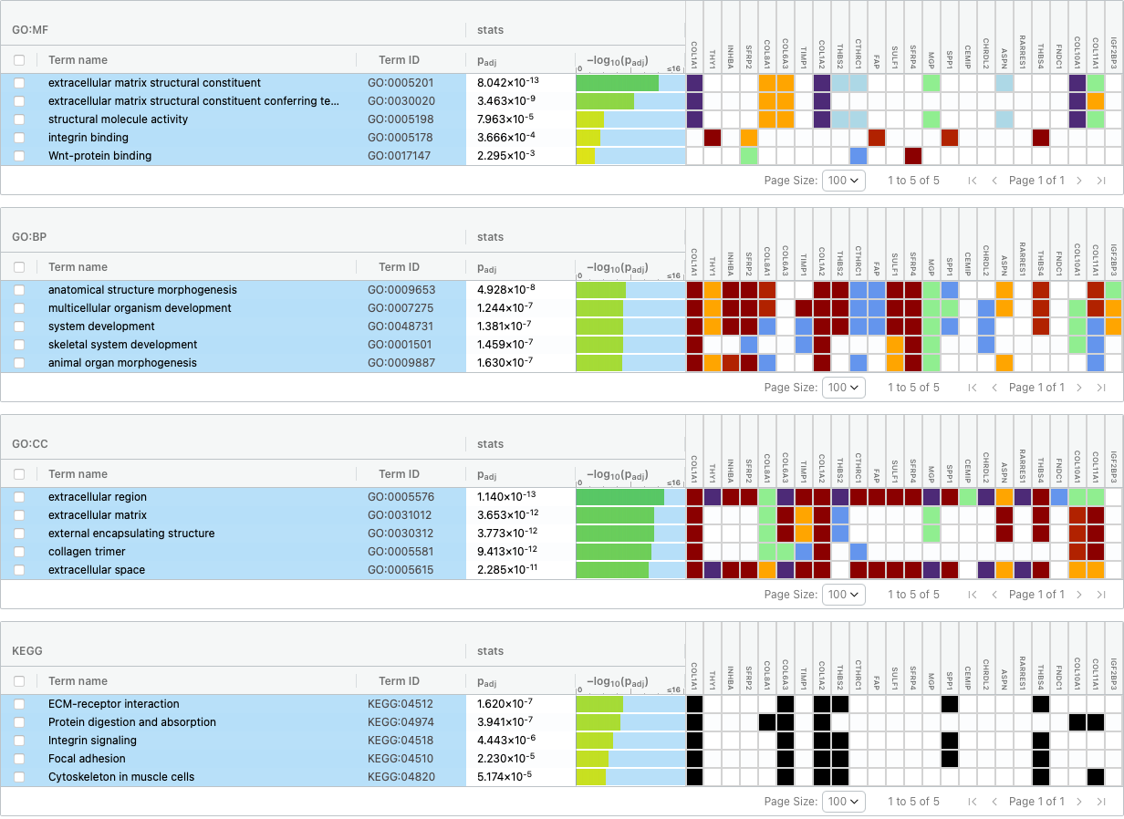
Figure 2. Functional enrichment analysis of common upregulated genes using g:Profiler.
The enriched pathways were dominated by extracellular matrix-related and cancer-associated processes, including ECM-receptor interaction, focal adhesion, PI3K-Akt signalling, protein digestion and absorption, and proteoglycans in cancer. These results support the involvement of extracellular matrix remodelling and tumour–microenvironment interaction in gastric cancer progression.

Table 2. Network-based pathway enrichment analysis using PathBIX. PathBIX analysis suggested functional relationships among enriched pathways rather than treating them as isolated terms. ECM-receptor interaction, focal adhesion, PI3K-Akt signalling, and cancer-related proteoglycan pathways were connected, suggesting coordinated pathway crosstalk involving extracellular matrix remodelling, cell adhesion, and tumour signalling

Pathway Name | q-value | Biological Interpretation
Protein Digestion And Absorption | 2.80 x 10 ⁻⁵ | Collagen and extracellular matrix gene enrichment
PI3K-Akt signalling pathway | 0.0031 | Survival, proliferation , and ECM-mediated signalling
Focal Adhesion | 0.0060 | Cell adhesion, migration, and invasion.
ECm-receptor interaction | 0.0064 | Tumour-matrix communication

Table 3. KEGG pathway enrichment analysis using DAVID. DAVID/KEGG enrichment was used as a traditional over-representation approach to compare with the g:Profiler and PathBIX results. Shared pathways such as ECM-receptor interaction, focal adhesion, and PI3K-Akt signalling indicate that the main biological signal was reproducible across enrichment tools.

Pathway | Original article DAVID/KEGG |  | g:Profiler | PathBIX/network | Biological Interpretation
ECM- receptor interaction | Present |  | Present | Connected with focal adhesion and ECM-related pathways. | Strong validation of extracellular matrix remodelling and tumour-matrix communication
Focal adhesion | Present |  | Present | Connected with ECM-receptor interaction and P13K-Akt signaling. | Supports tumour-cell adheshion,migration,invasion,and stromal interaction
PI3K-Akt signaling pathway | Present |  | Present* | Connected with adhesion and cancer survival signalling pathways | Suggests that extracellular matrix changes may be linked to cancer-cell survival and proliferation signalling.
Protein digestion and absorption/collagen processes | Present |  | Present | Connected to collagen/ECM related pathway themes | Likely reflects the strong contribution of collagen-related genes in the common DEG list.
* Although PI3K-Akt signalling was not displayed among the top five g results shown in Figure 2, it appeared within the broader top ten pathway results. Therefore, it was retained in this comparison because it was recovered in the extended enrichment output and was also connected to ECM- and adhesion-related pathways in the network-based analysis.

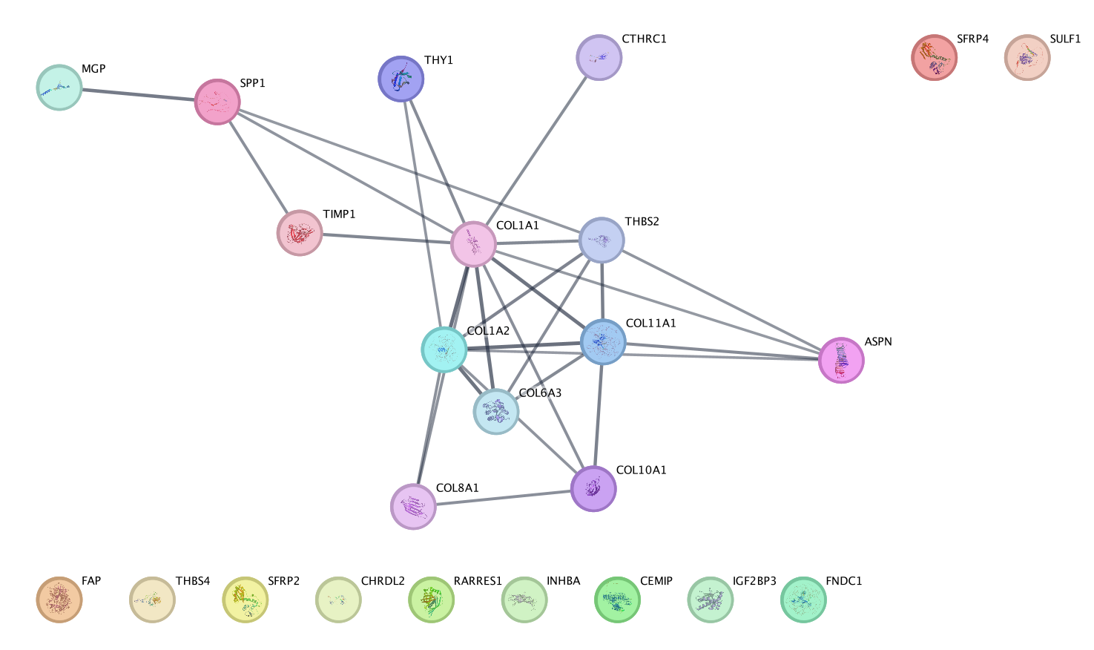

Figure 3. STRING protein–protein interaction network of common upregulated genes.
The common upregulated genes formed a connected protein interaction network enriched for collagen organisation, extracellular matrix structure, and stromal remodelling. Nodes represent proteins, while edges represent known or predicted protein–protein interactions.

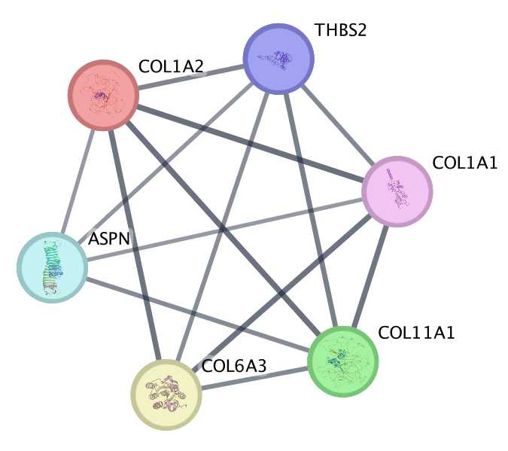
Figure 4. MCODE-detected hub module within the STRING protein–protein interaction network. MCODE identified a highly connected gene module containing collagen and extracellular matrix-associated genes. This module highlights a core group of interacting proteins that may contribute to gastric cancer progression through matrix remodelling and tumour–stroma interaction.

Table 4. Selection of key upregulated hub genes from the PPI network.This table summarises the process used to select the final upregulated hub genes from the PPI network. The common upregulated genes were compared across MCODE and two cytoHubba ranking methods, MCC and Degree. The hub-gene selection should be interpreted as a network-based prioritisation strategy rather than direct proof that these genes are functional drivers of gastric cancer. Genes identified across MCODE, MCC, and Degree were considered stronger candidates because they were supported by more than one network-ranking approach.

Common Upregulated | In MCODE | CytoHubba  (Top MCC) | CytoHubba  (Top Degree ) | Final Hub
COL1A1 | Yes | Yes | Yes | COL1A1(Core hub)
THY1 | - | Yes | Yes | Candidate only
INHBA | - | - | - | -
SFRP2 | - | - | - | -
COL8A1 | - | Yes | Yes | Candidate only
COL6A3 | Yes | Yes | Yes | COL6A3(Core hub)
TIMP1 | - | - | - | -
COL1A2 | Yes | Yes | Yes | COL1A2(Core hub)
THBS2 | Yes | Yes | Yes | THBS2(Core Hub)
CTHRC1 | - | - | - | -
FAP | - | - | - | -
SULF1 | - | - | - | -
SFRP4 | - | - | - | -
MGP | - | - | - | -
SPP1 | - | Yes | Yes | Candidate only
CEMIP | - | - | - | -
CHRDL2 | - | - | - | -
ASPN | Yes | Yes | Yes | APSN(Core hub)
RARRES1 | - | - | - | -
THBS4 | - | - | - | -
FNDC1 | - | - | - | -
COL10A1 | - | Yes | Yes | Candidate only
COL11A1 | Yes | Yes | Yes | COL11A1(Core Hub)
IGF2BP3 | - | - | - | -

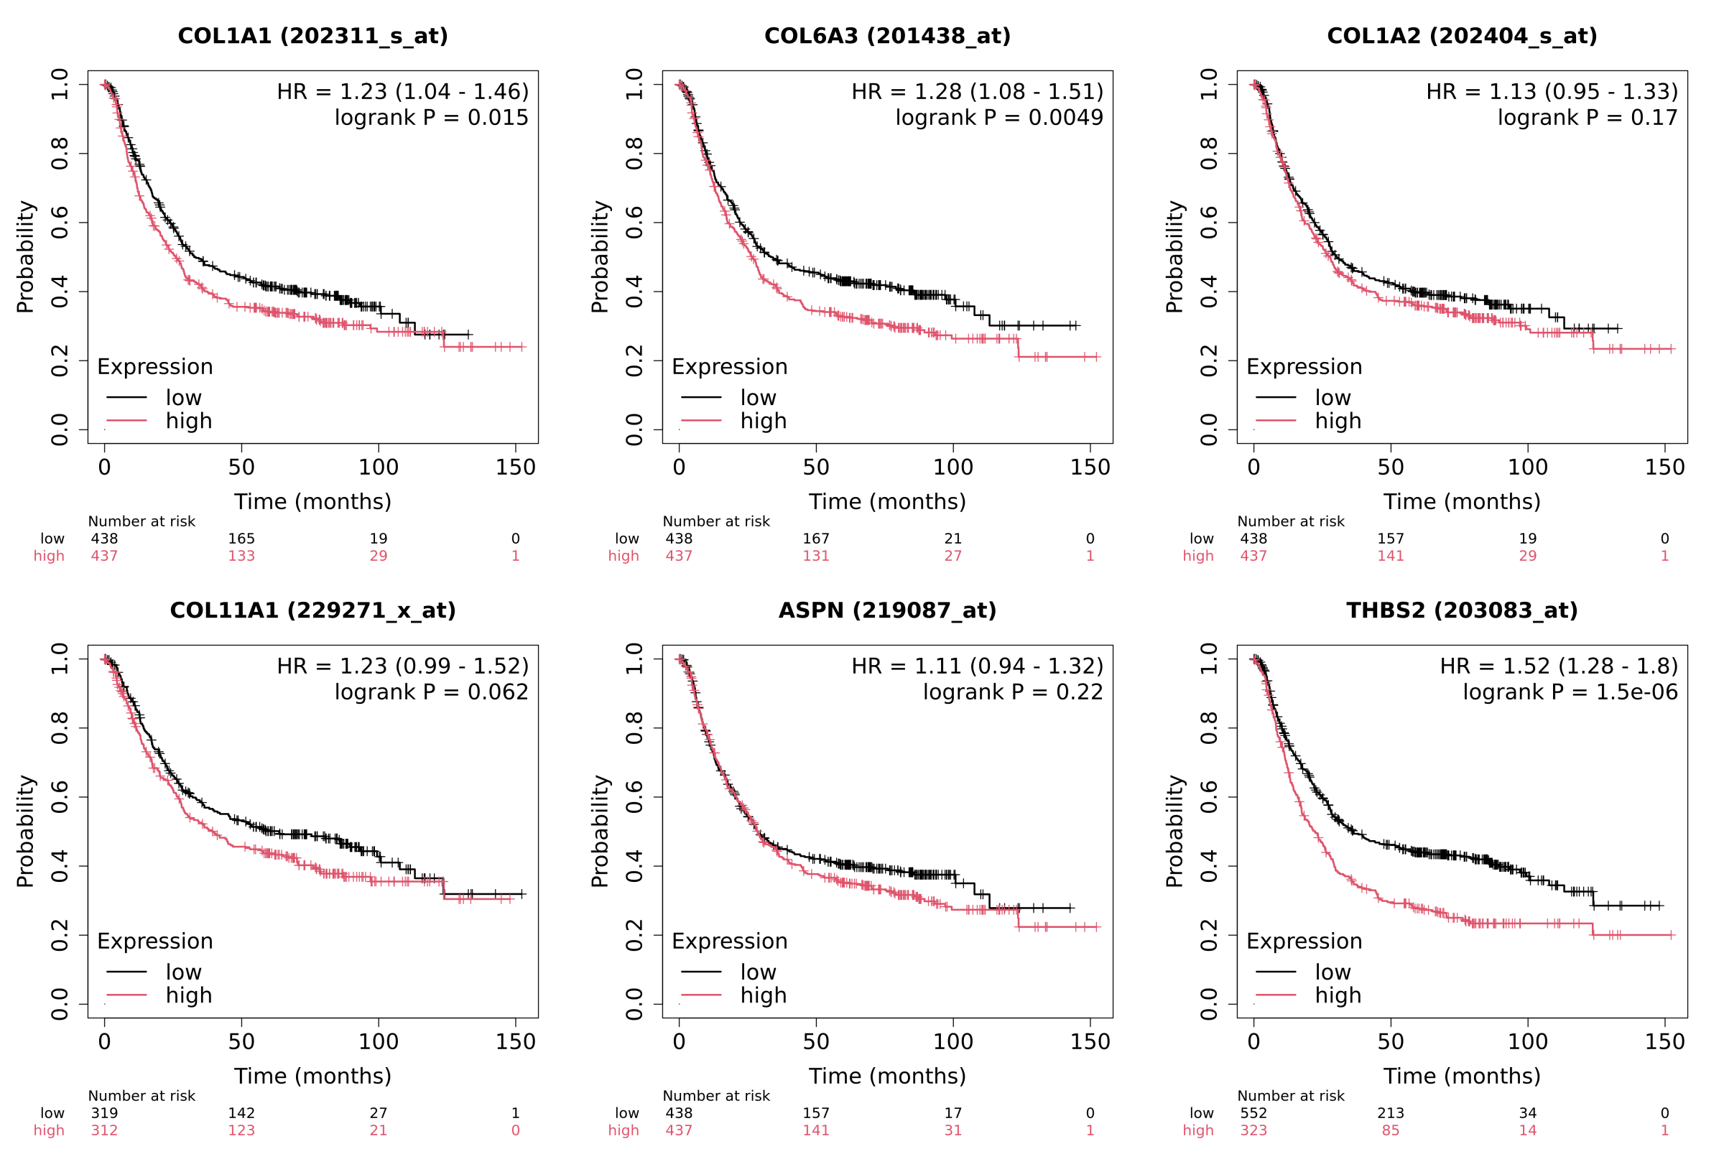
Figure 5. Kaplan–Meier overall survival analysis of selected hub genes in gastric cancer.
Kaplan–Meier survival curves were generated using the Kaplan–Meier Plotter database to assess the prognostic relevance of selected ECM-related hub genes. High expression of COL1A1 (HR = 1.23, p = 0.015), COL6A3 (HR = 1.28, p = 0.0049), and THBS2 (HR = 1.52, p = 1.5 × 10⁻⁶) was significantly associated with poorer overall survival. THBS2 showed the strongest prognostic association among the analysed genes. In contrast, COL1A2 (HR = 1.13, p = 0.17), COL11A1 (HR = 1.23, p = 0.062), and ASPN (HR = 1.11, p = 0.22) did not reach statistical significance, although their high-expression groups showed a general trend toward poorer survival. These results suggest that COL1A1, COL6A3, and THBS2 may represent the strongest clinically relevant hub genes from this analysis.

Discussion
The findings from this validation analysis support the main conclusion of Chivu-Economescu et al. that gastric cancer progression is strongly linked to collagen family genes and extracellular matrix remodeling. In the original study, 22 common upregulated genes and 18 common downregulated genes were identified, whereas this report identified 24 common upregulated genes and 60 common downregulated genes. Among the upregulated genes from this report, 10 overlapped with the original study, showing partial gene-level validation. This difference is expected because the present analysis used independent datasets, which may differ in platform type, sample size, tumour heterogeneity, patient background, and control sample composition. However, despite these differences, both studies still pointed toward the same biological direction: disruption of the extracellular matrix and collagen-associated tumour remodeling.
At the hub-gene level, the exact genes were not identical, but the biological message remained consistent. The original study highlighted ECM-related genes such as THBS2, SPP1, COL10A1, FAP, CTHRC1, and SULF1, while this report identified COL1A1, COL1A2, COL6A3, THBS2, ASPN, COL11A1, SPP1, and COL10A1. The overlap of THBS2, SPP1, and COL10A1 provides direct support for the original findings, while the additional genes identified here expand the same collagen-remodeling theme. This agrees with previous studies showing that collagen family genes, including COL1A1 and COL1A2, may act as prognostic biomarkers and immune-associated targets in gastric cancer (Chen et al., 2020; Sun et al., 2023).
The enrichment results also strengthened the comparison with the original work. Pathways such as ECM-receptor interaction, focal adhesion, protein digestion and absorption, collagen-related processes, and PI3K-Akt signalling were repeatedly identified in this report. These pathways are closely connected because extracellular matrix remodeling can influence tumour-cell adhesion, migration, invasion, and survival signalling. Yang et al. (2020) reported that ECM-receptor interaction signatures have prognostic value in gastric cancer, supporting the importance of this pathway in the present analysis. Similarly, Xu et al. (2025) highlighted the prognostic and immunological importance of ECM-related genes in gastric cancer, further supporting the relevance of the matrix-associated genes identified in this report. Therefore, the repeated enrichment of ECM- and adhesion-related pathways suggests that matrix remodelling is not only a structural feature of gastric cancer, but may also contribute to tumour progression by supporting tumour–matrix communication, stromal activation, invasion, immune modulation, and survival-related signalling.
The network and survival analyses further complemented the original study. STRING, MCODE, and cytoHubba showed that the common upregulated genes were not isolated markers, but part of a connected ECM-related network. This supports the interpretation that gastric cancer progression involves a coordinated stromal and matrix-remodeling programme. The survival analysis added clinical meaning by testing whether validation-derived hub genes were associated with overall survival. Kaplan–Meier analysis showed that high expression of COL1A1 (HR = 1.23, p = 0.015), COL6A3 (HR = 1.28, p = 0.0049), and THBS2 (HR = 1.52, p = 1.5 × 10⁻⁶) was significantly associated with poorer overall survival in gastric cancer patients. Among these genes, THBS2 showed the strongest prognostic association, suggesting that it may be one of the most clinically relevant hub genes identified in this analysis. In contrast, COL1A2, COL11A1, and ASPN did not reach statistical significance, although their high-expression groups showed a general trend toward poorer survival. This is supported by S. Zhang et al. (2022), who linked THBS2 with poor prognosis and immune-cell infiltration in gastric cancer, and by Wang et al. (2021), who reported COL1A1, THBS2, and SPP1 as genes associated with prognosis and immunotherapy response.
However, these findings should be interpreted with some caution. The analysis was based on publicly available microarray datasets, which may differ in platform design, sample processing, tumour stage, patient background, and control tissue composition. These differences may partly explain why the exact DEG and hub-gene lists were not identical to the original study. In addition, enrichment analysis, PPI network construction, MCODE, and cytoHubba are predictive bioinformatics approaches, meaning that they can prioritise biologically relevant genes but cannot prove direct functional causation. Similarly, the Kaplan–Meier survival analysis provides useful clinical support, but the results remain correlative and may be influenced by probe selection, patient stratification, treatment differences, and dataset heterogeneity. Therefore, the identified hub genes should be interpreted as prioritised candidate biomarkers rather than confirmed drivers of gastric cancer progression.
Overall, this report confirmed the original study more strongly at the pathway and network levels than at the exact gene level. The adjusted workflow, including independent datasets, g:Profiler, PathBIX, STRING, MCODE, cytoHubba, and Kaplan–Meier survival analysis, changed the exact DEG and hub-gene outputs but strengthened the broader biological interpretation. Rather than contradicting the original work, the new findings complemented it by identifying additional ECM-related hub genes such as COL1A1, COL1A2, COL6A3, ASPN, and COL11A1.
However, the survival analysis suggested that the clinical relevance of these genes was not equal. COL1A1 and COL6A3, together with THBS2, showed significant associations with poorer overall survival, whereas COL1A2, COL11A1, and ASPN did not reach statistical significance. Therefore, COL1A1, COL6A3, and THBS2 may represent the strongest survival-supported hub genes in this analysis, while COL1A2, COL11A1, and ASPN remain biologically relevant ECM-related candidates that require further validation. These genes fit well with published evidence linking ECM remodeling, cancer-associated fibroblasts, stromal activation, and tumour–microenvironment communication to gastric cancer progression (Jiang et al., 2019; J. Zhang et al., 2023). Taken together, the results suggest that extracellular matrix remodeling, collagen organization, focal adhesion, stromal activation, and tumour–matrix communication are central features of gastric cancer progression.

References
Chen, Y., Chen, W., Dai, X., Zhang, C., Zhang, Q., & Lu, J. (2020). Identification of the collagen family as prognostic biomarkers and immune-associated targets in gastric cancer. International Immunopharmacology, 87, 106798. https://doi.org/10.1016/j.intimp.2020.106798
Chivu-Economescu, M., Necula, L. G., Matei, L., Dragu, D., Bleotu, C., Sorop, A., Herlea, V., Dima, S., Popescu, I., & Diaconu, C. C. (2022). Collagen Family and Other Matrix Remodeling Proteins Identified by Bioinformatics Analysis as Hub Genes Involved in Gastric Cancer Progression and Prognosis. International Journal of Molecular Sciences, 23(6), 3214. https://doi.org/10.3390/ijms23063214
Jiang, K., Liu, H., Xie, D., & Xiao, Q. (2019). Differentially expressed genes ASPN, COL1A1, FN1, VCAN and MUC5AC are potential prognostic biomarkers for gastric cancer. Oncology Letters, 17(3), 3191–3202. https://doi.org/10.3892/ol.2019.9952
Li, W., Ng, J. M.-K., Wong, C. C., Ng, E. K. W., & Yu, J. (2018). Molecular alterations of cancer cell and tumour microenvironment in metastatic gastric cancer. Oncogene, 37(36), 4903–4920. https://doi.org/10.1038/s41388-018-0341-x
Liu, Y., & Chance, M. R. (2013). Pathway analyses and understanding disease associations. Current Genetic Medicine Reports, 1(4), 10.1007/s40142-013-0025–3. https://doi.org/10.1007/s40142-013-0025-3
Mamun, T. I., Younus, S., & Rahman, Md. H. (2024). Gastric cancer—Epidemiology, modifiable and non-modifiable risk factors, challenges and opportunities: An updated review. Cancer Treatment and Research Communications, 41, 100845. https://doi.org/10.1016/j.ctarc.2024.100845
Sun, H., Wang, Y., Wang, S., Xie, Y., Sun, K., Li, S., Cui, W., & Wang, K. (2023). The involvement of collagen family genes in tumor enlargement of gastric cancer. Scientific Reports, 13(1), 100. https://doi.org/10.1038/s41598-022-25061-0
Wang, Y., Zheng, K., Chen, X., Chen, R., & Zou, Y. (2021). Bioinformatics analysis identifies COL1A1, THBS2 and SPP1 as potential predictors of patient prognosis and immunotherapy response in gastric cancer. Bioscience Reports, 41(1), BSR20202564. https://doi.org/10.1042/BSR20202564
Xu, N., Zhang, T., Sun, W., Ye, C., & Zhou, H. (2025). Identification of an extracellular matrix signature for predicting prognosis and sensitivity to therapy of patients with gastric cancer. Scientific Reports, 15, 7464. https://doi.org/10.1038/s41598-025-88376-8
Yang, X., Chen, L., Mao, Y., Hu, Z., & He, M. (2020). Progressive and Prognostic Performance of an Extracellular Matrix-Receptor Interaction Signature in Gastric Cancer. Disease Markers, 2020, 8816070. https://doi.org/10.1155/2020/8816070
Zhang, J., Lu, S., Lu, T., Han, D., Zhang, K., Gan, L., Wu, X., Li, Y., Zhao, X., Li, Z., Shen, Y., Hu, S., Yang, F., Wen, W., & Qin, W. (2023). Single-cell analysis reveals the COL11A1+ fibroblasts are cancer-specific fibroblasts that promote tumor progression. Frontiers in Pharmacology, 14. https://doi.org/10.3389/fphar.2023.1121586
Zhang, S., Yang, H., Xiang, X., Liu, L., Huang, H., & Tang, G. (2022). THBS2 is Closely Related to the Poor Prognosis and Immune Cell Infiltration of Gastric Cancer. Frontiers in Genetics, 13. https://doi.org/10.3389/fgene.2022.803460

Appendix
Table 5. Common upregulated genes
Upregulated Genes (Symbol) | Gene Name
COL1A1 | Collagen type I alpha 1 chain
THY1 | Thy-1 cell surface antigen
INHBA | Inhibin subunit beta A
SFRP2 | Secreted frizzled related protein 2
COL8A1 | Collagen type VIII alpha 1 chain
COL6A3 | Collagen type VI alpha 3 chain
TIMP1 | TIMP metallopeptidase inhibitor 1
COL1A2 | Collagen type I alpha 2 chain
THBS2 | Thrombospondin 2
CTHRC1 | Collagen triple helix repeat containgin
FAP | Fibroblast activation protein alpha
SULF1 | Sulfatase 1
SFRP4 | Secreted frizzled related protein 4
MGP | Matrix Gla protein
SPP1 | Secreted phosphoprotein 1
CEMIP | Cell migration inducing hyaluronidase
CHRDL2 | Chordin like 2
ASPN | Asporin
RARRES1 | Retinoic acid receptor responder 1
THBS4 | Thrombospondin 4
FNDC1 | Fibronectin type III domain containing 1
COL10A1 | Collagen type X alpha 1 chain
COL11A1 | Collagen type XI alph 1 chain
IGF2BP3 | Insulin like growth factor 2 mRna binding protein 3

Table 6. Common downregulated genes.
Downregulated Genes | Gene Name
GATA4 | GATA binding protein 4
ADH7 | Alcohol dehydrogenase 7
CWH43 | Cell wall biogenesis 43 C-terminal homolog
PSAPL1 | Prosaposin like 1
ERO1B | Endoplasmic reticulum oxidoreductase 1 beta
CAPN9 | Calpain 9
CHGB | Chromogranin B
SCNN1B | Sodium channel epithelial 1 subunit beta
FBP2 | Fructose-bisphosphatase 2
ACER2 | Alkaline ceramidase 2
ADGRG2 | Adhesion G protein-coupled receptor G2
SCGB2A1 | Secretoglobin family 2A member 1
RDH12 | Retinol dehydrogenase 12
VSIG2 | V-set and immunoglobulin domain containing 2
HPGD | 15-hydroxyprostaglandin dehydrogenase
ADTRP | Androgen dependent TFPI regulating protein
KCNJ15 | Potassium inwardly rectifying channel subfamily J member 15
SSTR1 | Somatostatin receptor 1
UGT2B15 | UDP glucuronosyltransferase family 2 member B15
CYP2C18 | Cytochrome P450 family 2 subfamily C member 18
TRIM74 | Tripartite motif containing 74
TRIM73 | Tripartite motif containing 73
SOSTDC1 | Sclerostin domain containing 1
RASSF6 | Ras association domain family member 6
VSIG1 | V-set and immunoglobulin domain containing 1
SST | Somatostatin
DPCR1 | Diffuse panbronchiolitis critical region 1
HYAL1 | Hyaluronidase 1
FUT9 | Fucosyltransferase 9
AKR7A3 | Aldo-keto reductase family 7 member A3
FMO5 | Flavin containing dimethylaniline monoxygenase 5
GATA5 | GATA binding protein 5
SLC26A9 | Solute carrier family 26 member 9
KCNJ16 | Potassium inwardly rectifying channel subfamily J member 16
CA9 | Carbonic anhydrase 9
KCNE2 | Potassium voltage-gated channel subfamily E regulatory subunit 2
ALDH3A1 | Aldehyde dehydrogenase 3 family member A1
KIAA1324 | KIAA1324
C16orf89 | Chromosome 16 open reading frame 89
GKN2 | Gastrokine 2
TMED6 | Transmembrane p24 trafficking protein 6
ESRRG | Estrogen related receptor gamma
GIF | Gastric intrinsic factor
AKR1B10 | Aldo-keto reductase family 1 member B10
CA2 | Carbonic anhydrase 2
GKN1 | Gastrokine 1
ATP4B | ATPase H+/K+ transporting subunit beta
ATP4A | ATPase H+/K+ transporting subunit alpha
CXCL17 | C-X-C motif chemokine ligand 17
TFF2 | Trefoil factor 2
PSCA | Prostate stem cell antigen
CLDN18 | Claudin 18
TFF1 | Trefoil factor 1
PGC | Progastricsin
TCN1 | Transcobalamin 1
LIPF | Lipase F, gastric type
DAZ4 | Deleted in azoospermia 4
DAZ2 | Deleted in azoospermia 2
DAZ3 | Deleted in azoospermia 3

