Output
You can now view cricketapp in the browser.

Local: http://localhost:3000
On Your Network: *********

Note that the development build is not optimized.
To create a production build, use npm run build.

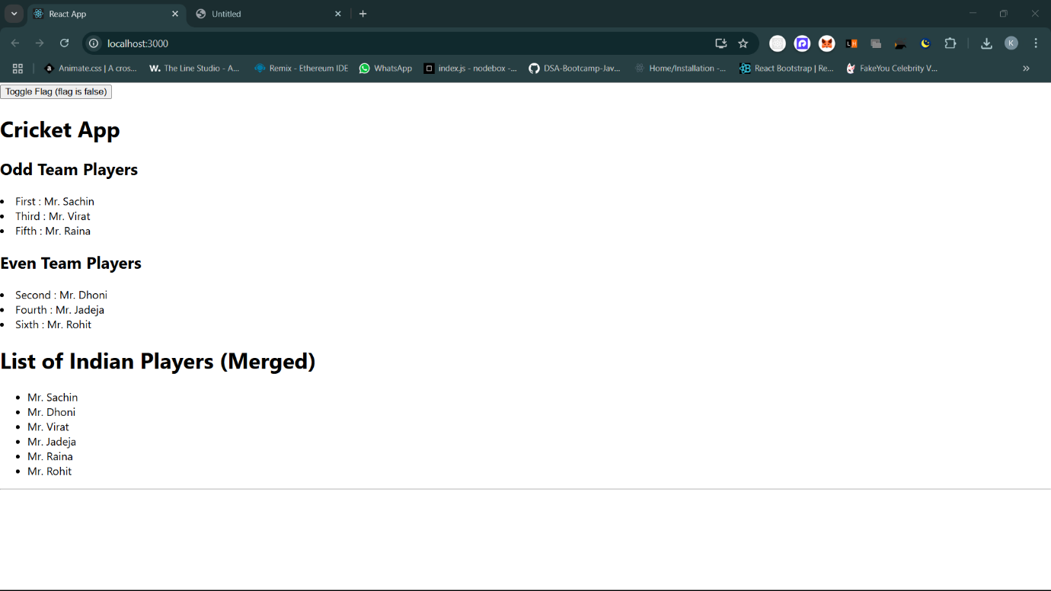
webpack compiled successfully
