Terminal Output – {I used Notepad }
godar@Kailash MINGW64 ~/OneDrive/Desktop/Cognizant Deep Skilling/Week-8-Git (main)
$ cd 'c:/Users/godar/OneDrive/Desktop/Cognizant Deep Skilling/Week-8-Git/Git-HOL-1/code'

godar@Kailash MINGW64 ~/OneDrive/Desktop/Cognizant Deep Skilling/Week-8-Git/Git-HOL-1/code (main)
$ git version
git version 2.45.1.windows.1

godar@Kailash MINGW64 ~/OneDrive/Desktop/Cognizant Deep Skilling/Week-8-Git/Git-HOL-1/code (main)
$ git config --global --list
filter.lfs.clean=git-lfs clean -- %f
filter.lfs.smudge=git-lfs smudge -- %f
filter.lfs.process=git-lfs filter-process
filter.lfs.required=true
user.name=kailzxh
user.email=137093796+kailzxh@users.noreply.github.com

godar@Kailash MINGW64 ~/OneDrive/Desktop/Cognizant Deep Skilling/Week-8-Git/Git-HOL-1/code (main)
$ setx GIT_EDITOR notepad

SUCCESS: Specified value was saved.

godar@Kailash MINGW64 ~/OneDrive/Desktop/Cognizant Deep Skilling/Week-8-Git/Git-HOL-1/code (main)
$ notepad

godar@Kailash MINGW64 ~/OneDrive/Desktop/Cognizant Deep Skilling/Week-8-Git/Git-HOL-1/code (main)
$ alias np="notepad"

godar@Kailash MINGW64 ~/OneDrive/Desktop/Cognizant Deep Skilling/Week-8-Git/Git-HOL-1/code (main)
$ np

godar@Kailash MINGW64 ~/OneDrive/Desktop/Cognizant Deep Skilling/Week-8-Git/Git-HOL-1/code (main)
$ (main
>
>
>
>
>
> ^C

godar@Kailash MINGW64 ~/OneDrive/Desktop/Cognizant Deep Skilling/Week-8-Git/Git-HOL-1/code (main)
$ echo "alias np='notepad'" >> ~/.bashrc
source ~/.bashrc

godar@Kailash MINGW64 ~/OneDrive/Desktop/Cognizant Deep Skilling/Week-8-Git/Git-HOL-1/code (main)
$ git config --global core.editor "notepad"

godar@Kailash MINGW64 ~/OneDrive/Desktop/Cognizant Deep Skilling/Week-8-Git/Git-HOL-1/code (main)
$ git config --global --get core.editor
notepad

godar@Kailash MINGW64 ~/OneDrive/Desktop/Cognizant Deep Skilling/Week-8-Git/Git-HOL-1/code (main)
$ git config --list --global
filter.lfs.clean=git-lfs clean -- %f
filter.lfs.smudge=git-lfs smudge -- %f
filter.lfs.process=git-lfs filter-process
filter.lfs.required=true
user.name=kailzxh
user.email=137093796+kailzxh@users.noreply.github.com
core.editor=notepad

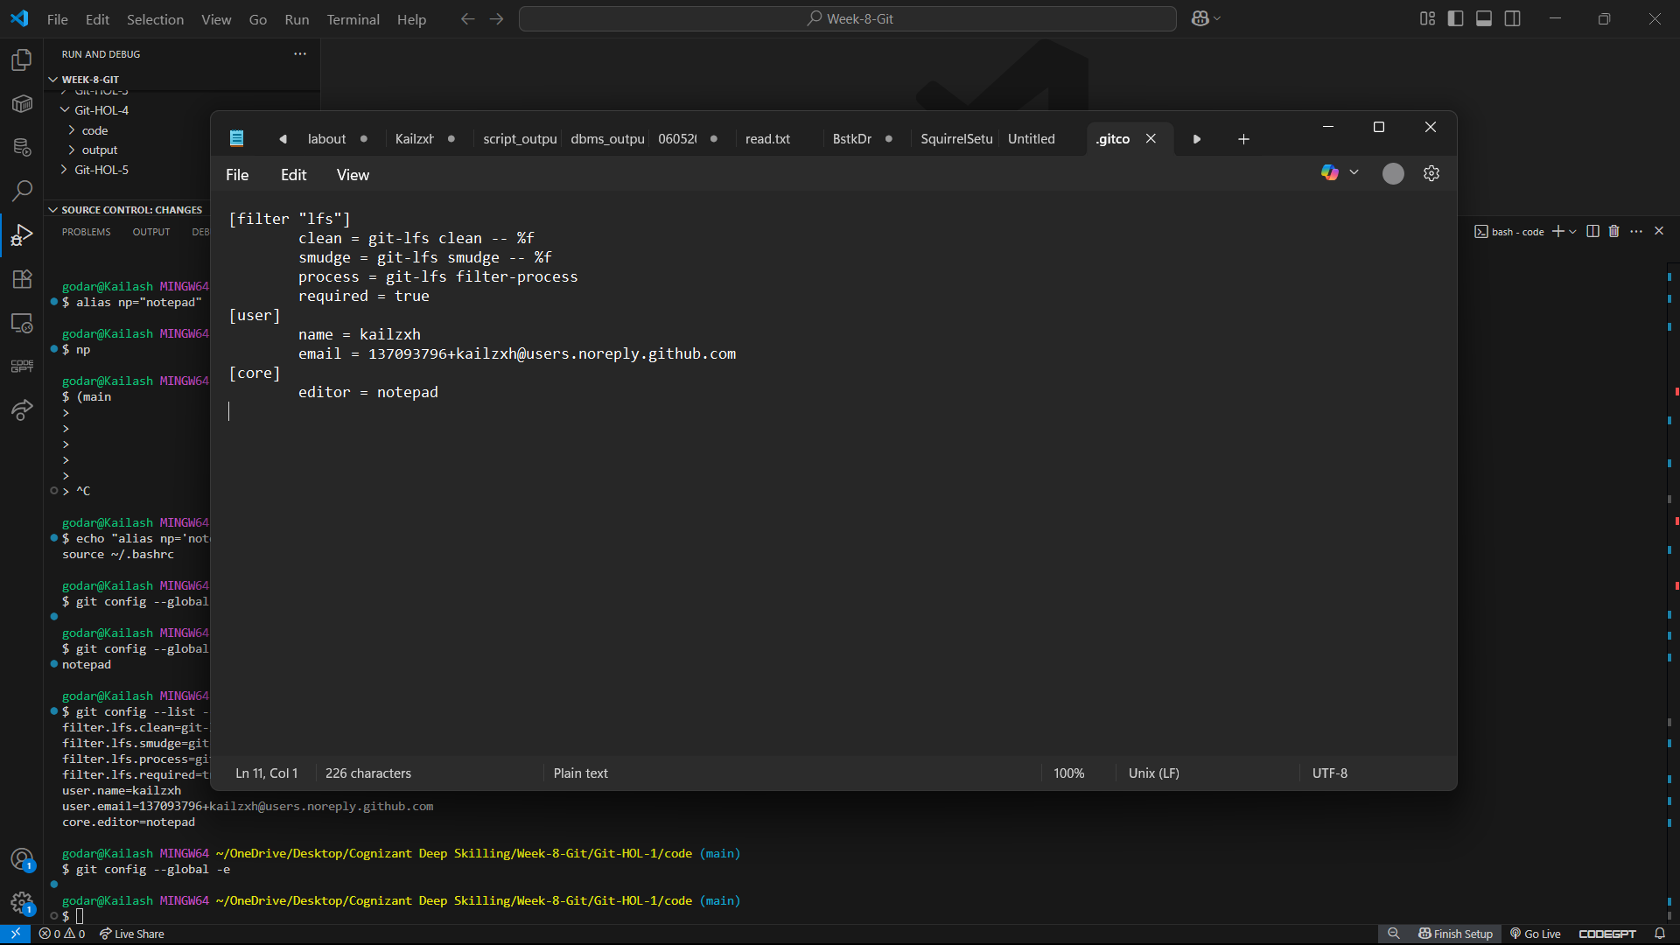
godar@Kailash MINGW64 ~/OneDrive/Desktop/Cognizant Deep Skilling/Week-8-Git/Git-HOL-1/code (main)
$ git config --global -e

