END OF SEMESTER PROJECT DOCUMENTATION:
UNIVERSITY OF GHANA MEDICAL CENTER SMART OPERATIONS SYSTEM



GROUP NAME: STACKX
COURSE CODE: DCIT 308 / DCIT 204
COURSE TITLE: DATA STRUCTURES AND ALGORITHMS I/II
DEPARTMENT OF COMPUTER SCIENCE
SCHOOL OF PHYSICAL AND MATHEMATICAL SCIENCES
COLLEGE OF BASIC AND APPLIED SCIENCES
UNIVERSITY OF GHANA, LEGON

DATE: 19TH JULY 2026

GROUP MEMBERS

STUDENT NAME | STUDENT ID
EZEKIEL TIMOTHY YELBAYA | 22044041
KENNETH NII-OKPEY MENSAH ADJETEY | 22125458
SENYO SENAYA | 22020018
KWADWO NSIA SARKODIE | 22243096
GYASI AMOS KWADWO | 22245133
ASIEDU ELVIS | 11174994
ELISHA AGYEI | 22301833
DARKO EMMANUEL OFORI | 22401302
RICHMOND ANKAN LARBI | 22414076
RITA ADUNI | 22300219
KEVIN BROWN | 22383988
ATAKLI QUEENSLEY ASEYE YAWO | 22411239
ANNOR RYAN ACQUAH | 22378820
RUTH APPIAH | 22396343

GROUP LEADER DETAILS
ID: 22245133
NAME: GYASI AMOS KWADWO
EMAIL: akgyasi004@st.ug.edu.gh
PHONE: +233 059 271 8321

PROJECT REPOSITORY LINK
https://github.com/GyasiAmosKwadwo/UGMC-Smart-Operations-System

ABSTRACT
The UGMC Smart Operations System is a Data Structures and Algorithms-based project developed around the operational activities of the University of Ghana Medical Centre (UGMC). The system demonstrates how data structures and algorithms can be used to address practical hospital operations such as service-request prioritisation, resource allocation, route optimisation, searching, sorting and performance analysis.
The system uses custom implementations of data structures including Dynamic Array, Linked List, Stack, Queue, Circular Queue, Deque, Priority Queue, Binary Search Tree, Red-Black Tree, B-Tree, Hash Table, Set, Map, Disjoint Set and Graph. These structures provide the foundation for the different algorithms implemented in the system.
The algorithms covered by the project include Linear Search and Binary Search; Selection Sort, Insertion Sort, Merge Sort and Quick Sort; Breadth-First Search, Depth-First Search, Dijkstra's Algorithm, Prim's Algorithm and Kruskal's Algorithm; and optimisation approaches based on Greedy methods and Dynamic Programming.
The project also includes automated testing, algorithm trace tables, correctness evidence and an empirical performance benchmarking component. The system is designed around a realistic hospital dataset containing locations, roads, service requests and resources. This provides a practical environment for demonstrating the use of Data Structures and Algorithms in a healthcare setting.

CHAPTER ONE: INTRODUCTION

1.1 Background
Modern healthcare facilities handle many operational activities at the same time. These activities include emergency service requests, movement between departments, laboratory sample delivery, ambulance dispatch, allocation of equipment and coordination of available personnel. Because many of these activities involve limited resources and different levels of urgency, efficient management is important.
The University of Ghana Medical Centre (UGMC) provides a suitable environment for demonstrating these challenges. The project models hospital locations such as the Emergency Unit, Outpatient Department, Pharmacy, Radiology, Laboratory, Intensive Care Unit, Surgical Theatres and other service areas. Connections between these locations are represented as roads or pathways within a graph.
The UGMC Smart Operations System applies Data Structures and Algorithms to these operational activities. It provides mechanisms for managing service requests and resources, searching and sorting records, exploring the hospital network, finding efficient routes and evaluating algorithm performance.
The project therefore connects the concepts studied in Data Structures and Algorithms with a practical healthcare environment. Instead of treating the algorithms only as theoretical concepts, the system demonstrates how they can be used to solve problems that can occur in the daily operation of a hospital.

1.2 Problem Statement
Hospital operations involve several requests that may have different priorities and may require different resources. Emergency requests need to be handled quickly, while routine requests must also be processed without unnecessary delays.
When these activities are not properly coordinated, available resources may not be assigned efficiently, routes between locations may not be optimal and important service requests may take longer to process.
The UGMC Smart Operations System addresses these operational challenges by modelling hospital information and applying appropriate data structures and algorithms. The system supports service-request prioritisation, resource management, route optimisation, searching, sorting and performance analysis.

1.3 Aim
The aim of the project is to design and implement a smart hospital operations optimisation system for UGMC that demonstrates the practical application of Data Structures and Algorithms to real-world healthcare operational problems.

1.4 Objectives
• Design a database for hospital operational information such as locations, roads, service requests and resources.
• Implement custom data structures without depending on Java's built-in collection implementations.
• Prioritise hospital service requests using suitable scheduling approaches.
• Determine efficient routes between hospital locations using graph algorithms.
• Support the management and allocation of hospital resources.
• Implement and compare different searching and sorting algorithms.
• Evaluate algorithm performance using runtime and memory measurements.
• Produce performance information showing how the algorithms behave as input sizes increase.

1.5 Project Scope
The system focuses on the operational side of hospital management. It covers department and location management, service requests, resources, queues, route optimisation, searching, sorting, algorithm performance and database integration.
The system does not attempt to replace clinical systems. Areas such as patient diagnosis, electronic medical records, billing and accounting, pharmacy inventory management and clinical treatment workflows are outside the main scope of the project.

CHAPTER TWO: SYSTEM DESIGN

2.1 System Architecture
The system is organised into separate components so that the user interface, algorithms, data structures and data storage responsibilities are clearly separated. The console application provides the main point of interaction with the system. From the console, users can load data, demonstrate data structures and algorithms, run tests and perform performance benchmarks.
The algorithm layer contains the major algorithm engines used by the project. These include the Search Engine, Sort Engine, Graph Engine, Optimization Engine and Performance Benchmark. The data-structure layer contains the custom implementations used by the algorithms, while the data access layer handles the loading, storage and retrieval of operational data.

2.2 Main System Modules
Module | Main responsibility
Input/Output and Problem Specification | Defines the computational problems, inputs, outputs, assumptions and constraints.
Database and Data Loader | Creates/loads operational data, validates records and makes data available to the system.
Custom Data-Structure Library | Provides the custom linear, hierarchical, hashing and graph structures used by the system.
Searching and Sorting Engine | Implements searching and sorting algorithms and supports their comparison.
Service Scheduling Engine | Models FIFO, circular-queue, deque and priority-based dispatch rules.
Indexing Engine | Supports search/indexing concepts using tree-based structures.
Graph Route Engine | Represents the hospital network and runs BFS, DFS, Dijkstra, Prim and Kruskal.
Optimisation Engine | Implements a Greedy approach and Dynamic Programming.
Testing and Correctness | Provides unit tests, traces and correctness evidence.
Empirical Efficiency Lab | Measures runtime and memory across varying input sizes.

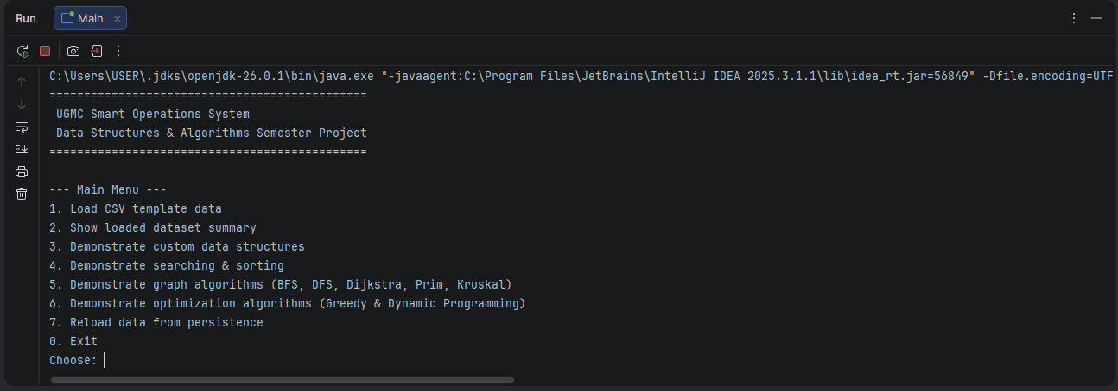

2.3 Data Flow
The system follows a simple operational flow. Data is first loaded into the application. The data is then represented using the appropriate data structures. Users can select the required operation from the console, after which the relevant algorithm is executed. The result is displayed to the user and, where applicable, performance information can be recorded for later analysis. The system also provides database and file-based persistence functionality for storing and retrieving operational information.

CHAPTER THREE: DATASET AND DATA MODEL

3.1 Dataset Description
The project uses hospital-oriented data representing locations, roads, service requests, and resources. The project brief specifies minimum dataset sizes for these entities, while the current repository also includes the project's data-loading and model components.
Dataset entity | Minimum records | Main fields
Locations | 50 | locationId, name, area, type, coordinates
Roads/Edges | 100 | fromLocationId, toLocationId, distance, travelTime, roadConditionWeight
Service Requests | 300 | requestId, source, destination, category, urgency, timeSubmitted, deadline, status
Resources | 30 | resourceId, type, homeLocation, capacity, availabilityStatus
Algorithm Runs | 30 | runId, algorithmName, inputSize, timeNs, memoryKb, dateRun

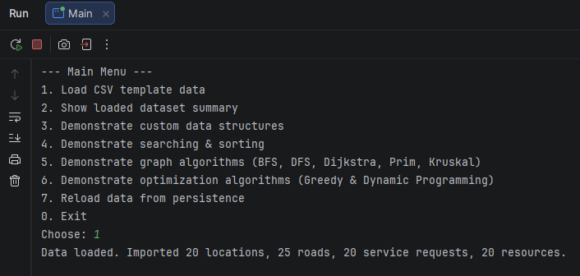

3.2 Data Dictionary
Entity | Description | Use in the system
Location | Represents a hospital department or operational location. | Used as a graph vertex and as a source/destination for operations.
Road | Represents a weighted connection between two locations. | Used by graph and route algorithms.
Service Request | Represents an operational request requiring attention. | Queued, prioritised, searched and sorted.
Resource | Represents an available operational resource. | Used for allocation and dispatch.
Algorithm Run | Represents an algorithm experiment record. | Stores performance-related information.

3.3 Database Schema
The project database represents the main operational entities and their relationships. The schema covers locations, roads, service requests, resources, algorithm runs and audit events. The database is intended to be part of the running system rather than simply a separate storage exercise.
Database table | Purpose
locations | Stores nodes in the local service network.
roads | Stores weighted edges between locations.
service_requests | Stores jobs that can be queued, prioritised, searched and sorted.
resources | Stores operational resources that can be assigned.
algorithm_runs | Stores empirical runtime measurements and input-size metadata.
audit_events | Stores audit/undo-related events and important system events.

CHAPTER FOUR: DATA STRUCTURES
Data structure | Role in the UGMC system
Dynamic Array | Provides a resizable array structure with indexed access and resizing.
Linked List | Stores elements using linked nodes and supports linked-list operations.
Stack | Follows LIFO order and supports operations such as push, pop and peek.
Queue | Follows FIFO order and is useful for request processing.
Circular Queue | Reuses positions through wrap-around behaviour in a fixed-capacity queue.
Deque | Allows insertion and removal from both the front and rear.
Priority Queue / MinHeap | Supports priority-based processing and efficient selection of the minimum-priority item.
Binary Search Tree | Stores ordered elements and supports search and traversal operations.
Red-Black Tree | Provides a self-balancing binary search tree structure.
B-Tree | Provides multi-way tree-based storage and search.
Hash Table | Stores key-value pairs using hashing and collision handling.
Set | Stores unique elements and supports membership/visited-state operations.
Map | Represents key-value relationships.
Disjoint Set | Maintains separate groups and supports union/find operations, especially for Kruskal.
Graph | Represents hospital locations and their connections for graph algorithms.
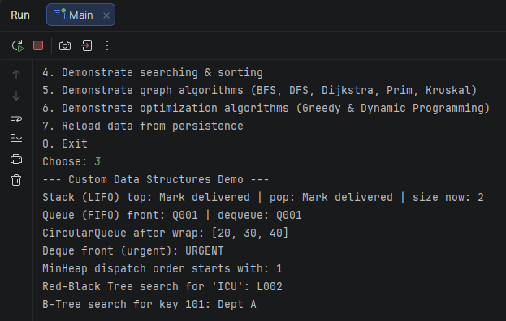

CHAPTER FIVE: ALGORITHMS

5.1 Searching Algorithms
Linear Search checks elements one after another until the required element is found or all elements have been checked. Its worst-case time complexity is O(n), and it is useful when the data is not necessarily sorted.
Binary Search works on sorted data. It repeatedly divides the search range into two parts and determines which half can contain the target. Its worst-case time complexity is O(log n), making it suitable for repeated searches on ordered data.

5.2 Sorting Algorithms
Algorithm | Main idea | Time complexity
Selection Sort | Repeatedly selects the smallest remaining element and places it in its correct position. | O(n²) worst case
Insertion Sort | Builds the sorted portion gradually by inserting each new element into position. | O(n²) worst case
Merge Sort | Divides the input, recursively sorts the parts and merges them. | O(n log n)
Quick Sort | Partitions around a pivot and recursively sorts the resulting parts. | O(n log n) average; O(n²) worst case

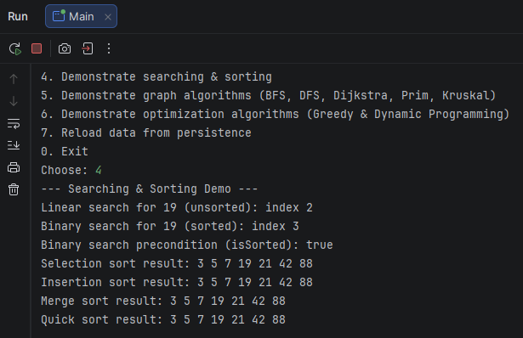

5.3 Graph Algorithms
Algorithm | Purpose in the hospital network
BFS | Explores reachable locations level by level.
DFS | Explores a path deeply before backtracking.
Dijkstra | Finds shortest paths in a weighted graph with non-negative edge weights.
Prim | Builds a minimum spanning tree by expanding from an existing tree.
Kruskal | Builds a minimum spanning tree by considering edges in increasing weight order and avoiding cycles.

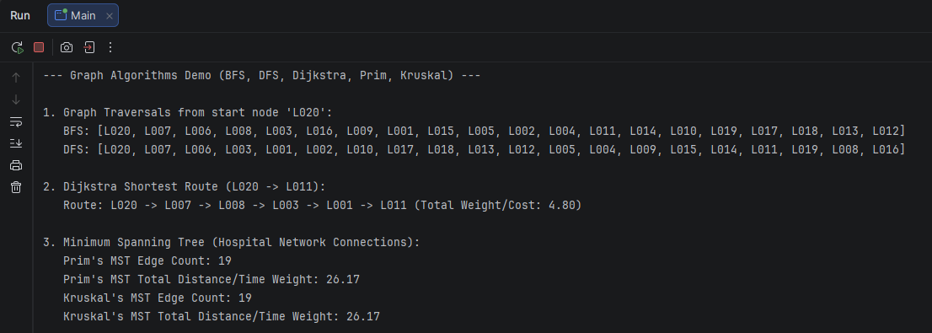

5.4 Optimisation Algorithms
The Greedy approach makes a locally favourable choice at each stage. In the UGMC context, priority-based scheduling provides a natural application because urgent requests can be considered before lower-priority requests. The project also recognises that Greedy selection does not automatically guarantee a globally optimal result for every constrained problem.
Dynamic Programming is used for a 0/1 Knapsack-style capacity-planning problem. It divides the problem into smaller subproblems and stores previously calculated results so that repeated calculations can be avoided.
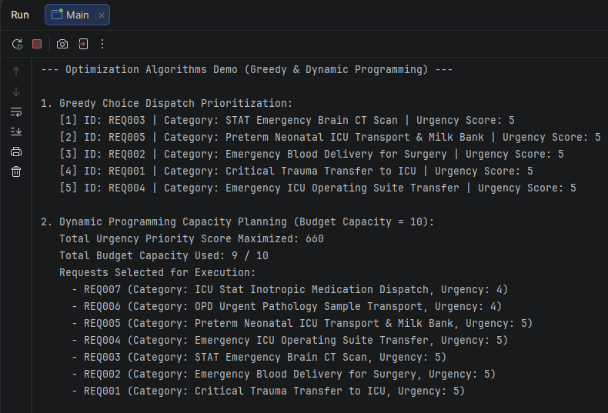

CHAPTER SIX: IMPLEMENTATION

6.1 Technology and Project Structure
The system is implemented in Java and organised as a standard Java project. The repository contains application source code, custom data structures, algorithm implementations, database components, tests, data templates and documentation.
Component | Examples in the repository
Model layer | Location, Road, ServiceRequest, Resource, AlgorithmRun
Data structures | Custom lists, queues, stacks, trees, hash table, heap, disjoint set and graph
Algorithm layer | SearchEngine, SortEngine, GraphEngine, OptimizationEngine, PerformanceBenchmark
Database layer | Database, FileDatabase, DataLoader, OperationalStore
Testing | UnitTestRunner
Documentation/Data | Project documentation, trace tables, proof material and CSV templates

6.2 Console Application
The system provides a console interface through which the major functions can be demonstrated. The menu allows the user to load data, inspect the dataset, demonstrate data structures, run searching and sorting, run graph and optimisation algorithms, reload persisted data, execute performance benchmarks and run automated tests.

CHAPTER SEVEN: TESTING AND CORRECTNESS

7.1 Testing Strategy
Testing is used to verify that the custom data structures and algorithms behave as expected. The project includes an automated UnitTestRunner covering the major data structures, searching algorithms, sorting algorithms, graph algorithms and optimisation algorithms.

7.2 Required Testing Evidence
Evidence | Requirement from the project brief
Unit tests | At least 40 tests across data structures and algorithms.
Trace tables | At least six, covering binary search, insertion sort, merge sort/quick sort, Dijkstra, Kruskal/Prim and DP.
Proof sketches | At least three, including loop-invariant, induction/recursion and greedy/DP correctness ideas.
Counterexamples | At least two, including a greedy failure and an invalid precondition such as unsorted Binary Search.
Edge cases | Empty structures, single elements, duplicate keys, disconnected graphs, unreachable paths, full/empty queues and hash collisions.

7.3 Correctness And Proof Sketches
The project provides trace tables showing how selected algorithms operate step by step. It also includes proof sketches and counterexamples to demonstrate algorithm correctness and to show situations where an algorithm's assumptions or limitations affect its behaviour.

Proof 1 — Binary Search
Binary Search maintains the condition that, if the target exists in the sorted array, it must remain within the current search interval. At each step, the middle element is compared with the target. If the target is smaller, the upper half is discarded; if it is larger, the lower half is discarded. Therefore, each step reduces the possible search space while preserving the possibility of finding the target. When the target is found, its index is returned; when the interval becomes empty, the target is absent.

Proof 2 — Merge Sort
Merge Sort divides the input into smaller subarrays until each subarray contains one element. A single-element array is already sorted. The algorithm then merges pairs of sorted subarrays while maintaining their ordering. Since each merge produces a sorted result and the final merge combines all elements, the complete output is sorted.

Proof 3 — Dynamic Programming
Dynamic Programming solves a larger optimization problem by using solutions to smaller subproblems. Once the optimal value for a smaller state has been computed, it can be reused when evaluating a larger state. By considering the available choices for each state and retaining the best feasible result, the final state represents the best solution obtainable under the defined constraints.

7.4 Edge-Case Testing
The testing requirements cover cases such as empty structures, single-element inputs, duplicate values, disconnected graphs, unreachable paths, queue boundary conditions and hash collisions. These cases help show that the implementations are not limited to normal inputs.

CHAPTER EIGHT: PERFORMANCE EVALUATION

8.1 Benchmarking Methodology
The project includes a PerformanceBenchmark component for empirical evaluation. The brief requires each experiment to be repeated at least three times, using the same machine for all experiments, with average runtime reported and the machine specification stated. Results are to be exported to CSV and presented using line graphs.
Experiment | Input sizes required | Expected comparison
Search comparison | 100, 500, 1,000, 5,000, 10,000 records | Linear vs Binary Search runtime
Sorting comparison | 100, 500, 1,000, 5,000, 10,000 requests | Selection, Insertion, Merge and Quick Sort runtime
Hash-table load factor | 100 to 20,000 keys | Load factor against collision count/time
BST vs balanced tree | Multiple input sizes | Height and search-time comparison
Heap priority dispatch | 100 to 20,000 requests | Insert/extract operation time
Graph algorithms | 50, 100, 200, 500 locations/edges | BFS/DFS/Dijkstra/MST runtime

8.2 Theoretical Complexity
Linear Search has O(n) worst-case time complexity, while Binary Search has O(log n) when its sorted-data precondition is satisfied. Selection Sort and Insertion Sort have O(n²) worst-case complexity, while Merge Sort has O(n log n). Quick Sort has O(n log n) average complexity and O(n²) worst-case complexity. The graph algorithms have complexities that depend on their implementations and supporting data structures.

8.3 Performance Interpretation
The purpose of the performance study is not only to show which algorithm is theoretically faster, but also to compare theoretical complexity with observed runtime as the input grows. Differences can arise from implementation details, machine characteristics, memory behaviour and the overhead associated with the selected data structures.

CHAPTER NINE: TRACE TABLES AND ALGORITHM EVIDENCE

9.1 Required Trace Coverage
Trace | What it demonstrates
Binary Search | Changes to the search interval and the effect of the sorted-input requirement.
Insertion Sort | Movement and insertion of elements into the sorted portion.
Merge Sort / Quick Sort | Divide-and-conquer or partitioning behaviour.
Dijkstra | Distance updates and predecessor/path selection.
Kruskal / Prim | Minimum-spanning-tree edge selection and total cost.
Dynamic Programming | Subproblem values, capacity decisions and reconstruction.

Algorithm Trace Tables
A. Binary Search Trace
Input: [3, 5, 7, 19, 21, 42, 88]
Target: 19
Step Low High Mid Mid Value Result
1 0 6 3 19 Found

Result: 19 was found at index 3.
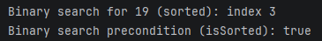

B. Insertion Sort Trace
The implementation successfully produced the sorted result for Insertion Sort. However, the available execution evidence records the final result rather than the intermediate states required for a complete trace table.

C. Merge Sort Trace
The available execution evidence shows the final sorted result:
3, 5, 7, 19, 21, 42, 88

D. Dijkstra Trace
Dijkstra's algorithm was executed on the hospital-location graph to determine a shortest route from the selected starting location.
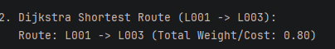

E. Prim/Kruskal Trace
The demonstration confirms that both Prim's and Kruskal's algorithms were executed to construct minimum spanning trees for the hospital network.
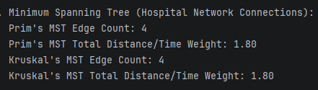

F. Dynamic Programming Trace
The Dynamic Programming demonstration was executed alongside the Greedy approach. The output was used to compare the optimisation strategies for the selected resource-allocation problem.


9.2 Proof and Counterexample Evidence
Proof sketches provide theoretical support for the correctness of selected algorithms. Counterexamples demonstrate situations where an algorithm can fail when its assumptions are not satisfied or when a particular strategy does not guarantee an optimal solution.

Counterexample 1 — Binary Search on Unsorted Data
Suppose the data is:
[3, 19, 7, 5, 21]
Although 19 exists, Binary Search assumes that the data is sorted. Applying Binary Search without satisfying this precondition can cause the algorithm to discard the part of the array containing the target.
Conclusion: Binary Search requires sorted input.

Counterexample 2 — Greedy vs Optimal Choice
The project recognizes that a locally attractive Greedy choice does not automatically guarantee a globally optimal solution for every optimization problem. This is why the implementation includes Dynamic Programming for problems where optimal substructure can be exploited.

CHAPTER TEN: DATABASE INTEGRATION

10.1 Database Design
The database represents locations, roads, service requests, resources, algorithm runs and audit events. These entities support the operational model used by the application.
Dataset | Current Records
Locations | 20
Roads/Routes | 25
Service Requests | 20
Resources | 20

During the documentation run, the system successfully loaded 20 locations, 25 routes, 20 service requests, and 20 resources from the available dataset files.

10.2 Persistence and Data Loading
The project contains components for loading CSV data and for storing and retrieving operational information. The project brief requires the final program to read from and write to the database so that the database forms part of the running system.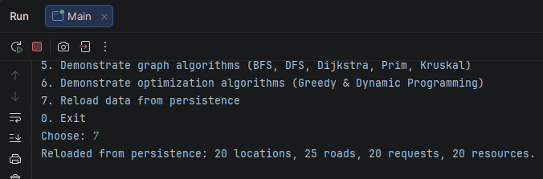

10.3 Database Evidence
Database integration is demonstrated through schema information, sample records and execution evidence showing that data can be loaded, used by the application and persisted for later retrieval.
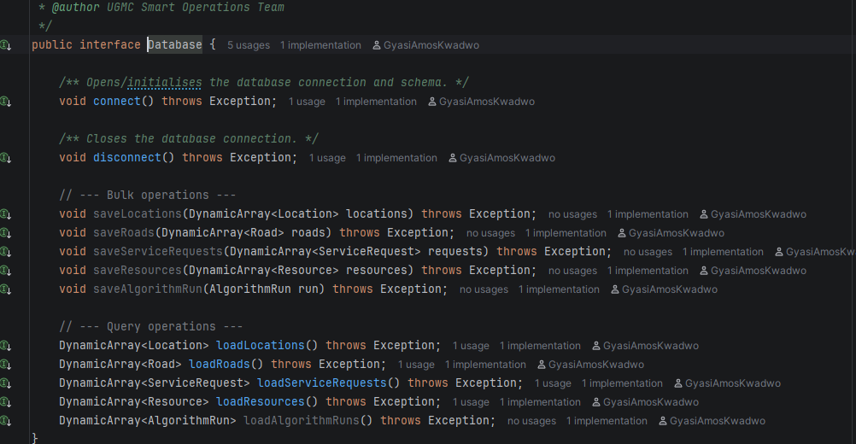

CHAPTER ELEVEN: RESPONSIBLE ALGORITHM SELECTION
Different algorithms are appropriate for different operational situations. Linear Search is useful when the data is not sorted or when a straightforward sequential search is sufficient. Binary Search is preferable when the data is sorted and repeated searching is required.
Selection Sort and Insertion Sort are simple comparison-based algorithms that can be useful for smaller inputs, while Merge Sort and Quick Sort provide better average asymptotic performance for larger inputs. BFS and DFS are useful for graph traversal, while Dijkstra is appropriate for shortest-path problems with non-negative edge weights. Prim and Kruskal are appropriate when the goal is to construct a Minimum Spanning Tree rather than find a shortest path between two locations.
A Greedy approach can be useful when a locally optimal choice is appropriate for the problem, but it should not automatically be assumed to produce a globally optimal result. Dynamic Programming is appropriate when a problem contains overlapping subproblems and optimal substructure and when the additional memory required to store previous results is acceptable.

CHAPTER TWELVE: CONCLUSION
The UGMC Smart Operations System demonstrates how Data Structures and Algorithms can be applied to a realistic healthcare operational environment. The project combines custom data structures with searching, sorting, graph and optimisation algorithms and connects these components to practical activities such as service-request management, resource allocation, route optimisation and performance evaluation.
The implementation also includes automated testing, algorithm traces, correctness evidence, database integration and empirical benchmarking. Together, these components provide a practical demonstration of how concepts from Data Structures and Algorithms can be applied to operational challenges within a hospital environment such as UGMC.

REFERENCES
University of Ghana, Department of Computer Science. Joint DSA Semester Project Brief.
UGMC Smart Operations System GitHub Repository. https://github.com/GyasiAmosKwadwo/UGMC-Smart-Operations-System

APPENDICES

Appendix A: Console Menu Functions
Option | Function
1 | Load CSV template data
2 | Display loaded dataset summary
3 | Demonstrate custom data structures
4 | Demonstrate searching and sorting
5 | Demonstrate BFS, DFS, Dijkstra, Prim and Kruskal
6 | Demonstrate Greedy and Dynamic Programming
7 | Reload data from persistence
8 | Run the performance benchmark
9 | Run automated tests
0 | Exit the application

Appendix B: Required Evidence Set
Evidence item | Purpose
Screenshots | Show the running system, database integration and selected demonstrations.
Trace tables | Show selected algorithms step by step.
Proof sketches | Support correctness reasoning.
Counterexamples | Show algorithm limitations or invalid preconditions.
Unit-test output | Show actual execution of the test suite.
Performance CSV | Preserve raw timing and memory measurements.
Performance graphs | Show runtime behaviour as input size increases.
Database run logs | Show persistence and reload behaviour.

Appendix C: Submission Items
Submission item | Required format/evidence
Source code | ZIP or Git repository export with README and run instructions.
Database | SQL scripts, schema.sql and sample CSV/seed data.
Technical report | PDF and DOCX.
Performance results | Raw CSV plus plotted graphs.
Demonstration video | 5–8 minutes showing database load, core algorithms, tests and graphs.
Oral defence | Each student explains one data structure and one algorithm.

