

Hoho Travel

Group 2

Names : Mindy Atikah Chiara Gyver (1710010059)

Rires Sutrisno(1710010085)

Class : 4SC4

CEP CCIT

FAKULTAS TEKNIK UNIVERSITAS INDONESIA

2019

**PROJECT ON**

*Hoho Travel*

**Developed by**

1. **Mindy Atikah Chiara Gyver(1710010059)**
2. **Rires Sutrisno(1710010085)**



**Hoho Travel**

Batch Code : 4sc4

Start Date : 10 Juni 2019  
End Date : July 2019

Name of Faculty : Riza Muhammad Nurman, S.Kom

Names of Developer :

1. Mindy Atikah Chiara Gyver
2. Rires Sutrisno

Date of Submission: July 2nd, 2019

**CERTIFICATE**

This is to certify that this report titled “Hoho Travel” embodies the original work done by Mindy Atikah Chiara Gyver and Rires Sutrisno. Project in partial fulfillment of their course requirement at NIIT.

Coordinator:

Riza Muhammad Nurman, S.Kom



**ACKNOWLEDGEMENT**

All the praises and thanks be to Allah for His guides and blesses, so that this paper entitled “Hoho Travel” can be completed on time.

Also, thanks to Mr. Riza Muhammad Nurman, S.Kom for the feedbacks and suggestions given. This paper is written to fulfil assignment and this paper has benefited a lot by the feedbacks.

And thanks for various parties, like:

1. Parents who always support through spirit or even material.
2. Dr. Muhammad Suryanegara, ST., M.Sc. as director of CEP-CCIT Faculty of Engineering, University of Indonesia.
3. Friends who give some suggestions.

Apologize if there are any mistakes in the project. Feel free to give any advice so that the project can be better in the future.

Depok, July 2nd, 2019

**SYSTEM ANALYSIS**

**System Summary**:

Hoho Travel is a web application that is built using Asp.Net MVC. This is an app that can be solution for user who looking for travel agent that is guiding the in their travelling activities in the Bali. In this web, it has two menus for Admin and User. In the Admin side, the Admin can do Create, Read, Update and Soft Delete of the data. While in the user side, the user can make a booking.

**HARDWARE AND SOFTWARE REQUIREMENTS**

\

**Hardware**: **I5 2.50GHz RAM 4GB HDD 1TB**

**Operating System: Windows 10**

**Software: Visual Studio 2017, SQL SERVER 2014**

\

sssssssssss

**INDIVIDUAL PROJECT SCHEDULE**

|  |  |  |  |  |  |  |  |  |  |  |
| --- | --- | --- | --- | --- | --- | --- | --- | --- | --- | --- |
| ***No*** | |  | | --- | | ***Activity Description*** | | |  | | --- | | ***Planned Date of Completion*** | | |  | | --- | | ***Actual Date*** | | |  | | --- | | ***Responsibility*** | | |  | | --- | | ***Remarks*** | |
| 1. | Make the database | 11 June 2019 | 11 June 2019 | Gyver |  |
| 2. | Build the backend of Program | 20 June 2019 | 20 June 2019 | Gyver |  |
| 3. | Make the frontend of Program | 19 June 2019 | 19 June 2019 | Rires |  |
| 4. | Implement the design to the program | 25 June 2019 | 25 June 2019 | Rires |  |
| 5. | Arrange The Report | 30 June 2019 | 30 June 2019 | Gyver |  |
| 6. | Make The Presentation | 30 June 2019 | 30 June 2019 | Rires |  |

**TECHNOLOGY DIAGRAM**

Packages

Bookings

Admins

PackagesController.cs

BookingsController.cs

AdminsController.cs

PackageClass.cs

BookingClass.cs

AdminClass.cs

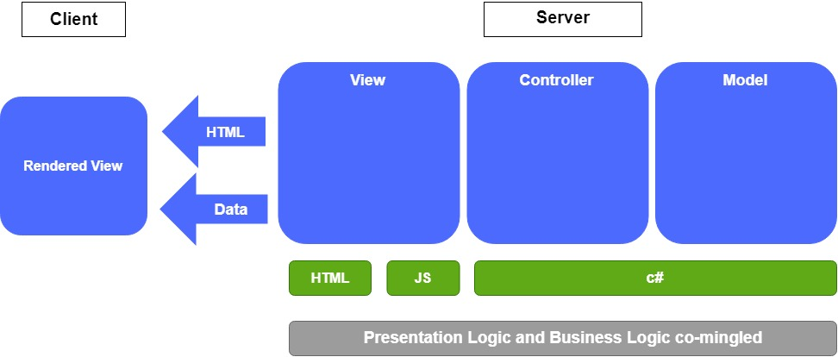

**PROJECT FILE DETAILS**

|  |  |  |
| --- | --- | --- |
| **S.No** | **File Name** | **Remarks** |
| 1. | HohoTraveltestlagi | Create, Read, Update, Delete |

\

sssssssssss