**PROJECT ON**

*MyPersonality*

**Developed by :**

1. Mindy Atikah Ciara Gyver
2. Nurul Awalia Rehania



**MyPersonality**

Batch Code : 3SC5

Start Date : January 7th, 2018

End Date : January 22th, 2018

Name of Faculty : Ar Royya Noor Gunadi Ahmad

Names of Developer :

1. Mindy Atikah Ciara Gyver
2. Nurul Awalia Rehania

Date of Submission : January 23rd, 2018

**CERTIFICATE**

This is to certify that this report titled “*MyPersonality*” embodies the original work done by Mindy Atikah Ciara Gyver and Nurul Awalia Rehania in partial fulfillment of their course requirement at NIIT.

Coordinator:

Ar Royya Noor Gunadi Ahmad

Coordinator:

Ar Royya Noor Gunadi Ahmad



**ACKNOWLEDGEMENT**

Writer give a massive thank you to God because of his blessing, writer can complete this project. Writer know this paper is far from perfection. Writer hope the reader would give comment and suggestion to make this paper better.

Writer give thank you to :

1. Our Family who give many support to make this paper completed.
2. Mr. Ar Royya Noor Gunadi Ahmad as the guide’s lecturer that give put together with the suggestion, idea & constructive spirit to make this project better.
3. Our Friends who give many idea, spirit and comment to our project.

If the writer made a mistake in writing the application of this Maui Shop application, Writer ask forgive to all reader of this paper.

**System Summary**:

Today, we live in society. The way we talk, greet, and response to something will be noticed by others. So, the important thing that we have to understand and will bring us to live better in society is our character—personality. By knowing ourselves we would know what response should we give when had an issue. So we create MyPersonality, this is an online based personality test which provides users to know about theirselves through the test. Users will get the result about what personality they in, and about the way to strengthen their personality.

**SYSTEM ANALYSIS**

**INTRODUCTION**

MyPersonality is an online based personality test which provides users to know about theirselves through the test. Users will get the result about what personality they in, and about the way to strengthen their personality.

**ACTIVITIES LIST**

|  |  |  |  |  |  |
| --- | --- | --- | --- | --- | --- |
| ***Januari*** | ***Activity Description*** | ***Planned Date of Completion*** | ***Actual Date*** | ***Responsibility*** | ***Remarks*** |
| *1* | *Create Layout using HTML and CSS* | Januari 10th, 2019 | Januari 10th, 2019 | Nurul Awalia R. |  |
| *2* | *Create forms* | Januari 11st, 2019 | Januari 11st, 2019 | Nurul Awalia R. |  |
| *3* | *Create User Logic* | Januari 13rd, 2019 | Januari 13rd, 2019 | Mindy Atikah C. G |  |
| *4* | *Create Admin* | Januari 15th, 2019 | Januari 15th, 2019 | Nurul Awalia R. |  |
| *5* | *Make a Paper* | Januari 21st, 2019 | Januari 21st, 2019 | Nurul Awalia R. |  |
| *6* | *Power Point* | Januari 22nd, 2019 | Januari 22nd, 2019 | Mindy Atikah C. G |  |

**HTML PAGES**

1. **User’s User Interfaces**
2. **Register**

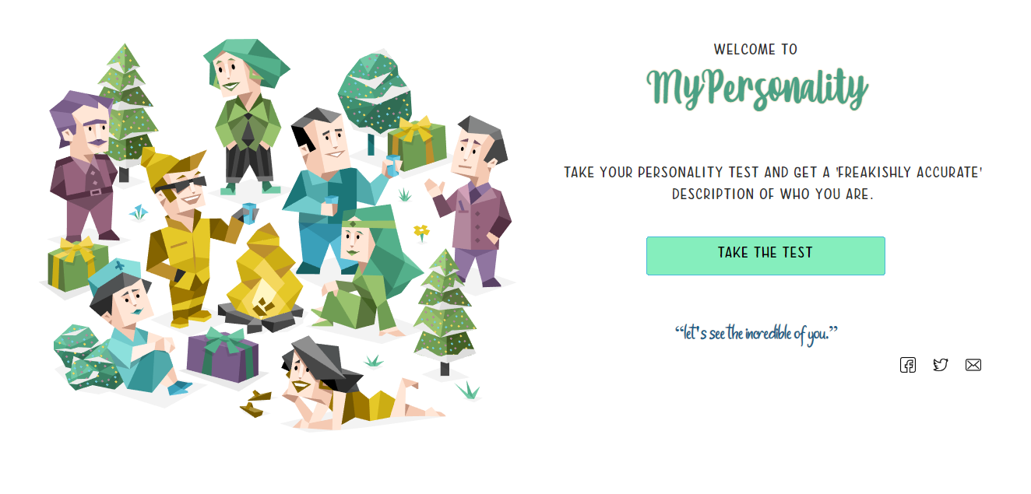

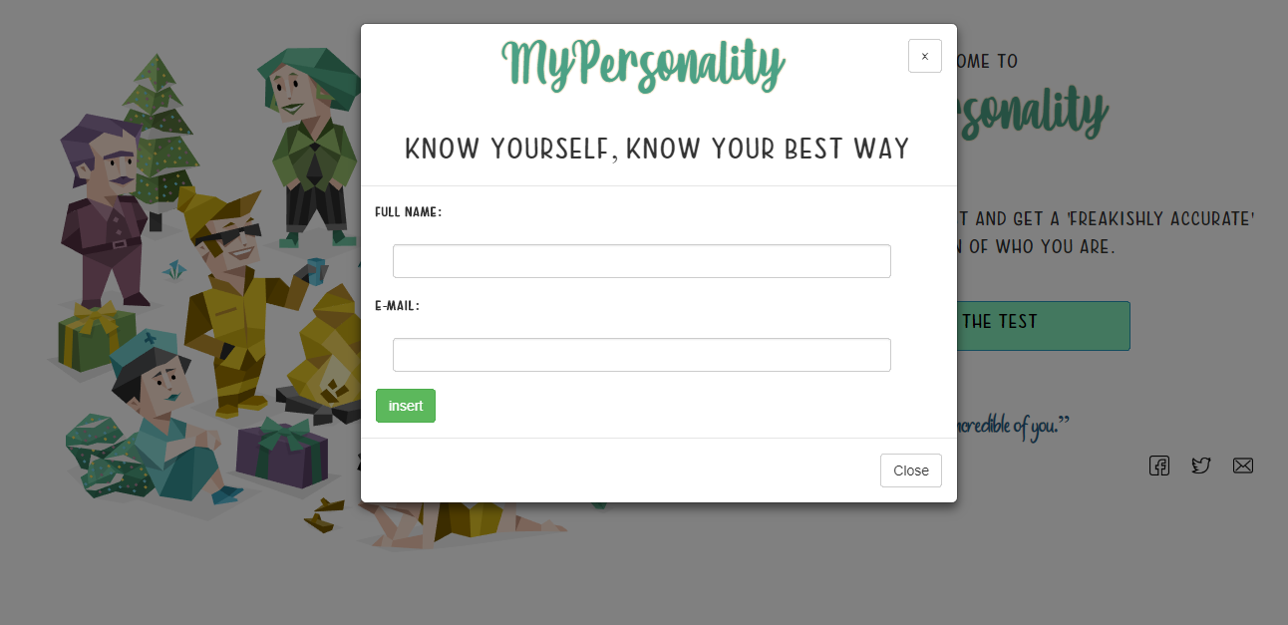

**HTML PAGES**

1. **User’s Home**

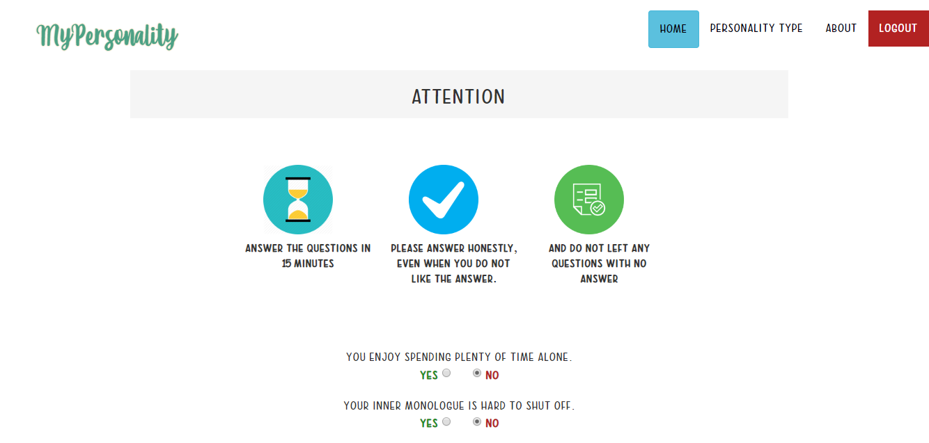

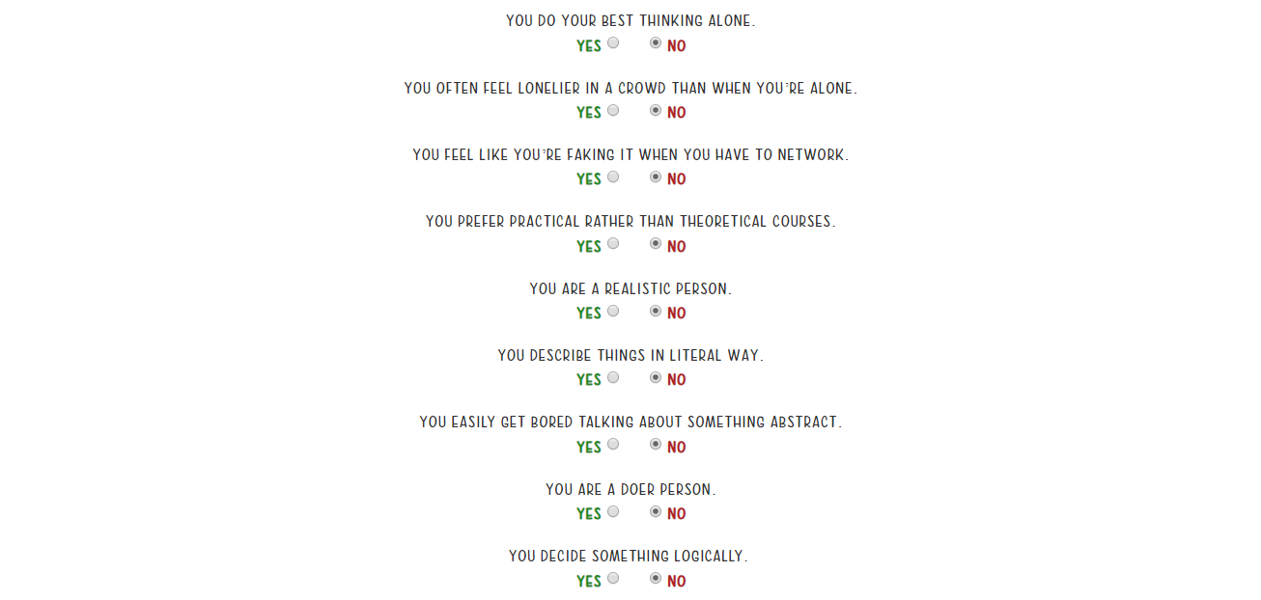

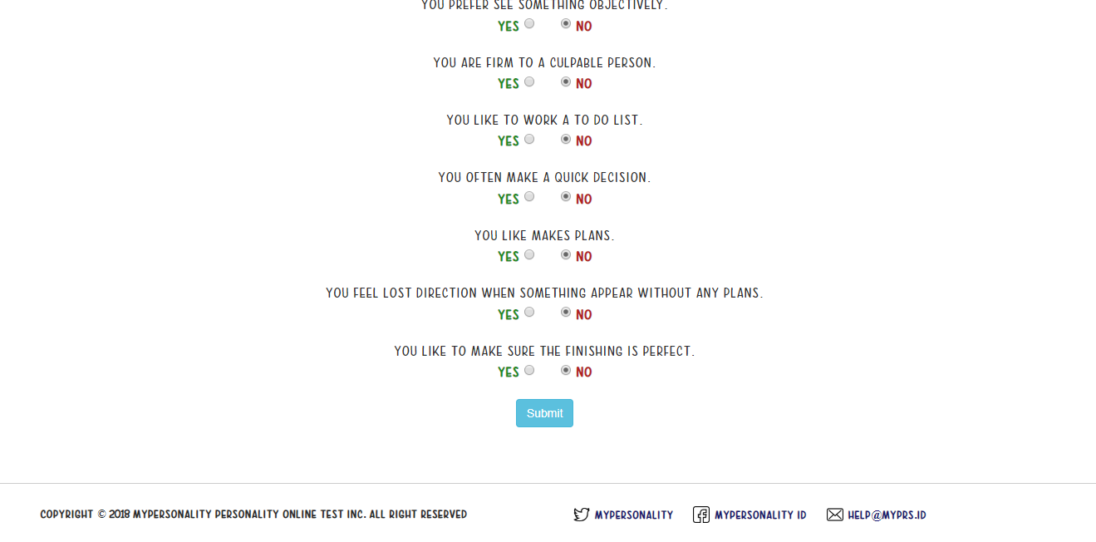

**HTML PAGES**

**3. Overview result**

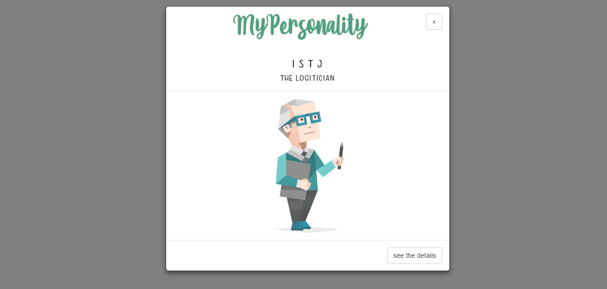

**4. Result**

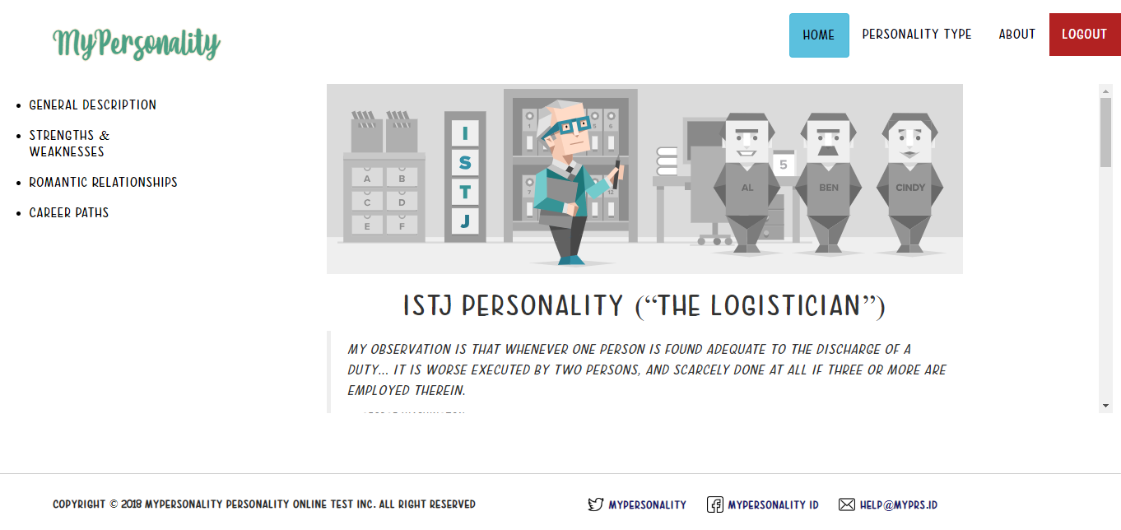

**HTML PAGES**

**B. Admin’s User Interface**

1. **Login**

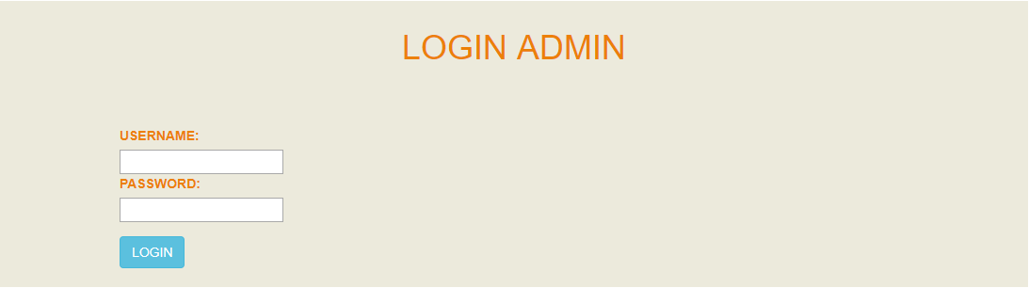

1. **Add new question**

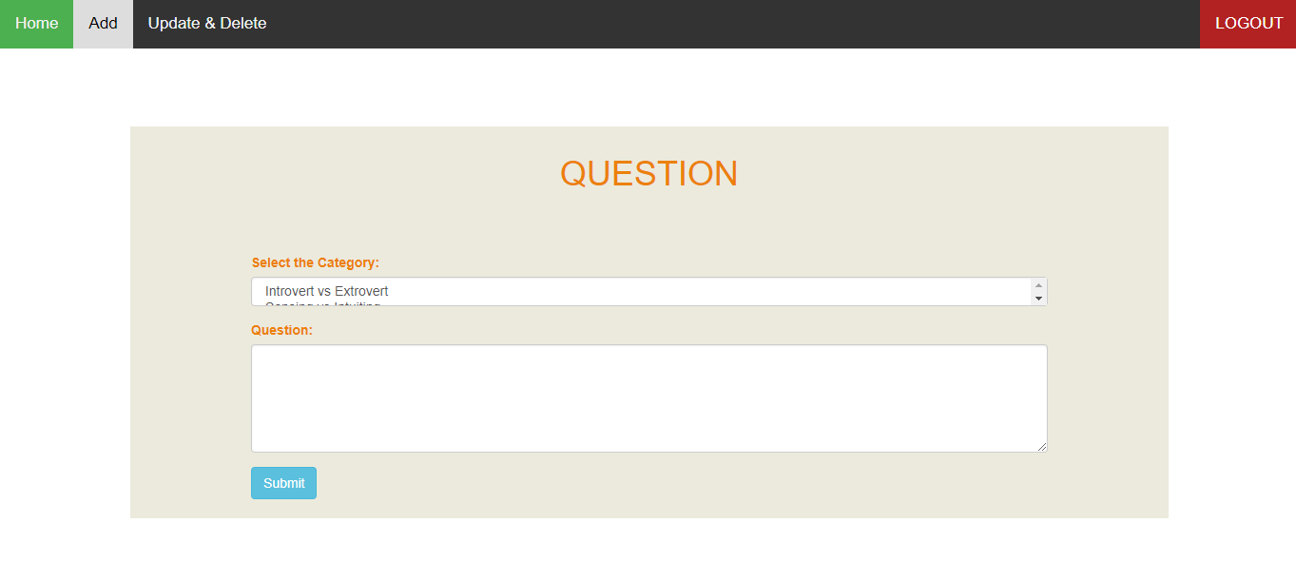

**HTML PAGES**

**5. Update and delete question**



**CONFIGURATION**

**Hardware :** Asus X555QA AMD A10 – 9620P

RADEON R5 (2,5 GHz) 4GB

**Operating System :** Windows 10 Home

**Software :** Visual Studio Code, XAMPP, Google Chrome.