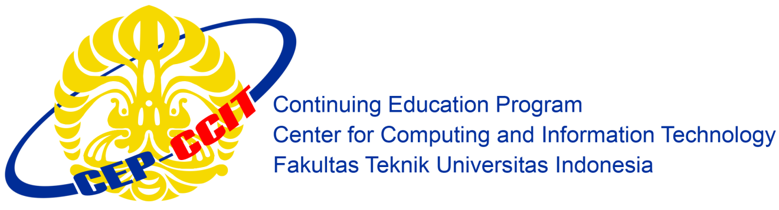

**“MyPersonality”**

Group 3

Names : Mindy Atikah Chiara Gyver(1710010059)

Nurul Awalia Rehania(1710010077)

Faculty :

Riza Muhammad Nurman, S.Kom

**CONTINUING EDUCATION PROGAM CENTER FOR COMPUTING AND INFORMATION TECHNOLOGY**

**FAKULTAS TEKNIK UNIVERSITAS INDONESIA**

**2019**

**PROJECT ON**

MyPersonality

**Developed by**

1. Mindy Atikah Chiara Gyver(1710010059)
2. Nurul Awalia Rehania(1710010077)



MyPersonality

Batch Code : 4 SC 4

Start Date : April 8th, 2019

End Date : April 29th, 2019

Name of Coordinator : Riza Muhammad Nurman, S.Kom

Name of Developer :

1. Mindy Atikah Chiara Gyver(1710010059)
2. Nurul Awalia Rehania(1710010077)

Date of Submission : April 29th, 2019

**CERTIFICATE**

This is to certify that this report, titled *MyPersonality,* embodies the original work by *Mindy Atikah Chiara gyver* and *Nurul Awalia Rehania,* partial fulfillment of his/her course requirement at NIIT.

Coordinator:

Riza Muhammad Nurman, S.Kom



**ACKNOWLEDGEMENT**

All the praises and thanks be to Allah for His guides and blesses, so that this paper entitled “MyPersonality” can be completed on time.

Also, thanks to Mr. Riza Muhammad Nurman, S.Kom for the feedbacks and suggestions given. This paper is written to fulfil assignment and this paper has benefited a lot by the feedbacks.

And thanks for various parties, like:

1. Parents who always support through spirit or even material.
2. Dr. Muhammad Suryanegara, ST., M.Sc. as director of CEP-CCIT Faculty of Engineering, University of Indonesia.
3. Friends who give some suggestions.

Apologize if there are any mistakes in the project. Feel free to give any advice so that the project can be better in the future.

Depok, April 29th, 2019

**SYSTEM ANALYSIS**

**System Summary**:

Today, we live in society. The way we talk, greet, and response to something will be noticed by others. So, the important thing that we have to understand and will bring us to live better in society is our character—personality. By knowing ourselves we would know what response should we give when had an issue. So we create MyPersonality, this is an online based personality test which provides users to know about theirselves through the test. Users will get the result about what personality they in, and about the way to strengthen their personality.

**ACTIVITIES LIST**

|  |  |  |  |  |  |
| --- | --- | --- | --- | --- | --- |
| ***April*** | ***Activity Description*** | ***Planned Date of Completion*** | ***Actual Date*** | ***Responsibility*** | ***Remarks*** |
| *1* | *Create Layout using HTML and CSS* | April 8th, 2019 | April 10th, 2019 | Nurul Awalia R. |  |
| *2* | *Create forms* | April 10th, 2019 | April 15th, 2019 | Nurul Awalia R. |  |
| *3* | *Create User Logic* | April 10th, 2019 | April 20th, 2019 | Mindy Atikah C. G |  |
| *4* | *Create Admin* | April 10th, 2019 | April 15th, 2019 | Nurul Awalia R. |  |
| *5* | *Make a Paper* | April 29th, 2019 | April 29th, 2019 | Nurul Awalia R. |  |
| *6* | *Power Point* | April 29th, 2019 | April 29th, 2019 | Mindy Atikah C. G |  |

**INTERFACE DESIGN FOR**

**“MyPersonality”**

1. **User’s User Interfaces**
2. **Register**

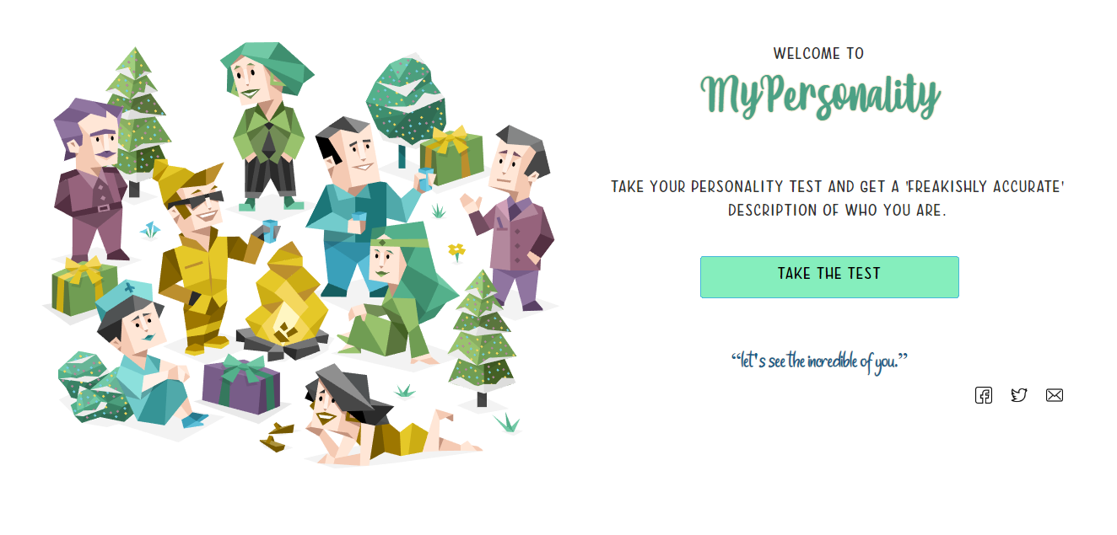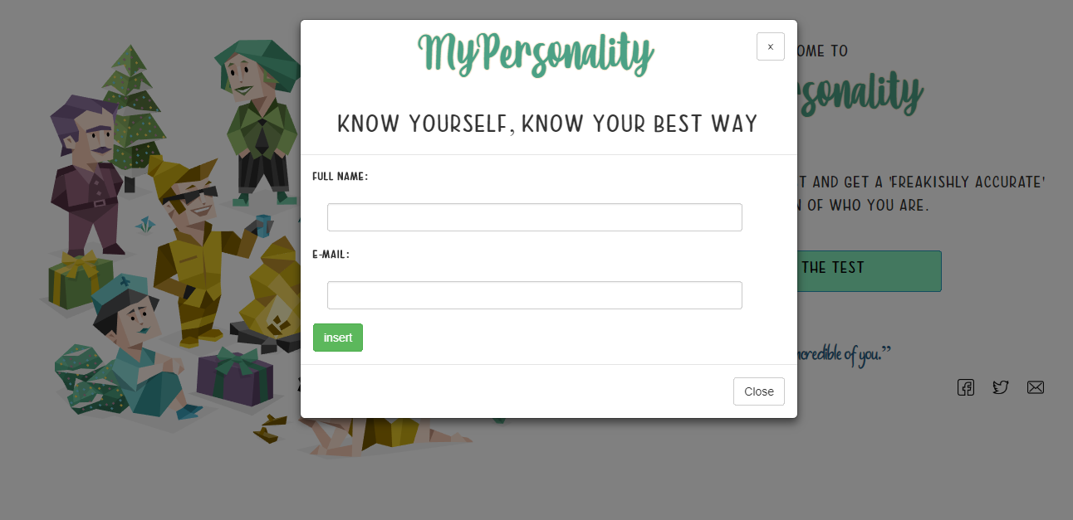

**INTERFACE DESIGN FOR ADMIN**

**“MyPersonality”**

**2. User’s Home**

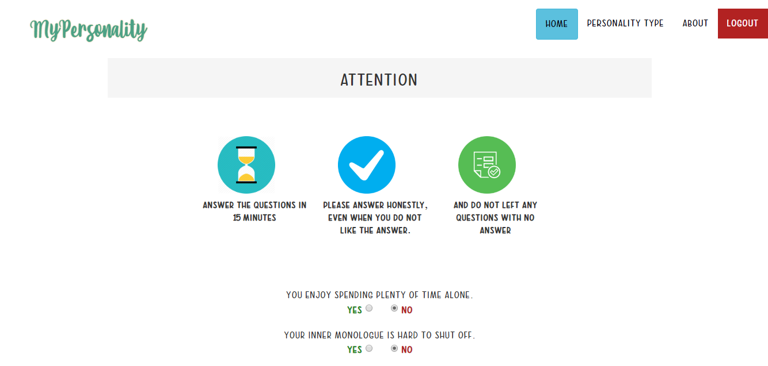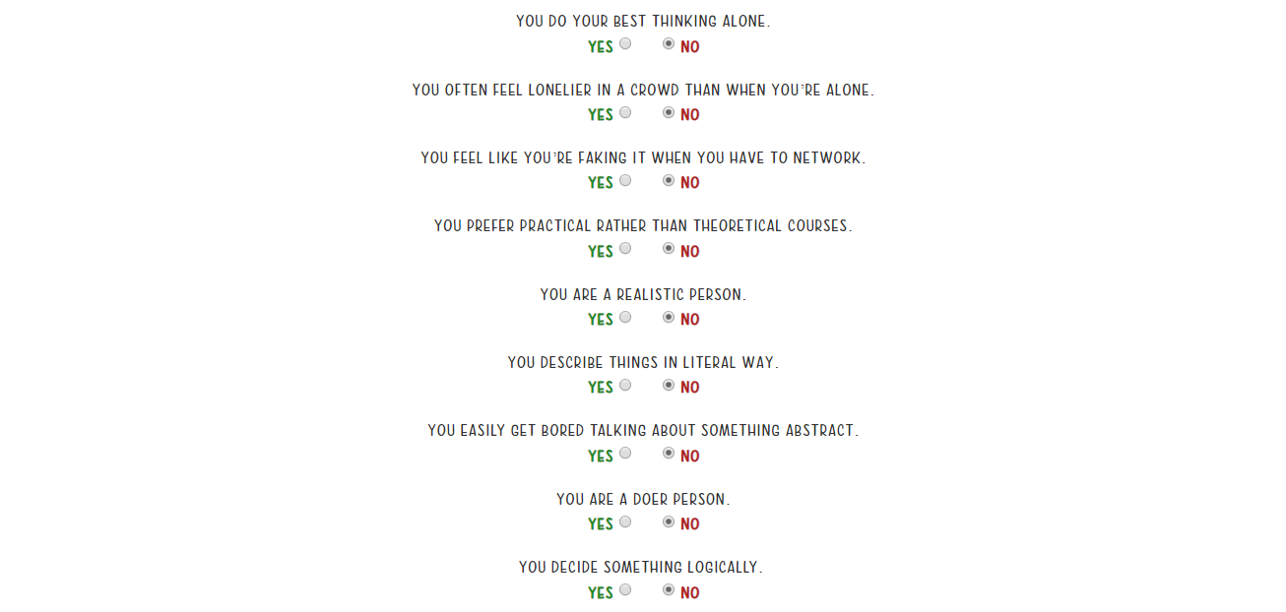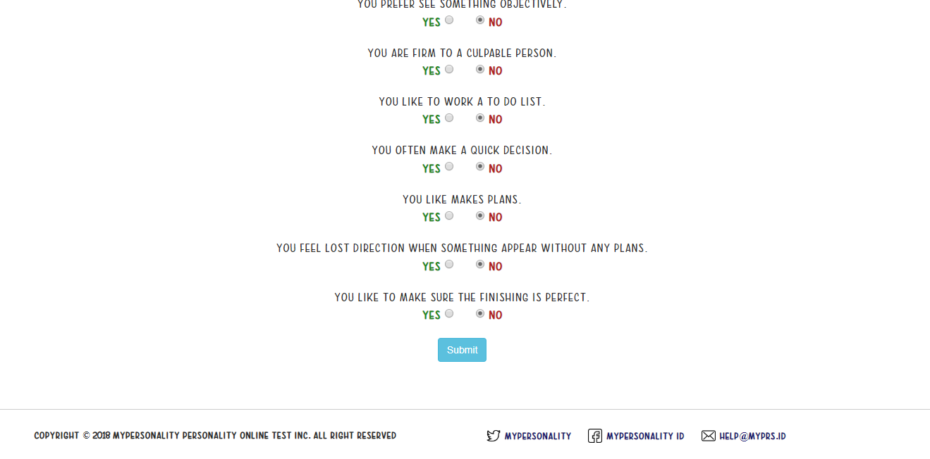

**INTERFACE DESIGN FOR ADMIN**

**“MyPersonality”**

**”**

**3. Overview Result**

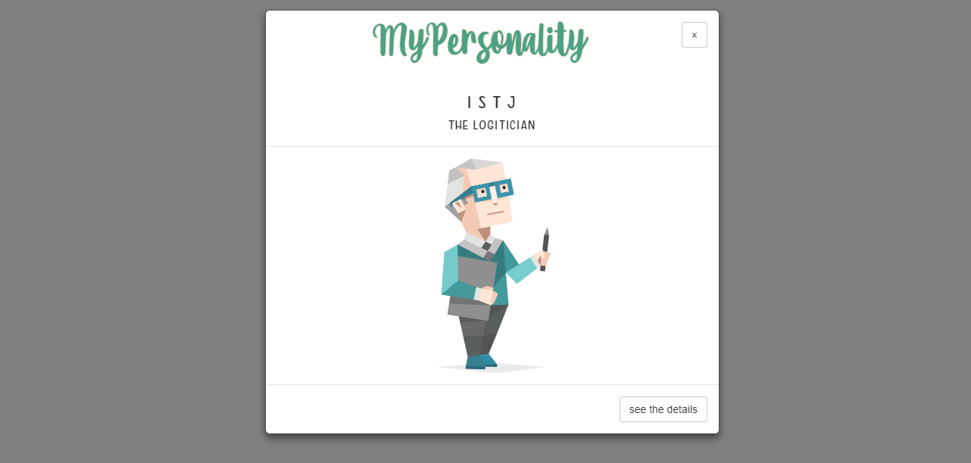

**4. Details of Result**

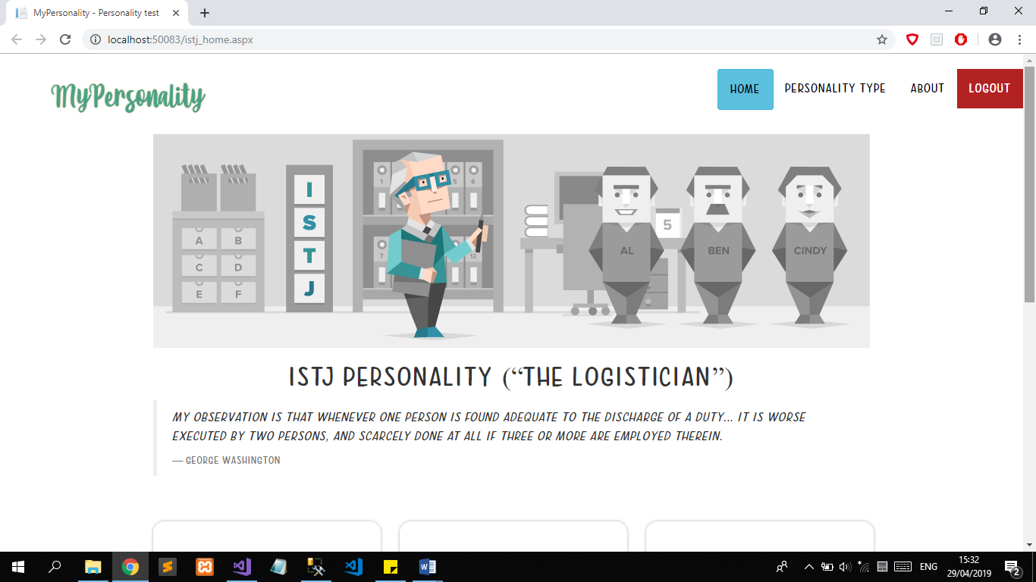

**INTERFACE DESIGN**

**“MyPersonality”**

**”**

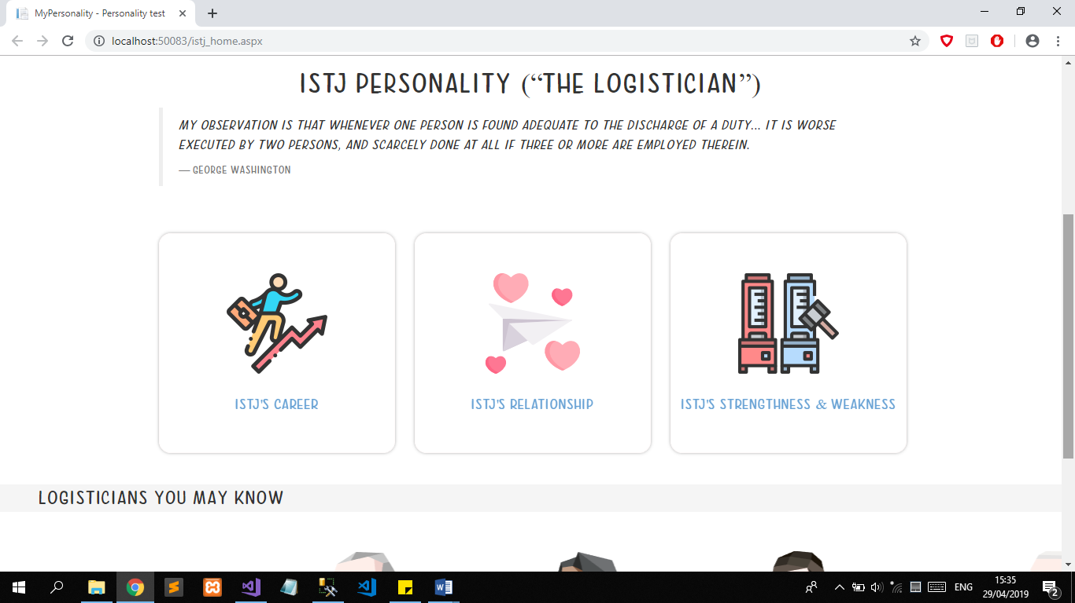

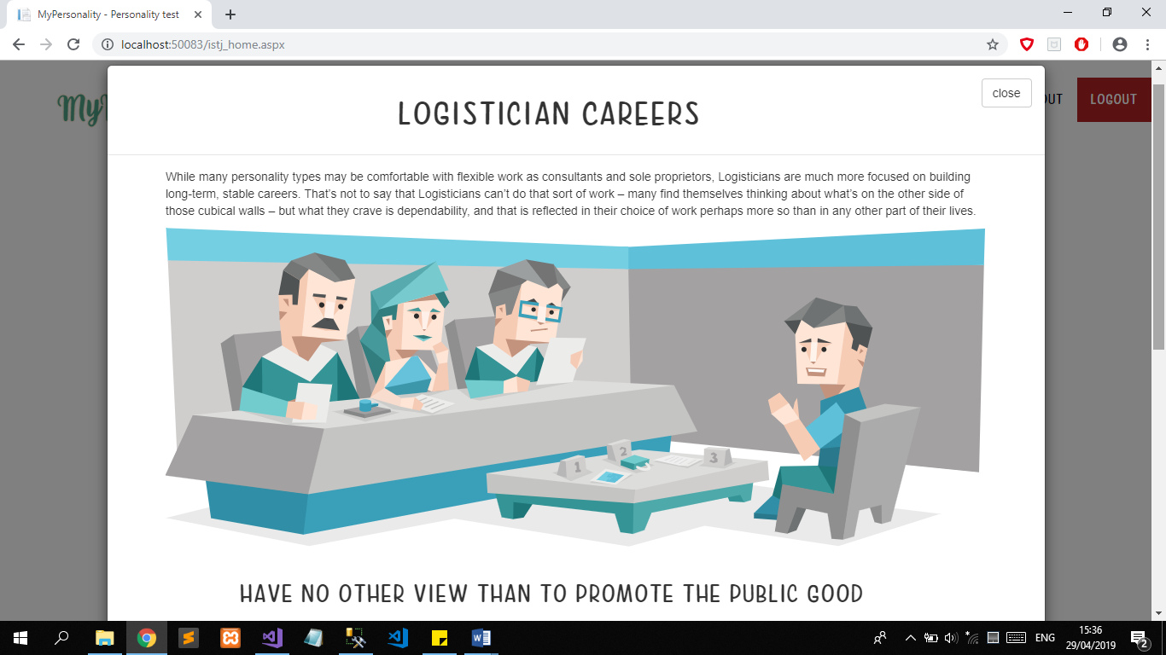

**INTERFACE DESIGN**

**“MyPersonality”**

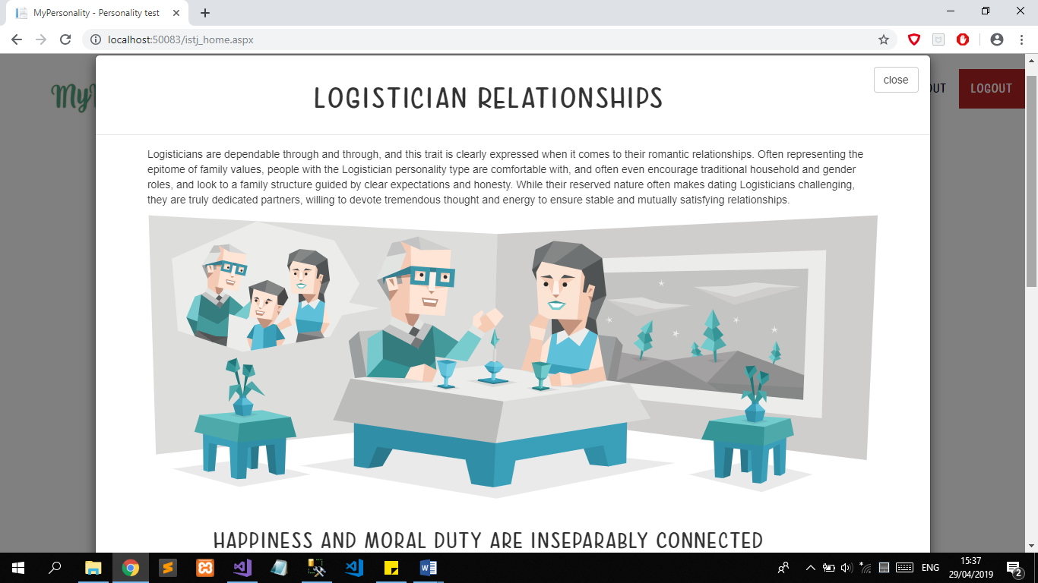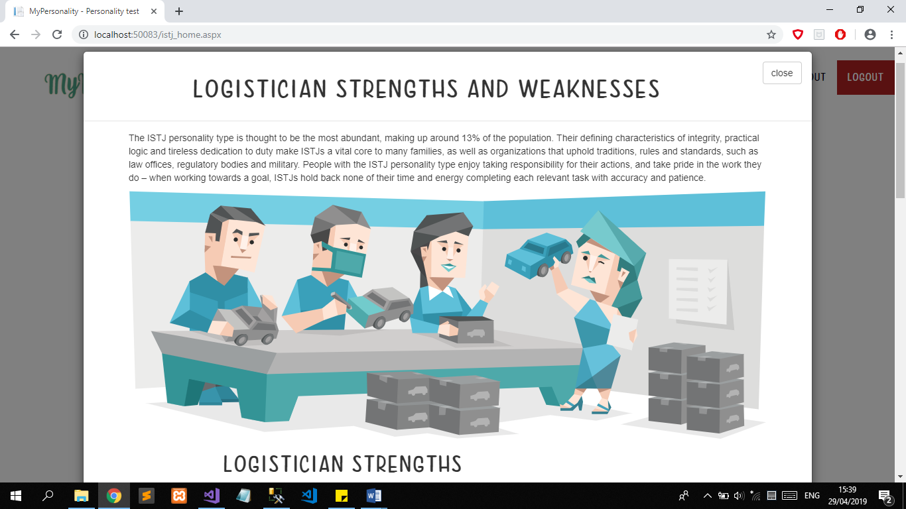

**INTERFACE DESIGN**

**“MyPersonality”**

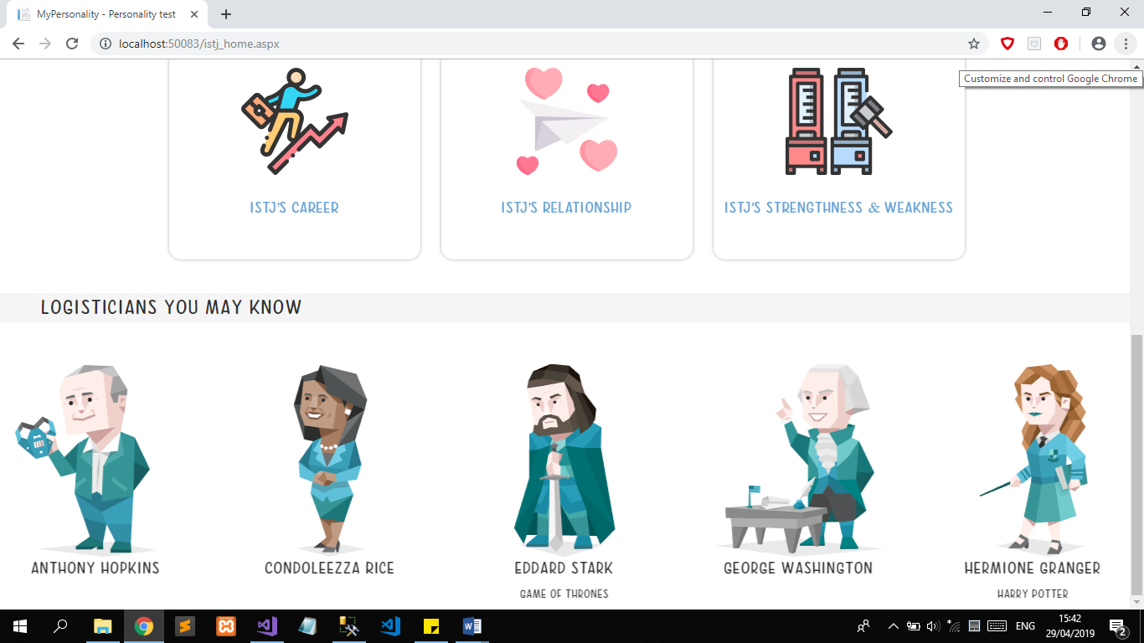

**5. Admin’s User Interface**

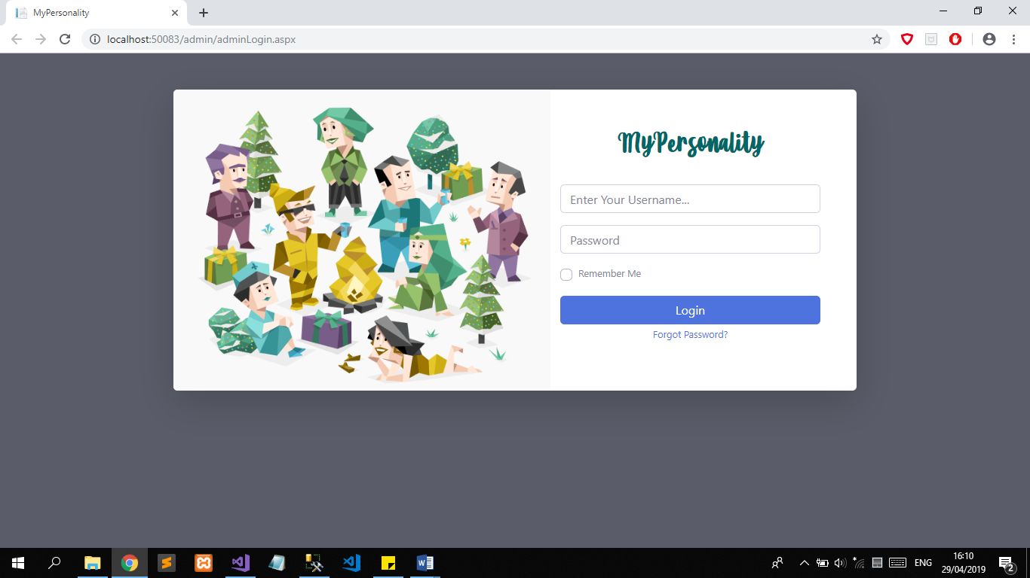

**INTERFACE DESIGN**

**“MyPersonality”**

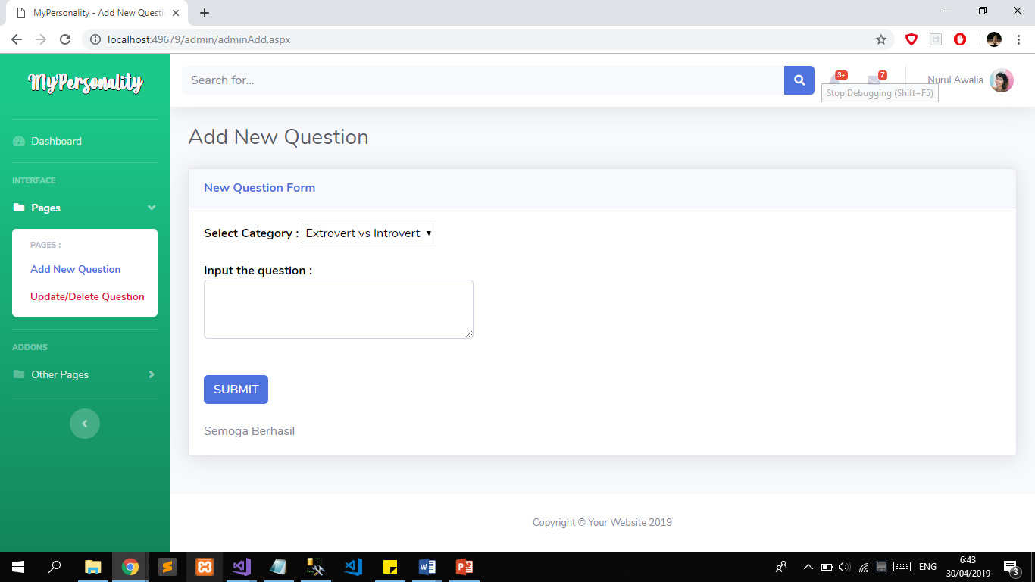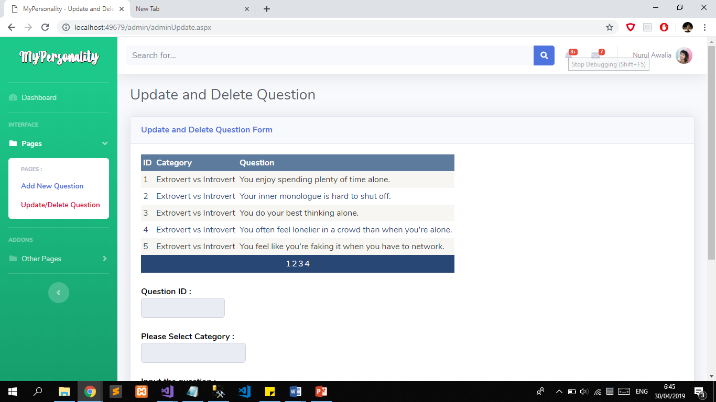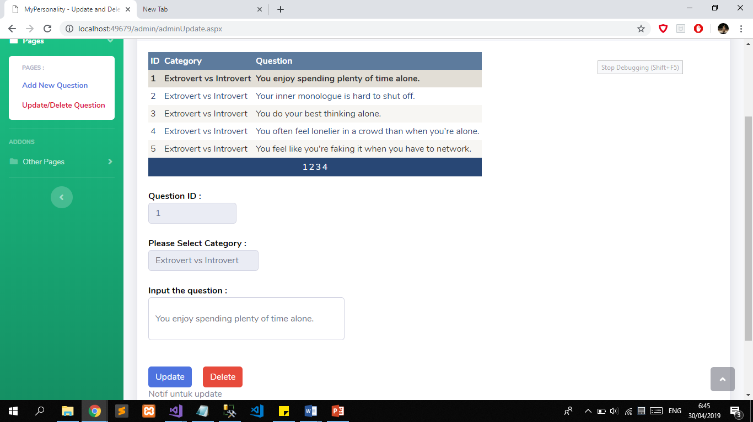

**CONFIGURATION**

**Hardware :** *AMD A10-9620P Radeon R5 2,5Ghz RAM 4GB HDD 1TB*

**Operating System :** *Windows 10 Home*

**Software :** *Microsoft**Visual Studio 2017, Microsoft SQL Server 2014 Management Studio*

|  |  |  |
| --- | --- | --- |
| **PROJECT FILE DETAILS** | | |
| **No.** | **File Name** | **Remarks** |
| 1 | MyPersonality | Create, Read, Update, Delete, and Search |