Question1
Syntax
#include<stdio.h>
int main(){
float radius,area,length,height,breath;
int choice;
printf("1.To calculate the area of circle\n");
printf("2.To calculate the area of rectangle\n");
printf("3.To calculate the area of triangle\n");
printf("Enter your choice to do operation:");
scanf("%d",&choice);
switch(choice){
case 1:
//this case will calculate the area of circle
printf("Enter the radius to find the area of circle:");
scanf("%f",&radius);
area = 3.14*radius*radius;
printf("The area of circle is = %f\n",area);
break;

case 2:
//case to calculate the area of rectangle
printf("Enter the length first and followed by breath second;");
scanf("%f",&length);
scanf("%f",&breath);
area=length*breath;
printf("The area of rectangle is=%f\n",area);
break;

case 3:
//calculate the area of triangle
printf("enter the height of triangle: ");
scanf("%f", &height);
printf("enter the breath of triangle: ");
scanf("%f", &breath);
area = 0.5*breath*height;
printf("The area of triangle = %f\n",area);
break;

default:
printf("invalid\n");

}
return 0;

}
Output:
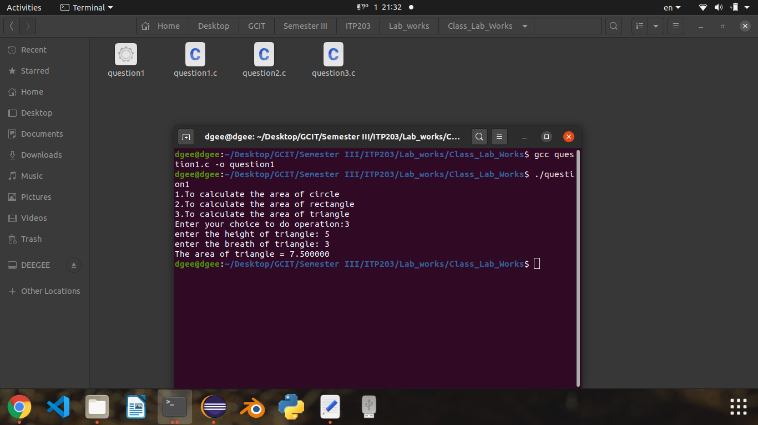

Question2
Syntax
#include<stdio.h>
int main(){
int i, number, count;

printf("Prime number from 2 to 200: ");
for(int number=2; number<=200; number++){
count = 0;
for(int i=2; i<=number/2; i++){
if(number%i==0){
count++;
break;
}
}
if(count==0 && number !=1){
printf(" %d ", number);
}
}
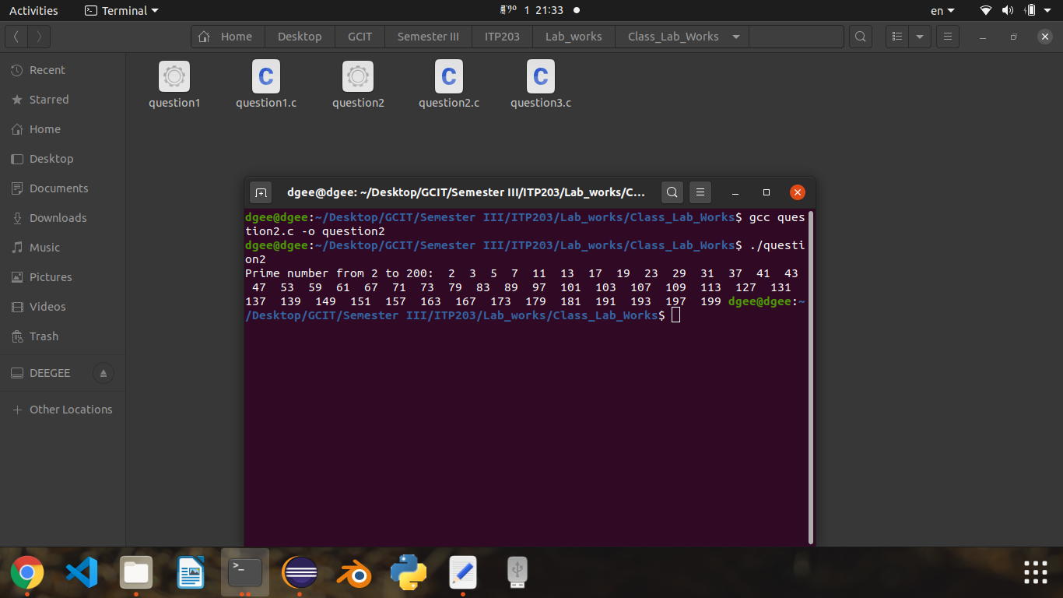
}

Output:

Question3
Syntax:
#include<stdio.h>
int main(){
int sum, i;
sum=0;
for(i=0;i<20;i++){
if(i%2==1){
continue;
}
sum=sum+i;
}
printf("%i\n",sum);
return 0;

}
Output:
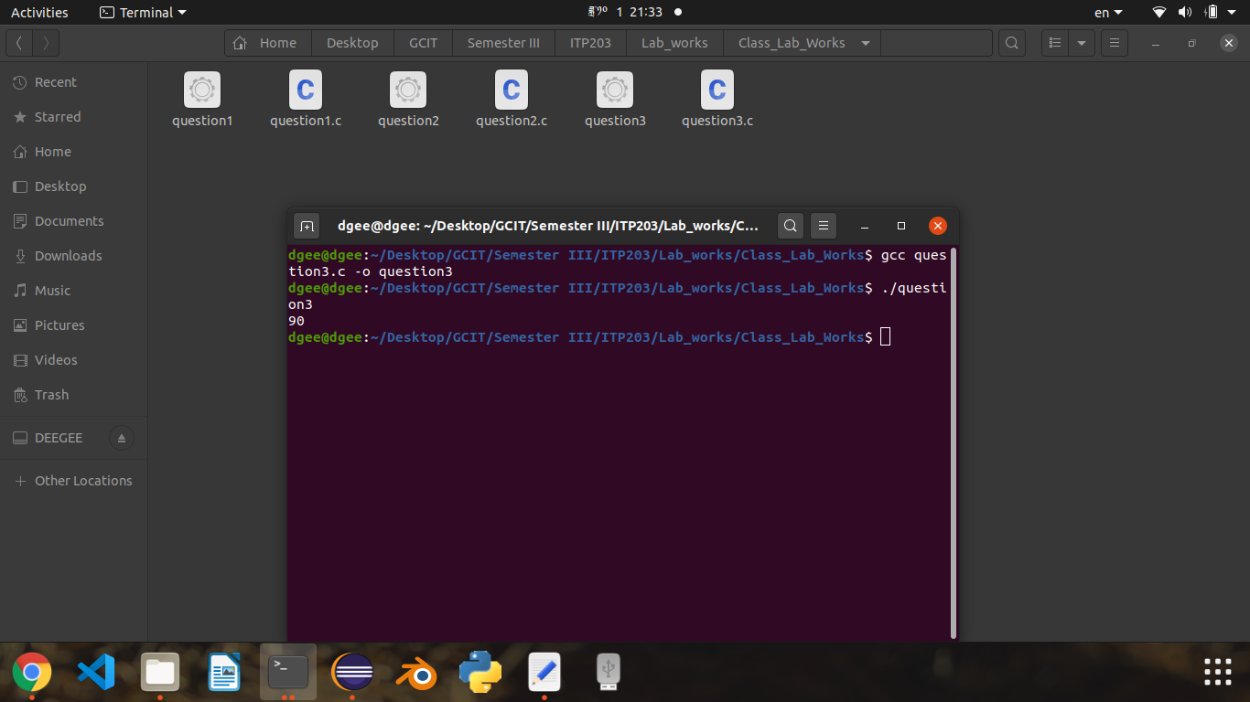

THANK YOU

