Question1
Syntax
#include<stdio.h>
int main(void){
float a= 45.6;
float b=45.6;
float c= 45.6;
float d=45.6;
float e = 45.4;
printf( " %6.3f, %6.3f, %9.3f, %-9.3f, %6.0f",a,b,c,d,e);
return 1;
}
Output
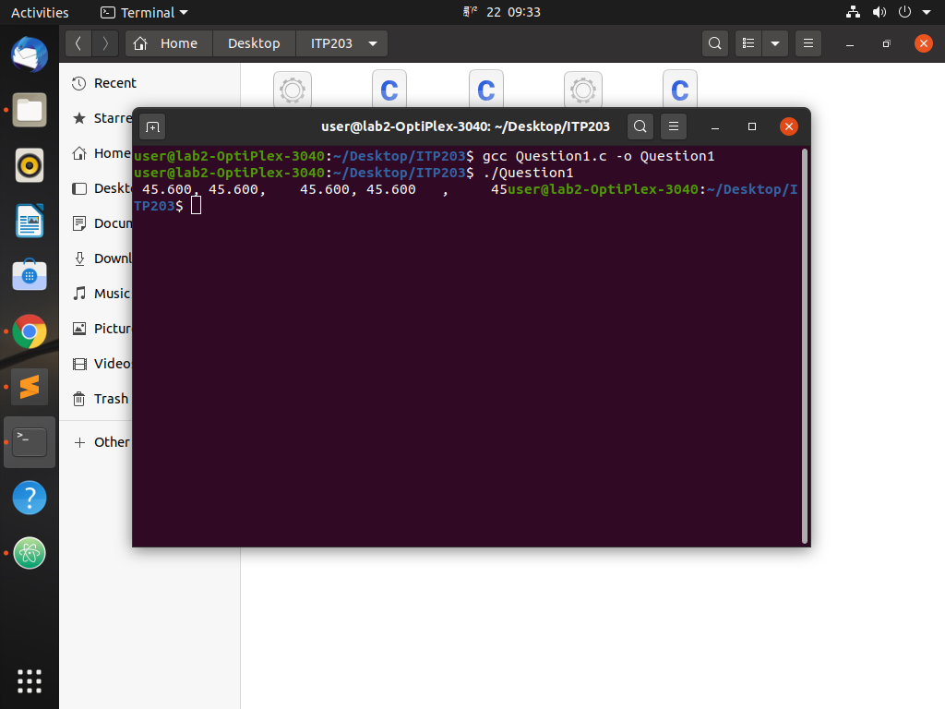

Question2
Syntax
#include<stdio.h>
int main(){
int value = 7 * 1 - (5 % 3) * 4 + 9;
int value2 = 9 ^ (6 % 2) + 1 * 3;
printf("%d, %d",value, value2);
return 0;
}
Output
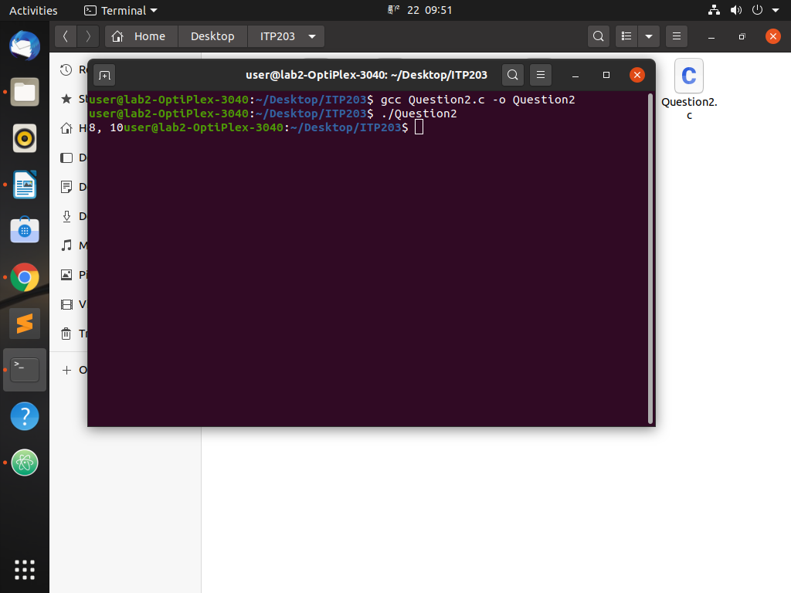

Question3
Syntax
#include <stdio.h>
int main()
{
int num1;
int num2;
printf("Enter any num1: ");
scanf("%d", &num1);
printf("Enter any num2: ");
scanf("%d", &num2);
int add = num1 + num2;
int sub = num1 - num2;
int div = num1 / num2;
int mult = num1 * num2;
int modu = num1 % num2;

printf("The sum of two nums are %d \n",add);
printf("The subtraction of two nums are %d \n",sub);
printf("The division of two nums are %d \n",div);
printf("The multiplication of two nums are %d \n",mult);
printf("The modulus of two nums are %d \n",modu);
return 0;
}
Output
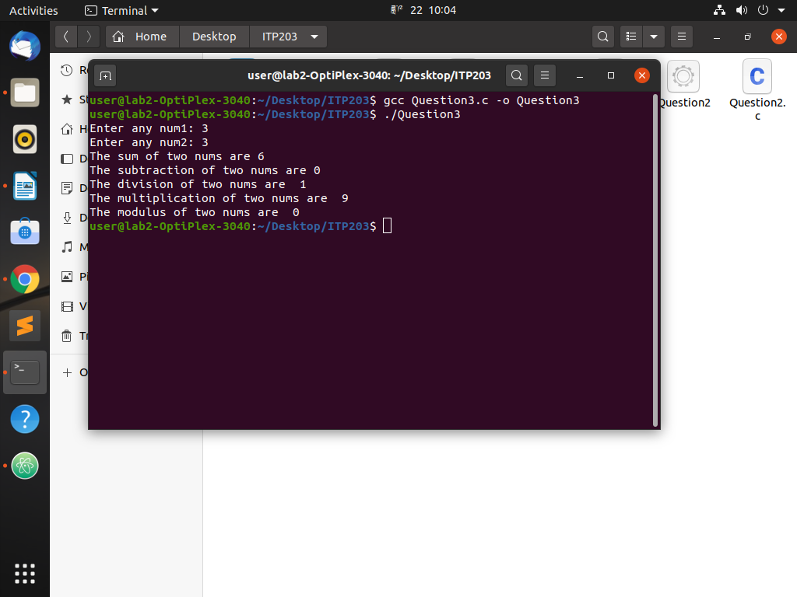

Question4
Syntax
#include<stdio.h>
int main(){
float mathscamarks;
float mathssemarks;
printf("Enter the marks of mathscamarks out of 100: ");
scanf("%f", &mathscamarks);
printf("Enter the marks of mathssemarks out of 100: ");
scanf("%f", &mathssemarks);
if(mathscamarks>=40 && mathssemarks>=40){
float averagecamarks = (mathssemarks/100)*60;
float averagesemarks = (mathssemarks/100)*40;
if(averagecamarks>=24 && averagesemarks>=16){
float averagemathsmarks = averagecamarks + averagesemarks;
printf("Your Averagemathsmarks is %f \n", averagemathsmarks);
printf("You were passed in maths");
}
else{
printf("You were failed");
}
}
else if(mathscamarks <= 40){
printf("You were failed in maths ca marks");
}
else{
printf("You were failed in maths se marks");
}
return 0;
}
Output
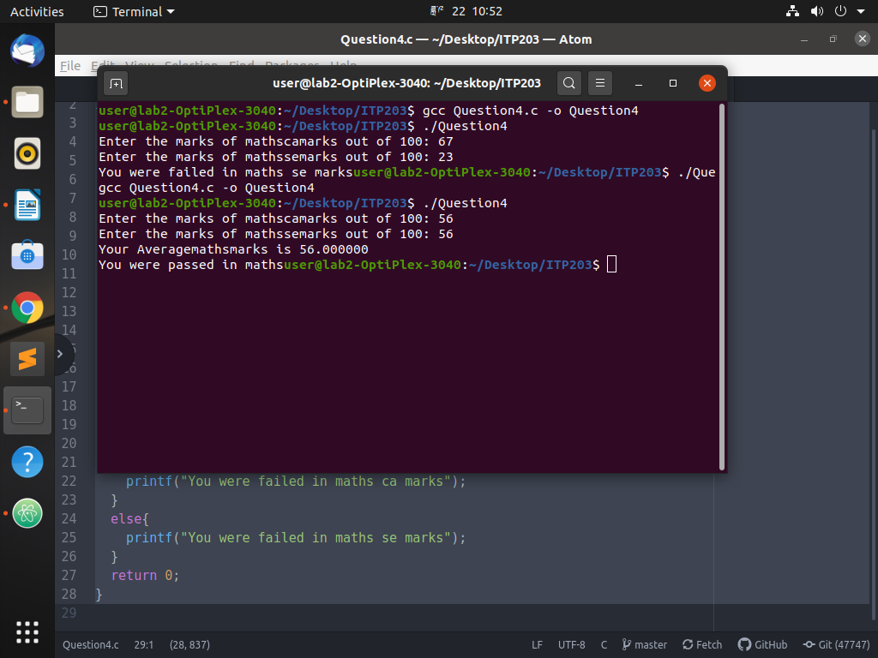

Question5
Syntax
#include<stdio.h>
int main(){
char w;
printf("Enter any alphabets: ");
scanf("%s", &w);
if(w == 'a' || w == 'e' || w == 'i' || w == 'o' || w == 'u'){
printf("The alphabets you have entered is vowel sound");
}
else if(w == 'A' || w == 'E' || w == 'I' || w == 'O' || w == 'U'){
printf("The alphabets you have entered is vowel sound");
}
else{
printf("The alphabets you have entered is consonant sound");
}
return 0;
}
Output
