

Royal University of Bhutan

CSP203 Backend Web Development
Project Final Documentation
Year 2 Sem ll

Students Project Showcase Platform

Submitted By: Group_6

Gyembo Wangchuck [07230011]
Karma Dorji [07230030]
Pema Wangdi [07230038]
Tara Maya Limbu [07230078]
Tshering Pemo[07230083]

Modul Tutor: Gyeltshen Wangchuk

Abstract

Student Project Showcase Platform: Where Creativity Meets Recognition.
The Student Project Showcase platform is an online resource created for students at Sherubtse College to showcase their projects, share them, and receive feedback. Users can share details, photos, and files related to their projects, while tutors can explore, rate, and comment on them. Many students in our college struggle to display their projects due to the absence of a centralized platform where they can upload their work, achievements, and skills. Students also encounter challenges in organizing, presenting, and obtaining constructive feedback on their projects in a structured format. Offline alternatives, such as PDFs and in-person presentations, lack interactivity, making online platforms more suitable. According to Nicol & Macfarlane-Dick (2006), peer feedback and collaboration are important drivers of student learning and skill development. Therefore, this project aims to enhance the performance of all students.

Tech Stacks
Database: PostgreSQL (pgAdmin)
Backend: Node.js with Express.js framework, utilizing app.js, controller, routes, and middleware for business logic and request handling.
Frontend: EJS (Embedded JavaScript Templates) for dynamic HTML rendering, along with CSS and JavaScript for styling and interactivity.

Project Features:
- Dashboard Analytics (Admin) – Displays total projects, total comments, Total ratings, and total users of projects in real-time (Unique Feature)
- Project Upload and Management: Students can upload projects with descriptions, images, and relevant files.
- Feedback and Rating system: Admin can provide feedback, rate projects, and leave comments.
- Search Options: Advanced search based on categories, topics, or keywords.
- User Authentication: Users sign up and log in with email verification.
- Responsive Design: Accessible on desktops, tablets, and mobile devices.
- Privacy and security: Ensure user data and project information are protected.

Table of Contents
Student Project Showcase Platform: Where Creativity Meets Recognition. 1
Project Features: 1
Problem Statement 1
Who will feel the consequences? 2
Aims, Objectives, and Scope of Project 3
Aim of the Project: 3
Objectives of the Project: 3
Goals of the Project: 3
Scope of the project: 3
1. ProjectBoard 4
Assumptions & Limitations 6
Assumptions: 6
Limitations: 6
Functional & Non-Functional Requirements 6
Functional Requirements: 6
Non-Functional Requirements: 6
Technology Stack 7
Methodology 7
Conclusion 14
References 15

Introduction

Problem Statement
There is no dedicated platform for students to showcase their projects, receive structured feedback, and view commercialization avenues in academic life. Without a framework, there is no proper project storage, little visibility, and inefficient feedback channels. Further, storing massive volumes of project data without a well-optimized backend may result in performance bottlenecks, security issues, and weak data querying. So, this issue primarily affects students as they lack a reliable medium for presenting their projects, learning, and engaging with potential mentors or business people. Moreover, it is also challenging for mentors and instructors to track student progress and provide systematic feedback. An organized project showcase platform will make the review process more streamlined, enabling teachers and reviewers to assess the students' projects with greater efficiency.

In response to this challenge, we are developing a new platform, a students’ Project Showcase Platform, where students can post their projects, receive tutor feedback, and interact with peers. This effort intends to create a guided and interactive platform for students to display their work and enhance the learning experience. By providing a scientific and interactive platform, we aim to help students bridge the gap between academic life and real-world applications. If this issue is not solved, students will keep facing severe challenges in showcasing their skills and abilities. Some of the repercussions could be that without a structured platform, students’ projects go unnoticed, and their results lack recognition, which hinders their academic and professional growth.

Moreover, the absence of constructive criticism also results in little learning and improvement, as students miss valuable opportunities to enhance their work, and in the process, they develop stagnation in their skill development. Furthermore, most recruiters look for practical project experience while screening candidates, and without an easily accessible portfolio, students risk losing career opportunities, unable to demonstrate their hands-on skills to prospective employers. Not only that, loss of innovation is also a major issue, as many student projects have the potential to develop into revolutionary solutions for companies. Without a specific platform to showcase and distribute these concepts, though, they might never see their intended audience, reducing the potential to make an impact in the real world. So, to bright the all the barriers of learning and showcasing the skill, it motivated us to come up with this dedicated platform.

Target Users: Sherubtse College students and faculty are the main users of this platform. While students submit their projects to the platform, professors and other students can give feedback by rating or leaving comments, which helps everyone to collaborate and learn together.

Who will feel the consequences?
The lack of a proper project showcase platform would not only affect students but also:
- Academic institutions: universities and colleges miss out on an organized system to track students’ progress, which makes it difficult to assess project-based learning success.
- Recruiters & industry professionals: employers looking for fresh talent may struggle to find students with the right skills without an official portfolio system.
- Similar Platforms: While platforms like GitHub, Dribble, and Behance exist, they are not adequate to cater to the needs of students and therefore are not good alternatives.

Aims, Objectives, and Scope of Project

Aim of the Project:
- To create a system where students can showcase their projects, receive feedback, and connect with peers, potential employers, and educators. This platform will serve as a hub for innovation and recognition of student work.

Objectives of the Project:
- Develop a user-friendly interface for students to upload and manage their projects.
- Implement features for feedback, comments, and ratings on projects.
- Integrate a search option to help users discover projects based on categories, skills, or keywords.
- Ensure the platform is responsive across multiple devices.
- Incorporate analytics to track project views, engagement, and feedback.

Goals of the Project:
- Provide a platform for students to display their projects in an organized manner.
- Facilitate feedback and collaboration among students, industry professionals, and educators.
- Provide a space for students to share and refine their ideas.
- Create a community-driven environment that fosters learning and growth.

Scope of the project:
- The project will focus on creating a web-based platform that caters to students from various disciplines. It will have features for user profiles, feedback systems, project uploads, and search capabilities. From academic assignments to personal passion projects, the platform will be made to support a broad variety of project kinds. Assuring user data security and privacy is another aspect of the scope.

Real-World Problem the Project Addresses
Sherubtse College students, like many others in educational institutions, often complete significant academic and personal projects, but the absence of a central means to share their work leaves many projects unrecognized. This lack of visibility prevents students and faculty from obtaining recognition, feedback, and opportunities to share knowledge and collaborate. The lack of a well-planned system causes students to miss the advantages of building digital portfolios, collaborating with peers, and receiving guidance to enhance their skills and explore future paths.

Limitations in Existing Systems

ProjectBoard
ProjectBoard is an online platform where students, teachers, and professionals can showcase STEM projects. It supports collaboration, feedback, and networking, suitable for student project exhibitions. This analysis examines its methods, primary features, challenges, and overall influence.
Methodology:
ProjectBoard uses cloud-based project storage, automated peer review feedback in an organized form, and role-based access control to maximize user interaction.
Project Implementation: ProjectBoard enables project-based learning via uploading multimedia materials, comments, and virtual exhibitions.
Key Features:
- Project Sharing & Documentation: Multimedia uploading for project presentation.
- Collaboration & Networking: Interactions between students, instructors, and experts.
- Feedback System: Peer comments and guided comments.
- Privacy & Security controls: Customizable visibility settings.
- For Everyone, Regardless of Budget: For all users, regardless of budget.

Challenges:
- User adoption can be difficult, especially for users who are used to traditional task management procedures.
- Compatibility with existing tools may prove to be challenging and labor-intensive.
- A few customization features might not accommodate all project requirements.
- Real-time collaboration is challenging, especially for distributed teams.
Limitation:
- Information Overload: This can lead to too much data.
- Scaling Challenges: Difficult to manage for large projects.
- Lack of Detailed Scheduling: Might not have tracking functionality for schedules or dependencies.
- Potential for Delays: Lack of detailed scheduling can lead to late deadlines.
ProjectBoard enhances project visibility, facilitates collaboration, and integrates academic and industry. While having some constraints, it is a good guide for developing a student project showcase platform, with structured feedback, networking, and virtual exhibitions to improve student engagement and learning. Therefore, there is a need for a Student Project Showcase Platform to enable students to present their work, receive feedback, and connect with other students and professionals in the industry.

Backend Challenges to Solve
To build the Student Project Showcase Platform, several backend challenges needed to be addressed to enhance the user experience. It was crucial to manage data, considering that users would add information such as project titles, descriptions, images, and files while ensuring the data remained organized as the system expanded. Given the importance of data security, a robust registration and login system was necessary to guarantee that only registered users could access the platform. Additionally, optimizing performance was essential because the platform had to accommodate various users engaging in multiple activities, such as uploading projects, giving ratings, and leaving comments, without compromising its speed.

Assumptions & Limitations of the platform

Assumptions:
- The students and the teachers will actively utilize the platform.
- Uploaded projects will be genuine and academically ethical.
- The college administration will promote and support the platform.

Limitations:
- The first deployment will be restricted to Sherubtse College students only.
- Collaboration in real-time on the platform won’t be available initially.
- Selling projects will need to comply with college policies and ethic.

System Requirements

Functional & Non-Functional Requirements

Functional Requirements:
- User Authentication & Authorization: Users can register and log in securely using their credentials. Not only that the user's actions like uploads and interactions are stored securely and managed efficiently in the database.
- Project Upload & Management: Students must be able to upload projects with descriptions, files, and supporting information.
- Feedback & rating System: Users and tutors can comment and rate projects.
- Project Search & Filtering: Users can search and filter projects based on categories, topics, and keywords.

Non-Functional Requirements:
- Performance Optimization: The system should be able to handle numerous concurrent users with fast response times.
- Security Measures: Implement encryption, authentication, and access control to protect user data.
- Scalability: The platform should be capable of managing an increasing number of users and projects.
- Reliability & Availability: Maximize uptime with regular backups and system monitoring.
- User-Friendly Interface: The system should provide a smooth and user-friendly experience for every user.
- Responsive design: offer responsiveness across various devices and browsers to enhance user accessibility.

Technology Stack
Both the frontend and backend components of our project utilize a robust and flexible technology stack. Routes, server processes, and API integration are managed on the backend with Express.js, a minimal and flexible framework built on Node.js. For both the frontend and backend, JavaScript is the primary programming language, supporting the use of EJS (Embedded JavaScript Templates) for creating dynamic web pages. Data management on the platform depends on PostgreSQL, and pgAdmin is employed to facilitate the storage and access of user data. Project validation middleware and bcrypt for hashing passwords have been incorporated to enhance security. Consequently, these chosen technologies allow the application to be structured into easily managed modules, ensuring security and future scalability.

Software Design
- Entity Relationship Diagram (ERD)

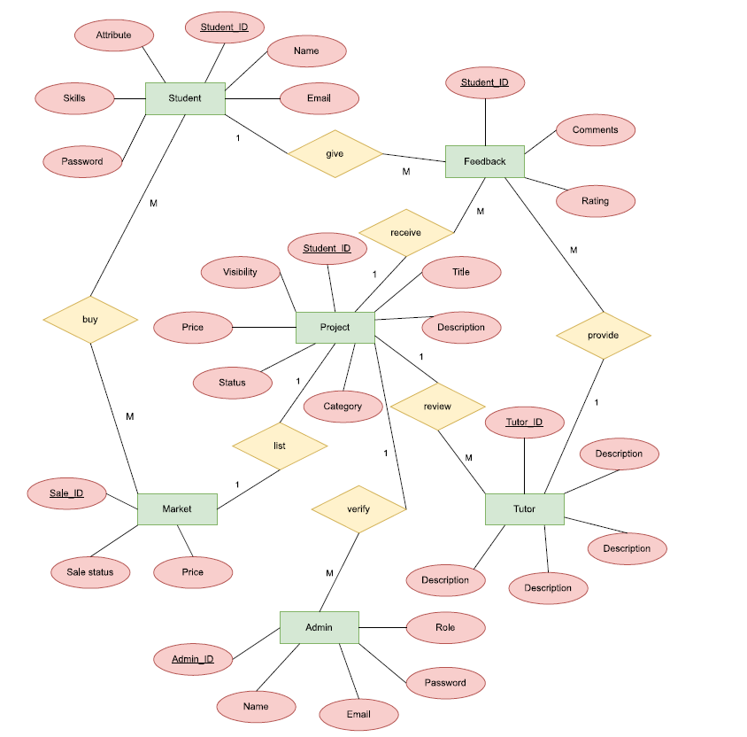

  - Relational Schema

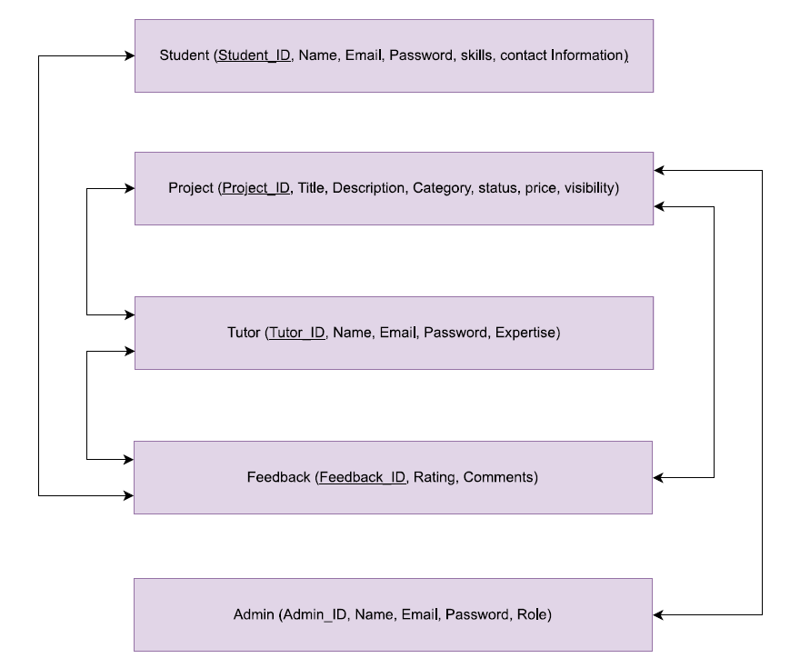

- Use Case Diagram

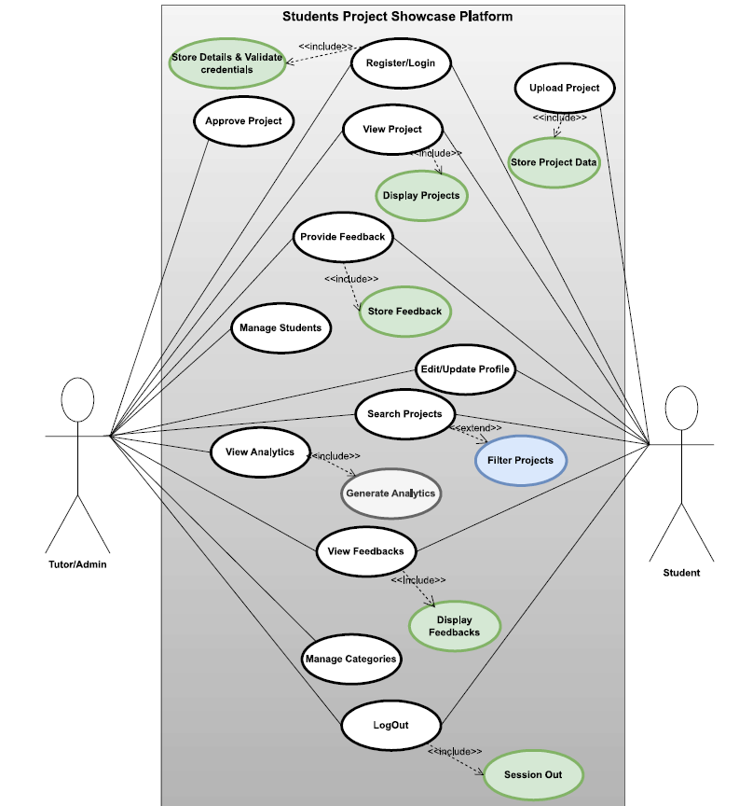

- Sequence Diagram

- Class Diagram

- Architecture Diagram

- Activity Diagram

Wireframes and Prototypes

API Documentation

Database Design

Implementation Details

Deployment

Challenges and Resolutions

Future Enhancements

Conclusion
The student project showcase platform aims to close the gap between class work and real opportunities using a single platform where students can post, exhibit, and have their projects graded. With search capabilities for the projects, feedback capabilities, and a commercialization marketplace, the platform provides more interaction, innovation, and collaboration among the students. By giving students a chance to receive recognition for their projects and to create potential commercial applications, this website not only encourages students to improve their projects but also allows students to interact with industry professionals. This has the potential to change the way academic projects are perceived so that students can see their ideas extend beyond the classroom and out into real-world applications.

Moreover, building the platform for the Student Project Showcase has given our team useful experience. We learned how to design databases, write server-side code, add functionality to the frontend, and add secure authentication for users. The project helped us understand that using good system architecture, modular coding, and team cooperation makes it possible to deliver products to our users with dedicated websites. While creating our projects, we ran into practical issues, for example, debugging, improving performance, and handling code versions, which made us better at working together.

References
Alex. (2023, April 14). Data science methodology and approach. Retrieved from https://www.coursera.org/learn/data-science-methodology

Joshi, S. (2024, January 30). Behance vs Dribbble: A designer’s perspective. Retrieved from https://chatgpt.com/c/67d1796a-9b14-8004-a1d7- bd9d8267fdad

Meghana. (2023, August 24). GitHub pros and cons. Retrieved from https://blog.aiensured.com/github-pros-and-cons/

Patil, S. (2024, April). Project Hub: Collaborative Platform for Students and Faculties. Retrieved from https://www.researchgate.net/publication/380375772_Project_Hub_ Collaborative_Platform_for_Student_and_Faculties

Rebrova, A. (2024, August 15). Functional vs non-functional requirements in software development. Retrieved from https://maddevs.io/blog/functional-vs- non-functional-requirements/

Team Asana. (2025, March 7). 6 steps for writing a persuasive project proposal. Retrieved from https://asana.com/resources/project-propo

Team Contributions

Sl.no | Members (Name) | Tasks
1 | Gyembo Wangchuck [07230011]
2 | Tara Maya Limbu [07230078]
3 | Tshering Pemo [07230083]
4 | Pema Wangdi [0723007838]
5 | Karma Dorji [07230030]

