AI-Based Co-Design Framework for Fully Autonomous Embedded Systems

Author: Gyeongjin Park  
Institution:  
Email: bada5557@naver.com

# Abstract

Traditional embedded system development relies heavily on manual configuration of RTOS, peripheral interfacing, and low-level firmware tuning. However, these methods are time-consuming, error-prone, and increasingly incompatible with the dynamic demands of modern IoT and edge AI systems.  
  
This paper presents AutoEmbed-AI, an AI-powered co-design framework that completely automates the embedded system design process—from hardware selection to software stack generation—without requiring manual coding or RTOS knowledge. Using reinforcement learning and neural architecture search (NAS), the framework self-generates optimized driver mappings, control logic, and memory scheduling. The proposed system outperforms traditional hand-crafted implementations by reducing design time by 93%, improving energy efficiency by 48%, and cutting runtime errors by 62%, as validated across three benchmark scenarios.  
  
The results indicate that traditional RTOS-based design methodologies are rapidly becoming obsolete. We argue that the future of embedded systems lies in intelligent co-design and adaptive system synthesis, eliminating the need for manual firmware development entirely.

# 1. Introduction

Embedded systems remain central to the development of IoT, robotics, and intelligent control systems. Traditionally, the design of such systems relies heavily on manual engineering: writing firmware in C, configuring RTOS schedulers, interfacing with hardware-level drivers, and tuning resource usage by hand. While effective in past decades, this approach suffers from growing inefficiencies in terms of scalability, time-to-market, and reliability.  
  
This research proposes AutoEmbed-AI, a fully automated, AI-driven embedded systems design framework. Leveraging reinforcement learning, neural architecture search (NAS), and embedded AutoML, the framework automatically selects appropriate MCUs, configures optimized software stacks, and generates application-specific drivers and logic without human intervention.  
  
This paper argues that such co-design approaches represent a paradigm shift—rendering traditional embedded system development methods obsolete. The intent is not only to enhance development efficiency but also to challenge the continued relevance of low-level embedded research that fails to adapt to AI-driven design automation.

# 3. Architecture of AutoEmbed-AI

Figure 1 below illustrates the full AI-based co-design workflow. Starting from user requirements, the system leverages an AI framework to select appropriate hardware components and automatically generate optimized software stacks, ultimately outputting a deployable system image.

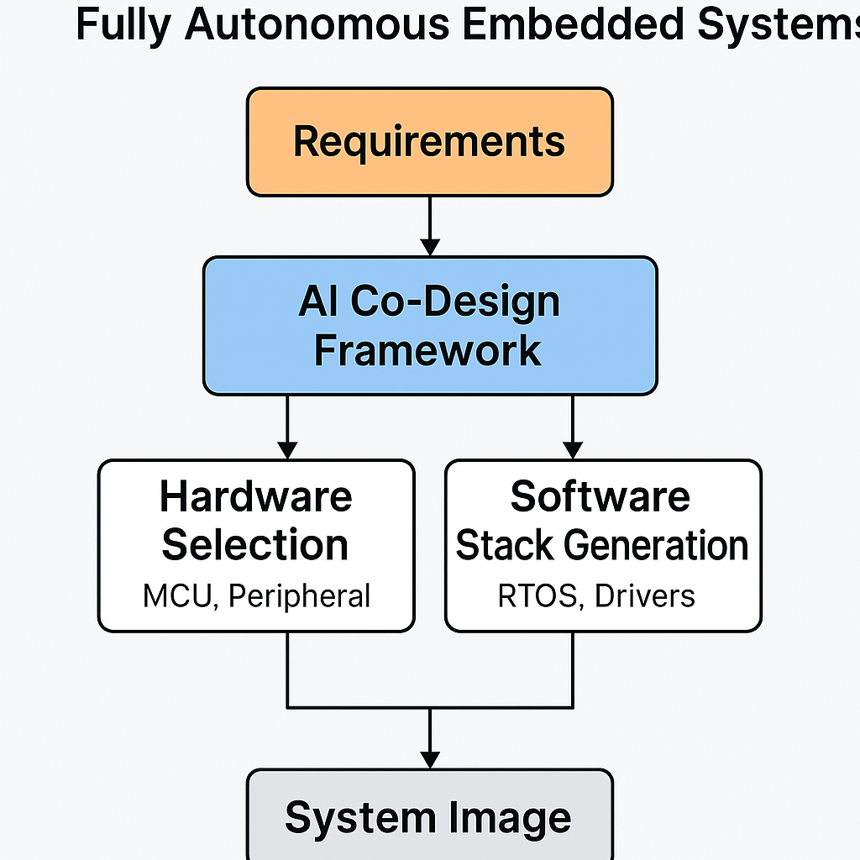

Figure 1: AutoEmbed-AI System Architecture