Intro to computer science

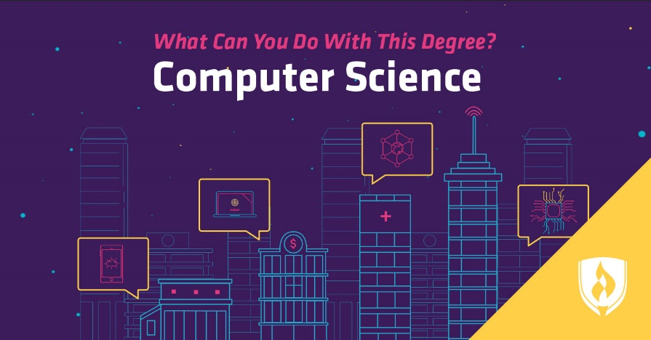

Report:

**The different job opportunities available in Computer Science**

Sufiyan Mohammad

Vanier College

Table of Contents

**Introduction3**

**Body**4

Software Developer5

Web Developer**6**

Data Engineer7

**Conclusion** 8

Introduction

There are many different job opportunities in the domain of computer science. Working with computers in general is a broad subject. The involvement of computers and computer programs are basically present in almost every aspect of our lives. Many jobs heavily depend on computers. The field of computer science is one of the most lucrative fields and is also the third most popular area of study for international students coming to America.



Body

The good thing about computer science is there’s a plethora of job opportunities that come with a degree. My perspective of the field is constantly in motion. I mean coming into computer science I knew that I wanted to be able to develop applications for myself for clients or for whatever company hires me, but then as I learned a little bit more and more about computer science, I’m like: Oh, do I want to be a hacker? Everyone wants to be a hacker you know? Whether you’re just playing video games or whether you’re doing something crazier it would be cool to be able to hack. There are countless amounts of jobs pursuable with a computer science degree. A few namely examples are Software developer, web developer, data engineer etc. For someone like me who wishes to pursue computer science in university opens up even more job opportunities.



**Software Developer**

The software developer is a specialist in computer languages. Its role is to create computer programs, which will then become software. It is often he who drafts the user guide and ensures its proper use. The average Software Engineer salary in Canada is $90,000 per year or $46.15 per hour. Entry level positions start at $44,947 per year while most experienced workers make up to $153,000 per year. Career Developments Software Developers typically move to Project Manager or System Administrator positions



**Web developer**

The web developer must have a thorough knowledge of Internet protocols and applications, as well as a good understanding of business strategies. He must have excellent communication skills and be able to work alone or in a team. Employers usually look for a candidate with a bachelor's degree in computer science or a related field, as well as several years of experience as a developer. The education requirement can sometimes be relaxed if the candidate has good work experience. Companies often request sample codes and web links to work done in the past. The average Web Developer salary in Canada is $62,519 per year or $32.06 per hour. Entry level positions start at $38,555 per year while most experienced workers make up to $106,283 per year.



**Data engineer**

Data engineers get important information from the data and give it value. Coming from a data analysis work environment or a business analyst position, they work with companies of all sizes and across all departments to derive the most accurate conclusions from the data available to improve processes business. The average salary for a Data Engineer is $114,946 per year in Canada. Salary estimates are based on 110 salaries submitted anonymously to Indeed by Data Engineer employees, users, and collected from past and present job advertisements on Indeed in the past 36 months.

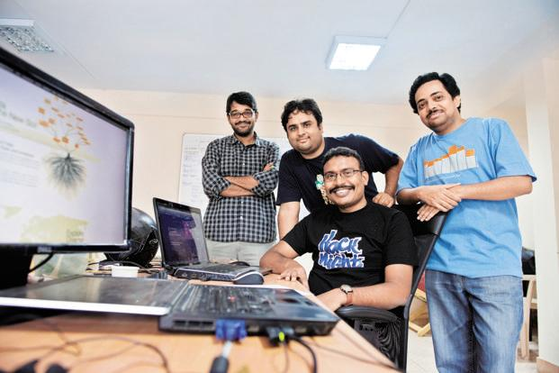

Conclusion

For the longest of time I’ve wanted to get into the game industry. I wanted to work as a game developer and I still hope to do that one day. I’ve made a few 2d games and have a base with C# and Unity. The more I learn about the gaming industry and the workers are treated the more I strive away from that goal. I’ve realised that working in the gaming industry isn’t always what it appears to be. It looks like every kids dream, but the reality is that it’s a lot of hard work that doesn’t necessarily guarantee success.

