**Java代码：**

package com.example.geoquiz;  
  
import androidx.appcompat.app.AppCompatActivity;  
  
import android.os.Bundle;  
import android.util.Log;  
import android.view.View;  
import android.widget.Button;  
import android.widget.ImageButton;  
import android.widget.TextView;  
import android.widget.Toast;  
  
public class MainActivity extends AppCompatActivity {  
 private static final String *TAG* = "MainActivity";  
 private static final String *KEY_INDEX* = "1";  
 private Button mTrueButton;  
 private Button mFalseButton;  
 private Button mNextButton;  
 private Button mPrevButton;  
 private Button mSumButton;  
 private TextView mQuestionTextView;  
 private int fenshu = 0;  
 private int sum = 0;  
 private boolean[] suo = new boolean[]{true, true, true, true, true, true};  
 private two.Question[] mQuestionBank = new two.Question[]{  
 new two.Question(R.string.*question_australia*, true),  
 new two.Question(R.string.*question_oceans*, true),  
 new two.Question(R.string.*question_mideast*, false),  
 new two.Question(R.string.*question_africa*, false),  
 new two.Question(R.string.*question_americas*, true),  
 new two.Question(R.string.*question_asia*, true)  
 };  
 private int mCurrentIndex = 0;  
  
 @Override  
 protected void onCreate(Bundle savedInstanceState) {  
 super.onCreate(savedInstanceState);  
 if (savedInstanceState != null) {  
 mCurrentIndex = savedInstanceState.getInt(*KEY_INDEX*, 0);  
 fenshu = savedInstanceState.getInt("A", 0);  
 sum = savedInstanceState.getInt("B", 0);  
 }  
 Log.*d*(*TAG*, "onCreate(Bundle) called");  
 setContentView(R.layout.*activity_main*);  
 mQuestionTextView = (TextView) findViewById(R.id.*question_text_view*);  
 updataQuestion();  
  
 mTrueButton = (Button) findViewById(R.id.*true_button*);  
 mTrueButton.setOnClickListener(new View.OnClickListener() {  
 @Override  
 public void onClick(View view) {  
 if (suo[mCurrentIndex] == true)  
 checkAnswer(true);  
 else  
 suoding();  
 }  
 });  
  
 mFalseButton = (Button) findViewById(R.id.*false_button*);  
 mFalseButton.setOnClickListener(new View.OnClickListener() {  
 @Override  
 public void onClick(View v) {  
 if (suo[mCurrentIndex] == true)  
 checkAnswer(false);  
 else  
 suoding();  
 }  
 });  
 mNextButton = (Button) findViewById(R.id.*next_button*);  
 mNextButton.setOnClickListener(new View.OnClickListener() {  
 @Override  
 public void onClick(View v) {  
 mCurrentIndex = (mCurrentIndex + 1) % mQuestionBank.length;  
 updataQuestion();  
 }  
 });  
 mPrevButton = (Button) findViewById(R.id.*prev_button*);  
 mPrevButton.setOnClickListener(new View.OnClickListener() {  
 @Override  
 public void onClick(View view) {  
 if (mCurrentIndex != 0)  
 mCurrentIndex = (mCurrentIndex - 1) % mQuestionBank.length;  
 else  
 mCurrentIndex = mQuestionBank.length - 1;  
 updataQuestion();  
 }  
 });  
 mQuestionTextView = (TextView) findViewById(R.id.*question_text_view*);  
 mQuestionTextView.setOnClickListener(new View.OnClickListener() {  
 @Override  
 public void onClick(View view) {  
 mCurrentIndex = (mCurrentIndex + 1) % mQuestionBank.length;  
 updataQuestion();  
 }  
 });  
 mSumButton = (Button) findViewById(R.id.*sum_button*);  
 if (sum == mQuestionBank.length)  
 mSumButton.setVisibility(View.*VISIBLE*);  
 mSumButton.setOnClickListener(new View.OnClickListener() {  
 @Override  
 public void onClick(View view) {  
 double p = 100.0 * fenshu / mQuestionBank.length;  
 String z = String.*format*("正确率为%.0f%%", p);  
 mSumButton.setText(z);  
 }  
 });  
 }  
  
 @Override  
 public void onSaveInstanceState(Bundle savedInstanceState) {  
 super.onSaveInstanceState(savedInstanceState);  
 Log.*i*(*TAG*, "onSaveInstanceState");  
 savedInstanceState.putInt(*KEY_INDEX*, mCurrentIndex);  
 savedInstanceState.putInt("A", fenshu);  
 savedInstanceState.putInt("B", sum);  
 }  
  
 @Override  
 public void onStart() {  
 super.onStart();  
 Log.*d*(*TAG*, "onStart() called");  
 }  
  
 @Override  
 public void onResume() {  
 super.onResume();  
 Log.*d*(*TAG*, "onResume() called");  
 }  
  
 @Override  
 public void onPause() {  
 super.onPause();  
 Log.*d*(*TAG*, "onPause() called");  
 }  
  
  
 @Override  
 public void onStop() {  
 super.onStop();  
 Log.*d*(*TAG*, "OnStop() called");  
 }  
  
  
 @Override  
 public void onDestroy() {  
 super.onDestroy();  
 Log.*d*(*TAG*, "onDestroy() called");  
 }  
  
  
 private void updataQuestion() {  
 int question = mQuestionBank[mCurrentIndex].getTeextResId();  
 mQuestionTextView.setText(question);  
 }  
  
 private void checkAnswer(boolean userPressedTrue) {  
 boolean answerIsTrue = mQuestionBank[mCurrentIndex].isAnswerTrue();  
 int messageResId = 0;  
 if (userPressedTrue == answerIsTrue) {  
 messageResId = R.string.*correct_toast*;  
 fenshu++;  
 } else {  
 messageResId = R.string.*incorrect_toast*;  
 }  
 Toast.*makeText*(this, messageResId, Toast.*LENGTH_SHORT*).show();  
 if (this.suo[mCurrentIndex] == true)  
 this.suo[mCurrentIndex] = false;  
 sum++;  
 if (this.sum == mQuestionBank.length) {  
 mSumButton.setVisibility(View.*VISIBLE*);  
  
 }  
 }  
  
 public void suoding() {  
 Toast.*makeText*(this, "已回答，请勿重复回答", Toast.*LENGTH_SHORT*).show();  
 }  
}

**xml代码：**

<?xml version="1.0" encoding="utf-8" ?>  
<LinearLayout xmlns:android="http://schemas.android.com/apk/res/android"  
 android:layout_width="match_parent"  
 android:layout_height="match_parent"  
 android:layout_marginTop="50dp"  
 android:gravity="top|center"  
 android:orientation="vertical">  
  
 <TextView  
 android:id="@+id/question_text_view"  
 android:layout_width="wrap_content"  
 android:layout_height="wrap_content"  
 android:padding="100dp" />  
  
 <LinearLayout  
 android:layout_width="wrap_content"  
 android:layout_height="wrap_content"  
 android:orientation="horizontal">  
  
 <Button  
 android:id="@+id/true_button"  
 android:layout_width="wrap_content"  
 android:layout_height="wrap_content"  
 android:backgroundTint="#CBD3D3"  
 android:text="@string/true_button" />  
  
 <Button  
 android:id="@+id/false_button"  
 android:layout_width="wrap_content"  
 android:layout_height="wrap_content"  
 android:backgroundTint="#CBD3D3"  
 android:text="@string/false_button" />  
 </LinearLayout>  
  
 <LinearLayout  
 android:layout_width="wrap_content"  
 android:layout_height="wrap_content"  
 android:orientation="horizontal">  
  
 <Button  
 android:id="@+id/prev_button"  
 android:layout_width="130dp"  
 android:layout_height="wrap_content"  
 android:layout_gravity="right"  
 android:backgroundTint="#FD9800"  
 android:drawableLeft="@drawable/tup"  
 android:text="Return" />  
  
 <Button  
 android:id="@+id/next_button"  
 android:layout_width="130dp"  
 android:layout_height="wrap_content"  
 android:layout_gravity="left"  
 android:layout_marginLeft="5dp"  
 android:backgroundTint="@color/design_default_color_secondary"  
 android:drawableRight="@drawable/tup"  
 android:text="Next " />  
  
  
 </LinearLayout>  
  
 <Button  
 android:id="@+id/sum_button"  
 android:layout_width="wrap_content"  
 android:layout_height="wrap_content"  
 android:layout_marginTop="100dp"  
 android:backgroundTint="#00FDFB"  
 android:text="点击查看正确率"  
 android:visibility="invisible" />  
</LinearLayout>

2、

<?xml version="1.0" encoding="utf-8" ?>  
<FrameLayout xmlns:android="http://schemas.android.com/apk/res/android"  
 android:layout_width="match_parent"  
 android:layout_height="match_parent">  
  
 <TextView  
 android:id="@+id/question_text_view"  
 android:layout_width="wrap_content"  
 android:layout_height="wrap_content"  
 android:layout_gravity="center|top"  
 android:padding="24dp" />  
  
 <LinearLayout  
 android:layout_width="wrap_content"  
 android:layout_height="wrap_content"  
 android:layout_gravity="center"  
 android:orientation="horizontal">  
  
 <Button  
 android:id="@+id/true_button"  
 android:layout_width="wrap_content"  
 android:layout_height="wrap_content"  
 android:backgroundTint="#CBD3D3"  
 android:text="@string/true_button" />  
  
 <Button  
 android:id="@+id/false_button"  
 android:layout_width="wrap_content"  
 android:layout_height="wrap_content"  
 android:backgroundTint="#CBD3D3"  
 android:text="@string/false_button" />  
 </LinearLayout>  
  
 <LinearLayout  
 android:layout_width="150dp"  
 android:layout_height="100dp"  
 android:layout_gravity="left|bottom"  
 android:layout_marginLeft="10dp"  
 android:layout_marginBottom="70dp"  
 android:orientation="vertical">  
  
 <Button  
 android:id="@+id/prev_button"  
 android:layout_width="130dp"  
 android:layout_height="wrap_content"  
 android:layout_gravity="right"  
 android:backgroundTint="#FD9800"  
 android:drawableRight="@drawable/tup"  
 android:text="Return" />  
  
 <Button  
 android:id="@+id/next_button"  
 android:layout_width="130dp"  
 android:layout_height="wrap_content"  
 android:layout_gravity="right"  
 android:layout_marginLeft="6dp"  
 android:backgroundTint="@color/design_default_color_secondary"  
 android:drawableRight="@drawable/tup"  
 android:text="Next" />  
 </LinearLayout>  
  
 <Button  
 android:id="@+id/sum_button"  
 android:layout_width="wrap_content"  
 android:layout_height="wrap_content"  
 android:layout_gravity="bottom|center"  
 android:layout_marginTop="50dp"  
 android:layout_marginBottom="60dp"  
 android:backgroundTint="#00FDFB"  
 android:text="点击查看正答率"  
 android:visibility="invisible" />  
</FrameLayout>

另外：

更改了软件图标

删掉了软件顶部的紫色框框

成果展示：

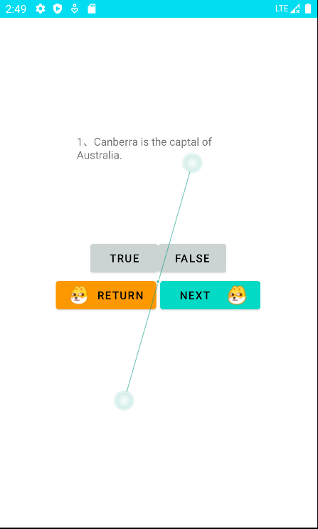

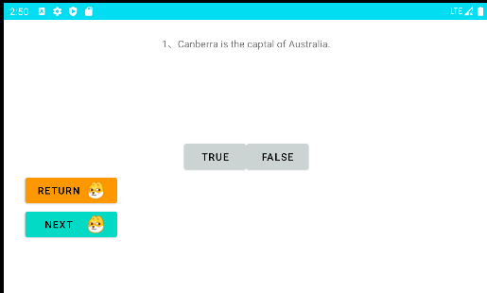

当所有题目完成时：

